BEHAVIOUR POLICY

Recommended by: Principal / Damian Belshaw

Recommendation Date: 30 September 2022

Ratified by: LAGB

Signed: TO BE RATIFIED BY GOVERNORS 30.11.22

Position on the Board: Acting Chair of LAGB

Ratification Date: 30 November 2022

Next Review: November 2023

Policy Tier (Central/Hub/School): School / WHHS

Contents
1. Aims 3
2. Legislation and statutory requirements 6
3. Definitions 7
4. Bullying 8
5. Rewards and sanctions 9
6. Roles and responsibilities 10
7. Behaviour management 11
8. Pupil transition 13
9. Training 13
10. Monitoring arrangements 13
11. Links with other policies 13
Appendix 1 ……………………………………………………………………………………………………………………………………………14

Aims

This policy aims to:
- Provide a consistent approach to behaviour management and the creation of our positive culture
- Define what we consider to be unacceptable behaviour, including bullying
- Outline how pupils are expected to conduct themselves
- Summarise the roles and responsibilities of different people in the school community with regards to behaviour management
- Outline our system of rewards and sanctions
Intent:

The culture that we want to build is based on creating a school where teachers can teach and students can learn. A system that everyone understands and is clear, is consistent and is fair. We are a school that is Warm/Strict. We are a school where we believe in certainty of consequence over severity.

Being warm, through kind words, body language, and being a caring mentor whilst upholding our clear expectations that everyone knows and understands. This shows students that adults have high expectations for them and although s/he will not make exceptions to the rules already in place, they will still care for them and want what is best for them.

Adults at Waseley are relentlessly positive. We expect the best of all children and reward them with certainty when they have done the right thing.

Implementation:

In order to have clarity we have developed and published a set of expectations that are applied consistently alongside a set of character traits that we want students to aspire to. We track behaviour using ETHIC Coins which are published weekly in a Pay Cheque session. These expectations all come with a debit when students don’t live up to them, and conversely, the traits are rewarded with a Credit when students meet them.

Our basic expectations (O5) are clear and outlined below. If students fail to meet these then they will be issued with a debit and a 10 minute detention at break time or after school on the day that the issue occurred.

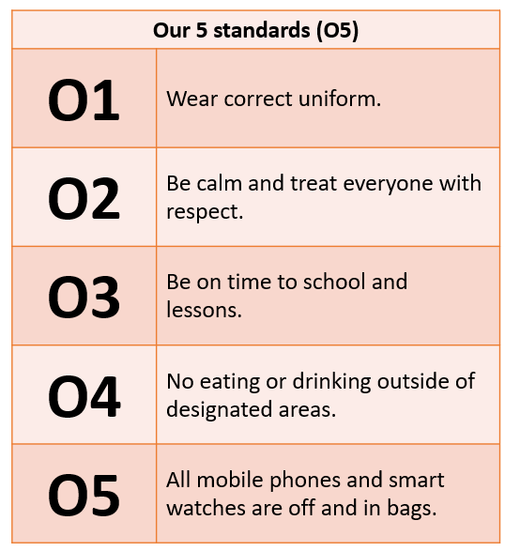

Our expectations in lessons (L5) are outlined below. Where students fail to meet these expectations, they will be corrected first using the strategy outlined beneath. Adults will judge the need for a consequence based upon how far a behaviour meets the following 3 tests.

- Persistence and Repetition: When students persistently engage in off-task behaviour that they know they shouldn’t, the teacher will err on the side of a consequence. If it seems like the cause is distraction or a misunderstanding, they will err on the side of correction.
- Degree of disruption: If a student’s behaviour doesn’t disrupt others’ learning, then they will be given a correction; if it does, give a consequence.
- Motivation: If a student is clearly testing expectations, teachers will give a consequence.

A consequence will result in a debit for the student. Multiple debits will then result in removal to our Refocus room and a 30-minute detention.

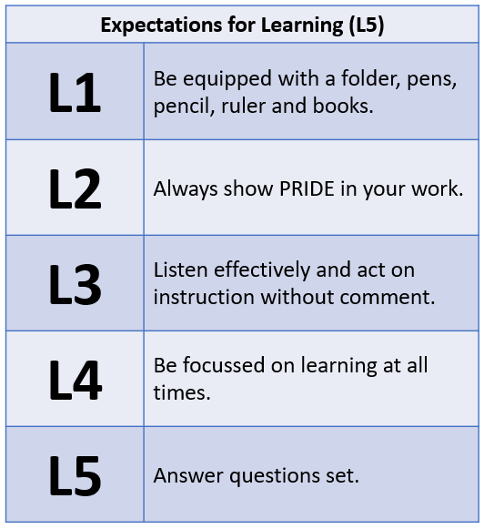

At Waseley, our character traits are outlined below, each one of these are also part of the KASE curriculum that defines the Knowledge, Attributes, Skills and Experiences that we want all of our students to acquire.

These ETHICs come with Credits that are attached. Over the course of a year, students will build a balance of ETHIC coins that they can use to purchase different items from our rewards stall.

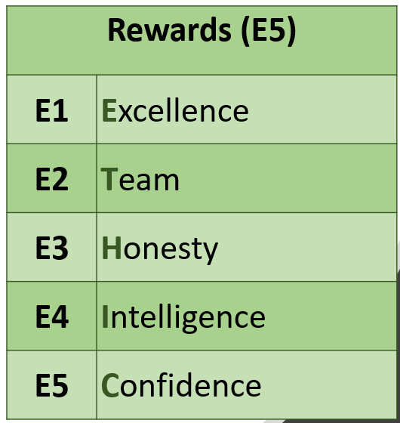

Tier 2 behaviours:

Tier 2 behaviours are those behaviours that are likely to result in time away from normal lessons. This may mean a session in Refocus, suspension or possible permanent exclusion. Where suspension or permanent exclusion are issued, this is a legal process as outlined in the Exclusions Policy. The list below is not exhaustive but indicates the types of behaviour that sit in this category.

Behaviour Incident
Refusal to complete Refocus
Cigarettes or alcohol in school (not used)
Illegal narcotics in school
Verbal abuse to public
Verbal abuse in presence of staff
Verbal abuse towards staff
Racist comments made
Walking off from staff and/or refusing to follow instructions
Fight in a classroom
Fight in unstructured times
Fights in the Community
Bullying
Cyberbullying
Bullying against a member of staff
Sexist assault
Non-consensual touching
False allegations against staff
Theft
Graffiti
Graffiti about staff
2 missed consequences
Name calling (families)
Dangerous behaviour
Bringing a weapon onto site
Truanting
Leaving the site without permission
Walking out of lesson
Multiple L Consequences

Responsibilities:

Staff, parents and students have a collective responsibility for:

- Promoting good behaviour in all areas of school and on the way to and from school
- Promoting self-esteem, self-discipline, proper regard for authority and positive relationships based upon mutual self-respect
- Ensuring fairness of treatment for all
- Responding consistently to both positive and negative behaviour
- Developing a positive and active partnership

It is the duty of all staff to correct breeches of our school rules. Adults will always look to correct behaviour before issuing a consequence. A summary of our Corrections and Consequences chart is outlined underneath.

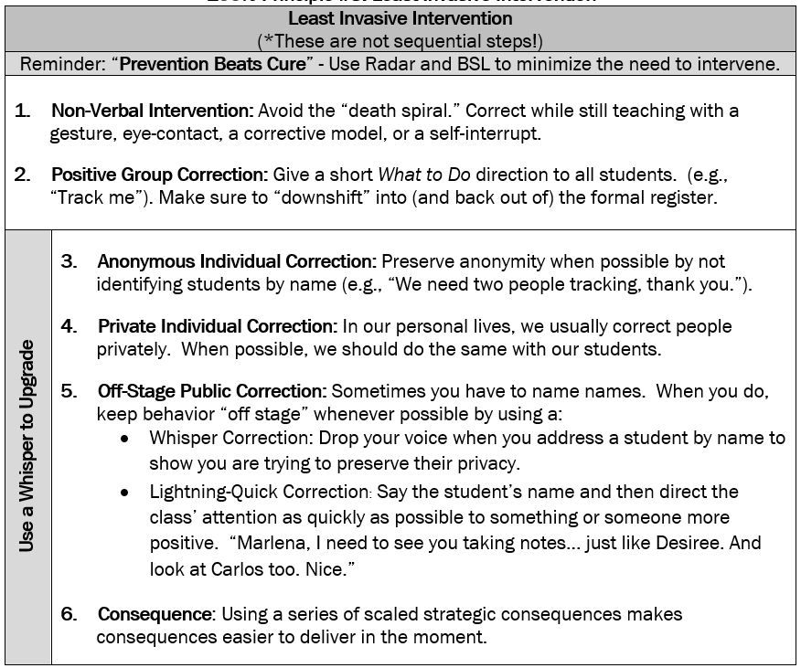

Legislation and statutory requirements

This policy is based on advice from the Department for Education (DfE) on:
- Behaviour and discipline in schools
- Searching, screening and confiscation at school
- The Equality Act 2010
- Use of reasonable force in schools
- Supporting pupils with medical conditions at school
It is also based on the special educational needs and disability (SEND) code of practice.

In addition, this policy is based on:
- Schedule 1 of the Education (Independent School Standards) Regulations 2014; paragraph 7 outlines a school’s duty to safeguard and promote the welfare of children, paragraph 9 requires the school to have a written behaviour policy and paragraph 10 requires the school to have an anti-bullying strategy
- DfE guidance explaining that academies should publish their behaviour policy and anti-bullying strategy online
This policy complies with our funding agreement and articles of association.

3. Definitions

Misbehaviour is defined as:
- Disruption in lessons, in corridors between lessons, and at break and lunchtimes
- Non-completion of classwork or homework
- Poor attitude
- Incorrect uniform

Serious misbehaviour is defined as:
- Repeated breaches of the school rules
- Any form of bullying
- Sexual assault, which is any unwanted sexual behaviour that causes humiliation, pain, fear or intimidation
- Vandalism
- Theft
- Fighting
- Smoking
- Racist, sexist, homophobic or discriminatory behaviour
- Possession of any prohibited items. These are:
  - Knives or weapons
  - Alcohol
  - Illegal drugs
  - Stolen items
  - Tobacco and cigarette papers
  - Fireworks
  - Pornographic images
  - Any article a staff member reasonably suspects has been, or is likely to be, used to commit an offence, or to cause personal injury to, or damage to the property of, any person (including the pupil)

Behaviour likely to lead to exclusion includes:

- Serious cases of rude, disrespectful behaviour
- Violent and aggressive behaviour – including bullying and intimidation
- Persistent disregard of school rules, consequence procedures, discipline code and dress code
- Failure to comply with health and safety regulations – fire notices, going on the roof, climbing over fences in the tennis courts, persistent smoking
- Acts of vandalism, damage or theft
- Possession or use of prohibited items
- Acts of abuse of any nature including incitement to abuse on religious, racial, age or gender related issues
- Persistent disruption of teaching and learning
- Being found in possession of any prohibited items, specifically weapons, smoking items and illegal substances

4. Bullying

Bullying is defined as the repetitive, intentional harming of one person or group by another person or group, where the relationship involves an imbalance of power.
Bullying is, therefore:
- Deliberately hurtful
- Repeated, often over a period of time
- Difficult to defend against

Bullying can include:

Type of bullying | Definition
Emotional | Being unfriendly, excluding, tormenting
Physical | Hitting, kicking, pushing, taking another’s belongings, any use of violence
Racial | Racial taunts, graffiti, gestures
Sexual | Explicit sexual remarks, display of sexual material, sexual gestures, unwanted physical attention, comments about sexual reputation or performance, or inappropriate touching
Direct or indirect verbal | Name-calling, sarcasm, spreading rumours, teasing
Cyber-bullying | Bullying that takes place online, such as through social networking sites, messaging apps or gaming sites

Details of our school’s approach to preventing and addressing bullying are set out in our anti-bullying strategy.
- Rewards and Sanctions

Use of Rewards

Positive Praise is at the heart of everything we do at Waseley, we have a positive tone when we speak to students and our teachers always assume the best.

Credits are given to students in line with our ETHICs.

Other methods of reward include:

- Verbal praise
- Thanking students for working hard
- Credits
- Formative marking of work
- Displaying students work
- Positive letter home
- Positive post card home
- Positive phone call home
- Autumn/Spring/Summer letters home regarding commendable attainment and effort grades
- Head of Year Commendation
- Subject Lead Post Cards
- Governors’ award for outstanding achievement
- Awards evenings
- Certificates for attendance

Corrections and Consequences:
Corrections and Consequences are used as part of our approach to ensure a calm, orderly and effective school. Consequences available include:

- Correcting
- deploying effective classroom management techniques
- lesson planning to incorporate good behaviour
- moving a student within a classroom
- waiting behind to discuss behaviour at end of lesson
- repeating work
- 10-minute O Consequence
- 20-minute lunchtime consequence
- 10 and 30-minute after school consequence
- Reports
- parental interview (some with police present)
- Refocus
- Suspension
- Permanent Exclusion

Circumstances in which the police could be called:

WHHS has the authority to contact the police when any evidence of a criminal act has been uncovered as a result of internal school investigations, adhering to guidance set out in the NPCC “When to Call the Police” These will include:

- possession or selling of illegal drugs
- cyber bullying, persistent bullying or harassment
- theft of property
- assault
- possession of offensive weapons (including knives and guns) or imitation weapons

Incidents away from school:

In line with the “Headteachers Guide for Behaviour and Discipline in School” WHHS also has the authority to punish students for incidents of negative behaviour outside of school hours for misbehaviour when the pupil is:
- taking part in any school-organised or school-related activity or
- travelling to or from school or
- wearing school uniform or
- in some other way identifiable as a student at the school (this can include a report from any member of the public who identifies a student as attending WHHS)

or misbehaviour at any time, whether or not the conditions above apply, that:
- could have repercussions for the orderly running of the school or
- poses a threat to another pupil or member of the public or
- could adversely affect the reputation of the school

Detentions

Staff are not required to give 24 hours notification for detentions. Our consequences are short and based on the principle of certainty over severity. It is critical that consequences are served as close to transgressions as possible so that students understand how their choices have led to a consequence.

- Roles and Responsibilities

All Staff:
Staff are responsible for:
- Implementing the behaviour policy consistently
- Modelling positive behaviour
- Providing a personalised approach to the specific behavioural needs of particular pupils
- Recording behaviour incidents (via SIMS, parental view available)

The Governing Board:
The governing board is responsible for monitoring this behaviour policy’s effectiveness and holding the Principal to account for its implementation.
The Principal:
The Principal is responsible for reviewing and approving this behaviour policy. The Principal will ensure that the school environment encourages positive behaviour and that staff deal effectively with poor behaviour, and will monitor how staff implement this policy to ensure rewards and sanctions are applied positively.

Parents:
Parents are expected to:
- Support their child in adhering to our expectations
- Inform the school of any changes in circumstances that may affect their child’s behavior
- Discuss any behavioural concerns with the class teacher/tutor promptly

Malicious allegations:
Where a student makes an accusation against a member of staff and that accusation is shown to have been malicious, the Principal will discipline the pupil in accordance with this policy.

7. Behaviour Management

Classroom management:
Teaching and support staff are responsible for setting the tone and context for positive behaviour within the classroom.
They will:
- Teach high quality lessons.
- Display the E5, L5 and O5
- Develop a positive relationship with pupils, which may include:
  - Greeting pupils in the morning/at the start of lessons
  - Following consistent and clear routines
  - Communicating expectations of behaviour in ways other than verbally
  - Rewarding using the Waseley ETHIC
  - Starting every lesson afresh
  - Never shouting

Refocus:
This system is designed to support all staff in the teaching and learning of their students. If a student repeatedly and willfully fails to meet L expectations they will be removed to Refocus. In here they will complete work in silence. If a student fails to meet the Refocus expectations they will have to repeat the time in Refocus. Should a student be removed from a lesson they will be issued a 30 minute after school consequence.

We may use Refocus in response to serious or persistent breaches of this policy or as an alternative to suspension. Pupils may be sent to Refocus during lessons if they are disruptive, and they will be expected to complete work as they would in class. Students who do not attend a given detention may also be placed in Refocus.

Physical restraint
In some circumstances, staff may use reasonable force to restrain a pupil to prevent them:
- Causing disorder
- Hurting themselves or others
- Damaging property
Incidents of physical restraint must:
- Always be used as a last resort
- Be applied using the minimum amount of force and for the minimum amount of time possible
- Be used in a way that maintains the safety and dignity of all concerned
- Never be used as a form of punishment
- Be recorded and reported to parents

Confiscation
Any prohibited items (listed in section 3) found in pupils’ possession will be confiscated; these items will not be returned to pupils. We will also confiscate any item which is harmful or detrimental to school discipline. These items will be returned to pupils after discussion with senior leaders and parents, if appropriate.

Searching and screening pupils is conducted in line with the DfE’s latest guidance on searching, screening and confiscation.

Mobile Phones

Pupils may bring mobile devices into school but are not permitted to use them during the school day at all, this also included smart watches and personal music devices; we have a gate to gate policy and students phones should be switched off and remain in their school bag from the point of arrival at the school gate, until they exit the school gate at the end of the day.
- First breach – phone confiscated and collected by student from Reception at the end of the school day
- Second breach – phone confiscated and remain in school until parent/carer has met with a member of SLT/Head of Year to collect the phone; 30 minute consequence issued
- Third breach – phone confiscated and remain in school until parent/carer has met with a member of SLT; 30-minute consequence set. Any further breaches could result in suspension from school and/or the need to sign phone in and out of reception each day.

Pupil support
The school recognises its legal duty under The Equality Act 2010 to prevent pupils with a protected characteristic from being at a disadvantage. Consequently, our approach to challenging behaviour may be differentiated to cater to the needs of the pupil through reasonable adjustments.
Where students are identified as having multiple consequences, repeat suspensions or other identifiable concerns, they will be placed upon a 6-week Pastoral Support Plan which will be done in-line with their Head of Year.
The school’s special educational needs coordinator will evaluate a pupil who exhibits challenging behaviour to determine whether they have any underlying needs that are not currently being met. Where necessary, support and advice will also be sought from specialist teachers, an educational psychologist, medical practitioners and/or others, to identify or support specific needs. When acute needs are identified in a pupil, we will liaise with external agencies and plan support programs for that child. We will work with parents to create the plan and review it on a regular basis.

Other support may include:
- Specific student CPD.
- Effective PSHCE education.
- Tutor programme.
- 1:2:1 sessions with adults including head of year and SWOs.
- The use of Alternative Provision or other educational settings.

8. Pupil transition

To ensure a smooth transition to the next year, pupils have transition sessions with their new teacher(s). In addition, staff members hold transition meetings. To ensure behaviour is continually monitored and the right support is in place, information related to pupil behaviour issues may be transferred to relevant staff at the start of the term or year. Information on behaviour issues may also be shared with new settings for those pupils transferring to other schools.

9. Training

Our staff are provided with training on managing behaviour, as part of their induction process. Clear expectations are set for all teaching staff, Tutors, Subject Leads and Heads of Year, which outline a supportive mechanism in response to supporting colleagues with managing and maintaining behaviour.

Behaviour management will also form part of continuing professional development including training in how to talk to students and the importance of positivity.

Students have been trained in how to respond to corrections

10. Monitoring arrangements

This behaviour policy will be reviewed by the Headteacher and full Governing Body annually. At each review, the policy will be approved by the Headteacher.

11. Links with other policies

This behaviour policy is linked to the following policies:
- Exclusions policy
- Safeguarding policy
- Online Safety
- SEND Policy

Appendix 1: written statement of behaviour principles

- Every pupil understands they have the right to feel safe, valued and respected, and learn free from the disruption of others
- All pupils, staff and visitors are free from any form of discrimination
- Staff and volunteers set an excellent example to pupils at all times
- Rewards, sanctions and reasonable force are used consistently by staff, in line with the behaviour policy
- The behaviour policy is understood by pupils and staff
- The exclusions policy explains that exclusions will only be used as a last resort, and outlines the processes involved in permanent and fixed-term exclusions
- Pupils are helped to take responsibility for their actions
- Families are involved in behaviour incidents to foster good relationships between the school and pupils’ home life

