Year 9 Child Development Lessons 11&12 Developmental chart for PHYSICAL DEVELOPMENT for a child aged……

Age of Child | Aspect of Physical Development | Gross / Fine? | Toys / activities suitable to use to play with the child and observe? | How you could collect evidence?
E.g. 3 Year old (if you know a child use their age, otherwise do 3 years) | Walks and runs on tiptoes (from PIES coloured cards) | Gross (choose some that are gross and some that are fine) | Hide and seek / tag (your own ideas) | Video, photograph (from video you watched in lesson 2)
1

2

3
4

Year 9 Child Development Lessons 11&12 Developmental chart for INTELLECTUAL DEVT for a child aged……

Age of Child | Aspect of Intellectual Development | Toys / activities suitable to use to play with the child and observe? | Pictures of suitable toys / activities | What concept is this teaching
E.g. 3 Year old (if you know a child use their age, otherwise do 3 years | Can name colours from PIES coloured cards) | Number and matching board (search the internet or ask parent of child) | 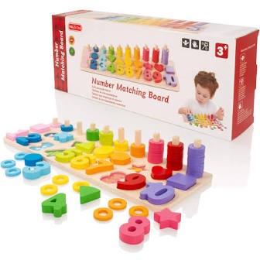 | Colours & Numbers (think what you know about concepts)
1

2
3
4

Year 9 Child Development Lessons 11&12 Developmental chart for SOCIAL DEVELOPMENT for a child aged……

Age of Child | Aspect of Social Development | Toys / activities suitable to use to play with the child and observe? | How would you play this game / carry out the activity? | What is the developmental milestone for the lower and upper age?
Eg 3 Year old  (if you know a child use their age, otherwise do 3 years | Can tell others how he or she is feeling  from PIES coloured cards) | 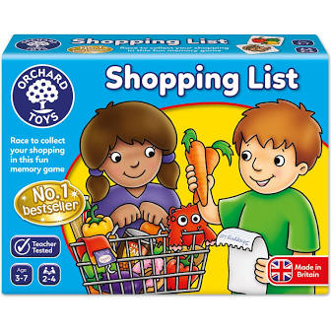 | The child and I would have a list of foods that we needed to turn over and collect, we can discuss what we like and dislike and so I can see how the child is feeling and if he or she can tell me. | 2 year old- begins to understand own feelings.  4 year old – may be confident socially. (look at suitable statements on PIES charts)

