6th June 2021

Dear Parent/Carer

I am writing to inform you that our school Governors have resolved for Waseley Hills High School to join the Central RSA Academies Trust. This is an excellent opportunity to support the development of those within the wider RSA family.

The RSA, the Royal Society for Arts, Manufacturers and Commerce, are committed to a future that works for everyone. They have been at the forefront of significant social impact for over 250 years by providing platforms, opportunities and networks for those who share their vision to connect, engage, share ideas and expertise.

The Central RSA Academies Trust is a group of primary and secondary RSA Academies with a strong link with the RSA. This is an incredibly exciting opportunity to join a forward thinking, Midlands based multi academy Trust with an utter moral drive to ensure the best educational outcomes for our students and striving to make a difference to the lives of our young people.

There are currently nine schools within the Trust, with children from the age of three up to Sixth Form aged young adults. The schools are in hubs in the West Midlands, in Worcestershire and in the Black Country. The schools and their staff work together to ensure the best possible learning for the young people by supporting each other through expertise and sharing so that our staff can be the best they can be.

We are currently waiting for formal confirmation which we expect to receive shortly. We will keep you informed of progress, and we hope you are excited as we are about the future with the Central RSA Academies Trust.

Kind Regards
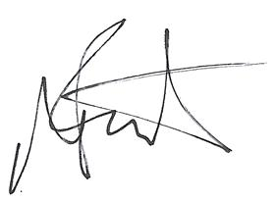

Carole Gallant Andy Boot
Chair of Governors Acting Headteacher

