2 Week Independent Learning plan Week 13 and 14
Support contact details:
Email general queries to: nbaker@waseleyhills.worcs.sch.uk
Teachers email addresses in this subject area:
Subject Leader (J.Williams ) email: jewilliams@waseleyhills.worcs.sch.uk

Monday July 6th – Wednesday July 15th
Subject: Child Development
Year: 10
Topic/theme: RO20LO3 Child Study – This will look the same as previous weeks, but you MUST ensure you have planned the activities that you will CARRY OUT OVER THE SUMMER HOLIDAYS with your child.

Three stages to online learning
Stage One – Reading Task | Stage Two – Completing Tasks | Stage Three – Assessing your learning and feedback
Read the lessons in the table below. Think about what you need to learn from the task. It may help to look at the other lessons too as this will show you where your learning is heading. | Find the resources you need. In some instances you may need to log into HomeAccess+ and find the file on the coursework drive (S). Login with your normal school username and password. Use the resource as described to complete the suggested task. Reflect on the teacher’s question.  Click here for HomeAccess+ drive  Click here for help with accessing HomeAccess+ | At the end of the two weeks you will be set a task by your teacher on Show My Homework. This is submitted in SMHWK. This task will assess your learning and allow us to give you feedback.  These assessment tasks are optional but submitting them is very helpful for you and your teacher to understand what you have learnt.

We are here to help you within school opening hours:
Email your teacher | Join your teacher for a support chat session | Ring school reception
You can now email your teacher using your Office 365 email address. You can also email Mr Baker or the Subject Leader using the contact info above (top right). | You will also receive an invite during the two week period to join an online support chat with your teacher. | Call 0121 4535211 within school hours. They will email your teacher and ask them to contact you.

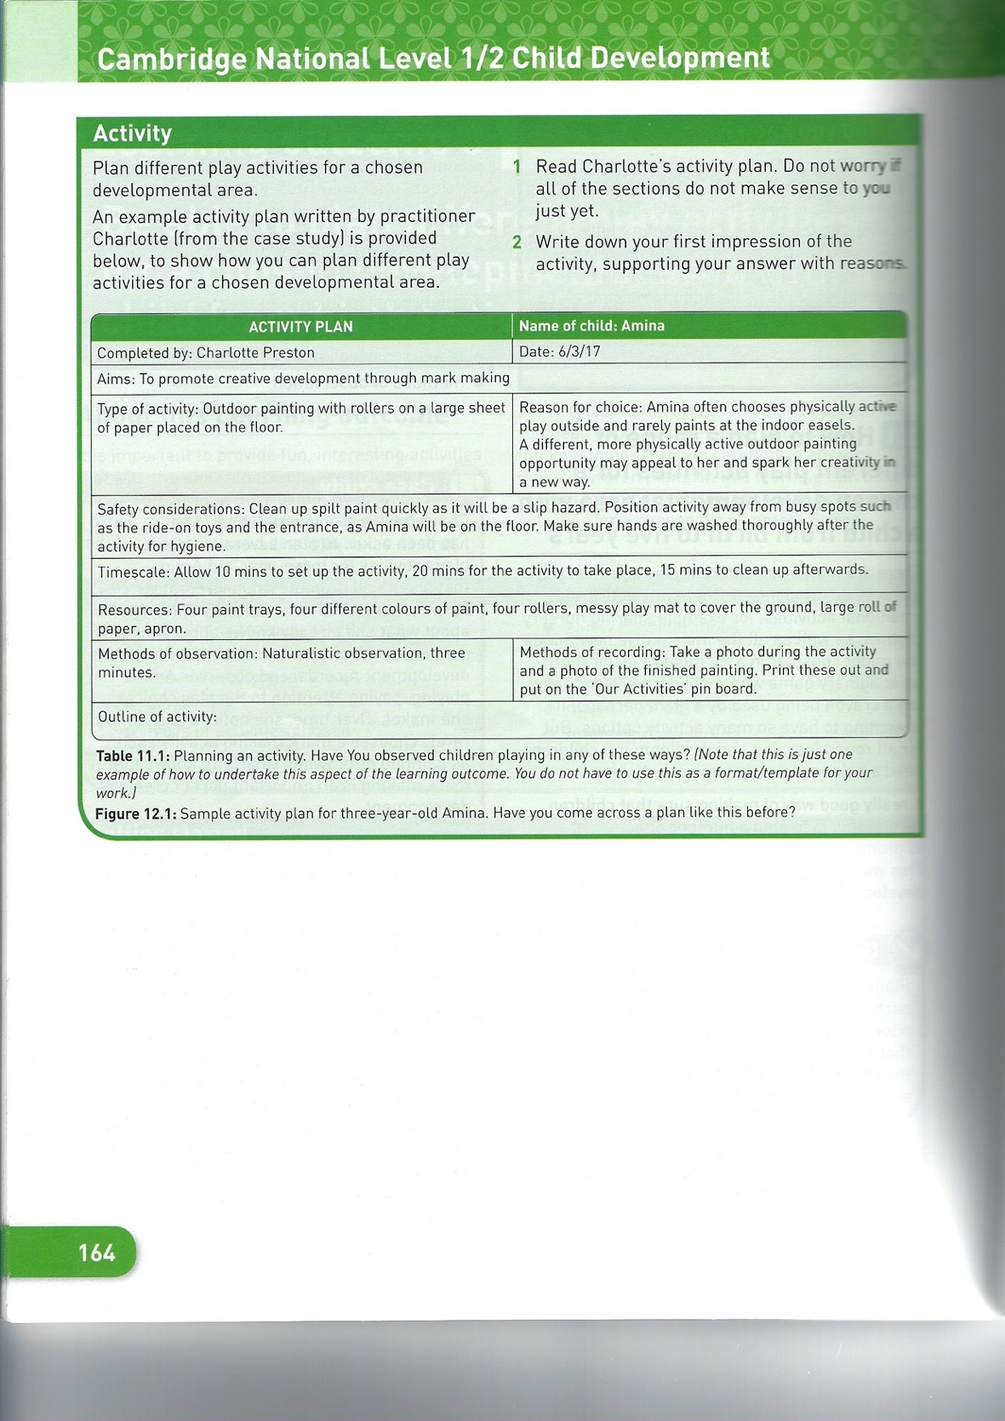
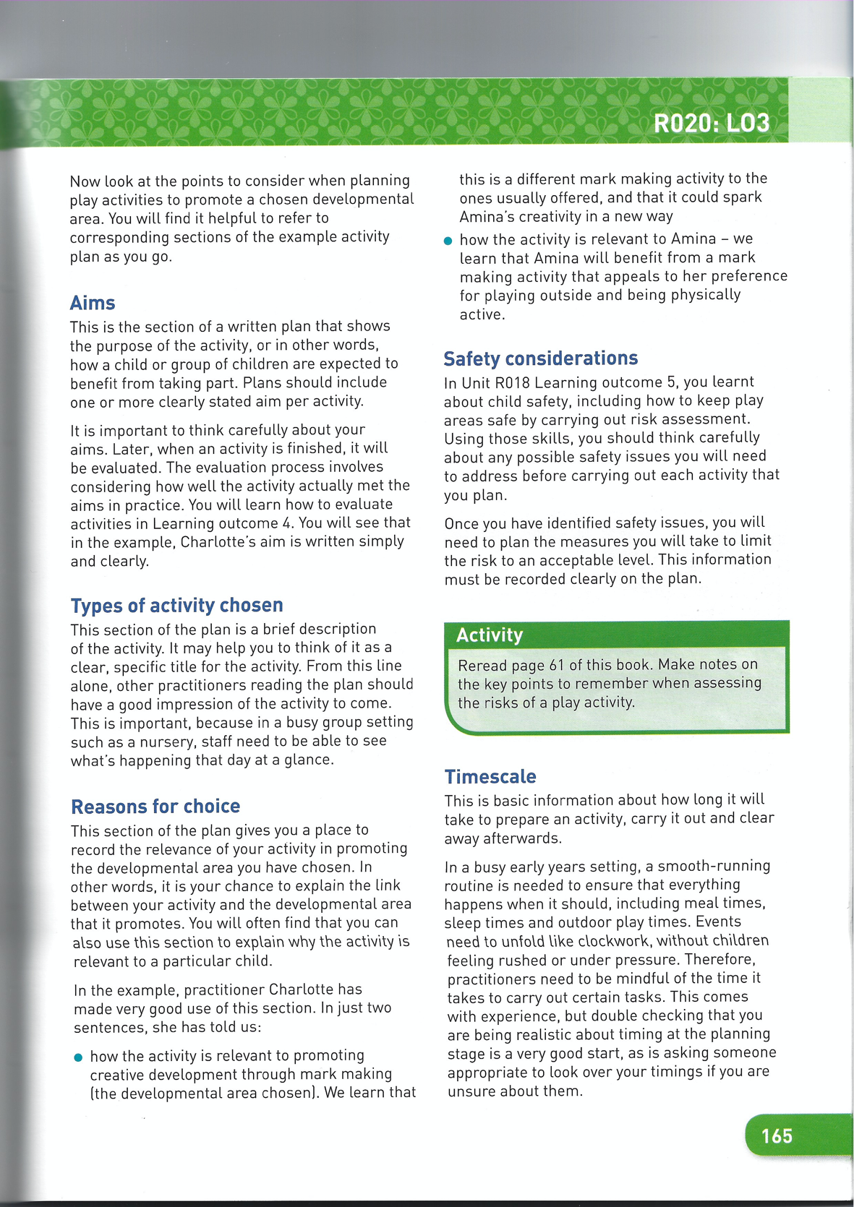
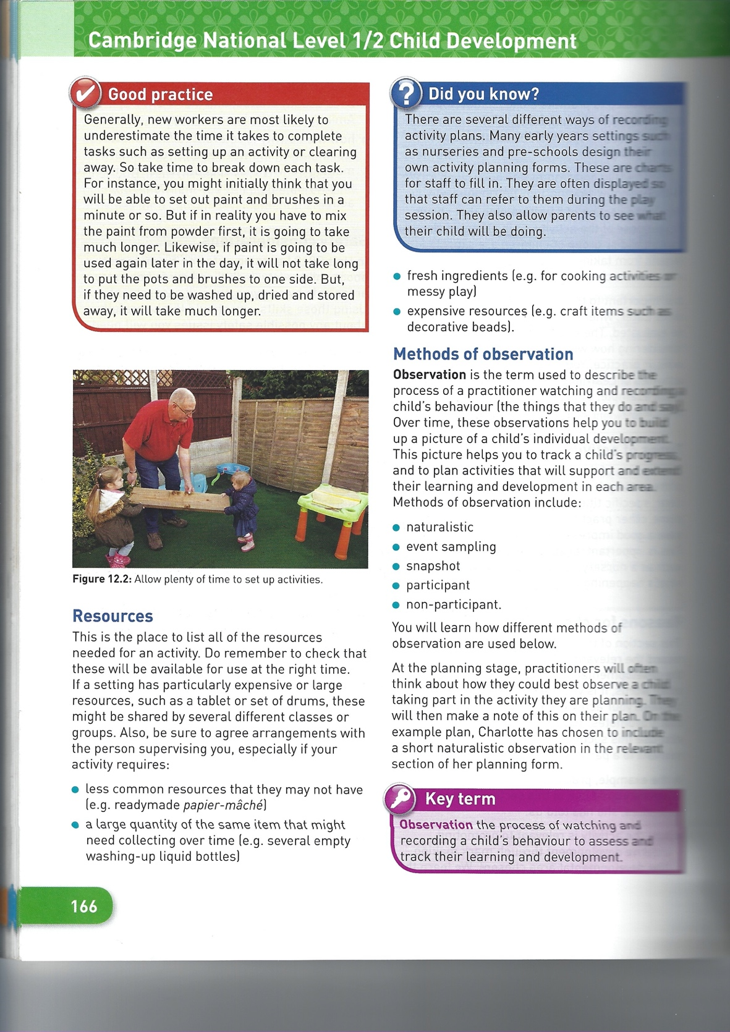

Learning tasks for this fortnight: You will be again working on planning your activities for your child study. Many thanks as most of you have had a discussion with me about your activities you plan to do and have sent me your planning for me to feedback and for you to improve. As it says above, you will do these activities over the summer – take lots of pictures!!

Lesson | Aim:  What you need to take from this lesson | Resource(s) to use:  Hyperlinks to videos etc  HomeAccess+ file location | Suggested task:
1 | In this lesson you will learn.  How to plan relevant activities for your child study.  You must plan and carry out 2 activities on your child.  Both activities need to be linked to 1 area of Devt.(PIS) | Description of resource:  Location: HomeAccess+/Coursework drive / Child development / Cambridge National / RO20 / LO3  File Name: Child study planning.  File name: exemplar work | Description of what you need to do (step by step):  Read the exemplar work samples alongside Mrs Williams feedback for your planned activities.  A question your teacher would have asked you at the end of this lesson is:  What improvements do you need to make?
2 | In this lesson you will learn…  That you must complete planning for activity one, this can be as a chart like the example or can be written out with the titles as in the notes. | You could attend a support chat session with Mrs Williams before completing this to discuss what you will make.  See the exemplar folder of past work in the CW area, follow link on page 1 above to see how people have set out work.  Description of resource:  Location: HomeAccess+/Coursework drive / Child development / Cambridge National / RO20 / LO3  File Name: Child study planning.  File name: LO3 & 4 checklist | Description of what you need to do (step by step):  Look at the checklist and start to put you work in the correct order, including making any improvements from feedback from Mrs Williams.  Complete the details explaining for activity one what your AIMS are, what TYPE of activity you are doing, your REASONS FOR CHOICE, SAFETY CONSIDERATIONS, TIMESCALE, RESOURCES, METHOD OF OBSERVATION (participative) METHOD OF RECORDING (usually photos and completing the observation chart) and OUTLINE OF ACTIVITY (here say what you will do step by step and what the child will do – look at examples)  A question your teacher would have asked you at the end of this lesson is:  How will you make the resources suggested?
3 | In this lesson you will learn…  That you must complete planning for activity two, this can be as a chart like the example or can be written out with the titles as in the notes. | You could attend a support chat session with Mrs Williams before completing this to discuss what you will make.  File name: LO3 & 4 checklist | Look at the checklist and start to put you work in the correct order, including making any improvements from feedback from Mrs Williams.  Description of what you need to do (step by step):  Complete the details explaining for activity one what your AIMS are, what TYPE of activity you are doing, your REASONS FOR CHOICE, SAFETY CONSIDERATIONS, TIMESCALE, RESOURCES, METHOD OF OBSERVATION (participative) METHOD OF RECORDING (usually photos and completing the observation chart) and OUTLINE OF ACTIVITY (here say what you will do step by step and what the child will do – look at exemplar work)  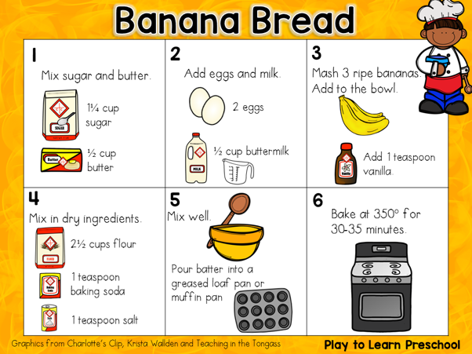  A question your teacher would have asked you at the end of this lesson is:  How will you make the resources suggested like the recipe sheet above?
4 | In this lesson you will learn…  That you must prepare resources which could be used for your child study observations. | You will need to attend a support chat session with Mrs Williams before completing this to discuss what you will make.  File name: LO3 & 4 checklist | Look at the checklist and start to put you work in the correct order, including making any improvements from feedback from Mrs Williams  Description of what you need to do (step by step):  Prepare the resources that you need, eg the treasure hunt map, a card sorting game, a book. These can be prepared and emailed to Mrs Williams for printing at school if needed.  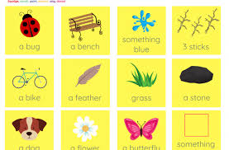  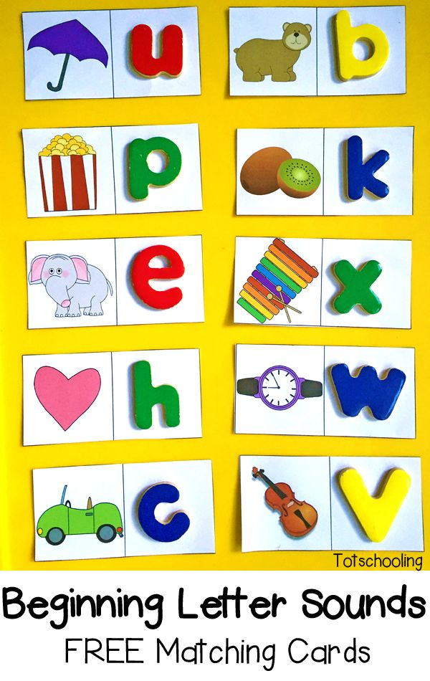  A question your teacher would have asked you at the end of this lesson is:  Have you got enough resources to keep the child occupied? What else can you have ready e.g. a book, an opportunity to watch their favourite programme.
5 | In this lesson you will learn…  That you need to prepare a participative observation chart to fill in when your child does the planned activity. | You will need to attend a support chat session with Mrs Williams before completing this to discuss what you will make.  File name: LO3 & 4 checklist | Look at the checklist and start to put you work in the correct order, including making any improvements from feedback from Mrs Williams  Description of what you need to do (step by step):  For both activities, prepare a participative observation chart saying what you would expect your child to be able to show, the outline is below and in the coursework area link above, and an example is here if you were going to do a treasure hunt with a 4 year old focusing on gross motor skills. You only need to prepare the first column, but only choose things in there that relate to what you want them to do, eg if you are making cakes, you would not say ‘confidently climbs and slides on apparatus’ you may say confidently climbs onto a chair.  Activity / Norm Date child can do this Date child attempts to do this Date child does not attempt Comments  Changes direction whilst running Put the date and add a photo Put the date and add a photo Put the date Example: In the treasure hunt, xxxx had to run around the garden to find clues and he did this with no problem and did not fall over.  Walks in a straight line successfully  Confidently climbs on apparatus  Hops safely  A question your teacher would have asked you at the end of this lesson is:  Do you have a plan for both activities, a participative observation chart for both activities, resources for both activities?  As you will need to show these / email to jewilliams@waseleyhills.worcs.sch.uk
How will we assess you learning?
Years 7 and 8: Pupils will be set an interactive quiz using this information on Show My Homework or asked to submit a piece of work such as a photograph of art work.
Year 9 to 11: Pupils may be set an interactive quiz or a written task via Show My Homework.

Need help?
HomeAccess+ https://facility.waseley.networcs.net/HAP/login.aspx?ReturnUrl=%2fhap (use your normal school username and password).
Pupil and parent help page: https://www.waseleyhills.worcs.sch.uk/coronavirus-independent-learning/help-for-parents-and-pupils
RO20 LO3 &LO4 - Structure of write up for Child Study

USE IN CONJUNCTION WITH HELPSHEETS IN CW AREA

Task | Description | Mark allocation | Completed
1 | Front cover with candidate name and number  Create a footer with your name and the course number which is J818 and RO20 LO3 or LO4.
2 | Title of the task  Planning different play activities for a chosen developmental area for a child from birth to five years’ | LO3  15  Marks
3 | Background to the child  - Use capital letters for parents and for name of child and any family members.  - Explain where they live, who they live with, what toys they have, who cares for them, no specific details such as surname or actual place names.  - Add pictures but not of faces
4 | Introductory Visit  - Explain what naturalistic observation means and why you have carried it out in your introductory visit.  - Write the date, time and place of observation ‘the child’s house’  - If a child speaks, write what they said eg ‘I want car’  - Use the terms eg pincer grasp, palmar grasp.  - Use good punctuation such as commas and apostrophes.  - Add photographs to show evidence of the child doing something, such as using a type of grasp, but block out faces.  - Explain what the child was doing in the observation, .  - Look at suitable toys for the age you are studying to help plan activities.  - Ensure you finish with a summary of what you saw, what the strengths were and which PIES you plan to observe further.
5 | Planning visits, explain the following for each one:  - Aims – what do you want to do in the visit?  - Type of activity chosen – what are you doing and why?  - Reasons for choice – link to introductory visit, link to developmental milestones, link to information given to you about the child and link to their likes / dislikes.  - Safety Considerations – discuss issues such as road safety, allergies, safety of equipment, labelling. (Use learning from RO18)  - Timescales – Explain what you will do, step by step, and if necessary, what the child will do and what you will do.  - Resources – Explain what you will use, explain what you will make and link to devt charts, learning from RO18, and put copies in.  - Type of observation and method of recording, and why and a copy of the observation sheet you plan to use.

Fancy showing your best work off?
You can email a photo of you doing something great, or an example of your best piece of work to your Head of Year for our celebrations assemblies when we return.
Yr 7 please email Mrs Williams at jewilliams@waseleyhills.worcs.sch.uk
Yr 8 please email Mrs Bridgeman at jbridgeman@waseleyhills.worcs.sch.uk
Yr 9 please email Mrs Bradley at kjbradley@waseleyhills.worcs.sch.uk
Yr 10 please email Mr Jones at djones@waseleyhills.worcs.sch.uk

Please keep your work organised in subjects as we are excited to see what you have achieved and reward you for it when we return.

