Year 11 Bridging Tasks Drama
The global transferable skills gap
In recent years, universities and employers have highlighted the need for students and graduates to develop a range of transferable skills, often referred to as ‘soft skills’, to enable them to better meet the demands of undergraduate study and the world of work. In fact, universities and employers consider transferable skills to be the largest skills gap overall.

1 in 6  employers have difficulty finding candidates with the skills they require1 | 54%  of companies say that skills shortages impact their ability to serve their customers2 | 1 in 3  skills in a job posting is a “soft skill”1 | 87%  of university professors do not think students have the research skills needed for degree-level study3
1 Employability - Personal & Social Capability Framework report from Pearson, 2016.
2 Employability report from PSB for Pearson, 2016.
3 Bridging the Gap: Understanding the Differing Research Expectations of First-Year Students and Professors, Meg Raven, Mount Saint Vincent University), 2016.
The transferable skills gap demonstrates that students require more than just ‘knowledge’ to be successful.
It’s about skills as well as knowledge to be successful at further study, higher education and in the workplace.

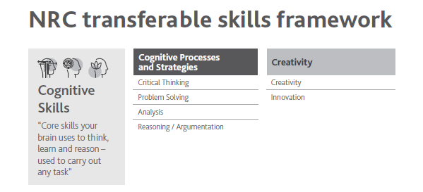
Task One:
Consider how you have used Cognitive skills throughout your GCSE Drama studies. Complete the table below and then use this to write a paragraph that could be used in an application or Personal Statement.
Please refer to the glossary attached if you are unsure or unfamiliar with any of the terms
Cognitive Skills | Components One: Devising | Component Two:  Performance from a text | Component Three:  Theatre makers in practice
Critical thinking
Problem solving
Analysis
Reasoning/Argumentation
Creativity
Innovation

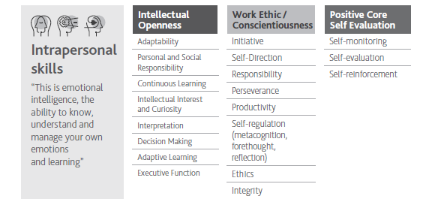
Task Two:
Consider how you have used Intrapersonal skills throughout your GCSE Drama studies. Complete the table below and then use this to write paragraphs that could be used in an application or Personal Statement.
Please refer to the glossary attached if you are unsure or unfamiliar with any of the terms
Intrapersonal Skills | Components One: Devising | Component Two:  Performance from a text | Component Three:  Theatre makers in practice
Adaptability
Personal and social responsibility
Continuous learning
Intellectual interest and curiosity
Interpretation
Decision making
Adaptive learning
Executive function
Initiative
Self direction
Responsibility
Perseverance
Productivity
Self-regulation
Ethics
Integrity
Self-monitoring
Self-evaluation
Self-reinforcement

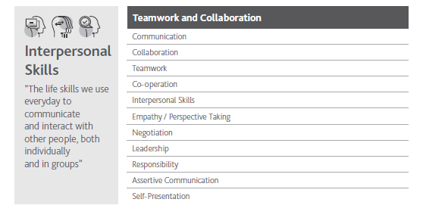
Task Three:
Consider how you have used Interpersonal skills throughout your GCSE Drama studies. Complete the table below and then use this to write paragraphs that could be used in an application or Personal Statement.
Please refer to the glossary attached if you are unsure or unfamiliar with any of the terms
Interpersonal Skills | Components One: Devising | Component Two:  Performance from a text | Component Three:  Theatre makers in practice
Communication
Teamwork
Co-operation
Interpersonal Skills
Empathy/Perspective taking
Negotiation
Leadership
Responsibility
Assertive Communication
Self Presentation

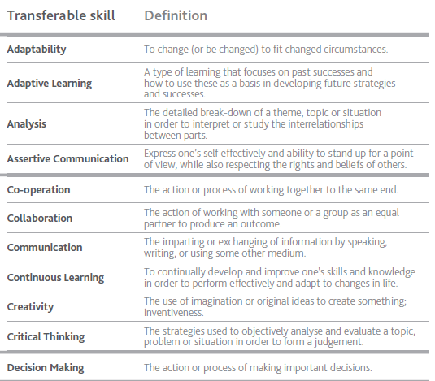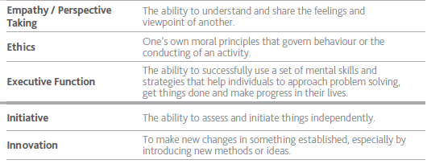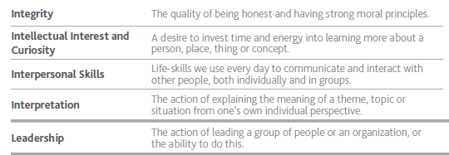

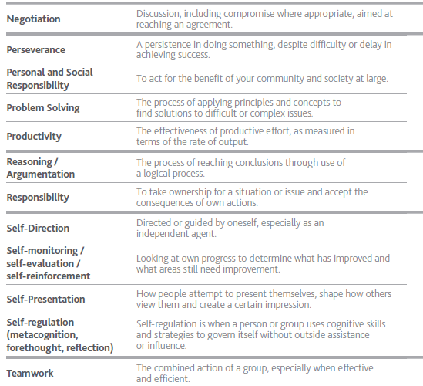

Task Four: Edexcel Drama and Theatre Studies:
Read the A’level overview and consider how GCSE Drama has prepared you for the course:
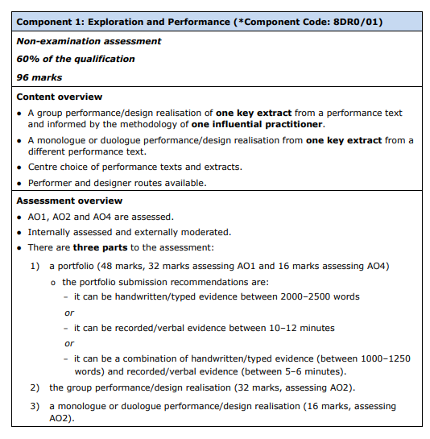

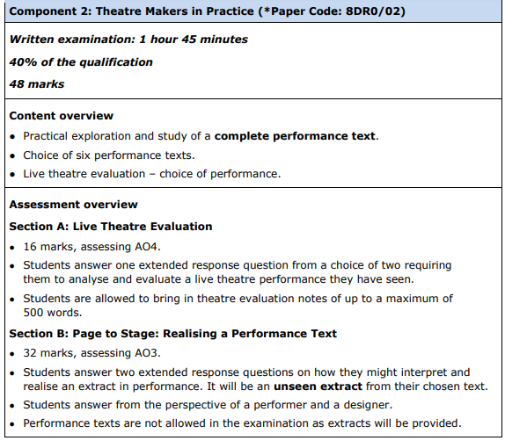

Task Five: Set Text research
Conduct research into one of the set texts. You do not need to read the play but you could if you wish too.
Choose from one of the following:
- Dr Fautus, Christopher Marlowe
- Lysistrata, Aristophanes
- Woyzeck, Georg Buchner
You could record your research as a PowerPoint presentation.
Remember if you include quotes from a book or web site you have used, you must put them in quotations marks and include the book or web site in the last slide of your presentation.
Within your research notes or research PowerPoint include the following:
A brief summary of the prescribed text (play).
A brief summary of the main characters
Explain what genre your prescribed text is (social thriller, mystery, historical drama, black comedy, romantic comedy, political satire).
Describe the structure of the play (episodic, prologue, flashbacks, narration etc.)
Provide a brief biography of the playwright.
When was the play first performed? Where was the play first performed?
Include a theatre review of the play.
Include images of professional performances of the play.
Remember to record all the sources you have used and write a bibliography. If you are creating a Power Point this should be your final slide.

