Indian cuisine
Complete this table.

Distinctive features and characteristics of Indian cooking
The foods grown, reared and caught in India
(Make sure you understand the difference between grown, reared and caught)
Traditional dishes made in India
Equipment and cooking methods used in Indian cooking
Eating patterns in India
Difference in regional cooking within India (i.e. north, south, east, west or the different states)

Task 2
Watch the demonstration of Mrs Patel making Potato and Pea Samosas. Link will be put on SMHW.

Task 3
Read the recipe thoroughly.

Potato and Pea Samosas – makes 15-20 samosas
Pastry Ingredients
- 300g plain flour , plus extra for dusting
- ¼ teaspoon baking powder (if you do not have any then just make the dough without it)
- Pinch of salt
- 50ml oil

Filling Ingredients
- 2 tablespoons oil plus extra for brushing
- 2-3 medium sized potatoes
- 60g frozen peas
- 1 small onion
- 1 clove of garlic
- 2cm piece of ginger
- 1 fresh green chilli OR ¼ tsp chilli powder
- ½ teaspoon cumin seeds
- ½ teaspoon garam masala
- ½ teaspoon ground coriander
- Salt, to taste
- ½ a lemon
- handful of fresh coriander (optional)

*NOTE- if you do not have all of the spices then just use what you have, you could even use curry powder. However, it will be more authentic with the separate spices.

Method
- To make the dough, combine the flour, baking powder and salt in a large bowl.
- Use your fingers to rub in the oil until the mixture resembles breadcrumbs. Stir in 75ml of cold water, then bring it together with your hands into a rough dough, add more water, if needed.
- Place in an oiled bowl, cover with a damp tea towel and leave to rest for 30 minutes.
- Peel and chop the potatoes into rough 2.5 cm cubes
- Add the potatoes to a large pan of boiling salted water and cook for 8-10 minutes, or until tender. Add the peas for the final minute, then drain.
- Peel and finely chop the onion and garlic, then peel and finely grate the ginger. Deseed and finely chop the chilli.
- Put the 2 tbsp. of oil into a large non-stick frying pan over a medium heat, add the cumin seeds and let them sizzle for a few seconds then add the onion and cook for 8 minutes, or until softened but not coloured.
- Stir in the garlic, ginger and chilli, then fry for a further few minutes.
- Add the garam masala and ground coriander. Stir well.
- Stir the cooked veg into the pan and crush gently with a potato masher – don't overdo it: you want a fairly chunky mixture. Squeeze in the lemon juice and season to taste. Leave to cool, then finely chop and stir in the coriander leaves.
- Preheat the oven to 180ºC/350ºF/gas 4. Lightly grease a large baking tray with oil.
- On a flour-dusted surface, halve the dough and roll out each portion to about 1cm thick. Using a 7cm pastry cutter, stamp out as many circles as you can, then roll into ovals, roughly ½cm thick and 15-18cm in diameter.
- Cut each oval in half, then brush the straight edges with a little water. Roll into a cone shape, bringing the straight edges together and pressing lightly to seal.
- Spoon in the filling, brush the exposed dough with a little water, make a small pleat on the larger side, then press to seal. Place onto the prepared baking tray, then repeat with the remaining ingredients, keeping the samosas covered with a damp tea towel as you go.
- Brush the samosas with a little oil and bake for 45 minutes, or until golden and piping hot through. Serve straightaway with mango chutney.

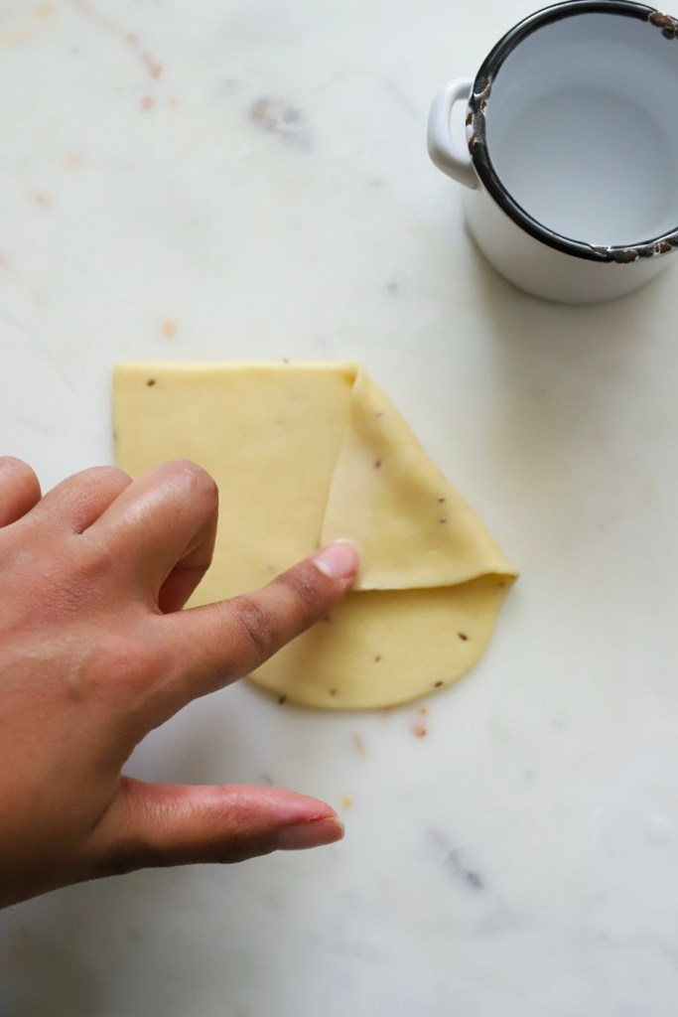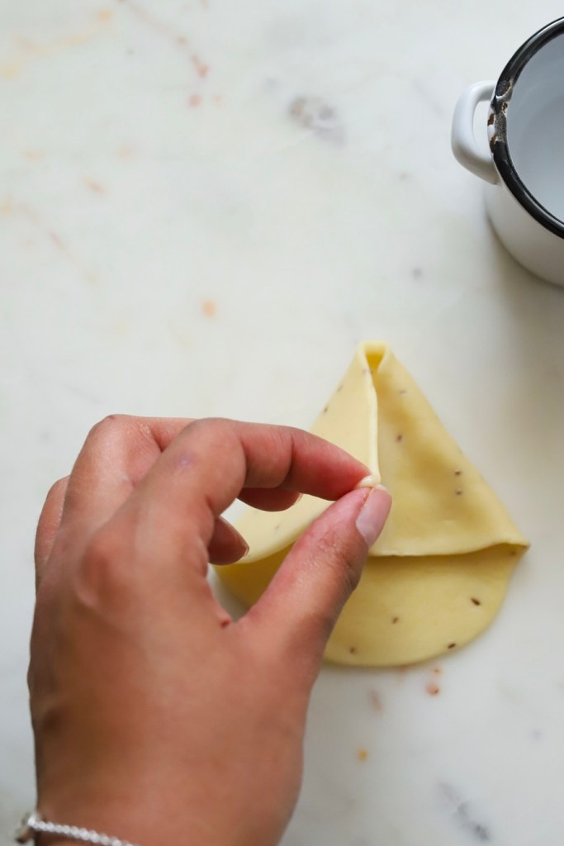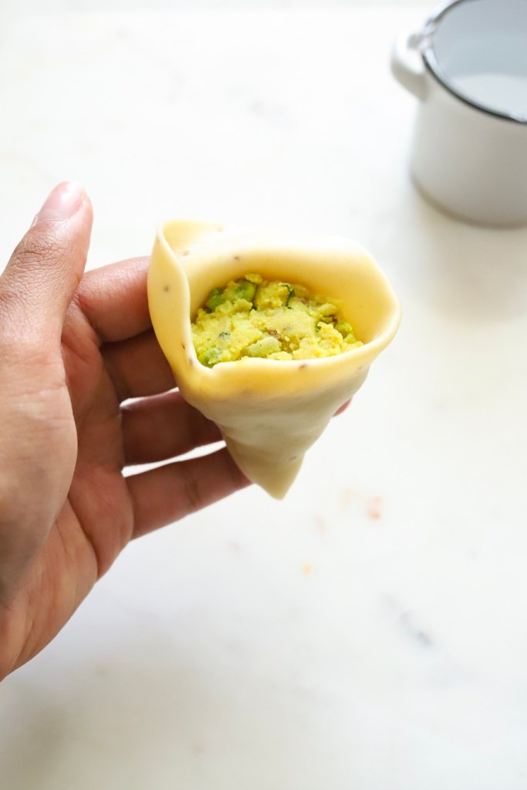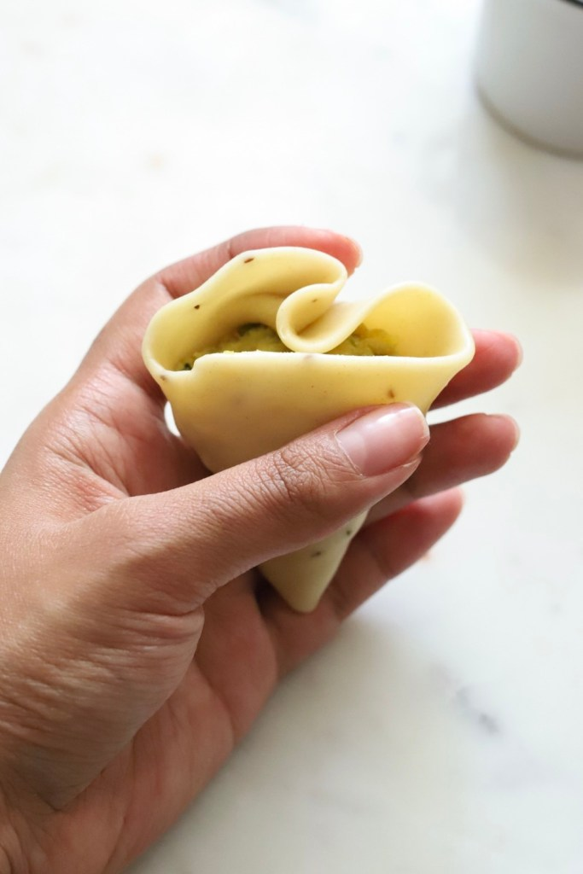

Task 4
- Make the dish as one of your family meals.
- Meet the success criteria:
  - Well-seasoned and well-spiced filling
  - Evenly cut potatoes
  - Even shaped samosas
- You can scale the recipe up or down as necessary.
- Take photos of your finished dish and email to your teacher:
apatel@waseleyhills.worcs.sch.uk
jewilliams@waseleyhills.worcs.sch.uk

*Note – if you do not have the resources to cook this dish then don’t worry but it is a fun recipe to try.

Task 5

- Name at least 10 spices used in Indian cooking.

- Can you identify the following spices? (Hint – Google ‘Indian Spices’, then images)

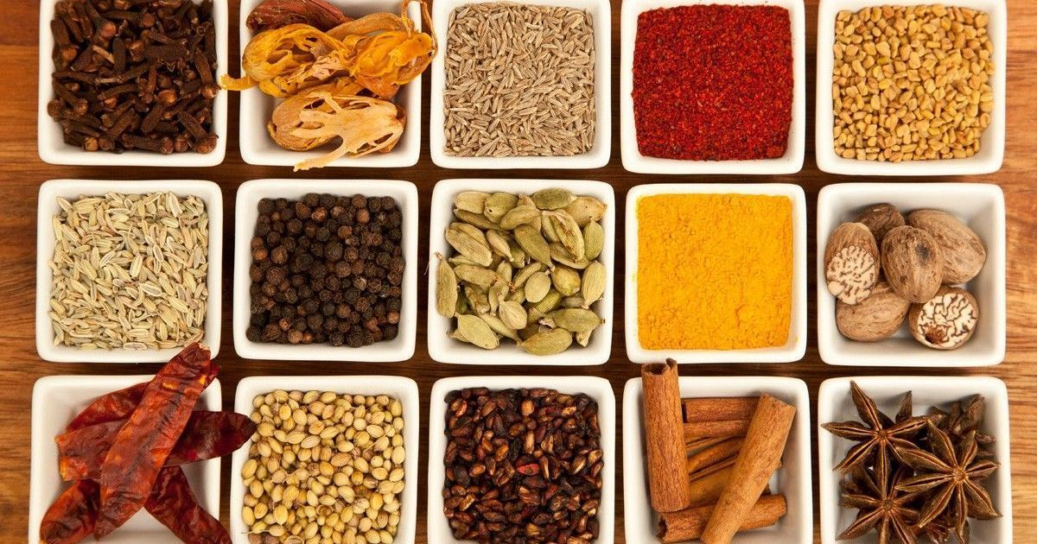
15
14
13
12
11
10
9
8
7
6
5
4
3
2
1

- On the map India below, the different colours represent the different Indian states. Choose one of them and research that state. Your research should include:
- What foods do they eat?
- What are their main spices?
- Climate
- Language/s spoken
- Main religion

*Note – do not feel that you need to print out this whole document when you submit your work. I am happy just to receive the answers to the questions and a photo of your samosas.

Mrs Patel’s family come from the state called Gujarat
