NEA 1 Task: To investigate the working characteristics and functional properties of the ingredients used to make the best chocolate chip cookies.
Section B – Investigation
- Watch these two clips demonstrating how to conduct an investigation.
https://youtu.be/l5pjbVKvuWw
https://youtu.be/IHtshB5QR0Y

- Write down what you think makes the perfect chocolate chip cookie. What characteristics should it have?

In this task, you are going to plan an investigation of your choice. When you conduct your investigation, you will be making 2-3 versions of the cookie based on changing one of the variables. One of the versions MUST be the control recipe as below:
Perfect chocolate chip cookies
120g salted butter, at room temperature
75g light brown sugar
75g granulated sugar
½ tsp vanilla extract
1 egg
240g plain flour
½ tsp bicarbonate of soda
170g dark chocolate, roughly chopped

1. Using a wooden spoon, or a food mixer, beat together the butter and sugars until just combined. Add the vanilla extract, then the egg, and beat in well.
2. Sift together the flour and bicarbonate of soda, then use a spoon to add to the mixture, stirring until it just comes together into a dough. Fold in the chocolate pieces.
3. Preheat the oven to 180C. Line two baking trays with greaseproof paper, and divide the mixture into golf-ball sized rounds, spacing them well apart. Bake for about 12-15 minutes, until golden, but not browned.
4. Allow to cool on the tray for a couple of minutes, before moving to a wire rack to cool completely.

You will also be making 1 or 2 other versions. It is best to split the above recipe so you do not end up with tons of cookies. I have split the recipe into thirds below.
Example: if you choose to change the sugar then your recipes could be as follows:
Control  (light brown sugar &  granulated sugar) | Light brown sugar only | Granulated sugar only
40g salted butter, at room temperature  25g light brown sugar  25g granulated sugar  1/8 tsp vanilla extract  1/3 egg  80g plain flour  1/8 tsp bicarbonate of soda  57g dark chocolate, roughly chopped | 40g salted butter, at room temperature  50g light brown sugar  1/8 tsp vanilla extract  1/3 egg  80g plain flour  1/8 tsp bicarbonate of soda  57g dark chocolate, roughly chopped | 40g salted butter, at room temperature  50g granulated sugar  1/8 tsp vanilla extract  1/3 egg  80g plain flour  1/8 tsp bicarbonate of soda  57g dark chocolate, roughly chopped

- Decide what experiment you would like to do from the ones you chose on your mind-map. You should only change ONE variable.
Examples:
- Change one of the sugars
- Change the flour
- Change the temperature of the oven
- Change the raising agent
- Change the butter to another fat
- Softened butter vs melted butter
- Chilling time of dough before cooking
- Etc.
The investigation I have chosen to do is:
_____________________________________________________________________ _____________________________________________________________________ _____________________________________________________________________

Now create your own table and amend the recipe based on your chosen investigation and highlight the variable (what you are changing):
Control

40g salted butter, at room temperature
25g light brown sugar
25g granulated sugar
1/8 tsp vanilla extract
1/3 egg
80g plain flour
1/8 tsp bicarbonate of soda
57g dark chocolate, roughly chopped

- Depending on the investigation you have chosen, review the function of that ingredient in baking. What is the function of that ingredient in chocolate chip cookies?

- What is the definition of ‘hypothesis?’

- Based on your research from last weeks task, write a hypothesis for your investigation. For example; if you have chosen to change the flour, then you should write a hypothesis based on that. It only needs to be 1-2 sentences. Example:
Based on my research, I believe that the most successful flour for making chocolate chip cookies is plain flour.

Your hypothesis: _______________________________________________________________________________________________________________________________________________________________________________________________________________
- Planning the investigation:
Write down a list of all the equipment you will need to conduct the investigation:
Equipment list

Write down the controls of the investigation – these are the things that must stay the same in order to conduct a fair test. I have started you off:
Controls:
- Weigh ingredients accurately
- Cook at the same temperature and same amount of time
- ________________________________________________________________
- ________________________________________________________________
- ________________________________________________________________
- ________________________________________________________________
- ________________________________________________________________
- ________________________________________________________________
- ________________________________________________________________
- ________________________________________________________________

- Conduct the investigation – you can finally cook!
*Note – if you do not have the resources to make the cookies at home then you do not have to. If you can, then it will give you the practice before doing the actual NEA1 in September. If you cannot do the cooking part then watch the videos from last weeks task again.
https://www.youtube.com/watch?v=hCzVqaFMlIw
https://sweets.seriouseats.com/2013/12/the-food-lab-the-best-chocolate-chip-cookies.html
Also ‘Google’ ‘chocolate chip cookie science’ and you will find many more sites to help you. You can then base your results on these although I think it would much more enjoyable to make and eat the cookies!

Things to consider when conducting the investigation:
- Keep everything the same except the variable!
- Measure accurately
- Control checks are used
- Work safely
- Take photos (raw / cooked / dissected etc – anything to help analysis)
- Complete full sensory testing

Photos of the cookies:
Photos of sample 1 | Photos of sample 2 | Photos of sample 3
- Record your results using the table below:
Sensory properties | Tester 1  /5 |  |  | Tester 2  /5 |  |  | Tester 3  /5
 | Sample  1 | Sample  2 | Sample  3 | Sample  1 | Sample  2 | Sample  3 | Sample  1 | Sample  2 | Sample  3
Taste
Texture
Aroma
Appearance

Based on the results above, which cookie was the best? ____________________________

- Write down eight words that can be used to describe the sensory characteristics of a chocolate chip cookie (do not just use taste, texture, appearance and aroma, you must use more descriptive words):
- __Crunchy___________
- __Thin______________
- ____________________
- ____________________
- ____________________
- ____________________
- ____________________
- ____________________

Use these words to label the star profile below and plot your results for each of your cookies using different colours.
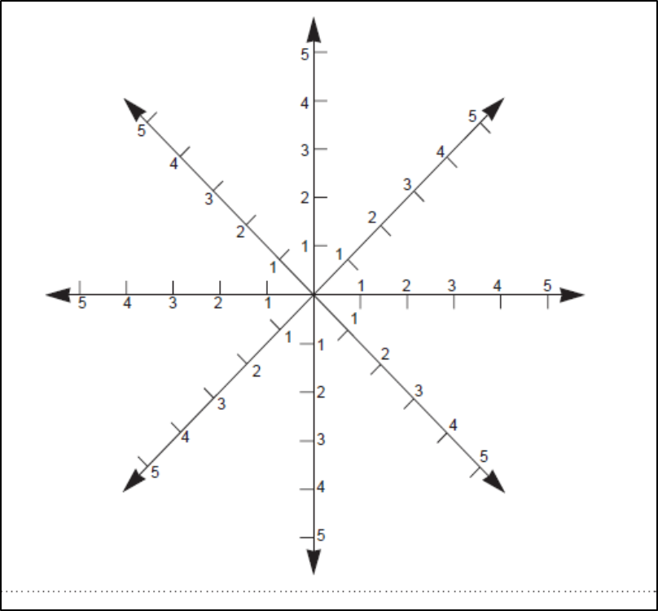
Thin
Crunchy
- Write a brief conclusion about the results of your cookies. Why do you think they turned out the way they did?

*Note – your next task for weeks 9 1n 10 will be to analyse and evaluate your results

