Year 11 Food Preparation & Nutrition Bridging Tasks

Task 1:
KEEP COOKING! Make the most of this unique opportunity and cook as much as you can. Keep practising those skills and techniques and make meals for your family.
There are plenty of YouTube clips you can watch and the internet is full of recipes.
Jamie Oliver has a show on right now called ‘Keep Cooking and Carry On’ which has recipes useful for lockdown using limited ingredients.
Ready, Steady, Cook is also good for making dishes out of limited ingredients.
For more advanced skills and presentation, Masterchef and Great British Menu are very good to watch.

Task 2:
It could be a good idea to start researching the Level 2 Food Hygiene course. See if it is a requirement for your further studies. I expect that it may be part of the course but it would be good to get ahead of the game.

Task 3:
Spend some time researching what job opportunities there are out there. Remember that a course in food could lead to all sorts of jobs such as:
- Nutritionist
- Management of restaurant or hotel
- Product/Research development
- Food scientist/Technologist
- Chef
- Business owner
- Food stylist

Task 4:
This is good for all of you even if you are not going into a food related career. It is good practice your personal statements for upcoming applications for further studies or even your CV. It can be difficult to think of what skills you have if you haven’t had any work experience. All of your subjects will have taught you some transferable skills. Look through the three types of skills below (cognitive, intrapersonal and interpersonal) and see which of the skills in each category you think you have gained while studying Food Preparation and Nutrition.
Tick the relevant skills and then write a paragraph that could be used in a personal statement.
A personal statement supports your application for college, university, an apprenticeship or a job. It is your chance to describe your ambitions, skills, and experience as well as an opportunity to shout about your strengths and achievements.
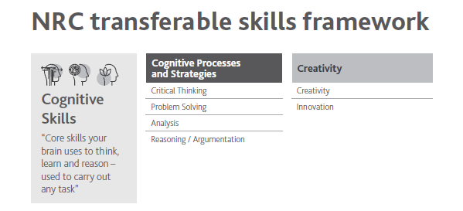
Please refer to the glossary attached if you are unsure or unfamiliar with any of the terms
Cognitive Skills | Did you use this skill in Food Preparation and Nutrition?
Critical thinking
Problem solving
Analysis
Reasoning/Argumentation
Creativity
Innovation

Note – You will have used many of the cognitive skills for NEA 1.
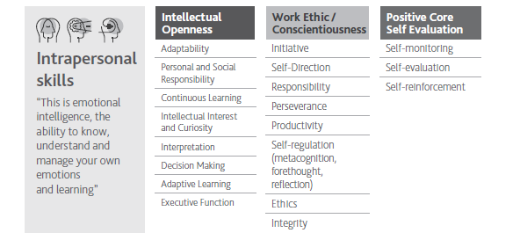
Please refer to the glossary attached if you are unsure or unfamiliar with any of the terms
Intrapersonal Skills | Did you use this skill in Food Preparation and Nutrition?
Adaptability
Personal and social responsibility
Continuous learning
Intellectual interest and curiosity
Interpretation
Decision making
Adaptive learning
Executive function
Initiative
Self direction
Responsibility
Perseverance
Productivity
Self-regulation
Ethics
Integrity
Self-monitoring
Self-evaluation
Self-reinforcement

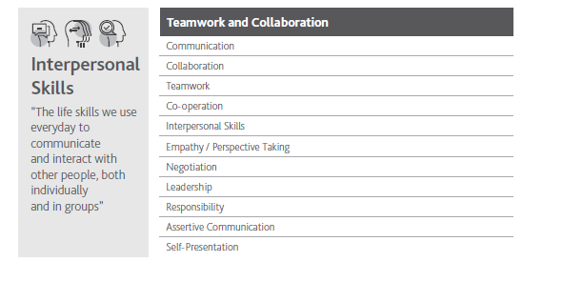
Please refer to the glossary attached if you are unsure or unfamiliar with any of the terms
Interpersonal Skills | Did you use this skill in Food Preparation and Nutrition?
Communication
Teamwork
Co-operation
Interpersonal Skills
Empathy/Perspective taking
Negotiation
Leadership
Responsibility
Assertive Communication
Self Presentation

