Task 1
Italian cuisine
Complete this table.

Distinctive features and characteristics of Italian cooking
The foods grown, reared and caught in Italy | Grown –  Reared –  Caught -
Traditional dishes made in Italy
Equipment and cooking methods used in Italian cooking
Eating patterns in Italy
How does the cuisine differ between the North of Italy and the South of Italy?

Task 2
Spanish cuisine
Complete this table.

Distinctive features and characteristics of Spanish cooking
The foods grown, reared and caught in Spain | Grown –  Reared –  Caught -
Traditional dishes made in Spain
Equipment and cooking methods used in Spanish cooking
Eating patterns in Spain
What is Tapas?

Task 3
As you can see below, Italy and Spain are surrounded by the Mediterranean Sea. The Mediterranean diet is one of the healthiest diets in the world.
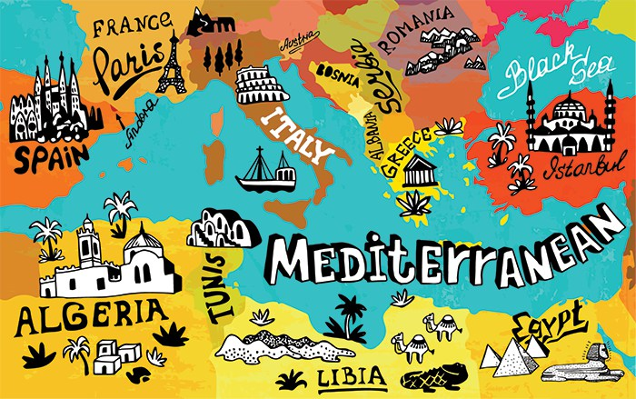

Write a short paragraph describing the Mediterranean diet and why it is so healthy. Think about the aging population, lifestyle, climate, foods that are grown there, olive oil, etc.

Task 4

Research dishes from Italy and Spain. Make a list of 5 savoury and 2 sweet dishes below.

Italy | Spain

Now choose one dish to make at home.
Once you have chosen the dish, find a recipe for that dish. Try to use UK recipes.
Make a list of the ingredients you need.

Write down 2 success criteria for your dish. The success criteria are characteristics that your dish should have to be successful. Eg: golden brown, evenly cut chicken, well-flavoured, crispy pastry, etc.

Success Criteria 1:

Success Criteria 2:

Task 5

Make the dish you have chosen.
Take a photo of the dish and send to your teacher:
apatel@waseleyhills.worcs.sch.uk OR
jewilliams@waseleyhills.worcs.sch.uk

Did your dish meet your success criteria? Why or why not?

