Internal Assessment Schedule (Yr 13) 21st March 2021
Dear parent/carer
Following on from my last letter explaining the process for awarding Centre Assessed Grades, I am now writing to let you have a copy of our planned internal assessment schedule (see below) that will commence from Monday 22nd March to 28th May. These assessments will take place in class during normal lesson time, and marked and moderated by subject staff. These will be used, along with previous assessment evidence to decide Centre Assessed Grades that will be submitted to examination boards by the 18th June.
The dates shown below will remain fixed as shown. They will only be changed in exceptional circumstances, in which case pupils will be given advance notice.
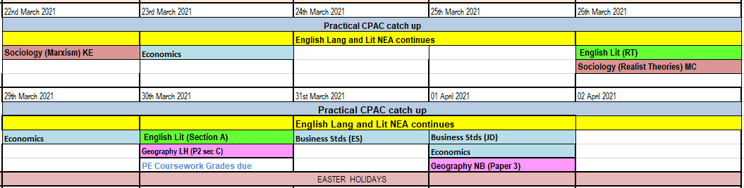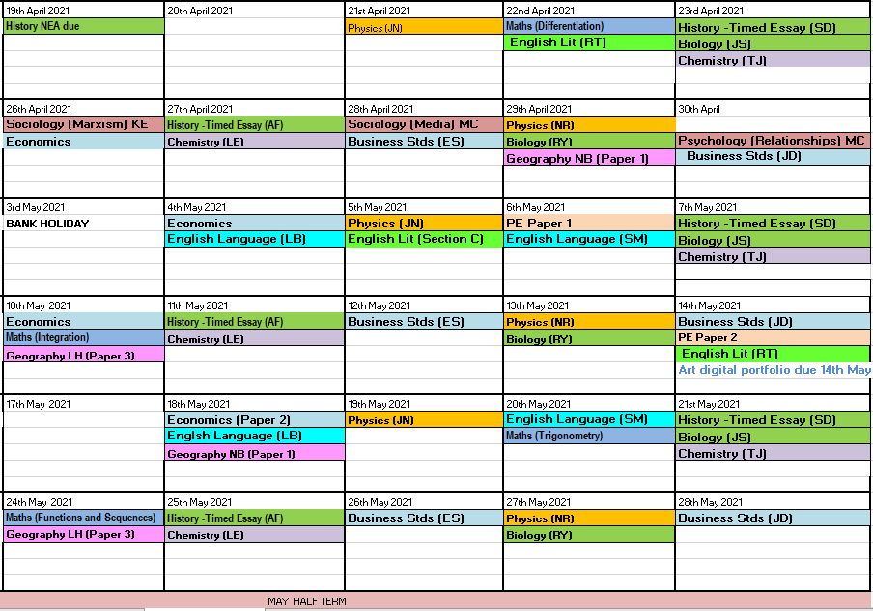

With thanks
Miss Purewal
(Assistant Head, Assessment, Recording Reporting)

