Subject: Geography
2 Week Independent Learning plan
Email queries to: lharris@waseleyhills.worcs.sch.uk
Teacher: LH and NB
Year: 9 Topic/theme: Living world
OPTIONAL: There are some interesting documentaries here: https://m.youtube.com/playlist?list=PLvahqwMqN4M0GRkZY8WkLZMb6Z-W7qbLA
Lesson | What you need to take from this lesson | Resource to use or hyperlink | Suggested task
1 | To be able to explain the economic development opportunities in the Western Desert and the challenges of living in the Western Desert, USA | VLE (Paper 1: Section B: Living Wold)  Revision 6 Western Desert | Complete all the tasks, including the optional tasks.
2 | Know what desertification is.  Understand the causes of desertification.  Know how strategies reduce the effects of desertification. | VLE (Paper 1: Section B: Living Wold)  Revision 7 Desertification | Complete all the tasks, including the optional tasks.
3 | Know the key terms in Section B: Living World unit of work. | Your completed homework tasks.  Your exercise book. | - Start at the beginning of this unit of work and highlight all the key terms. Your first one will be ECOSYSTEMS.  - Create a set of flashcards or a glossary (list of key terms and their definitions) so you can use them to revise for your end of unit assessment/mock exams
4 | Know the key information for each case study in the Section B: Living world unit of work | Your completed homework tasks.  Your exercise book. | Create a summary page of information for:  - Epping Forest  - Malaysia tropical rainforest  - The Western Desert USA  - The Sahel (desertification example)
5 | Check your understanding of Section B: Living World – key terms, concepts and case studies. | Revision 5 and 9 in this section:  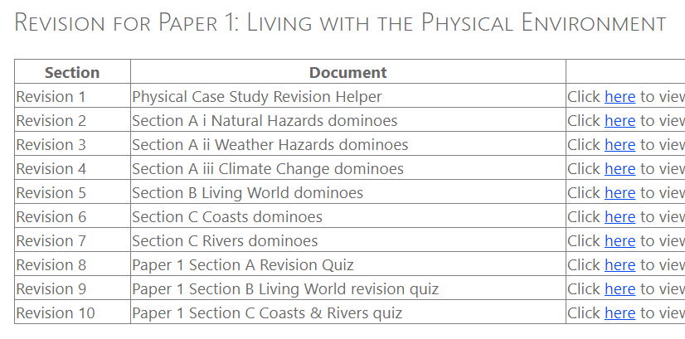 | - If you have a printer, you can print off the Living World dominoes (do them 16 to a page to save your printer cartridge) and play them. If you don’t have a printer, use your flashcards to test yourself on the key terms.  - Test yourself using Revision 9: Living world revision quiz.  - Use your book to check your answers.  - Highlight in your book and on your homework tasks any areas that you were not so good at so you know you have to revise that more for your end of unit assessments/mock exams when we’re back in school.
Don’t forget you can access the school drives and resources form the school website: https://www.waseleyhills.worcs.sch.uk/

