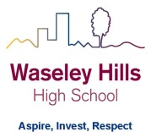
Subject: Geography
2 Week Independent Learning plan
Email queries to: lharris@waseleyhills.worcs.sch.uk
Teacher: LH and NB
Year: 10 Topic/theme: Physical geography revision: COASTS
Well done those of you completing the quizzes and keeping up with the work – these tasks are homework tasks so you’re making life easier for yourself when you get back to school – keep up the good work! This week you’ll finish off the Coasts section
OPTIONAL: There are some interesting documentaries here: https://m.youtube.com/playlist?list=PLvahqwMqN4M0GRkZY8WkLZMb6Z-W7qbLA
Lesson | What you need to take from this lesson | Resource to use or hyperlink | Suggested task
1 | Explain how hard and soft engineering strategies protect coastlines. | VLE  Revision 6 Coastal management | Complete all tasks (including the optional tasks):
2 | Explain why the coastline at Medmerry was moved backwards (coastal realignment).  Know the positive and negative effects of this coastal realignment. | VLE  Revision 7 Medmerry | Complete all tasks (including the optional tasks):
3 | Know the key terms in Section C: Coasts unit of work. | Your completed homework tasks.  Your exercise book. | - Start at the beginning of this unit of work (coasts) and highlight all the key terms.  - Create a set of flashcards or a glossary (list of key terms and their definitions) so you can use them to revise for your end of unit assessment/mock exams
4 | Know the key information for each case study in the Section C: Coasts unit of work | Your completed homework tasks.  Your exercise book. | Create a summary page of information for:  - Dorset coastline (you need to be able to name each landform e.g. Old Harry stack)  - Medmerry
5 | Check your understanding of Section C: Coasts – key terms, concepts and case studies. | Revision 6 and 10 in this section:  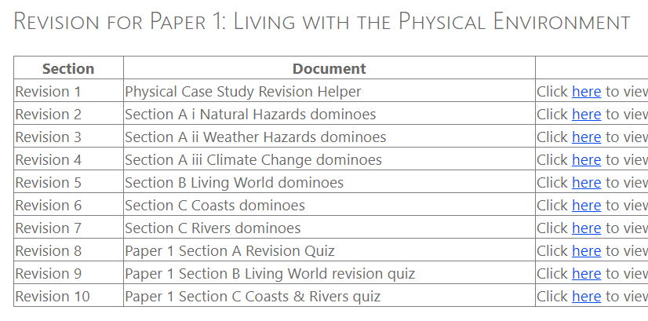 | - If you have a printer, you can print off the Coast dominoes (do them 16 to a page to save your printer cartridge) and play them. If you don’t have a printer, use your flashcards to test yourself on the key terms.  - Test yourself using Revision 10: Coasts and Rivers revision quiz – just the first page as the second page is Rivers.  - Use your book to check your answers.  - Highlight in your book and on your homework tasks any areas that you were not so good at so you know you have to revise that more for your end of unit assessments/mock exams when we’re back in school.
Don’t forget you can access the school drives and resources form the school website: https://www.waseleyhills.worcs.sch.uk/

