AQA A Level History
Developing as a Historian

Paper 1 – Breadth Study

The British Empire c1857-1967
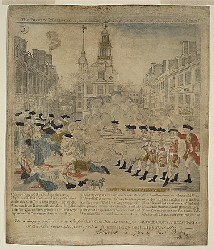
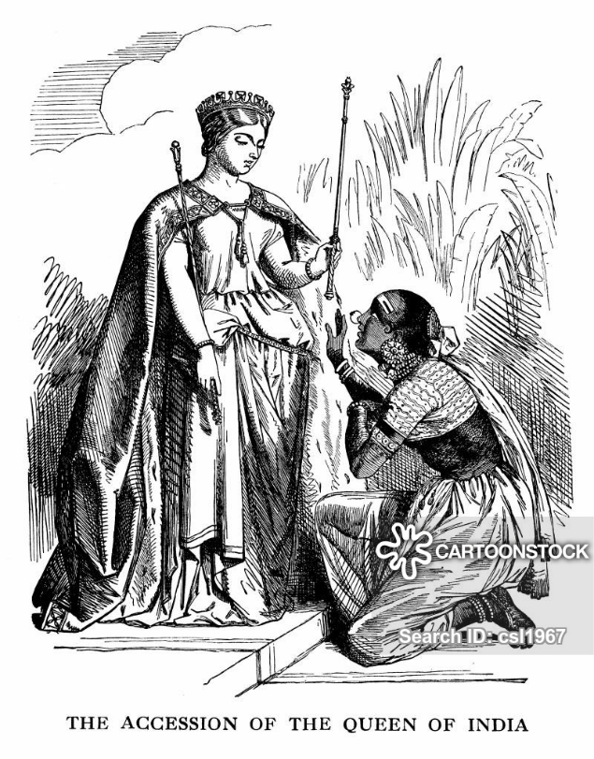
Paper 2 – Depth Study

The Birth of the USA c1760-1801

A Level History

These tasks are designed to give you a taster of what A Level History at Waseley will be like. They will introduce you to the topics that we study and give you a foundation in your knowledge and understanding in preparation for 6th Form. If you have any questions, please email either Mrs Dumycz (for Paper 2) and for Mr Flaxman (for Paper 1) for help.
sdumycz@waseleyhills.worcs.sch.uk
aflaxman@waseleyhills.worcs.sch.uk

We follow the AQA A Level options 1J and 2G. You can find out more about these here:
https://www.aqa.org.uk/subjects/history/as-and-a-level/history-7041-7042

These units are chosen to tie into GCSE, where we will have studied a little on the British Empire and on the American Revolution. However, you do not need to have studied History a GCSE to join us in 6th Form.

Developing as a Historian means being able to see beyond facts, figures and dates. It means being able to analyse cause and consequence, understand change and continuity, discuss significance and analyse impact. It is about being able to understand timelines and timeframes, whilst also appreciating that the events we study are happening to, and for, (mainly) ordinary people. Through this we can develop a deeper knowledge and understanding of how our world has come to be, and of how it works the way it does.

The British Empire c1857-1967

This unit will cover the development of the British Empire from the events of the Indian Mutiny in 1857 through the Scramble for Africa, the Boer Wars and the impact of the 20th Century Wars. It will look at the key concepts of Imperialism, Social Darwinism and the fights for Independence.
The best place to begin is by creating your own map of the British Empire for 3 key dates:
1850; 1914 and 1965. You need to be aware of when different countries became part of and left the British Empire. Use the map below as a guide. You can easily find one online with simple google search.
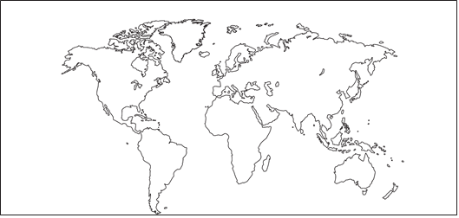

Mr Flaxman (and I!) will encourage you to read heavily. This includes fiction as well as non-fiction.
Non-fiction:
You can often find these second hand online, or in online libraries. There are copies in school, and the list does include the key text that you will be given in September.
A Holland & A Holland, Different Interpretations of the British Empire 1850-1950, Heinemann,2010
F McDonough, The British Empire 1815-1914, Hodder, 1994
M Chamberlain, The Scramble for Africa, Longman, 2010
A Jackson, The British Empire: A Very Short Introduction, OUP, 2013
J MacKenzie, The Partition of Africa, Routledge, 1983
B Porter, The Lion’s Share: A History of British Imperialism 1850-2011, Routledge, 2012
• N White, Decolonisation: the British Experience Since 1945, Longman, 1999
• A Wilkes, The Rise and Fall of the British Empire, Folens, 2010
Fiction:
Kim. Rudyard Kipling. Penguin. 1981 along with many other Rudyard Kipling novels.
A Passage to India. EM Forster. Penguin. 2005.
Both classics.
Old Filth series by Jane Gardam.
Flashman series. George MacDonald Fraser. These are easy to read, not to serious and can be adult in tone. They need to be read with a pinch of salt but are very good for gaining a good grounding of timeframes.
Podcasts and documentaries:
The BBC Empire documentary series by Jeremy Paxman is a MUST. You can find it here: https://youtu.be/vu5jPlsGYfo
The British Empire in Colour
https://youtu.be/A0BYcH2k4yo
BBC A History of Britain by Simon Schama. Episode 14.
http://www.infocobuild.com/books-and-films/social-science/HistoryOfBritain-SimonSchama/episode-14.html
In Our Time. BBC4 Podcasts
https://www.bbc.co.uk/programmes/p00547kp

The Birth of the USA c1760-1801

This unit will cover the Colonies in North America from being a relatively stable, economically viable part of the British Empire, though increasing unhappiness with British Rule to the Wars of Revolution and the Wars of Independence. It will conclude with the election of Thomas Jefferson as President of the United States of America. It will look at the concepts of liberty, rebellion, mercantilism and salutary neglect as well as republicanism and patriotism.
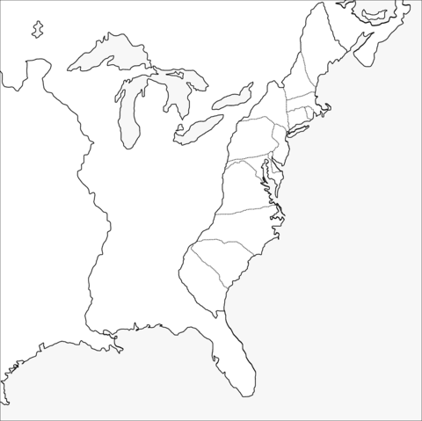
As with Paper 1, it is vital to be aware of the ‘map’ of this unit. Complete the colonial map, with the date that each of the colonies were founded. Find out a little about how and why each colony was founded, and by whom. Again, your own version of this is easy to find online with a simple google search.

Non-fiction:
You can often find these second hand online, or in online libraries. There are copies in school, and the list does include the key text that you will be given in September.
Edward Countryman, The American Revolution, Penguin Books, 1985
A Farmer, Access to History: Britain and the American Colonies 1740-89, Hodder Education,
2008
D Murphy, K Cooper, M Waldron, United States, 1776-1992, Collins Educational, 2001
G B Tindall, D E Shi, America, A Narrative History, W. W. Norton, 2004
M Grant, A Concise History of the United States of America, Cambridge University Press, 2012
M J Heale, The American Revolution, Lancaster Pamphlet, Routledge, 1986
Fiction:
Bernard Cornwell The Fort and Redcoat
David Liss The Whisky Rebels
Walter Edmonds Drums Along the Mohawk
Esther Forbes Johnny Tremain
Podcasts and Documentaries:
America: The Story of Us. Episode 2
https://youtu.be/uzlYqwHkSNE
Liberty! The American Revolution by PBS. The link below is for Episode 1, but there are 6 in total.
https://youtu.be/XEMQSdhvtx0
Liberty Kids – a cartoon series based on the people and events of the American Revolution. It’s simple and straightforward!
https://youtu.be/S7qRZmHLobQ
American Revolution Podcast – there are currently 142 episodes, so search for something that grabs you!
https://pod.amrevpodcast.com
And finally – dramas!
Hamilton – The Musical
Sons of Liberty by The History Channel
John Adams by HBO

