GCSE ICT- Exam Revision

Year 10

|  |  |
| --- | --- |
| **Features and Purposes of Computing Devices** | |
| **Key words I have Learnt from the lesson:** | **What you should know:**  *1) Different devices available*  *2) Their key features*  *3) The purpose of the device*  *4) Who they attract/who will use it* |
| **Extra Notes:** | **Command words likely to be used:**   |  |  | | --- | --- | | **Define** | **Explain** | | **Identify** | **Why** | | **Justify** | **Which** | |
| Lots of different people use lots of different devices to access IT. It depends on all sorts of things which one you use. Remember for each device they will be best suited to a different person. It is important you know the features of a device and what its main purpose is. | |
| **Example Questions**  1) Describe and explain **two advantages** and **three disadvantages** of using a laptop for a school office inputting student data [5]  2) Describe the following portable computer devices and state the features (i.e. word processing, voice calls, surf the internet etc. ) of each: [4]  Laptop  Netbook  Tablet  Smartphone | |

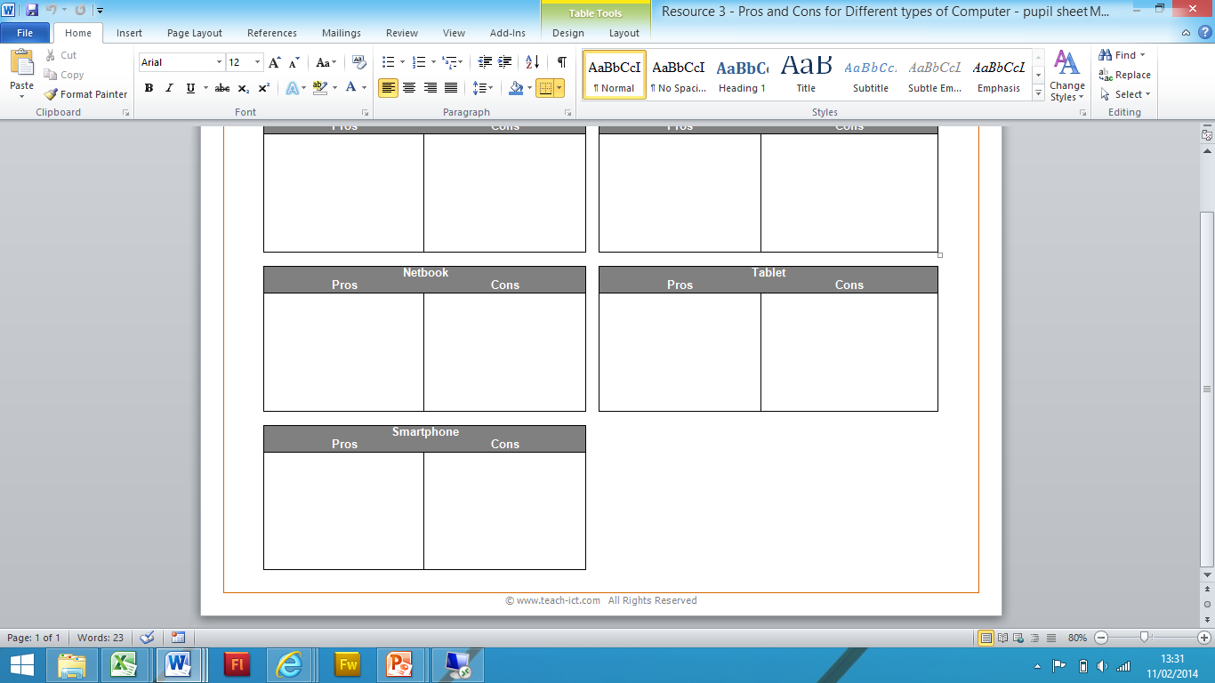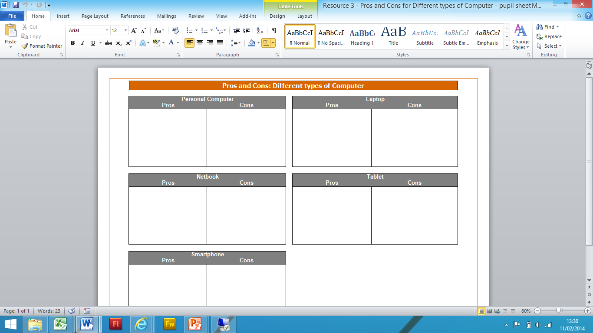

|  |  |
| --- | --- |
| **Input Devices** | |
| **Key words I have Learnt from the lesson:** | **What you should know:**  *1) Different Input devices*  *2) Who will use each type*  *3) Advantages & Disadvantages to each type* |
| **Extra Notes:** | **Command words likely to be used:**   |  |  | | --- | --- | | **Name** | **State** | | **What** | **Using** | | **Identify** | **Why** | |
| Input devices allow us to enter raw data into a computer. The computer processes the data and then produces outputs that we can understand using an output device. | |
| **Example Questions:**  1) Steve Jones wants to listen to the music stored on his computer system. Identify Two input devices that Steve could use to select a song stored on the system.  2) A Leisure centre, administration booking office needs technology equipment to support their role. List two input devices that would help in the booking office, state your reasons why you have chosen these [4] | |

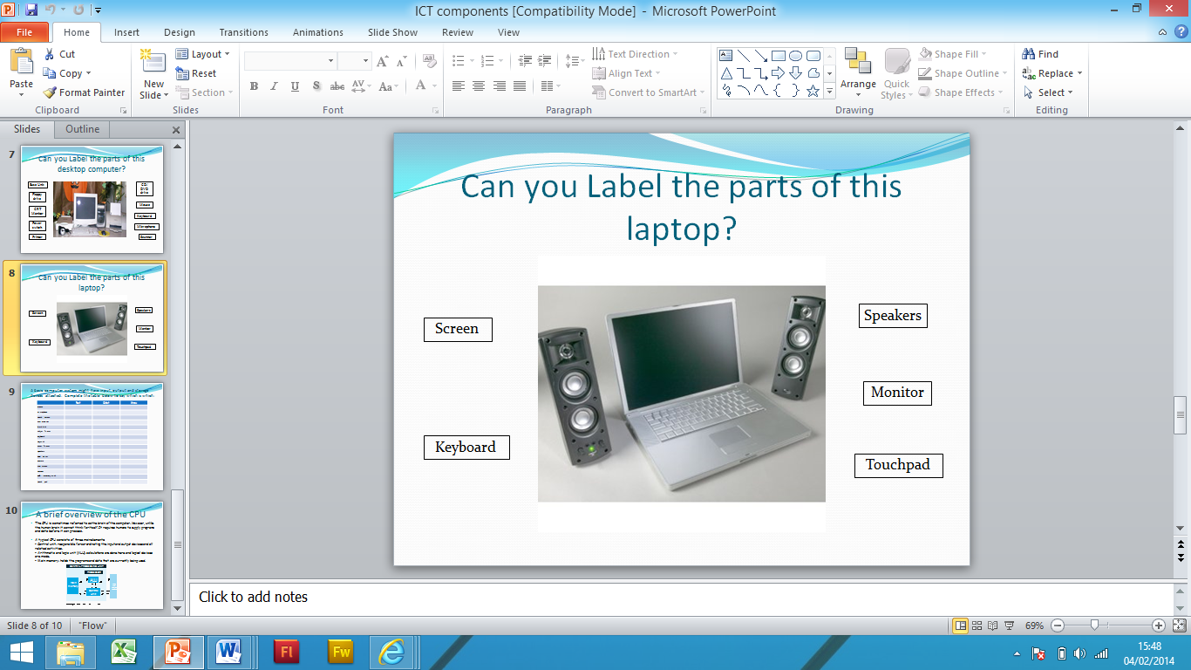**Task: Can you label the correct parts of a Computer/Laptop?**

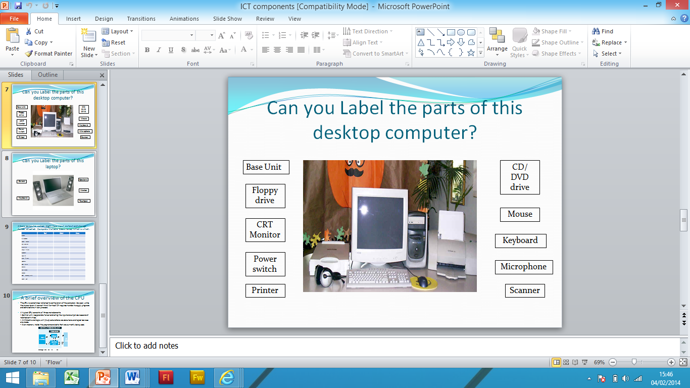

|  |  |
| --- | --- |
| **Other Input Devices: Sensors** | |
| **Key words I have Learnt from the lesson:** | **What you should know:**  *1) Role of automatic input devices*  *2) Explain scenarios is will be beneficial to a person* |
| **Extra Notes:** | **Command words likely to be used:**   |  |  | | --- | --- | | **Define** | **Explain** | | **Identify** | **Why** | | **Justify** | **Which** | |
| There are other input devices. The ones mentioned on the previous page are all manual; that means the user has to use them to get data in.  But what if it is not convenient? For example what if you needed to measure temperature in a volcano? A keyboard would not be idea. What if you also wanted to take temperature measurements every 0.01 of a second? Humans are just not fast (or accurate) enough.  Because of this, there are things called ‘sensors’ which are used all around us. | |

Not all Input devices are manual. Here is a look at some existing Automatic Input Devices.

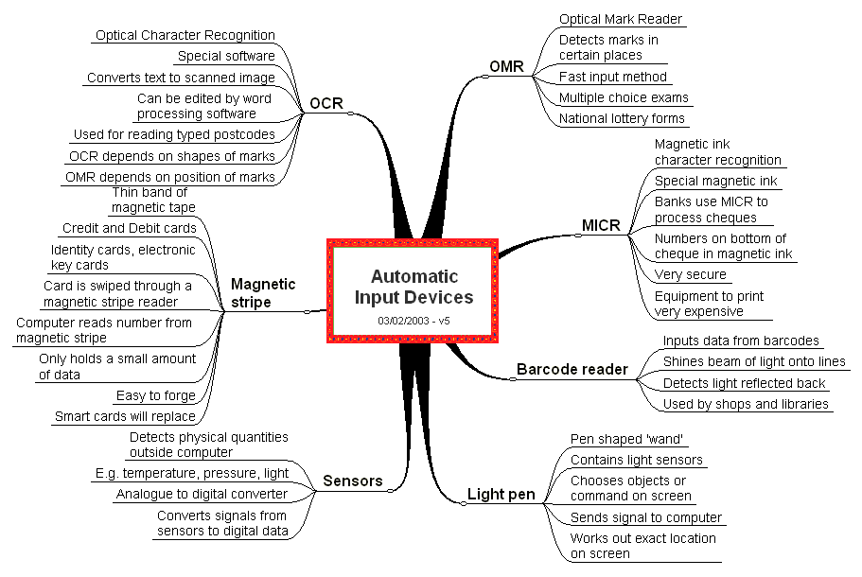

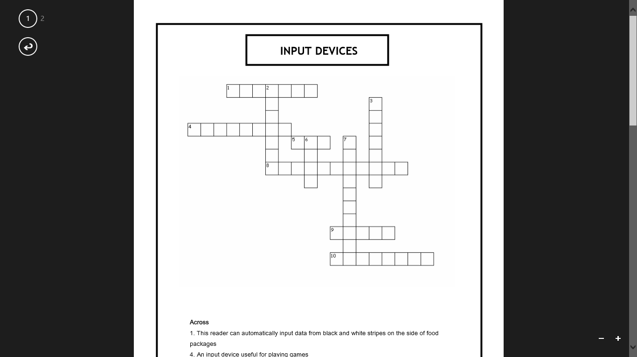

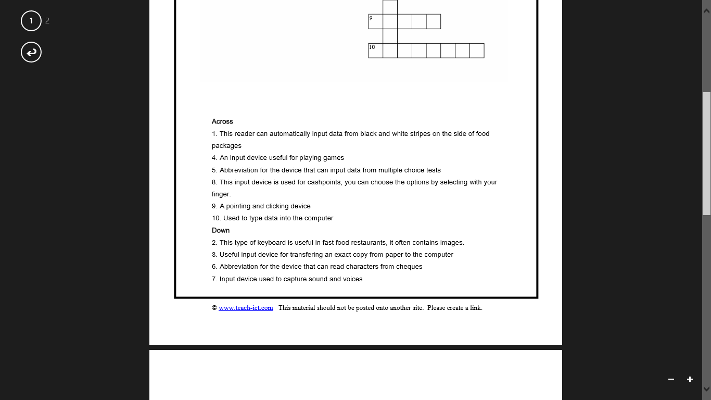

|  |  |
| --- | --- |
| **Output Devices** | |
| **Key words I have Learnt from the lesson:** | **What you should know:**  1*) Different types of output devices*  *2) What their roles are*  *3) Advantages & limitations to each type* |
| **Extra Notes:** | **Command words likely to be used:**   |  |  | | --- | --- | | **Define** | **Explain** | | **Identify** | **Why** | | **Justify** | **Which** | |
| An output device is something the computer uses to display information it has processed. This could be in the form of an image on screen, music from speakers or even a print out from a printer.  **Different Types of Printers:**  A **dot matrix printer** uses pins to push the letter, symbol or number onto a ribbon which then marks the paper it is pushed onto  There are many different types of plotter printers. A **traditional plotter** is loaded with a pen which is lowered and lifted on paper when needed. They are traditionally used for printing large vector graphics like posters or blueprints from an architect.  **A laser printer** is the fasted way of printing. A laser charges the drum with particles which then makes the ink from the toner stick to the paper as it comes through. It is then fused to the paper as it comes out.  An **inkjet printer** is slow but the quality of the printing is high. The printer will drip ink drops from the cartridge on the paper very accurately to make up the image being printed | |
| **Example Questions:**  1) Identify one output device that Steve would need so that he could listen to songs on his computer system.[1]  2) State one output device that would be used to create a hard copy of a data capture form[1]  3) State two output devices that a booking office may need, explain your reasons for your choices [4] | |

**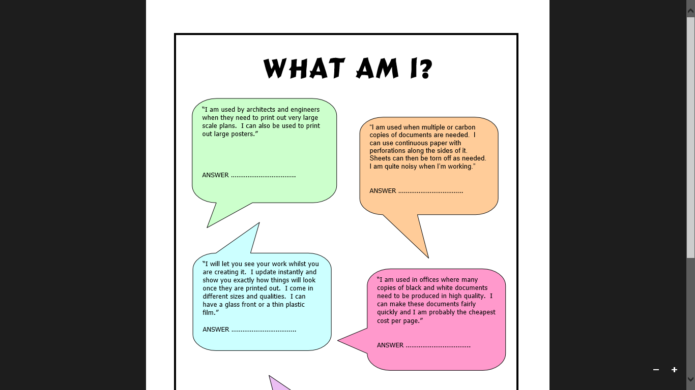Task: Can you guess the correct Output device?**

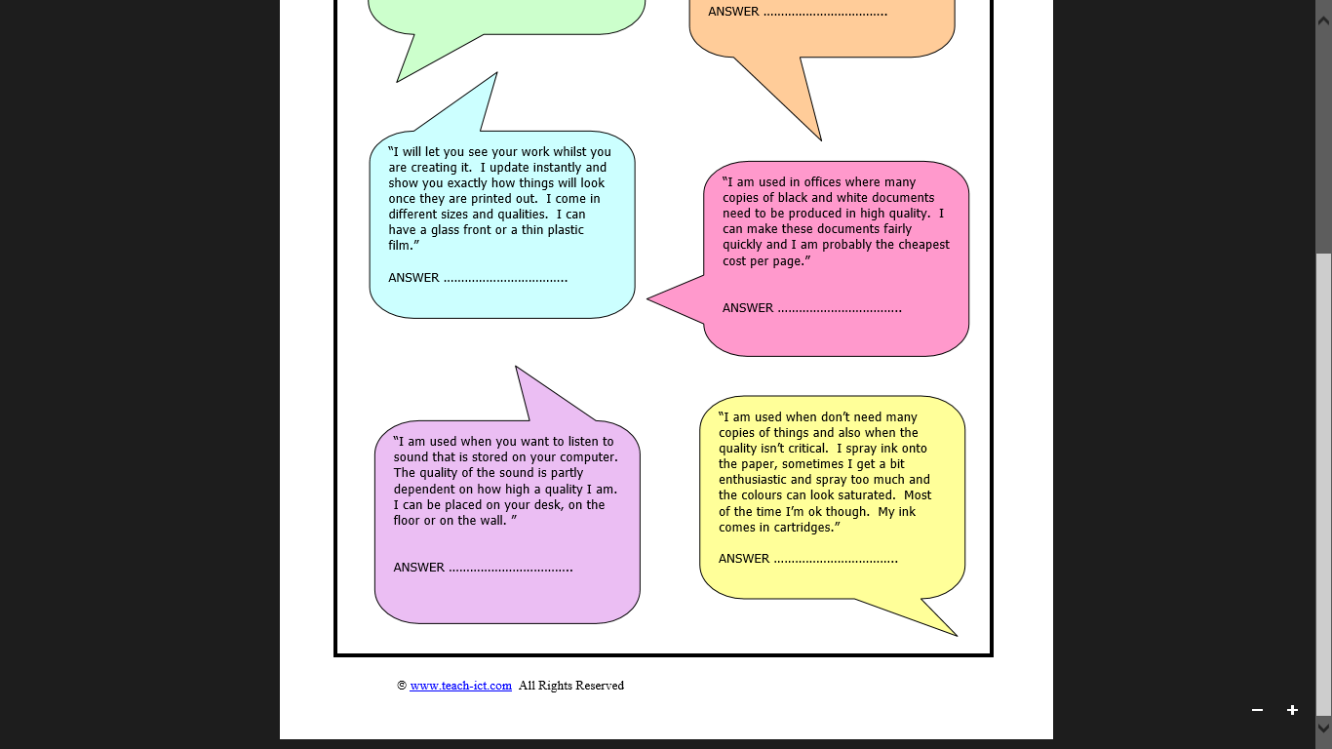

**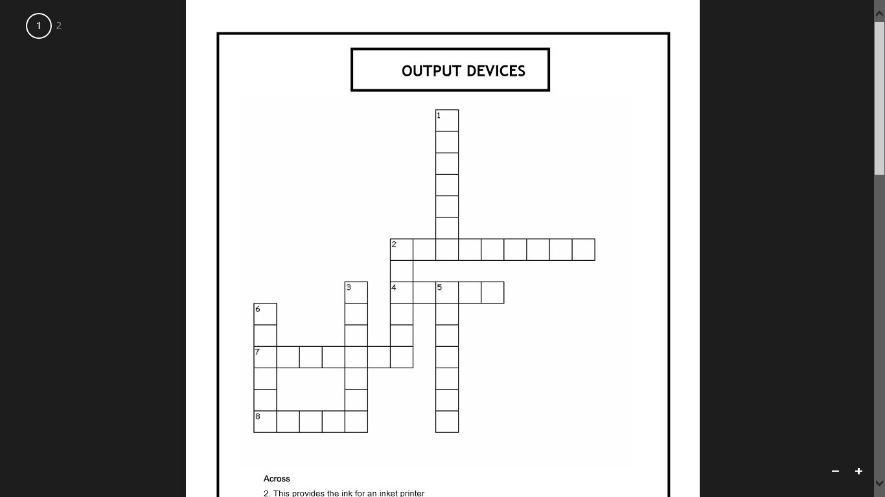Task: Can you complete the crossword for Output Devices?**

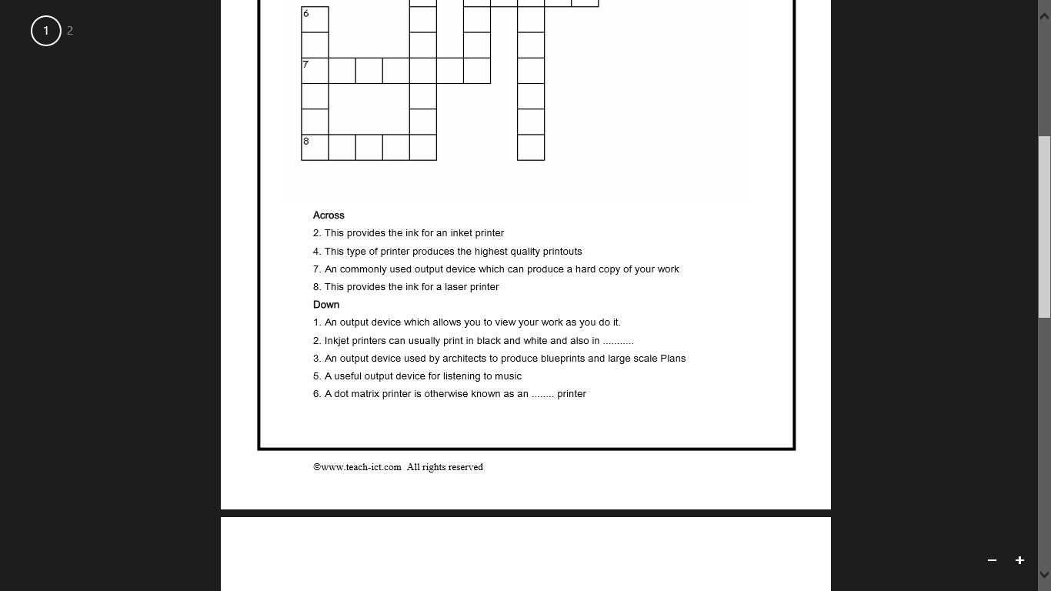

**Task: A basic computer system might have input, output and storage devices attached. Complete the table below to say which is which:**

|  |  |  |  |
| --- | --- | --- | --- |
|  | **Input** | **Output** | **Storage** |
| Mouse |  |  |  |
| Microphone |  |  |  |
| Touch Screen |  |  |  |
| CRT monitor |  |  |  |
| Hard disk |  |  |  |
| Inkjet Printer |  |  |  |
| Keyboard |  |  |  |
| Joystick |  |  |  |
| Laser Printer |  |  |  |
| Speakers |  |  |  |
| DVD writer |  |  |  |
| Camera |  |  |  |
| LCD screen |  |  |  |
| Scanner |  |  |  |
| USB memory stick |  |  |  |
| Touch pad |  |  |  |

|  |  |
| --- | --- |
| **Operating Systems** | |
| **Key words I have Learnt from the lesson:** | **What you should know:**  *1) The role of an operating system*  *2) The jobs it is responsible for*  *3) Different types of operating systems* |
| **Extra Notes:** | **Command words likely to be used:**   |  |  | | --- | --- | | **Define** | **Analyse** | | **Evaluate** | **Consider** | | **Explain** | **Apply** | |
| An operating system is what every computing device has to have. It allows us to interact (use) a computer. Without it, your computer would just be plastic and metal. It controls everything the computer does.  An **operating system** (or **OS**) is a **computer program** which controls everything the computer does (absolutely everything!!!).  It is essential software. Without it, a computer cannot run (It will not know what to do!!!)  The software that acts as the communicator between your computer's hardware and you. | |
| **Jobs of the OS:**  Load and run applications  Share out (and manage) memory  Communicate with peripherals  Accept data from input devices  Provide an interface | |
| |  |  | | --- | --- | | Basic Features | Geeky Features | | WIMP (Windows, Icons, Menus and Pointers)  Search facilities  Help  Personalisation (changed backgrounds etc)  Disability access  Touch? Drag?  Storage | Manage memory  Save, Print  Provide an interface  Shortcuts for experts  Run software  Communicate with devices.  Process inputs |   **Tailor Made Software**  Tailor made software is software that is made to the specifications of a client. In other words it is custom made, **bespoke**, or 'tailored' to address a specific need. This kind of software can be **expensive** as it has to be designed by a team who are making software to specific needs for a specific organisation.  Off the shelf software is more general and produced for the masses. Although it probably also costs a lot of money to make, it is cheaper to buy because it can be bought by anyone.  **Diary Management Software**  **Diary management software (DMS) is used day to day by business people to ensure that they are reminded about appointment/meetings.**  **It also allows employees who are working on the same project to plan and track the progress of the project.**  **1) Create appointments/meetings**  **2) Invite participants**   1. **Create tasks/projects** 2. **Create to-do lists** 3. **Set reminders** | |

|  |
| --- |
| **There are lots of different operating systems which you need to know about. Here they are…** |

**Task: Which of the following does an operating system do? There are 9 correct answers.**

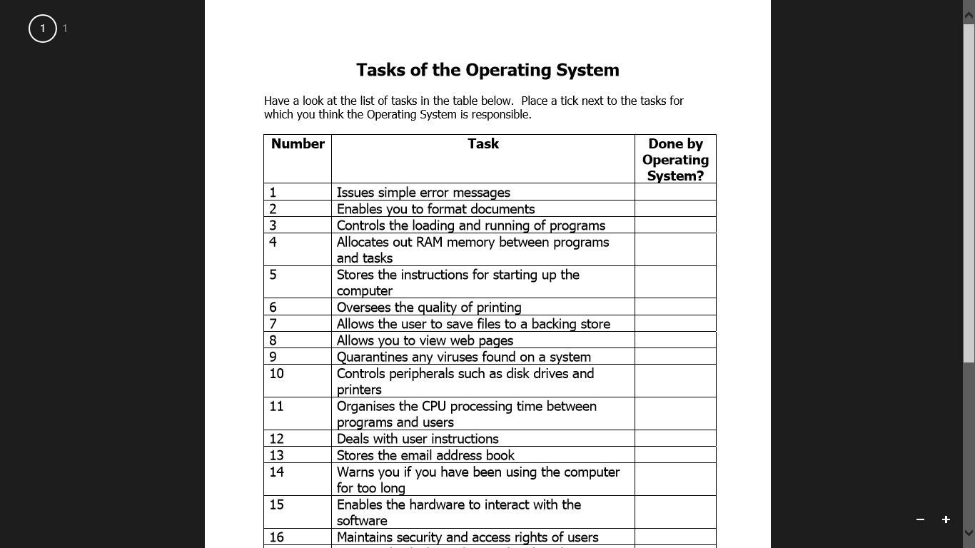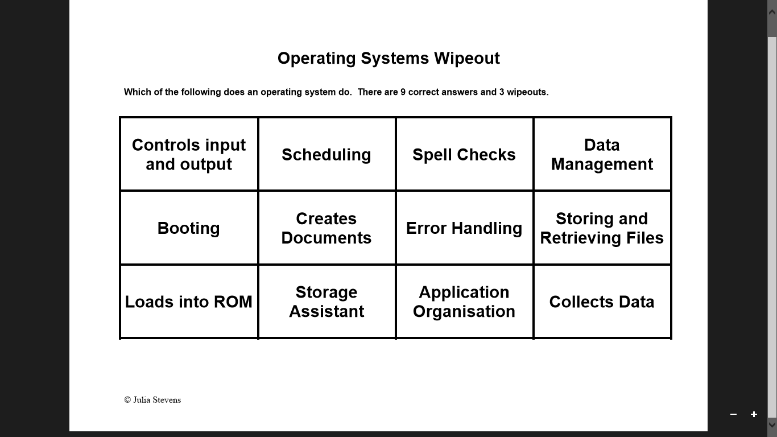

|  |  |
| --- | --- |
| **Utility Software** | |
| **Key words I have Learnt from the lesson:** | **What you should know:**  *1) The role of Utility Software*  *2) Examples of what it manages*  *3) Why each feature is beneficial to a user* |
| **Extra Notes:** | **Command words likely to be used:**   |  |  | | --- | --- | | **Consider** | **How** | | **Using Examples** | **Name** | | **Describe** | **Discuss** | |
| An operating system is something which allows us to interact with a computer. An example is Microsoft Windows. Many operating systems have four features; Windows Icons Menus and Pointers. Instead of pointers, some mobile operating systems like iOS or Android have a touch screen.  As well as these features, many operating systems have quick access to help facilities and shortcuts such as ctrl+c for copy and ctrl+v for paste. Most OS’ also allow the user to personalise the desktop, for example by changing the background or icon sizes.  Utility software allows us to manage specific parts of our computer. An example includes Anti-Virus software which protects us against viruses A firewall also stops hackers or other unauthorised people getting in to our computer.  Disk cleanup allows the system to remove old files and software from our computer saving space and allow the computer to run faster.  A programming language is a specially written code used for writing applications. **C++** and **Java** are examples of programming languages. These are known as **high level** languages because they have been developed to be a little like a **human language**. | |
| **Example Questions:**  1) Explain the role of anti-virus software and why it is important for a business to have such utility software [2]  2) State the role of a firewall and why it is needed on a computer [2] | |

|  |
| --- |
| Examples of Utility Software are: |

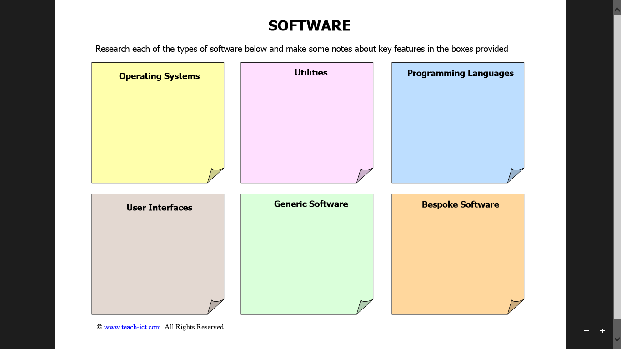

|  |  |
| --- | --- |
| **Storage and Connectivity Devices** | |
| **Key words I have Learnt from the lesson:** | **What you should know:**  *1) Different storage devices*  *2) Benefits to each type*  *3) Limitations to each type*  *4) Who/When you would use each type of storage* |
| **Extra Notes:** | **Command words likely to be used:**   |  |  | | --- | --- | | **Define** | **Explain** | | **Identify** | **Why** | | **Justify** | **Which** | |
| A computer uses two types of storage. A main store consisting of ROM and RAM, and backing stores which can be internal, eg hard disk, or external, eg a CD or USB flash drive  Storage capacities and file sizes are measured from lowest to highest in:   * bits * bytes * kilobytes * megabytes * gigabytes * terabytes   **Backing up and archiving data**  Data needs to be backed up for many reasons:   * a user may delete an important file * hard disks can fail * a virus can wipe out data * a fire may destroy the building where the data was being stored (businesses will often store their backups off-site)   If the data wasn’t backed up then the consequences could be disastrous depending on what data was lost. If a business lost details of all the payments it had yet to receive the business could go bankrupt as they wouldn’t know what was owed to them or by who. | |
| **Example Questions:**  1) A leisure centre is going to store their information on Cloud storage. Explain two reasons why they might chose to store files using cloud storage than on its own file servers [4]  2) Name two devices that could be used to transport music [2]  3)Name and explain two devices used for a wireless network [2]  4) Name and explain two devices used for a wired network [2]  5) Name and explain two backup devices that are portable [2] | |

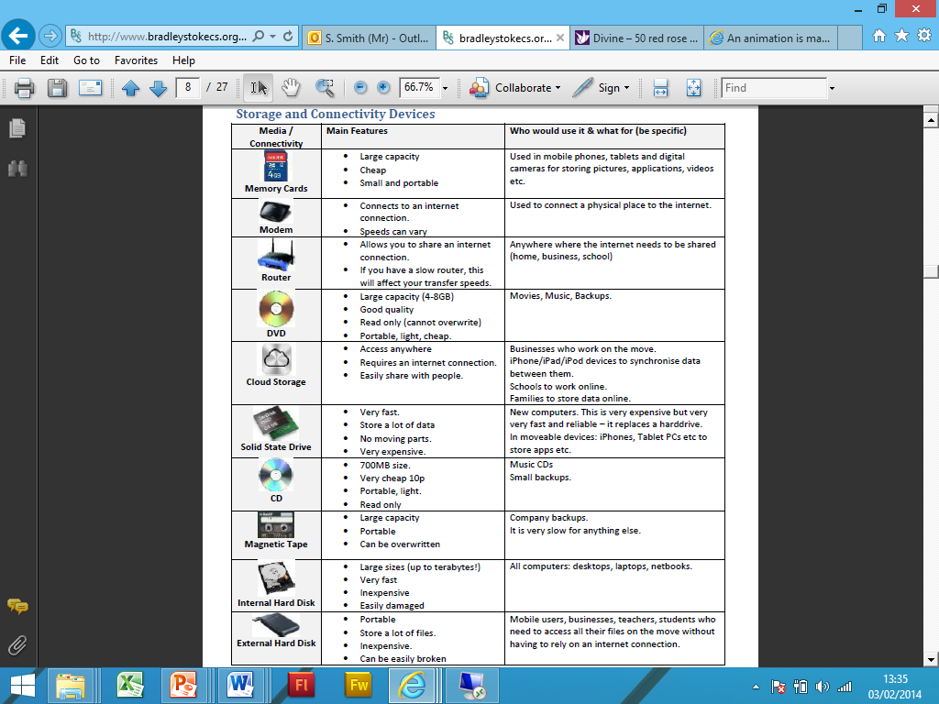

**Task: Can you give a description, Advantage & Disadvantage to each storage device?**

|  |  |  |  |
| --- | --- | --- | --- |
| **Storage Device** | **Description** | **Advantages** | **Disadvantages** |
| hd2External Hard Disk |  |  |  |
| tape1**Magnetic tape backup** |  |  |  |
| cd4**CD-ROM** |  |  |  |
| cdrw2**CD-RW** |  |  |  |
| dvd4**DVD** |  |  |  |
| **Flash Memory Stick**  cruzer_micro_21 |  |  |  |

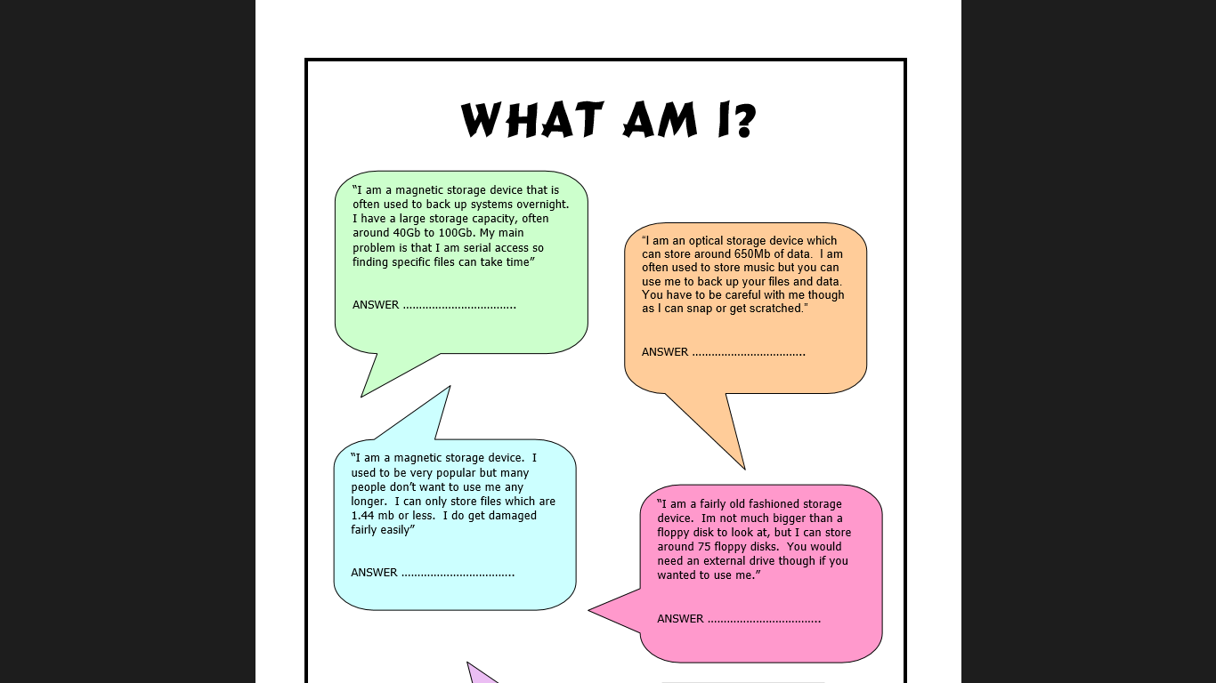

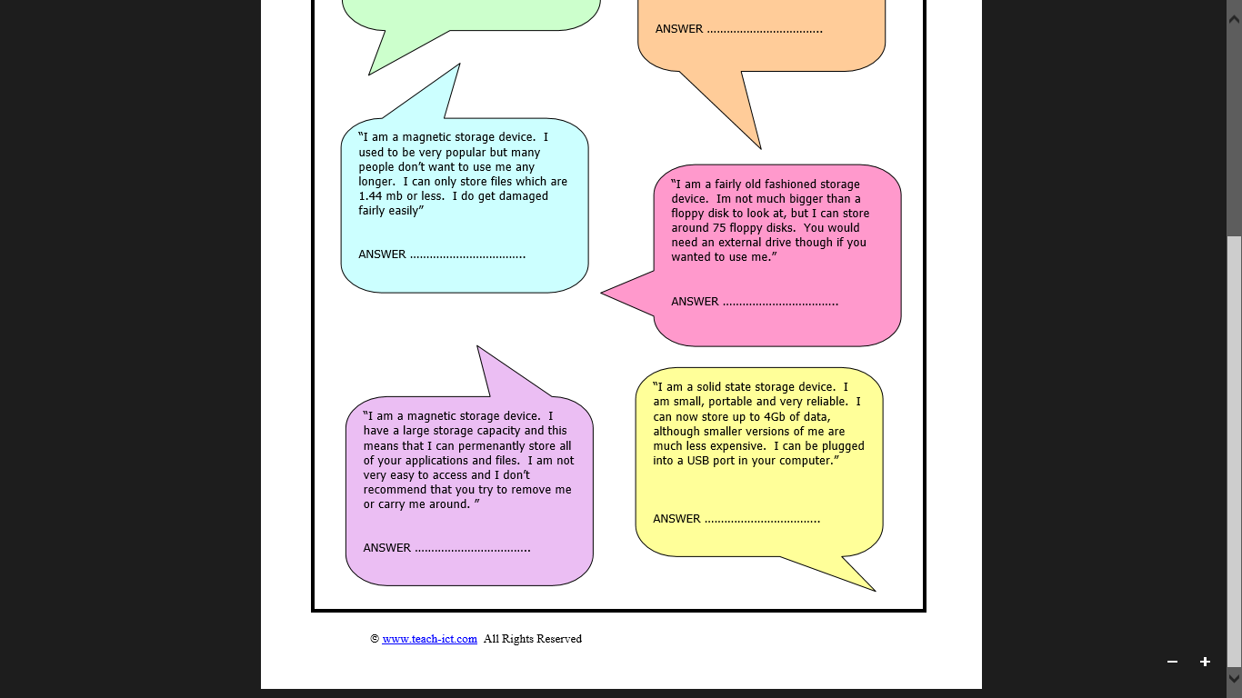

|  |  |  |  |
| --- | --- | --- | --- |
| **Office Configurations** | | | |
| **Key words I have Learnt from the lesson:** | **What you should know:**  *1) Different items of technology available*  *2) How it would benefit someone with an impairment*  *3) Justify its use for specific disabilities* | | |
| **Extra Notes:** | **Command words likely to be used:**   |  |  | | --- | --- | | **What** | **Why** | | **Explain** | **Give** | | **Consider** | **Advise** | | | |
| Generally, a configuration is the arrangement - or the process of making the arrangement - of the parts that make up a whole.  In computers and computer networks, a configuration often refers to the specific hardware and software details in terms of devices attached, capacity or capability, and exactly what the system is made up of.  Assistive technology (AT) is technology developed to help people with disabilities use computers. People with various impairments may need help when accessing IT systems. Lots of technology exists which would help them. It is important for each impairment you can identify a suitable item of technology and justify why it would help the individual. | | | |
|  | | | |
|  | | | |
| **Example Questions:**  1) A member of the administration staff is visually impaired. What technology could you include to support this member of staff [3]  2) State two disadvantages to using a Microphone as a form of input [2] | | | |
| **Factors affecting choice of System** | | | | |
| **Key words I have Learnt from the lesson:** | | **What you should know:**  *1) Explain different factors that should be considered when selecting technology*  *2) Be able to justify a choice taking into consideration Cost, Needs & Security* | | |
| **Extra Notes:** | | **Command words likely to be used:**   |  |  | | --- | --- | | **Define** | **Explain** | | **Identify** | **Why** | | **Justify** | **Which** | | | |
| When you are choosing what kind of computer to buy in a business you need to think about a few different things. Otherwise, the computer you may spend a lot of money on, may not actually be fit for purpose or be unusable by the person who will be using it. | | | | |
|  | | | | |
| **Connectivity** | | | | | |
| **Key words I have Learnt from the lesson:** | | | **What you should know:**  *1) Explain different types of connectivity*  *2) State the benefits to each type*  *3) State any limitations to each type*  *4) Justify what method of connectivity would be best in different circumstances* | | |
| **Extra Notes:** | | | **Command words likely to be used:**   |  |  | | --- | --- | | **Define** | **Explain** | | **Identify** | **Why** | | **Justify** | **Which** | | | |
| So when buying a computer system, there are lots of different add-ons that you could connect (e.g. printer, scanner, camera, keyboard, mouse, monitor etc.) These things are all called peripherals and they can connect in lots of different ways. | | | | | |
| **Router-**  This device is used to share an internet connection. • It allows more than one person to use an internet connection within a home or business. • It tends to allow people to share your connection wirelessly. • To let people connect they need to connect to a unique name for your connection and enter a password.  **Modem-**  This device allows a computer to connect to the internet. • It connects one computer to a server at your internet provider. • It allows the two computers to talk to each other. • Without a modem, a computer is not able to connect to the internet. • Most routers have in-built routers to allow you to share your connection with multiple people.  **The Internet-**  The term bandwidth refers to the speed at which information is passed over a network like the internet. The higher the bandwidth the more information can be passed through a network at once. Imagine it like water running through a drainpipe. The image on the right will empty out faster.    **Different Internet Speeds**  1. 56Kbps Dial Up (Slow) Analogue signal comes down phone line, Very slow and not used much now  2. ISDN (256Kbps Medium)  3. DSL Broadband (20Mbps Fast) Digital Signals that come down your phone line, much faster and widely used now  4. Fibre Optic Broadband (40Mbps Super-fast) • Digital Signal converted to light and passed down “Glass cable”  5.Mobile Broadband using 3G/4G signal 5Mbps and getting faster with new 4G | | | | | |
| **Monitoring Employees** | | | | |
| **Key words I have Learnt from the lesson:** | | **What you should know:**  *1) Explain different methods of monitoring employees*  *2) State the benefits to monitoring*  *3) State problems that can come from monitoring* | | |
| **Extra Notes:** | | **Command words likely to be used:**   |  |  | | --- | --- | | **Define** | **Explain** | | **Identify** | **Why** | | **Justify** | **Which** | | | |
| Some organisations regularly monitor what their employees are doing on the internet whilst at work.  They can see which chat rooms they visit, which sites they use, who they send emails to and who they receive emails from.  This monitoring enables organisations to build up a detailed profile of what people are doing online and with whom they communicate.  Employers say that this helps them to ensure that staff time is being used effectively and that work equipment is being used for approved purposes.  However, many employees view this monitoring as a breach of trust and an invasion of their privacy. | | | | |
| Task: Give 3 benefits and 3 limitations to using technology to monitor employer performance   |  |  | | --- | --- | | ***Benefits*** | ***Limitations*** | |  |  | |  |  | |  |  | |  |  | | | | | |
| **Example Question:**  1) A leisure centre will monitor employee’s phone calls and emails. Give two reasons why an employer may do this [2] | | | | |

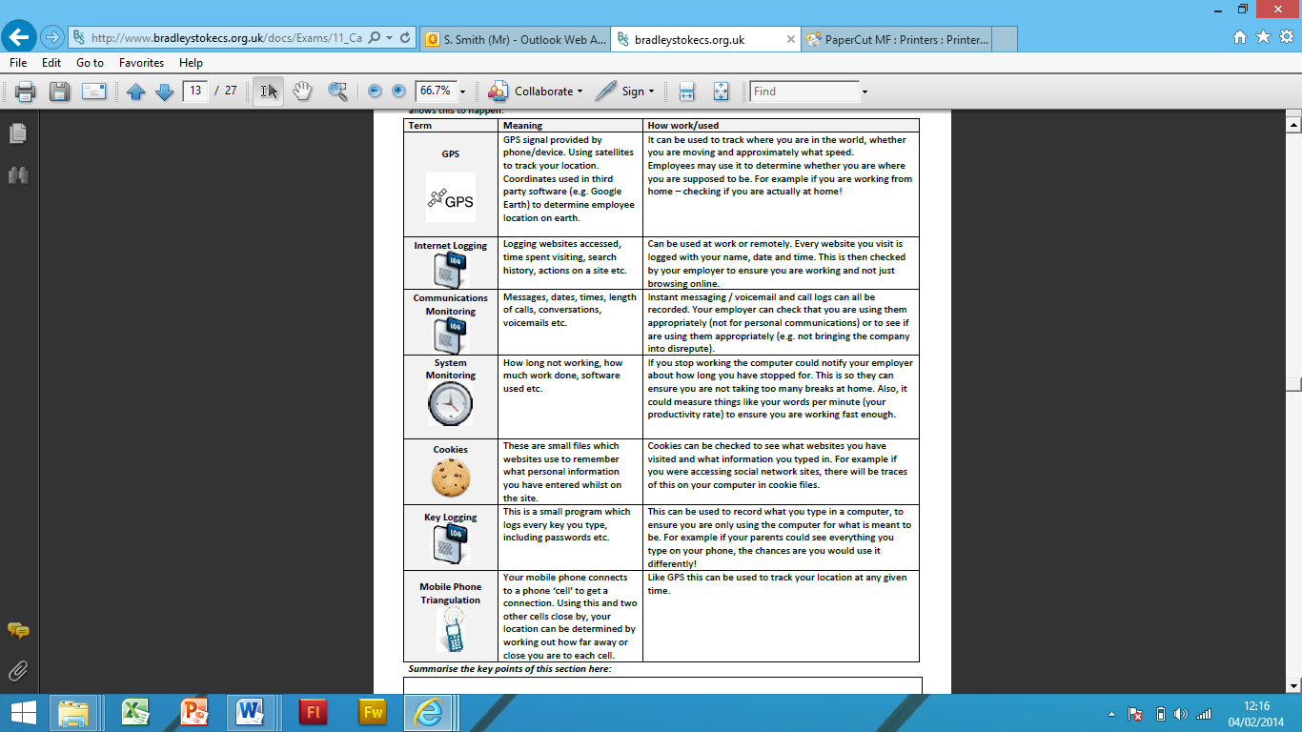

|  |  |
| --- | --- |
| **Data Validation** | |
| **Key words I have Learnt from the lesson:** | **What you should know:**  *1) The role of validation & verification*  *2) Different Validation checks and when they should be used*  *3) How verification online is completed* |
| **Extra Notes:** | **Command words likely to be used:**   |  |  | | --- | --- | | **Name** | **Outline** | | **Give** | **How** | | **Which** | **Why** | |
| Validation aims to make sure that data is **sensible**, **reasonable** and **allowable**.  It does NOT check data is correct. How can it! E.g. 9/7/1984 is a VALID date of birth, but it would not be correct for someone who is 14 years old.  **Validation Checks:**  **Type Check** – checks something of the correct type is entered. E.g. a date in a date field, a number in a number field etc.  **Range Check** – checks something is within a specific range. E.g. an order quantity is between 1 and 10, > 18years old, or <21 etc.  **Presence Check** – checks that something is there. E.g. Mandatory field. Makes sure REQUIRED fields are entered.  **Format Check** – checks what is entered is of the correct structure. E.g. Postcode (LLNN NLL) E.g. TS23 3DX. E.g. a phone number is STD: NNNNN Num: NNNNNN  **Length Check** – Ensures that information is of a specified  **Verification Checks:**  Entering the data twice.  Checking the data on the screen against the original paper document  Printing out a copy of the data and comparing the printout to the original paper document.  **Verification ONLINE**  This is used to ensure data is as accurate as possible. Remember, it is not possible to check data is 100% correct.  Verification means to check the data that you have entered against the original source data.  You may also be aware of CATCHPA checks which ask you to type in a word, phrase or collection of letters/numbers. This is to ensure you are a real person and not a scammer of automated computer trying to hack.  How is this done?  Entering the data twice (e.g. PASSWORDS).- Double Keying  Double Checking (Proof reading)  Verifying you are a human to prevent BOTS or AUTOMATED SIGN UPS by using CAPTCHA. | |
| **Task: Tick the validation checks that you could perform on each field (note: there may be more than one for each field)**   |  |  |  |  |  |  |  |  | | --- | --- | --- | --- | --- | --- | --- | --- | | **Field** | **Example** | **Range Check** | **Type Check** | **Presence Check** | **Length Check** | **Picture Check** | **Check Digit** | | Title | Mr, Mrs, Miss |  |  |  |  |  |  | | Surname | Jones, Bloggs |  |  |  |  |  |  | | Postcode | CV54 9TE |  |  |  |  |  |  | | Telephone Number | 01926 756435 |  |  |  |  |  |  | | Date of Birth | 12/09/86 |  |  |  |  |  |  | | ISBN Number | 1-84146-376-0 |  |  |  |  |  |  | | Gender | Male, Female |  |  |  |  |  |  | | Price | £19.99 |  |  |  |  |  |  | | Student Number | 1435 |  |  |  |  |  |  |   **Example Question:**  Explain why the use of data validation could improve the effectiveness of the data that is submitted on a data capture form [2] | |

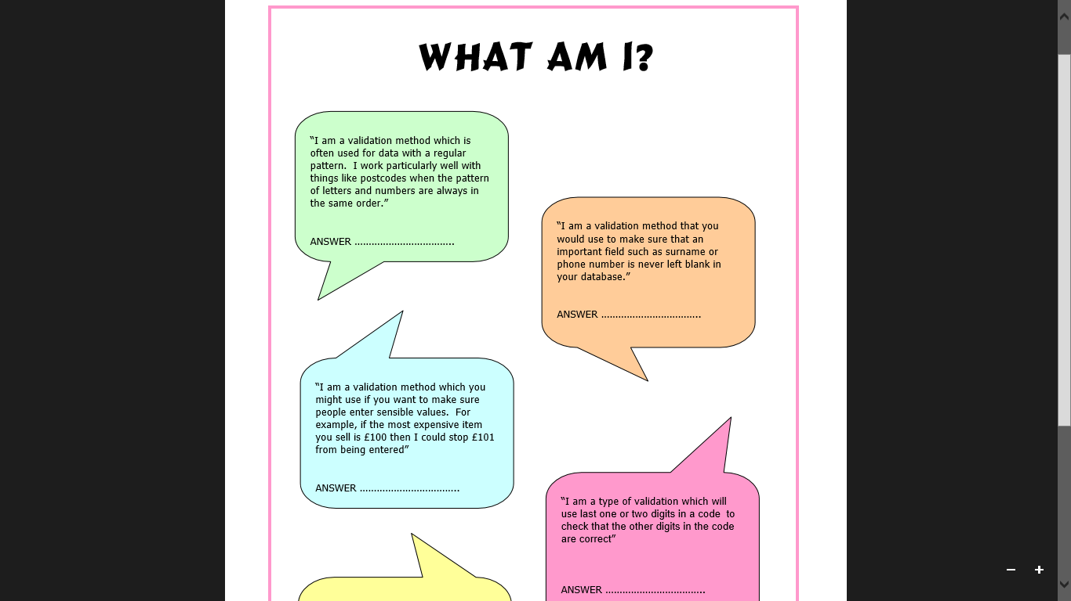

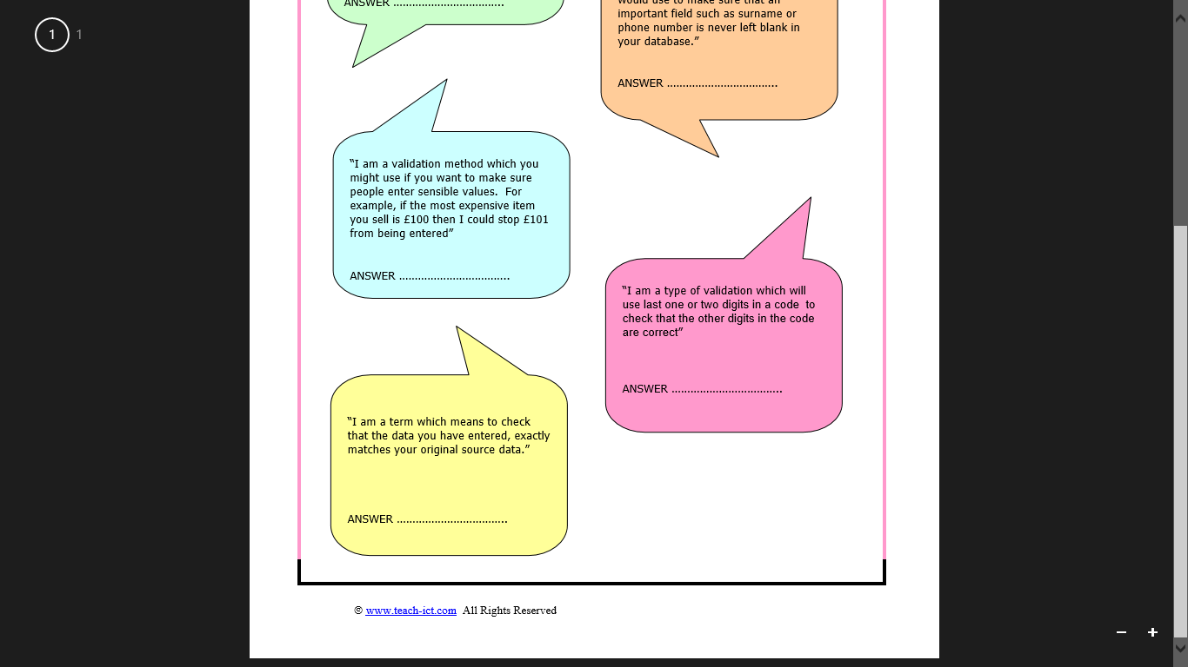

|  |  |
| --- | --- |
| **File Formats** | |
| **Key words I have Learnt from the lesson:** | **What you should know:**  *1) Explain the two different types of file formats*  *2) State when each format would be used*  *3) Know the different extension files for each format* |
| **Extra Notes:** | **Command words likely to be used:**   |  |  | | --- | --- | | **State** | **Name** | | **Using** | **Which** | |  |  | |
| There are two types of file formats: Proprietary & Open File Formats.  **Proprietary File Formats: created and owned by a company and can only be used properly in the software they create.**      **Open File Formats: general formats which do not need one specific software package and can be adopted and used by any developer.** | |
| **Test Yourself: Can you explain what the type of format is for each file each file and what it is used for**   |  |  |  | | --- | --- | --- | | File Format | Type (Open/Proprietary) | Used for? | | .doc |  |  | | .csv |  |  | | .mp3 |  |  | | .fla |  |  | | .xls |  |  | | .wma |  |  | | .rtf |  |  | | .ppt |  |  | | .aac |  |  | | .txt |  |  | | |
| **Example Question:**  1) Nico uses spreadsheet software to set suitable fees for each booking. Explain three reasons why this software is suitable for this purpose [3]  2) In order to store customer and member details, the leisure centre will need some systems. What type of software would be needed to store customer details [2] Give three examples of fields that could be used to collect their data [3]  3) Describe which type of software package would be used to produce the tickets and poster for a school open evening [1]  4) Identify two file formats that could be used for saving the finished images made before the poster [2] | |

|  |  |
| --- | --- |
| **Security Measures to Protect Data** | |
| **Key words I have Learnt from the lesson:** | **What you should know:**  *1) Explain different security threats*  *2) State actions a business can take to prevent threats* |
| **Extra Notes:** | **Command words likely to be used:**   |  |  | | --- | --- | | **Which** | **How** | | **Why** | **Describe** | | **Explain** | **Outline** | |
| Companies store a lot of data about us when we make purchases or register on their websites. It is important that they keep data secure and protected both from people outside and so that only required people can use the data inside the company. Measures which could be taken are discussed below.   |  |  | | --- | --- | | Physical Security | Access Security | | Alarms on  Doors locked  Fire protection  Lock windows/ Cabinets  Avoid Ground Floor  Blinds Closed | Usernames  Password  Password policy  Access Rights  Firewalls | | Data Security | Monitoring Systems | | Password protect  Restrict access  Backups  Read Only formatting on work  Encryption (scrambling a file to conceal its meaning) | System Checks  Checking of audit logs  Looking at transaction logs | | |
| **Definitions:**  **Access Levels** – give different people different levels of access. For example, someone may be able to see customer records but not change them. A senior manager may have a higher level of access where they can change them.  **Firewalls** – prevent unauthorised access from outside.  **Audit Transaction Logs** – these are files which keep a record of everything is done on a computer system. Should anything be changed, the log file can be checked. | |
|  | |

|  |  |
| --- | --- |
| **Backup and Recovery Systems & Choice of System** | |
| **Key words I have Learnt from the lesson:** | **What you should know:**  1) Explain why a backup is important to a business  2) State the difference between Automatic & Manual  3) Justify a method of backing up for a business |
| **Extra Notes:** | **Command words likely to be used:**   |  |  | | --- | --- | | **State** | **Aply** | | **Consider** | **Explain** | | **Justify** | **Outline** | |
| When using a computer system, companies need to be able to backup and restore data in case there are any problems with the system. Apart from the data being really important, it is also a legal requirement.  Things to consider when backing up   |  |  | | --- | --- | | Storage Media | What will you back up on to (see storage media section). If you have a handful of documents, would a USB stick do? If you have 100s of gigabytes of data, would cloud or magnetic tape be better? | | Backup Frequency | This is all about how often the data changes. For example a builder may only update his customer file once a month so he doesn’t need to back up every day. A bank might make lots of changes to people’s bank balances every day, so they need to backup constantly. In a school, student work changes every day, so we need to do a backup at least once a day. | | Archiving | How important is it to keep old information? E.g. does a small shop need to keep records of customers from 20 years ago? Probably not. A bank will need to keep information about all transactions so customers can see bank statements. A school may keep leavers work for two years before they delete it. The police will keep archives permanently in case they ever need information again. | | Automated v Manual | This goes back to the size of the data. If you are only backing up the odd file, then it may be quicker to just do this yourself, but it relies on you being able to remember to do this.  If you have a lot of data which MUST be backed up regularly, it may be worth making the computer system do It automatically for you. It is important though that the automatic backups are checked to ensure they were successful. |   So the choice of backup system will depend on the normal key questions:  **Remember: CASE**   |  |  | | --- | --- | | **Cost** | How much does the storage cost?  Is it cost effective?  Are there cheaper alternatives? | | **Availability** | Is the technology widely available?  Can it be easily replaced if there is a fault? | | **Security** | Will the data be secure?  Who will be able to access the data?  Where will the backups be kept? | | **Ease of Use** | How easy is it to back up?  How easy is it to restore if there is data loss. | | |
| **Example Questions**  1) Describe two ways other than voice calls that Steve could use to enable his audience to request songs using smartphones.  2) Give two methods of securing a backup device [2]  3) Give two advantages of using login and password on a network [2]  4) Identify two physical precautions a school would need to have to protect the school laptop with sensitive information from being stolen [2] | |

|  |
| --- |
| Business Communication Methods |
|  |

**Task: For each method of communication, explain the advantage/disadvantage**

|  |  |  |
| --- | --- | --- |
|  | **Advantages** | **Disadvantages** |
| E-mail |  |  |
| Forum |  |  |
| VideoConferencing |  |  |
| Real-time messaging e.g. MSN, ICQ |  |  |
| Telephone |  |  |

|  |  |
| --- | --- |
| **The Data Protection Act** | |
| **Key words I have Learnt from the lesson:** | **What you should know:**  *1) Explain the Data Protection Act*  *2) State the 8 key rules*  *3) Detail exemptions to the law*  *4) Explain how the Act can impact a business* |
| **Extra Notes:** | **Command words likely to be used:**   |  |  | | --- | --- | | **Define** | **State** | | **Give** | **Identify** | |  |  | |
| **The Data Protection Act 1998 sets out to protect the privacy of personal information.**  **Data subjects** are people who have data held about them – just about everybody really.  **Data users** are the people or organisations who hold the data. There are far more data users than many people think.  The Law states all Data must be:  1. Fairly and lawfully processed (used)  2. Used for limited purposes  3. Adequate and relevant. Only what is needed may be used  4. Accurate  5. Not kept for longer than is necessary  6. Accessible to the individual and able to be corrected or removed where necessary  7. Secure  8. Not transferred to countries without adequate protection.  **Your Rights:**  **see what data is being held about them** if they ask the data user. They may  have to pay to see it  **change anything** that is wrong  **refuse to have some data stored** at all, if it might cause damage or distress  **refuse to allow processing for direct marketing** – junk mail  **complain to the Data Protection Commission** if they think the rules have been broken  **claim compensation** if they can prove they have been caused damage by a data controller breaking the rules.  **Exemptions:**  **national security** – you cannot demand to see your data if national security is at stake  **police investigations** – information being used to prevent crime is not covered (though police records are)  **examination results are exempt** until they are published by the examining bodies.  **Example Question:**  Nico holds personal contact and bank account details of her DJ’s on her computer. State the name of the act that controls the storage of personal information by Nico. [1]  Describe one legal implication for Nico if this data is stolen [2] | |

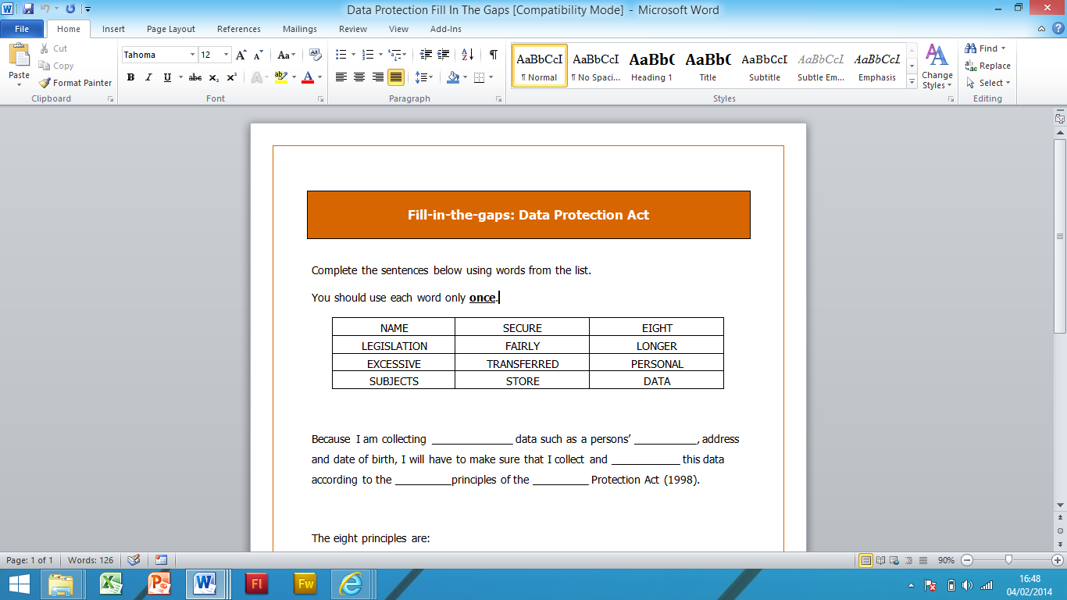

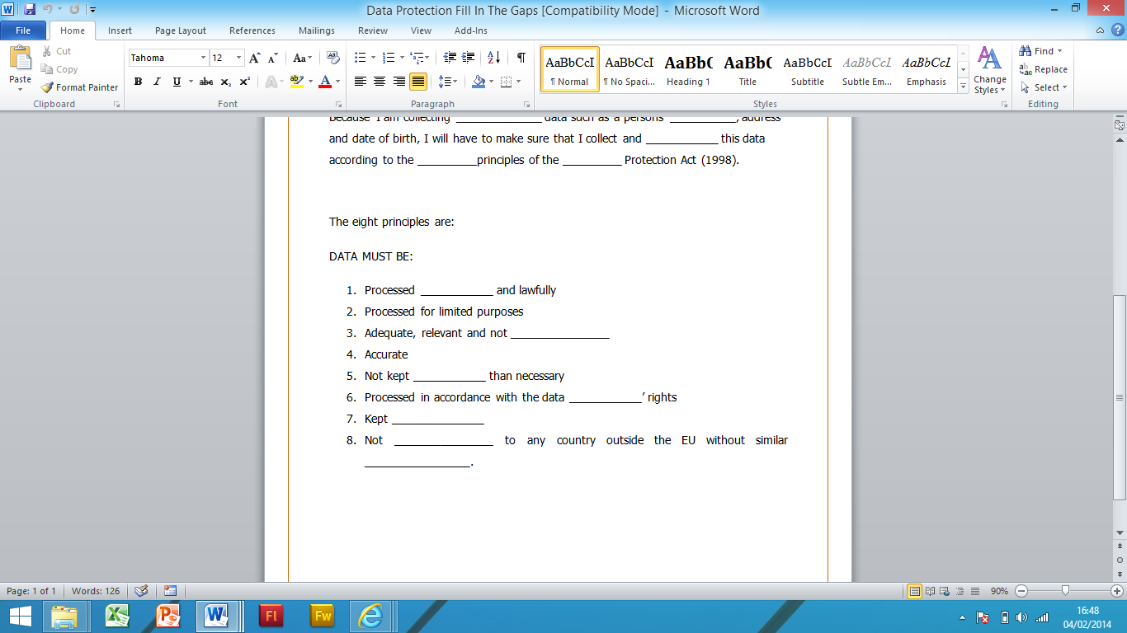

|  |  |
| --- | --- |
| **The Computer Misuse Act** | |
| **Key words I have Learnt from the lesson:** | **What you should know:**  *1) State three principles to the act*  *2) Different ways a business can lose data*  *3) Explain the impact hacking can have on Customers, Business, Employees* |
| **Extra Notes:** | **Command words likely to be used:**   |  |  | | --- | --- | | **Define** | **State** | | **Identify** | **Give** | | **Explain** | **Which** | |
| **Hacking** - **Unauthorised user who attempts to or gains access to an information system**  **Virus - A virus is a program written to cause mischief or damage to a computer system.**  The Computer Misuse Act (1990) was developed to cope with the problems of computer **hac**kers and **viruses**.  There are three principles to the act:  1. It is illegal to access unauthorised data e.g. **Hacking**.  2. It is illegal to access unauthorised data with the intent to commit a crime.  3. It is illegal to access unauthorised data and change it e.g. Planting **viruses** and **deleting files**.  A business can lose data in a few ways:  - Accidental loss  - Corruption (data becomes damaged)  - Data is stolen.  If a business does any of the above, they can be in serious trouble. The three ways below outline just how businesses can be affected.   |  |  |  | | --- | --- | --- | | Customers | Employees | Business | | Reduced confidence  Increases risk of identity theft  Increased Phishing  Vulnerable  Credit Rating affected | Disciplinary action  Sack/Dismissal  Intentional? Will lead to prosecution. | Legal action from Information Commissioners (DPA)  Increased costs to resolve issues  Loss of income  Brand name in disrepute  Customers leaving | | |

**Test yourself: Can you answer the following questions?**

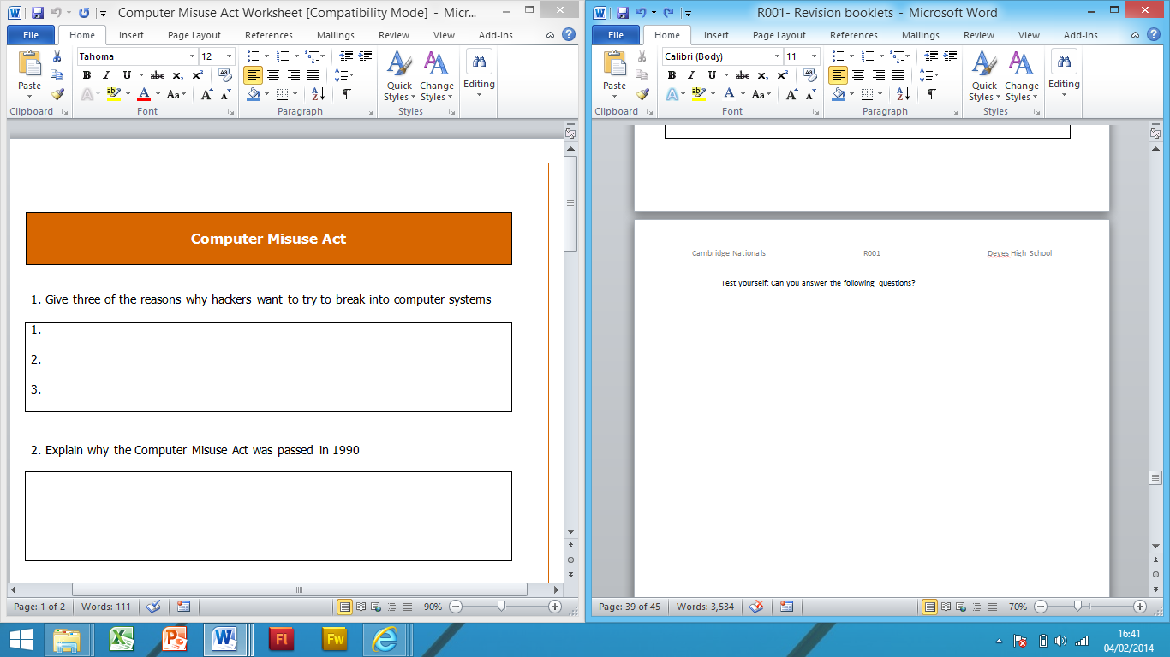

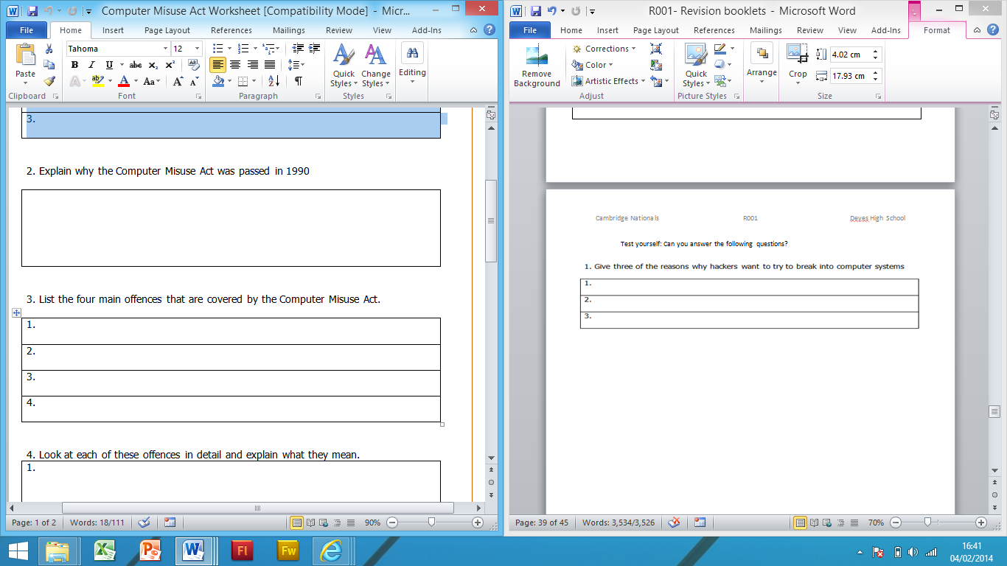

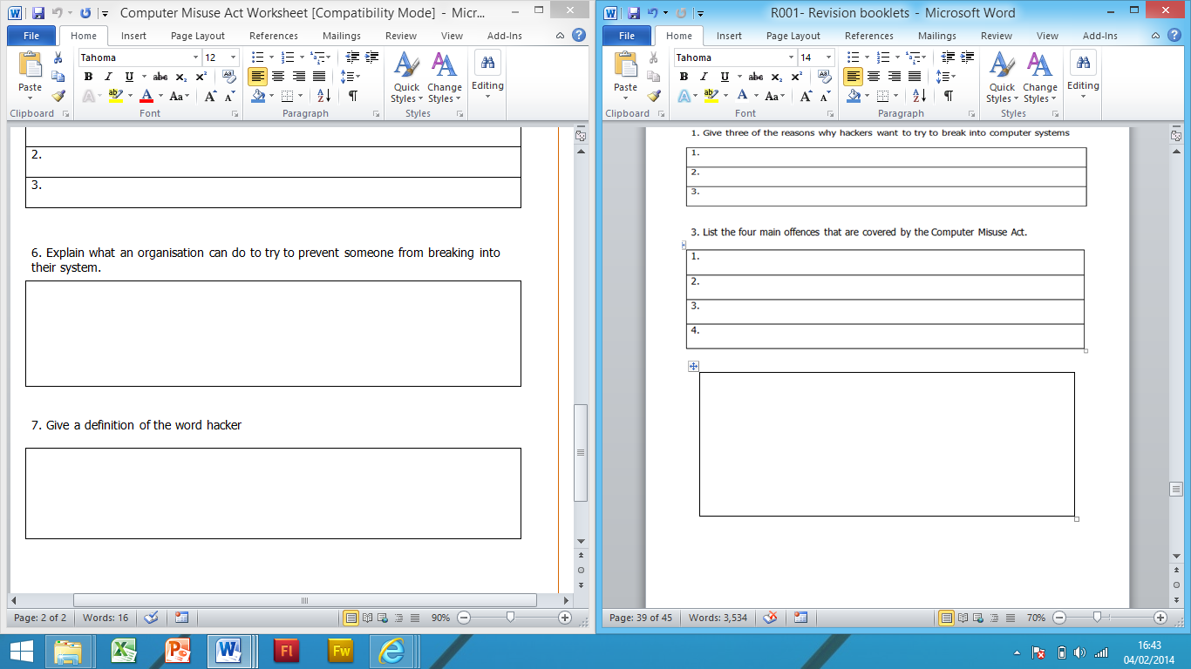

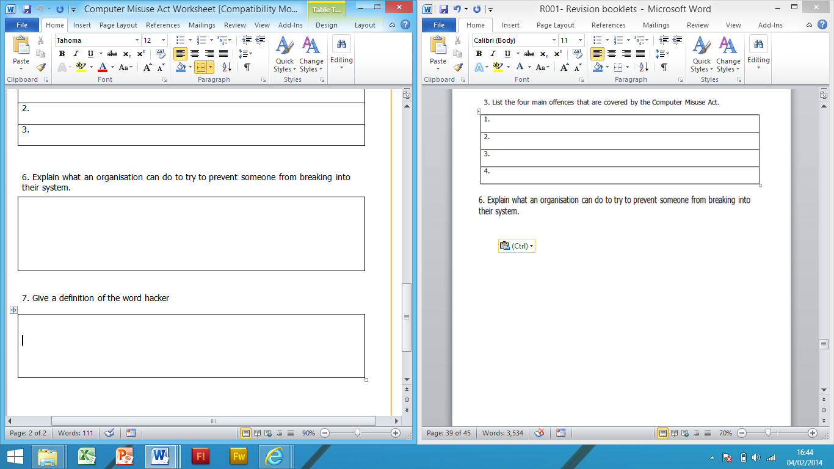

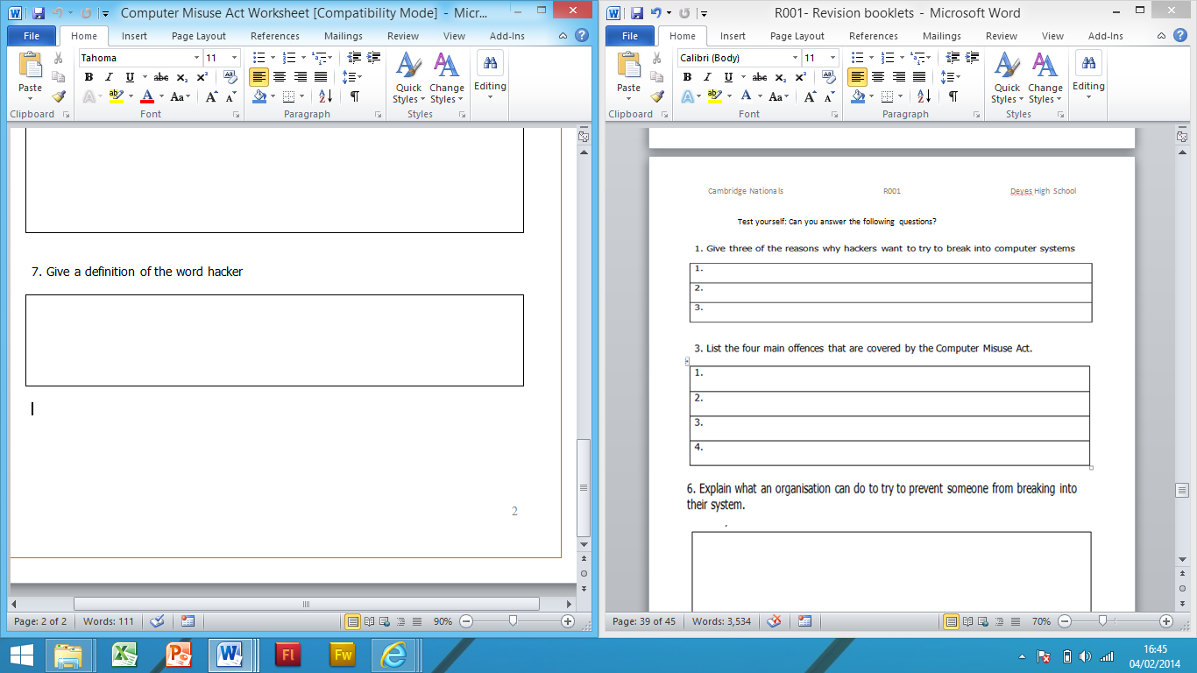

|  |  |
| --- | --- |
| **Health and Safety at Work Act** | |
| **Key words I have Learnt from the lesson:** | **What you should know:**  *1) Explain potential dangers at work*  *2) State how a business can prevent them*  *3) Explain the regulations of the law an employer must comply with* |
| **Extra Notes:** | **Command words likely to be used:**   |  |  | | --- | --- | | **Define** | **Explain** | | **Identify** | **State** | | **Justify** | **Advise** | |
| |  |  | | --- | --- | | Dangers | Prevention | | **Eye strain and headaches**  -- Sitting too close to the monitor (VDU) -- Bad lighting -- Spending too much time on the PC -- Flickering screen | Sit at arm’s length  Not too light or dark Regular breaks (15 minutes per hour)  New Monitor  Anti-Glare screens | | **Repetitive Strain Injury (RSI)**  -- Repeated movement of wrists and fingers over a long period of time -- Too much force when using keyboard/mouse (Aches + pains from muscle damage) | Prevention At least 5 minutes break every hour Mouse bags Keyboard rests Wrist supports Keep elbows close to your side | | **Back problems**  -- Caused by sitting in an awkward position at a computer. | Prevention Keep good posture Use an adjustable chair to allow a good position Sit with your back straight and head up Adjustable monitor so you don’t have to bend your neck |     **Employer regulations – (THE LAW)**  **The law states that an employer must:**  • **Provide tiltable screens**  • **Provide anti-glare screen filters**  • **Provide adjustable chairs**  • **Provide foot supports**  • **Make sure lighting is suitable**  • **Make sure workstations are not cramped**  • **Plan work at a computer so that there are frequent breaks**  • **Pay for appropriate eye and eyesight tests by an optician** | |
| **Example Question:**  When Working in a medium sized office at the same time, describe the three threats to physical health the staff face when working closely day after day and describe the solutions to these threats [6] | |

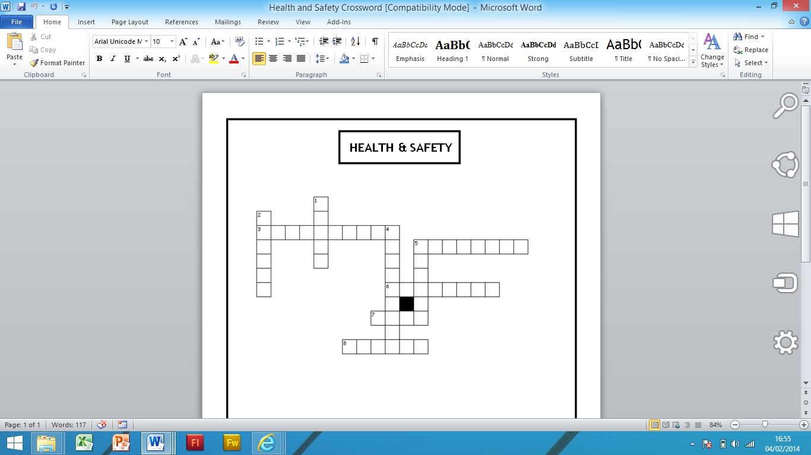

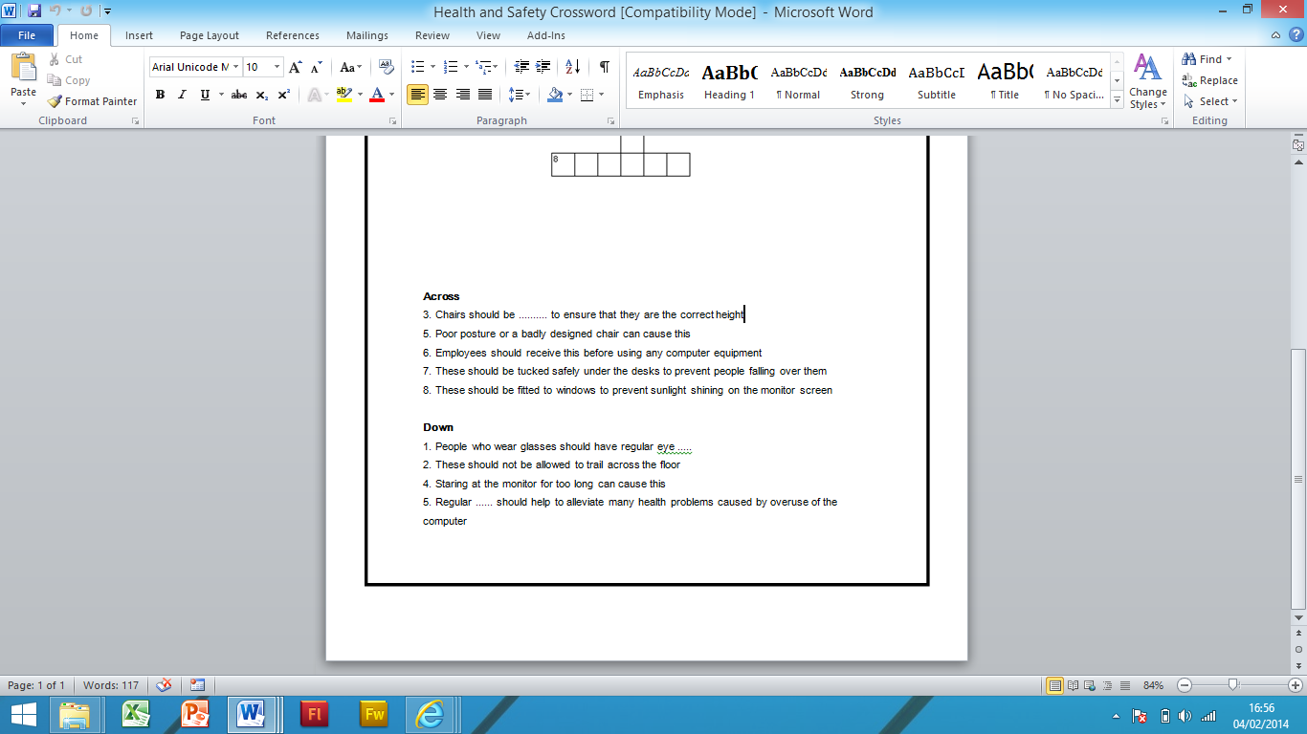

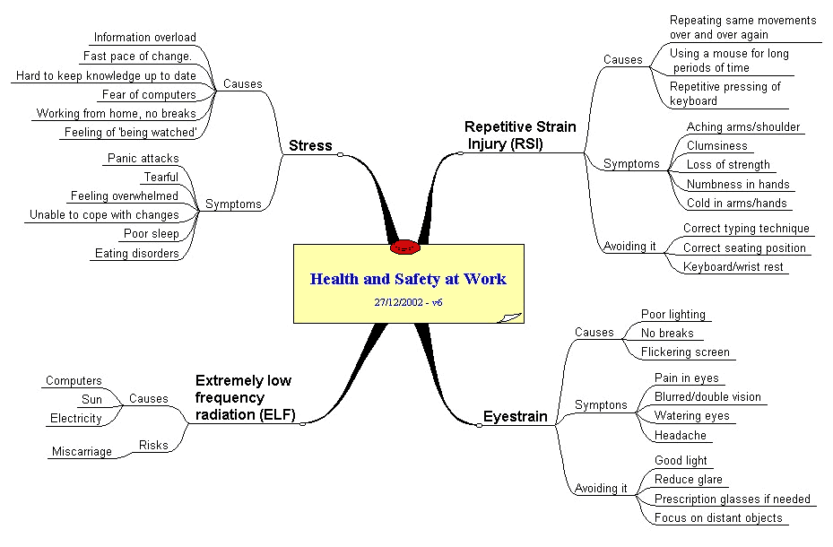

|  |  |
| --- | --- |
| **Question** | **Answer** |
|  | Fire, floods, lightening damage, theft of equipment and scratches on the hard disk |
|  | Backups |
|  | Lock the doors when not in use, use keypads on doors, CCTVs and in large firms, security guards |
|  | A program or hardware device that filters information coming through the internet |
|  | Software used to detect viruses and malware |
|  | It records every event or change to the system e.g. password change, file deletion |
|  | A method of scrambling data in such a way that only the people who have the ‘secret key’ can unlock and read the message. |

**Task: We are giving you the answers. All you have to do is to work out what the question**

|  |  |
| --- | --- |
| **Copyright** | |
| **Key words I have Learnt from the lesson:** | **What you should know:**  *1) Explain copyright issues*  *2) Justify why some users illegally download*  *3) State who suffers from illegal downloads* |
| **Extra Notes:** | **Command words likely to be used:**   |  |  | | --- | --- | | **Define** | **Explain** | | **Identify** | **State** | | **Justify** | **Which** | |
| **Downloading Music and Copyright Issues**  • Increasingly popular way of purchasing music.  • Can buy specific tracks you want!  • Can put on a range of devices.  • Can stream throughout your home.  BUT:  • Easier to make copies.  • More people download illegally.  • No original copy so if file lost – may have to purchase again.  A lot of different people suffer when music is downloaded illegally.  Here are some of the many different people who lose out from people who download illegally.  • It is illegal to download music without permission or purchase.  • You could face legal action or removal from your internet service under the three strike legislation.  • Ignorance is not an excuse  **What if someone illegally uses products from a business? (e.g. downloads a movie someone has produced without paying for it).**  1. Loss of sales?  2. Unemployment  3. Company have to pay legal expenses to prosecute.  4. Increased prices for consumers? Why?  5. Fewer products produced due to smaller budgets.  **What if a business uses something they have not got permission to use? (e.g. copying a design from one product in their own).**  1. Loss of confidence by consumes  2. Could be prosecuted.  3. Brand name in disrepute.  4. Fine/Sued  5. Forced to withdraw product. | |
| **Example Question**  Steve creates and plays his own tracks by combining together samples. Some of the samples are from tracks written or performed by other people. Explain three actions Steve must take in order to comply with the Copyright, Designs and Patents act when doing this. [3]  A leisure centre needs to adhere to Health and Safety in their office. Name two ways to protect physical safety in an office environment [2]  Suggest two ways to protect health whilst using computers for long periods of time [2] | |

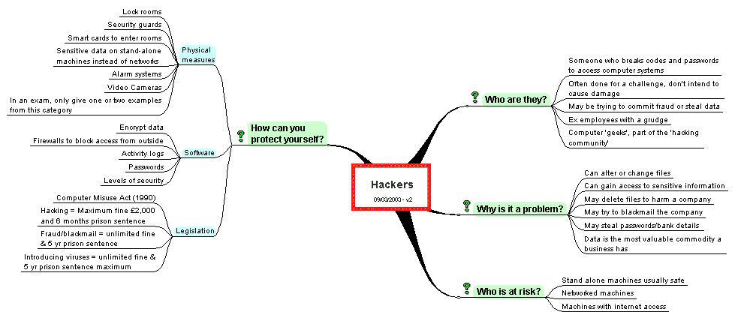

|  |  |
| --- | --- |
| **Threats to Data** | |
| **Key words I have Learnt from the lesson:** | **What you should know:**  *1) Describe different threats to computers*  *2) Explain the impacts of threats on a business network*  *3) Describe how businesses can prevent threats* |
| **Extra Notes:** | **Command words likely to be used:**   |  |  | | --- | --- | | **Define** | **Explain** | | **Identify** | **Consider** | | **Why** | **Which** | |
|  | |