10th December 2021

Dear Parents/Carers

As we approach the end of a busy Autumn term, I just wanted to share with you the arrangements for the final school day on Friday 17th December.

We will have a Christmas Jumper Day in school where students and staff can replace their usual school jumper for one with a festive twist. We will ask all participants to make a £1 donation which will then be shared with a local charitable organisation.

In terms of the school day lessons will be as follows:

AM registration 8.50am - 9.00am
Period 1 9.00am – 10.00am
Period 2 10.00am – 11.00am
Break 11.00am – 11.20am
Period 3 11.20am – 12.20pm
Period 4 12.20pm – 1.20pm
PM registration 1.20pm – 1.30pm

School will then close for students at 1.30pm.

Please note the school bus service and taxi services have been informed of these arrangements and collection times for students have been adjusted accordingly.

May I also take this opportunity to wish you all a very Mery Christmas and Happy New Year and look forward to welcoming the students back to school in January 2022!

Yours sincerely

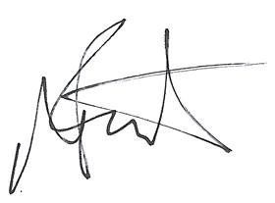

Mr A Boot
Acting Headteacher

