28th November 2021

Dear Parent/Carer

Following the briefing by The Prime Minister, Boris Johnson, on Saturday evening, the Department of Education have updated their guidance for schools.

From Monday 29th November 2021, face coverings will need to be worn by all pupils, staff and visitors in communal areas. Students who are exempt will need to wear the yellow lanyards previously provided.

This guidance will be in place immediately and will continue to be required for all students, staff and visitors until further notice.

Yours sincerely

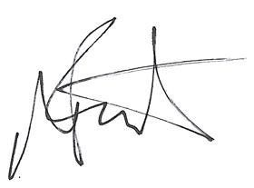

Mr A Boot
Acting Headteacher

