Waseley Hills High School

SCHOOL
INFORMATION

2019/20


Aspire We aspire to be outstanding: academically, professionally and personally.

Invest We invest fully in all we do, knowing that the more effort we commit the more benefits we can access.

Respect We respect each other, ourselves and the environment.

SCHOOL UNIFORM

At Waseley Hills we believe that school uniform helps to instil a sense of belonging to the school. We expect all parents to support our view that school uniform helps to create an orderly atmosphere conducive to work and a positive image in the community.

UNIFORM

Key Stage 3 Uniform

Plain pale blue shirt or blouse
Navy school V-necked jumper/cardigan with school logo*
Clip-on tie in House colours (broad stripe)*
Black school trousers
Plain black skirt (suitable for school; just above the knee)
Plain smart, dark low-heeled school shoes – training shoes, canvas shoes and boots are not permitted (see school website for further details).

Optional item for years 7 – 11

Navy blue waterproof fleece jacket

Coats

Outdoor coats, raincoats and anoraks in a sensible style and colour with no large logos/lettering are allowed. We do not allow denim, leather/faux leather, cord or novelty fabrics. Hooded sweatshirts, tracksuit tops and other sports tops ARE NOT part of our school uniform and MUST NOT be worn in school.

Physical Education and other equipment

Compulsory
House T-Shirt
House socks
Navy shorts / Navy skort with school logo embroidered

Optional
Navy hoodie with school logo
Navy joggers with school logo
Navy leggings with school logo
Ballet shoes for dance / gymnastics (no heeled dance shoes)
Plain Black / Navy base layer type top

Shin pads and football boots will be required for specific modules in all year groups.

All students with long hair must bring a bobble to tie it back, girls and boys. This is for health and safety reasons.

Please keep the school informed about any problems relating to school uniform. In sending your child to Waseley Hills High School we expect your full support over school uniform.

SAFETY REQUIREMENTS

In Science and other practical subjects it may be necessary to tie back long hair during practical work.

Jewellery – Students may wear a wrist watch, one discrete ring on each hand only and a maximum of one stud in each ear lobe. Earrings are not permitted in tops of ears. Other visible body piercing is not allowed.

Headbands should be of a plain (black/navy in colour) design with no decoration or adornment.

NO OTHER JEWELLERY OR ADORNMENT IS ALLOWED

Makeup – This is permissible in years 10 and 11 only. It should be discreetly applied.
Nail polish – including false nails – is not permitted.

Excesses of fashion in either clothing or hairstyle (including dyed hair or tramlines) are not appropriate for school. The Headteacher’s decision in such matters is final.

Other Items - The following items are not allowed:

- Cameras
- Pagers
- Aerosols
- Laser Pens

Students may bring a mobile phone to school for emergencies only. It must be switched off or on silent in lessons. Students are not allowed to use their mobile phones for social conversations at break or lunchtimes. If you need to contact your child in an emergency, then please telephone the school reception/office.

If mobile phones cause disruption to a lesson, they will be confiscated by a member of staff and may be collected at the end of the school day from reception. After three repeated infringements of this nature, the mobile phone will only be returned to a parent/carer and may be collected from the reception desk.

All the items above are brought onto the school site at the student’s risk. The school is not
liable for electrical items lost at school.

EQUIPMENT

EQUIPMENT

Years 7 - 11 are reminded to bring in only the books and equipment required for the relevant timetabled day.

ART & TECHNOLOGY

All aprons and protective equipment are provided for students.

PARENTAL ASSISTANCE

Please support the school by checking that your child is in the correct uniform every day. If your child is not in school uniform we will expect a letter to explain details and a date when your child will return to full school uniform. If a child does not produce such a note the school will contact home to ask for an explanation.

The school has two school uniform suppliers:
School Days https://www.schooldays-bromsgrove.co.uk/
Kids Essentials https://kidsessentialsschoolwearbirmingham.co.uk/

Details of both are on the school website. Please use the advised school uniform suppliers for all compulsory uniform items; school trousers, blouses, shoes and other items of uniform can be bought from any supplier provided they meet the school uniform colours and specifications.

If in doubt over the suitability of items of uniform please contact school before purchasing.

SPECIAL EDUCATIONAL NEEDS

Students are admitted to the school at the age of 11 in accordance with the Worcestershire LA admissions code. Their progress at primary school is noted and all relevant records are transferred. That information is used to place the student appropriately within the school structure. From September 2012, the school adopted a policy of placing students in a variety of sets to account for individual differences and abilities. Students are assessed regularly and movement between groups is discussed with both students and parents/carers.

Students with SEN fall into 5 broad categories;

- Students with sensory/physical difficulties (hearing/visual impairment/medical)
- Students with communication and interaction difficulties (ASC/SLCN)
- Students with cognition and learning difficulties (SpLD/Dyslexia)
- Students with social, emotional and mental health difficulties
- Students with exceptionally high academic ability in one or more subjects

The school’s Special Educational Needs Co-ordinator (SENCO) is Mr. J. Arnold.

The school also has a Mainstream Able-Autism Base (MAB) where specialist provision is given. This base is led by Mrs Wise as the MAB Manager and a small team of Teaching Assistants. Places in the MAB are allocated through Worcestershire Local Authority.

HOW HOMEWORK IS SET AND MANAGED

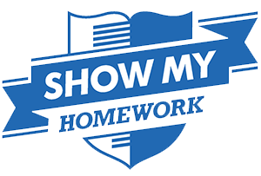
Homework should never be a battle between you and your child. Show My Homework has been designed with the busy parent in mind, finally involving you in the homework process by equipping you with all the details you need to help your child to succeed.

How it works:
All teachers create and publish their homework online, on the school’s calendar. Parents and students can manage submission of homework and view grades.

Here, you and your child can log into your own personalised accounts and see just the homework relevant to you. You can review submission times, see grades and communicate with teachers around specific assignments. We even have forgotten passwords covered - you can check for any homework set on the public homework calendar without ever having to log in.

Gone are the days of lost worksheets, illegible and missing instructions:
· All homework details are accessible 24/7, long after the school bell rings
· You can monitor from a distance: Stay in the loop without being intrusive
· You will enjoy peace of mind and never have to deal with late-night homework battles again!

Parental dissatisfaction as expressed through surveys, paired with poor audit results from the sampling of pupils’ planners was ultimately what led to the need to find a better homework solution. Having researched to find the best product that would help address our issues, Show My Homework proved to be the answer.

Many schools have introduced SMHW not only to combat complaints they have received regarding homework but as a direct response to parents’ requests. Schools that have implemented SMHW have seen an increase in parental satisfaction from 69% to 92%. Parents agree that homework set for their child is appropriate and helps them to learn. Being able to attach resources to homework means that pupils and parents can work through things together and will help to improve home-school communication. It will also allow pupils to catch up on missed lessons and serves as a very helpful archive of resources for revision and refresher materials.

SMHW allows senior leaders within school to track and monitor your child’s progress and ensure complete transparency, making it easy to spot when your child may be struggling. Not only that, but it ensures that the quality of homework your child receives is always up to scratch.

SMHW saves parents time trying to decipher whether their child has homework or not. You can now look online to find the information you need.

DISCIPLINE

“At all times we endeavour to think of others. Good manners and courtesy are the basis for relationships in our school and self-discipline and responsible behaviour are expected of everyone. We must clearly distinguish between right and wrong”.

GOVERNORS’ STATEMENT

Our school ethos is based upon a belief that encouragement, support and reward are central to all that we do. A system of rewards allows good behaviour and achievement to be recognised. However, at times some students show unsatisfactory behaviour and poor attitudes.

The vast majority of our students are not involved in any way with the following behaviours and are never removed from lessons. However, it is important to make clear to staff, parents and students what we value and believe in and where we will make a stand and take action.

ENCOURAGING GOOD BEHAVIOUR

Staff encourage good behaviour at all times by their own example. High standards of behaviour are expected in all lessons and at social times. Through assemblies and Tutor time (as well as lessons), students are given clear guidance on the difference between right and wrong. Our code of conduct is summarised in our four school rules:

1. Do as you are asked first time
2. Be on time for your lessons and with the right equipment
3. Listen to your teacher in silence
4. Keep hands, feet, objects and offensive comments to yourself

DISCIPLINE PROCEDURES (Behaviour for Learning)

The following sanctions can be applied:

- A verbal warning from the member of staff who is directly involved
- Second verbal warning given
- Written Warning issued via the internal electronic communication system
- 5-minute ‘stayback’ detention issued
- 30-minute Staff / Faculty Detention issued via school detention letter
- WITHDRAWAL from classroom by a Senior Teacher and taken to Time Out
- 60-minute Friday after school SLT Detention issued via school detention letter
- Students can be placed in Time Out for serious / persistent offences
- Students can be placed on Tutor / HoH / SLT report to monitor behaviour. Parents are informed
- Students may be placed in a different class within the faculty

- Interviews arranged with parents to discuss problems with relevant staff
- Exclusions – these are normally as a result of a series of problems but may be in response to a single act of unsatisfactory behaviour

DRUGS EDUCATION AND PREVENTION POLICY

The school has full policy on Drugs Education and Prevention, which is available on the school’s website. This includes references to illegal substances, tobacco and alcohol and explains the school’s procedures in the event of any student involvement.

WHAT IS UNSATISFACTORY BEHAVIOUR?

Acceptable behaviour: Is being well mannered and sensible at all times. All students must follow instructions, work quietly and produce work which is at least satisfactory for the student’s ability level. Movement around the school should be calm and orderly. Students are courteous towards other students.

Unacceptable behaviour: It is difficult to list all forms of unsatisfactory behaviour but the following are some examples:

- Failure to work to capacity and/or to complete homework
- Failure to come to a lesson properly equipped (including exercise books, PE kit, writing equipment)
- Poor time-keeping, eating in class, leaving litter, defacing books or other surfaces, using foul or abusive language
- Any form of rude, disrespectful and insolent behaviour
- Refusal to carry out instructions
- Bullying (the school has a separate policy on bullying)

Conduct and information on punishments for inappropriate behaviour are widely displayed throughout the school. The school’s bullying policy is also given high priority and is prominently displayed.

Bullying report forms are available for students who wish to forward information.

IMPORTANT INFORMATION: By law and under school policy, staff are authorised to use positive and professional handling, reasonable force and physical restraint in carrying out their duties and to prevent injury, damage, serious disruption and criminal offence.

Although rarely used, staff have the authority to confiscate items that are prohibited (mobile phones, items of jewellery and certain items of clothing). Designated staff are allowed to search persons and property with permission which is expected from students and parents and can, on reasonable grounds or where permission is not given, call in the police and other relevant agencies.

EXCLUSIONS

There are 3 forms of exclusion which the Headteacher may use;

INTERNAL – normally for 1 school day following a serious incident in school. During Internal Exclusion students will report to school in full school uniform and complete work set by their subject teachers in our Time Out room.

FIXED TERM – normally for 1 to 5 days (with a maximum of 45 days in any school year) following a series of incidents or a single incident deemed to be very serious. During the period of exclusion parents and student attend an interview with the Headteacher to determine the point of re-entry to school. Students will be allowed to return once guarantees of satisfactory behaviour have been given. Students returning from exclusion may be placed upon a contract or report to monitor behaviour. If an exclusion is for longer than 2 or 3 days, the school will set appropriate work.

PERMANENT – Normally following a series of incidents but can also be the result of a single incident.

For both types of exclusion parents have the right to make representations to the Governors and / or the LEA if they consider the exclusion to be inappropriate.

BEHAVIOUR LIKELY TO LEAD TO EXCLUSION includes:

Serious cases of rude, disrespectful behaviour
Violent or aggressive behaviour – including bullying and intimidation
Failure to follow school safety regulations (fire notices, going on roof, climbing over fence into tennis courts, etc)
Acts of vandalism, damage or theft
Persistent refusal to follow school rules, consequence procedures, discipline code and dress code
Possession / use of / association with alcohol, tobacco, cigarettes and any illegal weapons
Acts of abuse of any nature including incitement to abuse on religious, racial, age and gender related issues
Persistent disruption of teaching and learning, the right to teach, the right to learn and the right to feel safe and be safe
Being found in possession of items such as knives or imitation weapons
Posting school based images on public access web sites, or bringing the school into disrepute by discussing staff or students (YouTube / Facebook etc.)

EARLY HELP FOR CHILDREN AND FAMILIES

At Waseley Hills High School we recognise the challenges that families face in bringing up children. There may be times when you need extra help and support. If this is the case please come and talk to us. There are many ways in which we can help as outlined in this offer of early help.

The diagram below shows the range of needs at different levels. We use this graduated approach to make sure we provide the best support for different families’ individual situations.

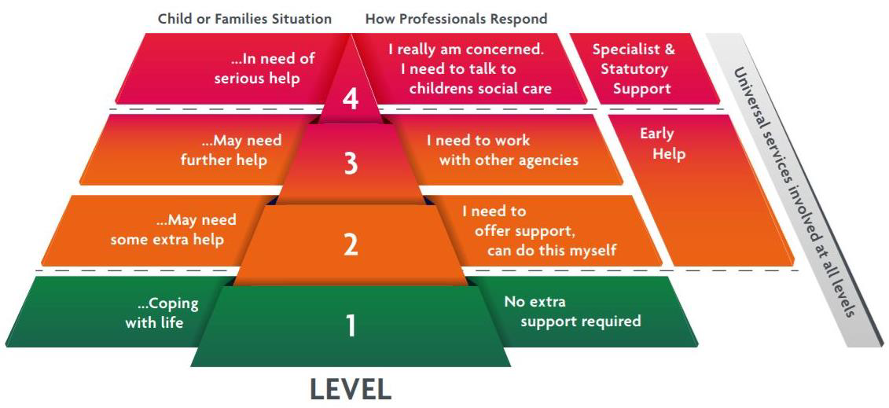

Providing early help to our pupils and families at Waseley Hills High School means we are more effective in promoting support as soon as we can. Early help means providing support as soon as a problem emerges, at any point in a child’s life, from the foundation years through to teenage years.

What is Early Help?
Early Help means providing support as soon as a problem appears, to stop it from getting worse. This could be at any point in a child's life, from birth to the teenage years. Anyone can provide early help – you don't need to be an expert professional. Early help is not about passing the issue on to an expert, but thinking about what is the best support you can offer.
Everyone needs help at some time in their lives and therefore an ethos of early help is important for any school. We believe that early interventions for children or families, in many cases, will prevent children from experiencing harm and reaching a point of crisis.

What is our Early Help Offer?

There are many key pastoral staff who work with students and families in our school:

Tutors: day to day support and guidance around academic and pastoral issues. First point of contact for parent/carer(s) and students with any issues or concerns.

Student Support Centre: dedicated team of non-teaching staff who offer a wide variety of means to support students in school. They deliver a range of mentoring to support our students with a variety of issues including organisation, self-esteem, mental health issues, self-confidence, incidents including bullying and resilience. Several members of the team are Mental Health First Aid Trained and offer a ‘Fresh Air Room’ where Cognitive Behaviour Therapy (CBT) is delivered.

Heads of Year: the next step up from Tutors in supporting students and their families. Parental Meetings in school, telephone conversations, home visits and, where appropriate, signposting and referring into outside agencies. Outside agencies and partnerships include;

Touchstones – bereavement counselling

Respect Project – intensive mentoring for students and families experiencing difficulties

Swanswel – addiction support

Child and Adult Mental Health Service (CAMHS)

Forward Thinking

Targeted Family Support – both Worcestershire and Birmingham

Support and guidance from local PCSOs

Reach Out project – intensive mentoring for a range of issues

School Health Nurse: We have a school health nurse who attends school once a week and holds a ‘drop in’ clinic for any students who wish to see a nurse.

Sexual Health Nurse: Attends school weekly and is available to see students as part of their ‘drop in’ clinic once a week

Attendance Officer: Supports students and their families to ensure good attendance is maintained. Provides home visits where necessary, meetings with students/parent/carer(s), text/email/phone calls regarding attendance and how we can best support (links to Head of Year and Student Support Centre Staff when students experience difficulties with coming into school).

CELEBRATING SUCCESS

REWARD POINTS

Rewarding students for their good attitude to learning and contribution to our positive school ethos is incredibly important to us as at Waseley Hills High School.

Working closely with our student-led School Council and Learning Council, the students have helped design their own rewards system.

The system allows teachers to reward students with Reward Points from 5 to 25 for their achievements in and out of school. These can be awarded for anything from everyday acts of kindness, a significant contribution to any school event or maybe an outstanding ILC (Independent Learning Challenge). Likewise, negative behaviour events are recorded, with each sanction carrying a Behaviour Score of 5 to 25.

The balance of these points is used to enable students to be awarded badges as they reach every 100 Reward Points. These badges are issued half termly by the Student Learning Council and worn with pride by our students on their ties.

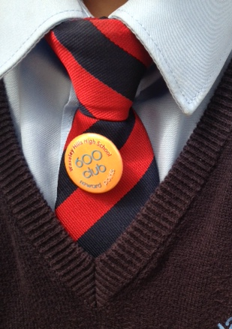
REWARDS CERTIFICATES

Every half term, students with the top 10% of Reward Points achieved in the previous half term receive a certificate from the Student Learning Council.

Certificates are also issued to all students who have achieved 100% or 97%+ attendance in the previous half term.

To reward those students who have shown significant improvement, certificates are also issued to the top 10% of improving students regardless of their total Reward Point score, i.e. if they began from a lower point but gained the most Reward Points in the previous half term, their achievement and improvement would be recognised.

REWARDS TRIP

At the end of the academic year, students achieving the top 10% of Reward Points in their Year Group who also have an average annual attendance figure of 97%+ are invited to attend a Rewards Ceremony and our Rewards Trip.

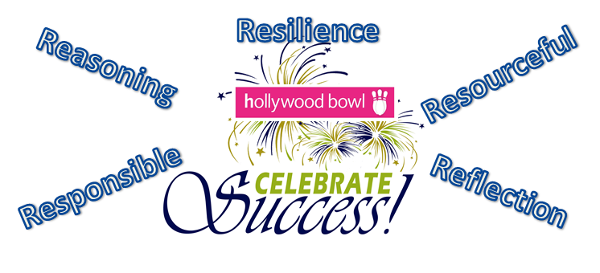

HEAD OF YEAR CELEBRATIONS

These celebrations take place during Tutor Time on a termly basis. Students with exceptional AtL grades (Attitude to Learning grades) are invited by their Head of Year to a commendation celebration where they are congratulated by Senior Staff and Heads of Year. These particularly rewarding occasions give us the opportunity to recognise and thank the students for their hard work and contribution to the school.

KEY STAGE THREE PRESENTATION EVENING - SUMMER TERM

This awards evening celebrates the hard work and effort put in by our Year 7 and Year 8 students. Invited students and their parents/carers attend as they have been nominated by teachers and support staff for their achievements, progress and attitude to learning across the curriculum and in our school community.

An invited guest of honour delivers a keynote speech and awards and certificates are presented by the guest of honour and the Headteacher. Students and proud parents are invited to join us in the Business and Enterprise Centre afterwards for refreshments and photographs.

EXTERNAL AWARDS AND CERTIFICATES PRESENTATION

External examination certificates (GCSE, ‘A’ level, Vocational) are presented at the annual Presentation Evening held in December each year. All students receiving examination certificates for GCSE or A level courses are invited to attend together with their parents.

Named Major School Awards

Headteacher’s Award for Achievement and a Caring Attitude
House Award for Outstanding Contribution to Athens
House Award for Outstanding Contribution to Rome
House Award for Outstanding Contribution to Sparta
House Award for Outstanding Contribution to Troy
Armitt Award for Reliability
Baker Award for Support to Others
Cutler Award for Effort in Work and Service to School
Davies Award for Enthusiasm for Languages
Gibson Award for Outstanding achievement by a Student with Individual Needs
Griffiths Award for Effort and Conduct
Hurlbutt Cup Award for Sporting Excellence
Long Award for Success Beyond Expectations
Waseley Hills High School Enterprise Award

Individual subject prizes are also awarded for achievement and endeavour.

Week 1

 | AM REG  8.50-9.00 | PERIOD 1  9.00-10.00 | PERIOD 2  10.00-11.00 | BREAK  11.00-11.20 | PERIOD 3  11.20-12.20 | PERIOD 4  12.20-1.20 | LUNCH  1.20-2.00 | TUTOR  2.00-2.20 | PERIOD 5  2.20-3.20
MON
TUE
WED
THU
FRI

Week 2

 | AM REG  8.50-9.00 | PERIOD 1  9.00-10.00 | PERIOD 2  10.00-11.00 | BREAK  11.00-11.20 | PERIOD 3  11.20-12.20 | PERIOD 4  12.20-1.20 | LUNCH  1.20-2.00 | TUTOR  2.00-2.20 | PERIOD 5  2.20-3.20
MON
TUE
WED
THU
FRI

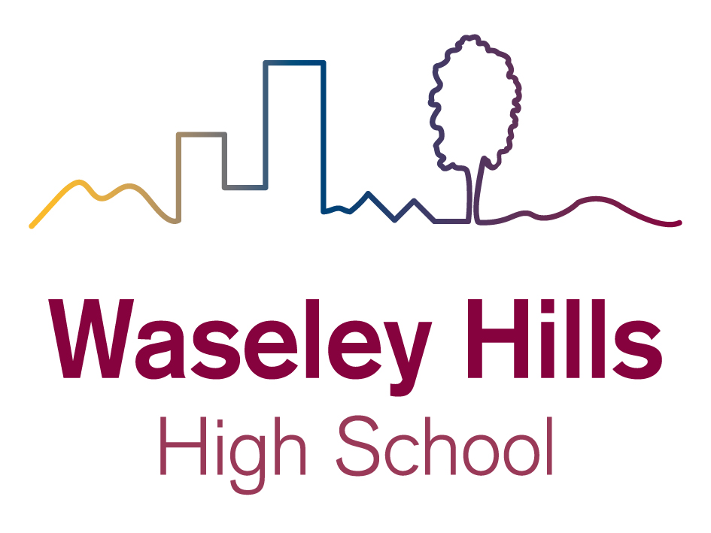
Aspire, Invest, Respect

Headteacher: Mr. A. Roll

School Road, Rubery, Birmingham B45 9EL

Tel: 0121 453 5211 Email:office@waseleyhills.worcs.sch.uk

www.waseleyhills.worcs.sch.uk

