Subject: Psychology
2 Week Independent Learning plan
Email queries to:
mcrowther-green@waseleyhill.worcs.sch.uk

Teacher: Miss Green
Year: 9 Topic/theme: Key concepts – Debates in Psychology
Lesson | What you need to take from this lesson | Resource to use or hyperlink | Suggested task
1 | - To revise the nature – nurture debate in psychology | Big piece of paper or stick 2/3 pieces of A4 paper together  https://www.youtube.com/watch?v=EmctxRcmloc | - Watch the link to remind yourself about the nature – nurture debate.  - Get the biggest piece of paper you can find or stick two or three plain pieces of A4 paper together. In the middle draw a large double-ended arrow (see below)  - On one side of your arrow write nature (with a simple definition)  - On the other side of your arrow write nurture (with a simple definition)  - Now add as many different behaviours that you can think of along your arrow. Think carefully about where you place them on your arrow – do you think they are more nature or nurture? You must be able to explain your choices and give some examples!  Make this bright and colourful, add images and drawings. If you’re really proud of what you have created I would love to see your work – please email me!
2 | - To revise the reductionism – holism debate in psychology | One piece of plain A4 paper  https://www.youtube.com/watch?v=3Uh8JqawdKw | - Watch the first 30 seconds of the link to remind yourself about the reductionism – holism debate. You may need to make a couple of notes to help you with the task.  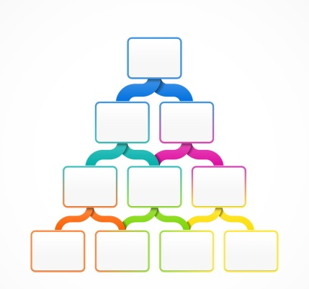  - You are going to explain why someone may commit a crime. You need come up with a scenario which ultimately ends up in a person committing a crime. You can choose any crime (but be sensible!). Think about the following: what was their upbringing like/are they in work/are they suffering with any mental health problems/ what were the circumstances surrounding the crime. HINT: Don’t make this too complex for yourself, this isn’t a murder mystery!  https://murderpedia.org/male.W/w/whitman-charles.htm  You can use the link above as a starting point  - Using the hierarchy template you are going to explain this persons crime. However you must begin in the top box and must use only ONE simple explanation, as you work down the hierarchy you can add more explanations and reasons as to why this person committed the crime.
3 | - To revise the freewill – determinism debate in psychology | Plain piece of A4 paper  https://www.youtube.com/watch?v=2gnUTmYydCk | - Watch the first minute of the link to remind yourself about the freewill – determinism debate in psychology  - On a piece of A4 paper draw a simple outline of a body (you can print one off if you are able to)  - Split your paper in half (lengthways)  - The body resembles you. Think about you as a person for a minute. Think about the way you are, your physical and mental health, your likes and dislikes, your friends, your hobbies.  - On one side of the body you are going to explain all the influences on who you are that you have had NO control over (determinism). On the other side of the body you are going to explain all the influences on who you are that you HAVE had control in.  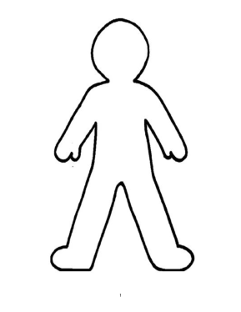  You will not be asked to share this as this is personal to you!
4 | - To consider whether psychology is a science? | A4 piece of plain paper | - Using the research methods key terms list at the bottom of this document you are going to consider whether you think psychology is a science.  - On your piece of paper create a large venn diagram. There is an example below. One circle will be scientific methods, the other circle will be non-scientific methods.  - Using the list of key terms below (and any other key terms you can remember from research methods), fill the venn diagram. Consider which of the methods are scientific, which are not and which may be somewhere in the middle. See if you can explain WHY you have placed each method where you have.  - At the bottom of your work use the venn diagram to come to a conclusion: Do you think psychology is a science and why?
5 | - To revise all the issues and debates in psychology | Large piece of paper/cardboard  Any resources which you can find at home! | - You are going to use all of your revision on the key issues and debates in psychology to create a game. This can be ANY GAME OF YOUR CHOOSING! It could be a card game, board game, online game (if you are a tech wiz!).  - Your game should be centred around the issues and debates that you have covered over the last 4 lessons, be as creative as you want to be!  - Challenge your family to a game, let them use your resources from the previous tasks to understand the key issues and debates and then see what they can do!  - I would love to see your creations and the most creative entries will win a prize on our return to school! Please email me your work at the email address above!

Don’t forget you can access the school drives and resources form the school website including the learning tables on the VLE: https://www.waseleyhills.worcs.sch.uk/
Research methods: lab experiment, field experiment, natural experiment, independent groups design, repeated measures design, random sampling, opportunity sampling, volunteer sampling, ethical issues, structured interviews, unstructured interviews, questionnaire, open-ended questions, closed-ended questions, rating scales, correlations, observations (overt, covert, naturalistic, controlled, participant, non-participant), case studies, primary data, secondary data, qualitative data, quantitative data, mean, mode, median, reliability, validity

