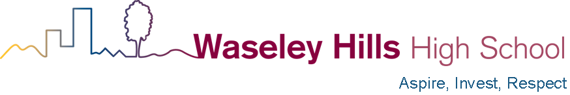

Thursday 31st December 2020

Dear Parents and Carers
I am sure that you have read the information that has been released by central government on Wednesday, the 30th of December. Once again schools have to deal with last-minute changes and I’m sorry to have to pass on that news to you at this late stage.
The timeline is probably best summarised below;
Monday January 4th, 2021
This is a teachers training day for all staff which will be aimed at getting our testing facility in place. We will require some time to work through the logistics of testing all of our students and staff as well as gaining parental permission to do so. A separate consent from will be sent via WEDUC on Monday 4th January; please return this asap as without it your child cannot be given a lateral flow COVID test.
Tuesday 5th January to Friday 8th January
Tuesday 5th January, Years 7 – 13 all attend an online assembly explaining how to access learning and ‘live’ lessons.
Wednesday 6th January, the blended lessons on SMHW and MS Teams start.

Some groups of children including children of key workers will attend school and those parents accessing this provision will have been contacted by Friday evening the 1st of January to confirm arrangements. By Wednesday 6th January there will be online learning provided for all of our year groups which will include ‘live’ lessons using Microsoft teams. Your child will need to log into their school office 365 account using their normal password provided by school and by Tuesday 5th they will find the invitations waiting for them to attend lessons online during the first week back. We will also send the online lesson schedule to parents so students won’t inadvertently miss any lessons.
To introduce this new blended learning there will be an online assembly for each year group on Tuesday 5th using MS Teams; please ask your child to look out for the invite to attend.
Monday, 11th January to Friday 15th January
We expect year 11 and year 13 students to return to full time education. Those students who have given consent for testing will be tested in school. Years 7, 8, 9 and 10 will continue with online learning blending a mixture of SMHW work tasks and live lessons. Year 12 will also follow this pattern during the week.
Monday, 18th of January
We expect all year groups to return to full-time education and their normal timetable, however this is subject to further government announcements. Those children for whom we have consent will be tested regularly using the lateral flow tests.
Finally, many thanks to those parents who have already contacted school to volunteer their time in helping with testing students in school. If you feel that you would be able to assist then please do not hesitate to contact us using the office@waseleyhills.worcs.sch.uk email address. For our school we estimate that we will require a team of 6–8 adults each day to help run testing. It would be wonderful if we could do this on a rota basis and we would be delighted to welcome parents to help us out. No DBS check is required.
I’m sure you will recognise that it has been a particularly stressful and difficult Christmas break and that not many of our teaching staff have been able to have their normal Christmas and New Year. We all hope that with the right support and funding from government will be able to make 2021 the year that we bounce back from this pandemic.

Yours sincerely

Mr A.W. Roll
Headteacher

