Next Steps in Physics
  - GCSE Physics Bridging Tasks

This task booklet is designed to support all students as they move on from GCSE Physics and take their learning to the next stage of education. It is designed to support you in your learning whatever your next step is, and for you to choose the tasks that are most relevant and interesting to you. There are three sections:

Developing as a Physicist
…through general reading around / watching videos / listening to podcasts etc. to develop your knowledge and understanding of Physics and the world around you.

Using Physics in the World
…through specific links to examples of how GCSE Physics is involved in real world jobs and careers.

Preparing for A-level…
…through mastering the GCSE topics, extending your mathematics and building links to the learning to come on the A-level course.

Being a great Physicist is more than just being “good” at Physics questions in an exam. There are many doctors, engineers, business owners, politicians and financial advisors who are excellent physicists – they have the ability to see cause and effect, to use evidence to compare and make valid decisions, to spot patterns and predict the consequences of an action. They know a great deal about the world and can link many different ideas together – not necessarily just electricity and forces! Above all, they remain curious and want to know why something happens when it does.

You don’t need to do every task and every activity, but I hope that many of these will be interesting to you. I hope that these activities will feed your curiosity and drive you to solve problems – these are the things which every great physicist has in common – wherever your next steps may lie.

Good luck!

Developing as a Physicist

Read

Websites
Physics World - https://physicsworld.com/ - The gold standard publication and website for research news in Physics. The language is quite technical – but the research is current and very interesting.
New Scientist - https://www.newscientist.com/round-up/physics-questions/ - This link directs to a section of the New Scientist website which focuses on questions in Physics.
BBC Science & Environment - https://www.bbc.co.uk/news/science_and_environment - Regular news articles which cover a broad spectrum of Science topics.

Books
IF YOU READ ONE BOOK READ…
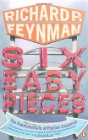 | “Six Easy Pieces” – Richard Feynman – This is the definitive go-to book for understanding some of the key ideas in Physics and explaining the position of Physics in relation to other Sciences. It is commonly available as a free download online.
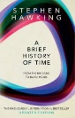 | “A Brief History of Time” – Stephen Hawking – What is a black hole? How did the universe form? How might it end? This is the best-selling exploration of the biggest questions in Physics – an essential read for A- level Physics students.
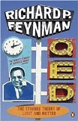 | “QED: The Strange Theory of Light and Matter” – Richard Feynman – A book which explores the foundations of Quantum Theory and explains the first truly “modern” theory of Physics – Quantum Electro-Dynamics.
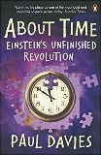 | “About Time” – Paul Davies – This is the classic exploration of the ideas of Einstein’s Special and General Theories of Relativity
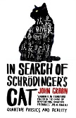 | “In search of Schrodinger’s Cat” – John Gribbin – If you’ve wondered why Schrodinger’s cat is so famous, or wondered about parallel universes and other worlds, this is the book for you.
Also recommended… “How to Teach Quantum Physics to Your Dog” (Chad Orzel), “The Emperor’s New Mind” (Roger Penrose), “Six not-so-easy pieces” (Richard Feynman, harder!), “The Science of Everyday Life” (Marty Jopson)
There is an excellent catalogue of books about Physics to read at: https://physicsworld.com/a/the-physicists-library/

Watch & Listen

Podcasts
BBC: The Infinite Monkey Cage – An irreverent look at questions from across science and nature, hosted by comedian Robin Ince and Professor Brian Cox. The whole back catalogue is available online, looking at questions from “Is time travel possible?” to “Is a strawberry alive?” https://www.bbc.co.uk/programmes/b00snr0w/episodes/downloads
Physics World Stories – Presented in an accessible way by world experts, this podcast covers topics from Quantum mechanics to Asteroid mining.

Online Video Channels
Minute Physics – https://www.youtube.com/user/minutephysics - this is a superb channel of short, interesting Physics videos which explain some of the biggest ideas in Physics in a really accessible format.
A-level Physics Online – https://www.youtube.com/channel/UCZzatyx-xC-Dl_VVUVHYDYw - We as a school have a subscription to these excellent videos which match the OCR A specification. Year 12 videos are all online on YouTube, and Year 13 videos can be accessed using our school subscription. Email Mr Nelson for the details if you want to watch some of the Year 13 videos.
Science Shorts - https://www.youtube.com/user/ScienceShorts - Another good channel of simple explanations for topics in Physics.
TED Talks – https://www.ted.com/talks?sort=relevance&q=physics – there are hundreds of fascinating talks about different ideas in technology and research

Documentaries
Cosmic Voyage - https://www.youtube.com/watch?v=2Mprlmx1C7M – Narrated by Morgan Freeman, this was originally created to bring Cosmology to a wider audience and was filmed in IMAX.
Cosmos with Carl Sagan - Episode 1 at https://www.youtube.com/watch?time_continue=8&v=gfCc7ZJjHiM&feature=emb_logo (and others on YouTube and Twitch) – The definitive introduction to astrophysics and cosmology, which looks at the history and current state of Cosmology.
Particle Fever - https://www.youtube.com/watch?v=akCJc7K3DUU - 2013 documentary looking at the first experiments at the Large Hadron Collider in Geneva, where the Higgs Boson was discovered in 2012.
ALSO: Brian Cox – Forces of Nature, Wonders of the Solar System and Wonders of the Universe (On BBC iPlayer)

Films & TV
The Martian  (2015 – cert 12)  When astronauts blast off from the planet Mars, they leave behind Mark Watney (Matt Damon), presumed dead after a fierce storm. With only a meager amount of supplies, the stranded visitor must utilize his wits and spirit to find a way to survive on the hostile planet. | 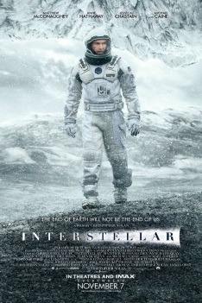  Interstellar  (2014 – cert 12)  In Earth's future, a global crop blight and second Dust Bowl are slowly rendering the planet uninhabitable. Professor Brand (Michael Caine), a brilliant NASA physicist, is working on plans to save mankind by transporting Earth's population to a new home via a wormhole. | 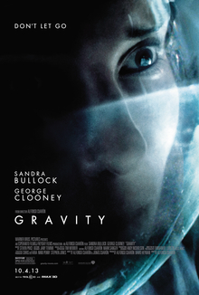  Gravity  (2013 – cert 12)  Dr Ryan Stone, an engineer, and Matt Kowalski, an astronaut, are on a space mission together. However, when they are hit by high-speed space debris, they must find a way to return to Earth.
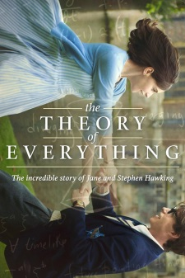  The Theory of Everything  (2014 – Cert 12)  Stephen Hawking, an excellent astrophysics student working on his research, learns that he suffers from motor neurone disease and has around two years to live. | Copenhagen  (2002 – Cert PG)  In 1941, physicists Niels Bohr (Stephen Rea) and Werner Heisenberg (Daniel Craig) meet to discuss atomic energy and the Nazis. | Infinity  (1996 – Cert PG)  Richard Feynman is a talented young physics student at the Massachusetts Institute of Technology when he meets Arline Greenbaum. But when Feynman is hired by the government to work on the creation of the atomic bomb, his faith in science is thrown into doubt.
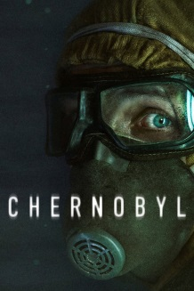
Chernobyl
(2019 miniseries)
In April 1986, the city of Chernobyl in the Soviet Union suffers one of the worst nuclear disasters in the history of mankind. Consequently, many heroes put their lives on the line to save Europe. This critically acclaimed series features detailed and fully accurate science presented in the terrifying context in which it was used to make life and death decisions.

Explore

Simulations & Games
Chronozoom – This is a zoomable timeline of the universe, full of fascinating information and historical sequences. Amazing for giving a “big picture” view on the timescales of the universe, the earth, life and human history. http://www.chronozoom.com
100,000 Stars – A breathtaking, zoomable model of the solar system, local stars and our galaxy which you can use to explore and just play with. https://stars.chromeexperiments.com/
Universe Sandbox – Available on PC and Mac, this game is essentially a planet-sized physics simulator, you can investigate models of solar systems, galaxies and clusters, but also invent your own situations and “crash test” with gravity. http://universesandbox.com/
Celestia – Also free, software for exploring 3D models and simulations of the universe. https://celestia.space/index.html
PHET – This is the world’s best collection of online Physics simulations which allow you to perform virtual experiments and explore different ideas in Physics. https://phet.colorado.edu/
Stellarium – this is a simulated, zoomable “sky-at-night” which allows you to view any part of space in the highest detail possible from millions of carefully stitched together photographs – like Google Earth for the night sky. - https://stellarium-web.org/
Institute of Physics - The IoP has produced a series of games featuring real physics to solve simulated problems. SimEnergy puts you in control of your home’s energy bills and you need to balance costs and savings to get through the winter. SimSpace pits you against the dangers of Near Earth Objects which could be on a collision course with Earth. http://www.iop.org/education/teacher/resources/sim/page_41572.html

Problems & Puzzles
IsaacPhysics – This fantastic resource (which we use at A-level) is full of mathematical physics problems which develop your skills in maths but also your reasoning and logic. https://isaacphysics.org/
Learn AP Physics – an American site, this has a “problem of the day” which covers a wide range of topics. https://www.learnapphysics.com/problem.php

Using Physics in the World
Each of these tasks provide links to some videos or pages, and then a few questions to think about.

Medicine

Radiation Therapy
Watch these videos about radiation therapy:
https://www.youtube.com/watch?v=qM6uxOaylaM – introduction
https://www.youtube.com/watch?v=gDmfr6-ft-I – Proton therapy
- Why is Physics so important in radiation therapy?
- What GCSE Physics have you learned which is relevant in these treatments?
- Why might any medical professional working with radiation therapy need to monitor their exposure carefully?

The Electron Microscope
Watch this video about the electron microscope
https://www.youtube.com/watch?v=ljTEG-B-kGc
- What is the magnification of an optical microscope?
- Why is an electron microscope better?
- What medicines and technology have been developed with the aid of the electron microscope?

Sport

Physics of sport
https://www.ted.com/talks/nick_pizzo_the_physics_of_surfing - Physics of Surfing
https://www.youtube.com/watch?v=llRkf1fnNDM – How do bikes stay up?
https://www.youtube.com/watch?v=oZAc5t2lkvo – How do you turn a bike?
https://www.youtube.com/watch?v=m57cimnJ7fc – Free Kick Physics
https://www.youtube.com/watch?v=fcjaxC-e8oY – Golf Ball physics

Engineering

Formula 1
Watch: https://www.youtube.com/watch?v=ZFEzMKYjShc – Formula 1 downforce
https://www.youtube.com/watch?v=r5pFyBHO8Fk (Part 2)
- What is the problem with the airflow for an F1 car?
- Why does it important to get the air to flow in layers?
- What would happen without these air pressure differences?

Jet engines
Watch: https://www.youtube.com/watch?v=KjiUUJdPGX0 and then https://www.youtube.com/watch?v=4n-lC-wblj0
https://www.youtube.com/watch?v=DmMVqyfrEBw
- What needs to happen for the Jet engine to work?
- What Physics at GCSE is being used in the design of the engine?
- Why might the engine need to made out of less dense materials?

Preparing for A-level
At Waseley, we follow the OCR “A” Physics course for A-level. The specification can be found here:
https://www.ocr.org.uk/qualifications/as-and-a-level/physics-a-h156-h556-from-2015/
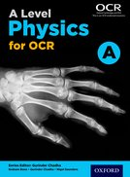
We use the Oxford A-level Physics textbook which is mapped to the course, and which you will be issued with for the two years of A-level. However, if you want to read ahead, or make notes in your own copy to keep after the course, you can buy the textbook here:
https://global.oup.com/education/product/9780198352181/?region=uk

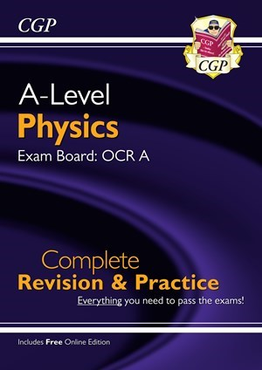
We also recommend the CGP Revision Guides and workbooks as an excellent companion to the course and to support your independent study:
https://www.cgpbooks.co.uk/secondary-books/as-and-a-level/science/physics/prar73-new-a-level-physics-ocr-a-year-1-2-com
https://www.cgpbooks.co.uk/secondary-books/as-and-a-level/science/physics?sort=best_selling&quantity=36&page=1&view=grid&currentFilter=BookType_647&filter_exam%20board=ExamBoard_511%2CExamBoard_512
CGP also produce two excellent books to support preparation for A-level Physics:
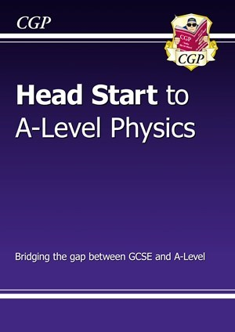
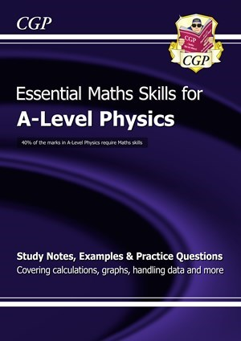

Physics Course Overview
The A-level course consists of six modules, which all contribute to the final A-level qualification. The course is for a full two-year period and cannot be dropped at the end of Year 12. All external exams are at the end of Year 13.

Year 12

Module 1 – Development of practical skills in physics
This module is taught throughout the two years, and is assessed through both the exams and the practical endorsement (see the section “Practical Endorsement” on page 11 for details). It includes:
1.1 Practical skills assessed in a written examination (Chapter 1)
1.2 Practical skills assessed in the practical endorsement
This module is assessed on all three exam papers.

Module 2 – Foundations of physics
This module is taught at the start of Y12, but is developed over the duration of the course. It includes:
2.1 Physical quantities and units (Chapter 2)
2.2 Making measurements and analysing data
2.3 Nature of quantities
This module is assessed on all three exam papers.

Module 3 – Forces and motion
This is the first module taught in Y12, between September and Christmas. It looks at the broad field of “mechanics”, including:
3.1 Motion (Chapter 3)
3.2 Forces in action (Chapter 4)
3.3 Work, energy and power (Chapter 5)
3.4 Materials (Chapter 6)
3.5 Newton’s laws of motion and momentum (Chapter 7)
This module is assessed on paper 1 “Modelling Physics” and paper 3 “Unified Physics”.

Module 4 – Electrons, waves and photons
This module is taught in Y12 between Christmas and the summer exams. It builds upon ideas of electricity and waves from GCSE, and introduces some of the fundamental ideas of quantum physics.
4.1 Charge and current (Chapter 8)
4.2 Energy, power and resistance (Chapter 9)
4.3 Electrical circuits (Chapter 10)
4.4 Waves (Chapters 11 & 12)
4.5 Quantum physics (Chapter 13)
This module is assessed on paper 2 “Exploring Physics” and paper 3 “Unified Physics”.

Year 13

Module 5 – Newtonian world and astrophysics
We usually start to teach this topic before the end of Y12, but it is not on the Y12 summer exam. Module 5 builds heavily upon module 3, but extends outwards: What happens when we apply mechanics at both atomic and astronomical scales? It includes:
5.1 Thermal physics (Chapters 14 & 15)
5.2 Circular motion (Chapter 16)
5.3 Oscillations (Chapter 17)
5.4 Gravitational fields (Chapter 18)
5.5 Astrophysics and cosmology (Chapters 19 & 20)
This module is assessed on paper 1 “Modelling Physics” and paper 3 “Unified Physics”.

Module 6 – Particles and medical physics
The final module is usually taught from December of Year 13 through to the end of the course, when revision for the A-level exams starts. This module builds on ideas from all of the previous modules, combining the field theory of Module 5 with the electronics and particles of Module 4 and the understanding of forces and energy from Module 3. It includes:
6.1 Capacitors (Chapter 21)
6.2 Electric fields (Chapter 22)
6.3 Electromagnetism (Chapter 23)
6.4 Nuclear and particle physics (Chapters 24, 25 & 26)
6.5 Medical imaging (Chapter 27)
This module is assessed on paper 2 “Exploring Physics” and paper 3 “Unified Physics”.

Resources
As a school we provide some resources free of charge and facilitate access to others at reduced rates. Key resources to help you include:
- The course handbook – written by your teachers
- Your textbook (“A-Level Physics for OCR A” from Oxford press)
- Revision guides – We don’t provide revision guides in school as with the wealth of material available on the internet combined with the depth of the textbook and other resources, they may not be necessary. However – if you are looking to get a revision guide / workbook then we recommend using those produced by CGP (see above)
- Isaac Physics – Available at www.isaacphysics.org, Isaac Physics is an online mastery learning tool focusing on developing mathematical skills and problem solving in physics. We provide copies of the accompanying “Mastering Essential Pre-University Physics” textbook to use. The website is free to use, but requires students to sign up / log in and to join classes run by the teachers.
- A-level Physics Online – Available at https://www.alevelphysicsonline.com, this is a suite of online resources and explanation videos covering the entire course and practical skills. While access to all videos is free in Year 12, there is a £20 yearly fee per student to access Year 13 resources. In recent years we have been able to negotiate a school subscription for the reduced price of £10 per student.

General notes to support you
http://hyperphysics.phy-astr.gsu.edu/hbase/hframe.html - looks quite old, but high quality notes on almost all A-level Physics topics.

Preparation tasks
Find out as much as you can about the following:
- How big is the uncertainty when making a measurement with a standard meter ruler? What might be a better instrument to measure small distances?
- What is the coldest temperature possible? Why can’t you go colder?
- Why does our GPS satellite network rely on Einstein’s theory of relativity?
- What is a quark? How do we know they exist?
- What is the Schwarzschild radius?
- What does Schrodinger’s cat demonstrate?
- What is the “three body problem”?
- What is the Drake equation?
- What did Einstein do in 1905?
- Why is proton beam therapy an improvement on traditional radiation therapy?

