2 Week Independent Learning plan Week 13 & 14
Support contact details:
Email general queries to: nbaker@waseleyhills.worcs.sch.uk
Teachers email addresses in this subject area:

Subject Leader Miss K Bond email: Kbond@waseleyhills.worcs.sch.uk

Subject teacher emails:
Mrs K Bradley email: kjbradley@waseleyhills.worcs.sch.uk

Monday 6th to 15th July
Subject: RPE
Year: 8
Topic/theme: Buddhism

Three stages to online learning
Stage One – Reading Task | Stage Two – Completing Tasks | Stage Three – Assessing your learning and feedback
Read the lessons in the table below. Think about what you need to learn from the task. It may help to look at the other lessons too as this will show you where your learning is heading. | Find the resources you need. In some instances you may need to log into HomeAccess+ and find the file on the coursework drive (S). Login with your normal school username and password. Use the resource as described to complete the suggested task. Reflect on the teacher’s question.  Click here for HomeAccess+ drive  Click here for help with accessing HomeAccess+ | At the end of the two weeks you will be set a task by your teacher on Show My Homework. This is submitted in SMHWK. This task will assess your learning and allow us to give you feedback.  These assessment tasks are optional but submitting them is very helpful for you and your teacher to understand what you have learnt.

We are here to help you within school opening hours:
Email your teacher | Join your teacher for a support chat session | Ring school reception
You can now email your teacher using your Office 365 email address. You can also email Mr Baker or the Subject Leader using the contact info above (top right). | You will also receive an invite during the two week period to join an online support chat with your teacher. | Call 0121 4535211 within school hours. They will email your teacher and ask them to contact you.

Learning tasks for this fortnight:
Lesson | Aim:  What you need to take from this lesson | Resource(s) to use:  Hyperlinks to videos etc  HomeAccess+ file location | Suggested task:
1 | In this lesson you will learn…  What are the Three Poisons?  How Buddhists believe they can overcome suffering. | Description of resource:  https://www.bbc.co.uk/bitesize/guides/zr3sv9q/revision/2  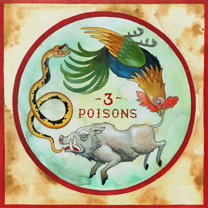 | Description of what you need to do (step by step):  - Using the link provided, read through the information on the 3 Poisons (halfway down the page).  - On a piece of paper, draw and label the 3 poisons. Why do you think these animals are used to represent the 3 Poisons?  - Give an example of suffering that is caused by greed, hatred, and ignorance. Try to consider recent world events (or past events).  - Do you agree with Buddhist teachings that all suffering is caused by greed, hatred, and ignorance? Give a reason to support your answer.  - Why might someone disagree with you? Try to give an alternative point of view.  A question your teacher would have asked you at the end of this lesson is:  Should we all aim to be less greedy, hateful, and ignorant? How might this make the world a better place?
2 | In this lesson you will learn…  What is the Eightfold Path?  How these Buddhist teachings help a Buddhist overcome suffering. | https://www.bbc.co.uk/bitesize/guides/zfnqmsg/revision/6  http://www.bbc.co.uk/schools/religion/worksheets/pdf/buddhism_nirvana_eightfold.pdf worksheet  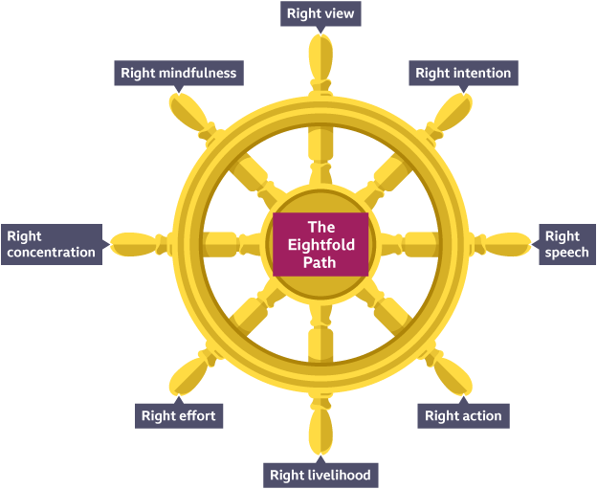 | Description of what you need to do (step by step):  - Read about the Eightfold Path from the BBC webpage. The Eightfold Path are teachings of the Buddha which Buddhists believe can help them overcome suffering.  - The Eightfold Path is often shown on the Buddhist Wheel. You may want to draw and label this.  - Complete the worksheet (link provided). For each of the 8 teachings, give a specific example of how it can be followed.  - Which teaching do you think would be the easiest/most difficult to follow?  A question your teacher would have asked you at the end of this lesson is:  How might these teachings help a Buddhist be free from suffering (do not forget, a Buddhist cannot remove suffering as it’s unavoidable, it’s simply how they deal with the feeling of suffering)?
3 | In this lesson you will learn…  Seven Wonders of the Buddhist World | https://www.youtube.com/watch?v=-WDG2DELq00  In this fascinating documentary, historian Bettany Hughes travels to the seven wonders of the Buddhist world and offers a unique insight into one of the most ancient belief systems still practised today. | Description of what you need to do (step by step):  - Watch the BBC documentary on YouTube. You do not need to watch the whole programme, although you can if you wish!  - Draw or copy a map of Asia. You could label some of the areas discussed on the documentary with the type of Buddhism practised there. You could also add some key events in the life of the Buddha to your map.  A question your teacher would have asked you at the end of this lesson is:  Why do you think followers of Buddhism are increasing? What is it about this belief system that attracts so many followers?
4 | In this lesson you will learn…  Consolidation of Buddhist terms/key beliefs | https://www.bbc.co.uk/bitesize/guides/zfnqmsg/revision/6 Scroll to the bottom to the Glossary.  https://www.bbc.co.uk/bitesize/guides/zfnqmsg/video  https://www.bbc.co.uk/bitesize/guides/zfnqmsg/test | Description of what you need to do (step by step):  - Using the glossary, create a ‘Buddhist Key Word’ page. You can set this out however you wish but try to be creative; add colour and images too.  - Test yourself – how many definitions can you remember? You could also get an adult to test you.
5 | In this lesson you will learn…  Consolidation of Buddhist terms/key beliefs | https://www.bbc.co.uk/bitesize/guides/zfnqmsg/revision/6 Scroll to the bottom to the Glossary.  https://www.bbc.co.uk/bitesize/guides/zfnqmsg/video  https://www.bbc.co.uk/bitesize/guides/zfnqmsg/test | Description of what you need to do (step by step):  - At the bottom of the page, click ‘move on to video’. Watch the video. What did you learn? What surprised you? How would you describe the life of a Buddhist?  - Now attempt the test.  A question your teacher would have asked you at the end of this lesson is:  What have you found interesting about Buddhism?  What have you enjoyed? What would you like to find out more about?
How will we assess you learning?
Years 7 and 8: Pupils will be set an interactive quiz using this information on Show My Homework or asked to submit a piece of work such as a photograph of art work.
Year 9 to 11: Pupils may be set an interactive quiz or a written task via Show My Homework.

Need help?
HomeAccess+ https://facility.waseley.networcs.net/HAP/login.aspx?ReturnUrl=%2fhap (use your normal school username and password).
Pupil and parent help page: https://www.waseleyhills.worcs.sch.uk/coronavirus-independent-learning/help-for-parents-and-pupils

Fancy showing your best work off?
You can email a photo of you doing something great, or an example of your best piece of work to your Head of Year for our celebrations assemblies when we return.
Yr 7 please email Mrs Williams at jewilliams@waseleyhills.worcs.sch.uk
Yr 8 please email Mrs Bridgeman at jbridgeman@waseleyhills.worcs.sch.uk
Yr 9 please email Mrs Bradley at kjbradley@waseleyhills.worcs.sch.uk
Yr 10 please email Mr Jones at djones@waseleyhills.worcs.sch.uk

Please keep your work organised in subjects as we are excited to see what you have achieved and reward you for it when we return.

