Covid Testing in School - Risk Assessment

Why is this document needed: Public Health England and the Health and Safety Executive require this documentation to ensure end to end health, safety and infection control risks for mass lateral flow testing are identified, pre-assessed, managed and monitored regularly by the site owners and testing operators

Assessment Date | 04/01/2021 | Lead Assessor |  | Seema Purewal | Contract |  |  |  | Assessment Number |  | One
Activity / Task
Description of task / process / environment being assessed | General and clinical activities on the asymptomatic testing site at Waseley Hills High School
Activities Involved | Traversing the site on foot  Testing school staff and students |  |  |  |  |  |  |  | Location |  | School Drama Studio
Who Might be affected | Employee  ✔ |  | Client  ✔ |  |  | Contractor  ✔ |  | Visitor  ✔ |  | Service User  ✔

Hazard Identification and evaluation
No | Hazards | Associated risks | Current Control/ Mitigation Measures | Risk Evaluation (post measures) |  |  | Additional control needed?  Action No
 |  |  |  | Probability | Severity | Risk
1 | Contact between subjects increasing the risk of transmission of COVID19 | Transmission of the virus leading to ill health or potential death | - Asymptomatic: All subjects are to be advised in advance not to attend if they have any symptoms of COVID 19, or live with someone who is showing symptoms of COVID 19 (including a fever and/or new persistent cough) or if they have returned within 14 days from a part of the world affected by the virus or have been in close contact with someone who is displaying symptoms.  - Face masks: Prominent signage reminding attending subjects of the above to be displayed at the entrance to the building.  - Face coverings/masks to be worn by subjects at all times whilst on the premises except for brief lowering at time of swabbing.  - Requirement to wear face covering/mask to be reminded to all subjects in advance at time of test booking.  - Compliance with wearing of face covering/mask of all subjects to be visually checked on arrival by reception / security staff.  - Compliance with wearing of face covering/mask of all subjects to be visually checked through building by queue managers and all other staff.  - Hand hygiene: All subjects to use hand sanitiser provided on arrival & adherence to this enforced by reception staff.  - Social distancing: Two metre social distancing to be maintained between subjects with measured floor markings in place to ensure compliance in addition to verbal reminders if necessary from reception, queue management & sampling staff.  - A one-way flow of subjects through the building is to be initiated and maintained at all times. Compliance with this is to be ensured by queue management staff.  - Cleaning: Regular cleaning of the site including wipe down of all potential touchpoints in accordance with PHE guidance.  - Limited clutter-chairs only on request; no physical handing of documents to subjects except barcodes.  - Good ventilation in testing centre at all times. | 1 | 4 | 4 | No
2 | Contact between subjects and registration staff increasing the risk of transmission of COVID19 :  Welcome & registration | Transmission of the virus from close contact leading to ill health or potential death | - Pupil registration to be completed prior to arrival, in order to reduce contact time between registration personnel and subject. Teachers have the option of self- registering beforehand.  - All subjects to line up 2m apart in distance in queue outside the testing room  - Subjects not to enter testing area if showing symptoms – checked by registrar.  - Personnel in registering role to wear full PPE..  - All subjects sanitise hands on arrival using hand sanitiser  - All subjects to wear a face mask on arrival.  - All subjects to stand in dedicated area away from the registration desk.  - Swab and bar code handed to subject in a plastic container to avoid touching and possible contamination. | 1 | 1 | 4 | No
3 | Contact between subjects and test assistant increasing the transmission of COVID19:  Sample taking | Transmission of the virus from close contact leading to ill health or potential death | - Test assistant wears full PPE  - Test assistant to direct/assist subjects from a reasonable distance, avoiding any direct touch with subjects.  - Appropriate waste disposal bins provided to dispose of tissues used prior to swabbing  - Hand sanitiser prior to swabbing  - Touch points - Test surfaces, mirror and chair if used, wiped down with disinfectant wipes after each swabbing, ready for the next subject.  - Subjects to leave the testing centre following the one-way signage marked on the floor, keeping to the required distance as specified by guidelines. | 1 | 1 | 4 | No
4 | Contact between subjects, samples and processors increasing the transmission of COVID19:  Sample processing and analysing. | Transmission of the virus leading to ill health or potential death | - Subject to drop swap directly into testing tube, rather than hand to processor, avoiding direct touching.  - Processors to wear full PPE at all times.  - Processors to wear gloves at all times and change gloves after each sample being processed.  - Used swabs disposed of in open top healthcare waste bin  - Test kits placed in plastic tubs to avoid risk of contamination of sample.  - Thorough cleaning of all equipment after each test is processed, using disinfectant spray and wipes. | 1 | 1 | 4 | No
5 | Contact between processors and recorders increasing the transmission of COVID19:  Sample recording. | Transmission of the virus leading to ill health or potential death | - Samples to be carried to recorders in plastic tray  - Sample recorders to wear full PPE at all times.  - Used samples to be disposed of in surgical waste bags/bins, to be disposed of accurately. | 1 | 1 | 4 | No
6 | Contact between samples and processors and recorders increasing the transmission of COVID19: Sample disposal and waste disposal | Transmission of the virus leading to ill health or potential death | - All clinical waste disposed of accurately in the correct bins and removed from site by appropriate service. | 1 | 1 | 4 | No
7 | Incorrect result communication | Wrong samples or miscoding of results | - 2 identical barcodes are provided to subject at check in  - The subject registers their details to a unique ID barcode before conducting the test  - Barcodes are attached by trained staff at the sample collection bay  Barcodes are checked for congruence at the analysis station 1 and applied to Lateral Flow Device at this station | 1 | 1 | 4 | No
8 | Damaged barcode, lost LFD, failed scan of barcode | Orphaned record on registration portal & No result communicated to individual | - Rule based recall of subjects who have not received a result within x hrs of registration  - Subjects are called for a retest | 1 | 1 | 4 | No
9 | Extraction solution which comes with the lab test kit contains the following components:  NA₂HPO₄ (disodium hydrogen phosphate), NaH₂PO₄ (sodium phosphate monobasic), NaCl (Sodium Chloride) | These components do not have any hazard labels associated with them, and the manufacturer states that there are no hazards anticipated under conditions of use as described in other product literature. This is the case for exposure to: eye, skin, inhalation, ingestion, chronic toxicity, reproductive and developmental toxicity, carcinogenicity, and medical conditions aggravated by exposure. | - PPE: nitrile gloves which meet the Regulation (EU) 2016/425 to be used at all times when handling the extraction solution. Safety glasses with side shields which are tested and approved under appropriate government standards to be worn at all times when handling the extraction solution. Impervious clothing to be worn to protect the body from splashes or spillages.  - Environmental: do not let product enter drains  - Spillages: wipe surfaces which the solution has been spilt on and dispose of cleaning material in line with the lab's waste disposal procedures.  - Do not use if the solution has expired  - Training to be provided in handling potentially biohazardous samples, chemicals and good lab practice. Adhere to guidelines in these training procedures to prevent improper handling.  - Follow procedures on the MSDS form provided by Innova to mitigate against inhalation, skin contact or ingestion of these chemicals. | 1 | 1 | 4 | No
10 | Occupational illness or injury | Staff exhibiting /feeling effects that may indicate COVID 19 is present | - Full staff training and information provided  - Staff to isolate and remove themselves from the test centre immediately and get a PCR test if displaying symptoms | 1 | 1 | 4 | No
11 | Manual handling | Injury caused by incorrect manual handling techniques. Attempting to lift beyond capacity. | - All materials are divided in to small light weight packages  - All relevant training regarding handling of equipment/packages provided. | 1 | 1 | 4 | No
12 | Unauthorised access by members of the public | Members of the public unfamiliar with the environment. | - Only authorised access permitted to the Drama Studio (including cleaners)  - Reception and registration area manned at all times  - Drama Studio locked when not in use. | 1 | 1 | 4 | No
13 | Uneven surfaces (floor protection in the Testing and Welfare areas) | Trip hazards | - All areas kept clear of unnecessary items.  - Traffic areas kept clear and marked appropriately.  - Drama studio has been checked for uneven surfaces and other trip hazards | 1 | 1 | 4 | No
14 | Electrical safety / plant & equipment maintenance  Defective electrical equipment | Failure of equipment due to poor maintenance.  Electric shock from faulty equipment | - All electrical equipment has an in-date PAT certificate/test label. | 1 | 1 | 4 | No
15 | Use of shared equipment | Cross contamination of equipment increasing the possibility of COVID transference. | - Laptop keyboards and screen wiped down after each session use, and in between change in operatives.  - All other shared testing equipment is wiped down after change in operatives. | 1 | 1 | 4 | No
16 | Test subjects unfamiliar with surroundings | Test subjects crossing into sterile areas | - Individual guidance to be provided from test station staff.  - Floor signage to provide direction, | 1 | 1 | 4 | No
17 | Lack of staff welfare facilities | No separate area for staff to get changed into PPE, have a break consume food/drink | - Separate room provided for staff to change into PPE.  - Nearby separate staff toilet facilities.  - Regular staff breaks scheduled into testing sessions. | 1 | 1 | 4 | No
18 | Fire Alarm activation | Persons unfamiliar with actions in the event of a fire. | - Staff briefing on ‘Actions in event of fire’ provided. | 1 | 1 | 4 | No

Control Improvements
Action No | Recommended additional control measures | Responsibility | Target Date | Date completed
1 | Content of the risk assessment to be communicated with all workers as part of induction | Covid Coordinator | W/K Beg 4th Jan 21 | w/k Beg 4th Jan 21
2 | Toolbox talks to be delivered to all workers on a regular basis including slips trips falls and complacency | Covid Coordinator

Additional Notes
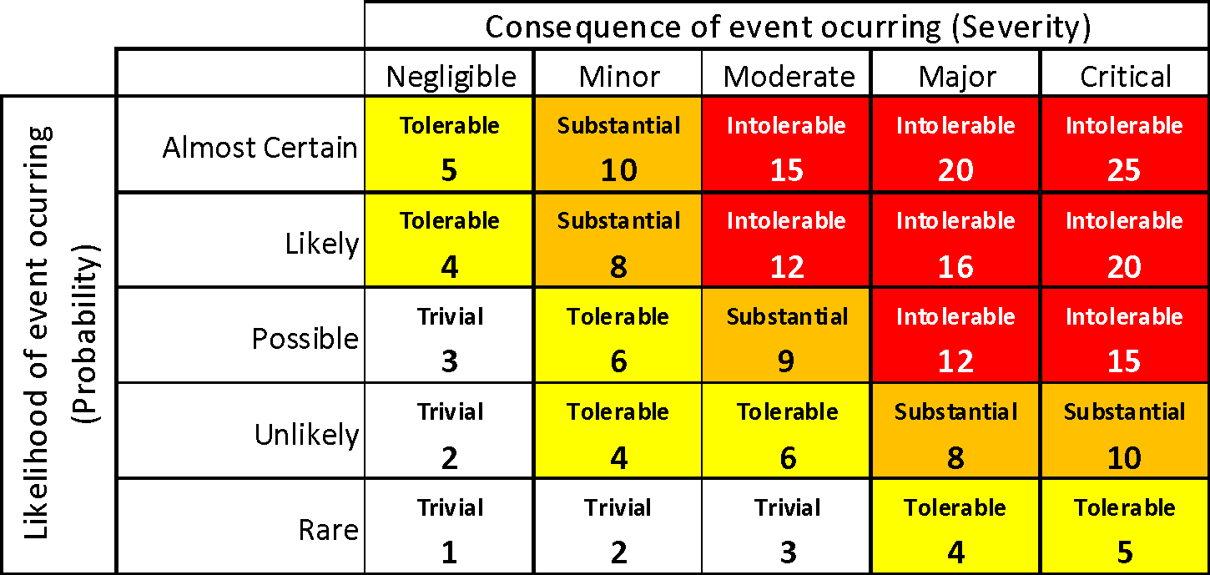
Risk Evaluation
Severity
Negligible
Minor
Moderate
Major
Critical

Risk control strategies

Intolerable – stop activity, take immediate action to reduce the risk
Substantial - Take action within an agreed period
Tolerable – monitor the situation
Trivial – No action required

Likelihood
Rare, will probably never happen/recur
Unlikely, do not expect it to happen, but is possible
Possible, Might happen
Likely, will probably happen
Almost Certain, will undoubtedly happen

Declaration - If the above control measures are implemented the risks posed by the task / process / environment assessed will be controlled to as low as is reasonably practicable.
Persons involved in assessment
Signature of Lead Assessor |  | Date

Reviews – this assessment should be reviewed at intervals no greater than 12 months or when there are changes in operational procedure, personnel, the work environment or following an incident
Review date | Comments | Reviewed by | Signature |  | Review date | Comments | Reviewed by | Signature

Health and Safety Risk Assessment Sign off Sheet | Assessment Number

Declaration by employees involved in the activity detailed above – I fully understand the activity outlined above and the risk control measures that I must implement, use or wear. I have received sufficient information, instruction and training so as to enable me to conduct this activity with the minimum of risk to myself and others.

Employee Name | Signature | Supervisors Name | Date | Employee Name | Signature | Supervisors Name | Date

