SEN Policy

Recommended by: Principal / Damian Belshaw

Recommendation Date: 30 September 2022

Ratified by: LAGB

Signed: T. Forty

Position on the Board: Acting Chair of LAGB

Ratification Date: 5 October 2022

Next Review: September 2023

Policy Tier (Central/Hub/School): School / WHHS

Contents
1. Aims 2
2. Legislation and guidance 3
3. Definitions 3
4. Roles and responsibilities 4
5. SEN information report 5
6. Monitoring arrangements 11
7. Links with other policies and documents 12

…………………………………………………………………………………………………………………………….

Aims
1. Mission and Inclusion Statements
1.1. The School’s Mission Statement is published in the Prospectus and on the website. In essence our vision is to enable each student regardless of ability or background to achieve:

“Aspire, Invest, Respect”.

The learning support department along with the teaching and support staff promote the SEND motto/slogan of:

‘Every student matters, every moment counts’

1.2. The school is committed to providing an inclusive education and environment for all students. We aim to achieve this by
- setting suitable learning objectives for each student
- responding to students’ diverse learning needs
- overcoming barriers to learning and
- developing a whole school ethos on accepting difference.

1.3 We recognise that inclusion is a whole school responsibility, and that effective inclusion requires attitudes, policies and practices, which enable all students to participate as fully as possible.
The Code of Practice says that every teacher is a teacher of SEN. It says that 'class and subject teachers, supported by the senior leadership team, should make regular assessments of progress for all pupils'.

The SEND department philosophy is one of ‘no limits’ and to make the reasonable adjustments to be inclusive.

2. Legislation and guidance
COMPLIANCE This policy complies with the statutory requirement laid out in the SEND Code of Practice 0 – 25 (January 2015) and has been written with reference to the following guidance and documents:
➢ Equality Act 2010: advice for schools DfE Feb 2013 – including students with Disabilities
➢ Children and Families Act (2014) – Part 3; Schools SEN Information Report (2014) - Regulation 51, Part 3, section 69(3)(a) of the Act
➢ Supporting Students at school with medical conditions (August 2017) ➢ Mental Capacity Act Code of Practice: Protecting the Vulnerable (2005)
➢ Working Together to Safeguard Children (July 2018)
➢ The Worcestershire SEND Local Offer which includes the Graduated Approach response / and the Worcestershire SEND Action Plan (October 2018) & the Worcestershire SEND Improvement Boards Updated Plan (17th October 2019)
➢ Ofsted Framework (May 2019 – updated September 2019): https://www.gov.uk/government/publications/education-inspection-
This policy and information report is based on the statutory Special Educational Needs and Disability (SEND) Code of Practice and the following legislation:
- Part 3 of the Children and Families Act 2014, which sets out schools’ responsibilities for pupils with SEN and disabilities
- The Special Educational Needs and Disability Regulations 2014, which set out schools’ responsibilities for education, health and care (EHC) plans, SEN co-ordinators (SENCOs) and the SEN information report

3. Definitions
A pupil has SEN if they have a learning difficulty or disability which calls for special educational provision to be made for them.
They have a learning difficulty or disability if they have:
- A significantly greater difficulty in learning than the majority of others of the same age, or
- A disability which prevents or hinders them from making use of facilities of a kind generally provided for others of the same age in mainstream schools
Special educational provision is educational or training provision that is additional to, or different from, that made generally for other children or young people of the same age by mainstream schools.
A child of compulsory school age or a young person has a learning difficulty or disability if they: (a) Have a significantly greater difficulty in learning than the majority of others of the same age; or (b) Have a disability which prevents or hinders them from making use of educational facilities of a kind generally provided for others of the same age in mainstream schools or mainstream post-16 institutions.
Disabled children and young people - Definition of disability A child is disabled if he is blind, deaf, or dumb or suffers from a mental disorder of any kind or is substantially and permanently handicapped by illness, injury or congenital deformity or such other disability as may be prescribed. Section 17 (11) Children Act 1989. A person has a disability for the purposes of this Act if they have a physical or mental impairment which has a long term ‘year or more’ and substantial ‘more than minor or trivial’ adverse effect on their ability to carry out normal day-to-day activities (Section 6), Equality Act 2010; Code of Practice 2015. This definition includes sensory impairments such as those affecting sight or hearing, and long-term health conditions such as asthma, diabetes, epilepsy, and cancer. Children and young people with such conditions do not necessarily have SEN, but there is a significant overlap between disabled children and young people and those with SEN. Where a child or young person with a disability requires special educational provision, they will also be covered by the SEN definition.
Supporting Students at School with Medical Conditions (Section 100 of the Children and Families Act – 2014) https://www.gov.uk/government/publications/supporting-students-at-school-with-medical-conditions--3 See associated Policy
Students at school with medical conditions will be properly supported so that they have full access to education, including school trips and physical education. School leaders and any staff leading trips will consult health and social care professionals, students, and parents/carers to ensure that the needs of children with medical conditions are effectively supported.
Whole school statutory training on asthma, diabetic EpiPen use, and epilepsy will take place. - In addition to the educational impacts, there are social and emotional implications associated with medical conditions. Students may be self-conscious about their condition, and some may be bullied or develop emotional disorders such as anxiety or depression around their medical condition. Long-term absences due to health problems affect children’s educational attainment, impact on their ability to integrate with their peers and affect their general wellbeing and emotional health.
Reintegration back into school will be properly supported so that children with medical conditions fully engage with learning and do not fall behind when they are unable to attend. Short-term and frequent absences, including those for appointments connected with a student’s medical condition (which can often be lengthy), will be effectively managed and appropriate support put in place to limit the impact on the child’s educational attainment and emotional and general wellbeing. - For students who have medical conditions that require Education and Health Care plans (EHCP), compliance with the SEND Code of Practice (2015) will ensure compliance with all the statutory elements of care.

4. Roles and responsibilities
“High quality teaching that is differentiated and personalised will meet the individual needs of the majority of children and young people. Some children and young people need educational provision that is additional to or different from this. This is special educational provision under Section 21 of the Children and Families Act 2014.
Schools … must use their best endeavors to ensure that such provision is made for those who need it. Special educational provision is underpinned by high quality teaching and is compromised by anything less” (Code of Practice – January 2015)
“All teachers are teachers of pupils with special educational needs. Teaching such students is therefore a whole school responsibility, requiring a whole school response” (DfES - 2001 / Ofsted 2014)
“Leaders take on or construct a curriculum that is ambitious and designed to give all learners, particularly the most disadvantaged and those with special educational needs and/or disabilities (SEND) or high needs, the knowledge and cultural capital they need to succeed in life” (Ofsted May/Sept 2019 Ref: 313 > 317)
Jim Arnold is the school SENCO. His responsibilities are set out below.
Sue Maguire - Manager of the Autism Base. Her responsibilities are set out in the MAB policy.
James Nelson is the Teacher with responsibility for Gifted and Talented Students. His responsibilities are set out in his job description as Assistant Head teacher.
Emma Dodds is the Designated Teacher for Looked After Students. His responsibilities are set out in his job description as Deputy Head teacher.
Andy Boot is the Deputy Head Teacher with overall pastoral responsibility for all years.
Simon Mitchell is the Head of Sixth Form Studies combining achievement with Sixth Form pastoral care.

4.1 The SENCO
The SENCO will:
- Work with the headteacher and SEN governor to determine the strategic development of the SEN policy and provision in the school
- Have day-to-day responsibility for the operation of this SEN policy and the co-ordination of specific provision made to support individual pupils with SEN, including those who have EHC plans
- Provide professional guidance to colleagues and work with staff, parents, and other agencies to ensure that pupils with SEN receive appropriate support and high-quality teaching
- Advise on the graduated approach to providing SEN support
- Advise on the deployment of the school’s delegated budget and other resources to meet pupils’ needs effectively
- Be the point of contact for external agencies, especially the local authority and its support services
- Liaise with potential next providers of education to ensure pupils and their parents are informed about options and a smooth transition is planned
- Work with the headteacher and governing board to ensure that the school meets its responsibilities under the Equality Act 2010 with regard to reasonable adjustments and access arrangements
- Ensure the school keeps the records of all pupils with SEN up to date
4.2 The SEN governor
The SEN governor will:
- Help to raise awareness of SEN issues at governing board meetings
- Monitor the quality and effectiveness of SEN and disability provision within the school and update the governing board on this
- Work with the headteacher and SENCO to determine the strategic development of the SEN policy and provision in the school
4.3 The Principal
The Principal will:
- Work with the SENCO and SEN governor to determine the strategic development of the SEN policy and provision in the school
- Have overall responsibility for the provision and progress of learners with SEN and/or a disability
4.4 Class teachers
Each class teacher is responsible for:
- The progress and development of every pupil in their class
- Working closely with any teaching assistants or specialist staff to plan and assess the impact of support and interventions and how they can be linked to classroom teaching
- Working with the SENCO to review each pupil’s progress and development and decide on any changes to provision
- Ensuring they follow this SEN policy

5. SEN information report
5.1 The kinds of SEN that are provided for
Our school currently provides additional and/or different provision for a range of needs, including:
- Communication and interaction, for example, autistic spectrum disorder, Asperger’s Syndrome, speech and language difficulties
- Cognition and learning, for example, dyslexia, dyspraxia,
- Social, emotional, and mental health difficulties, for example, attention deficit hyperactivity disorder (ADHD),
- Sensory and/or physical needs, for example, visual impairments, hearing impairments, processing difficulties, epilepsy
SEND statistics for Waseley Hills High School
The students identified as SEND will follow the graduated response.
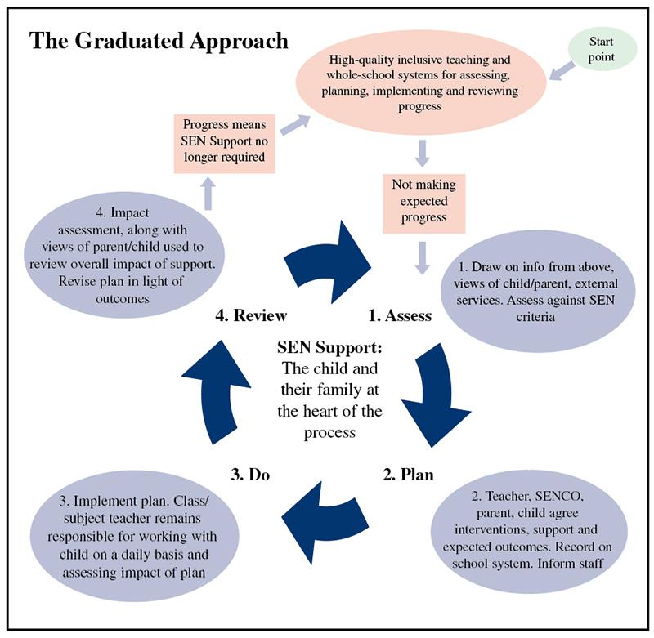

5.2 Identifying pupils with SEN and assessing their needs
We will assess each pupil’s current skills and levels of attainment on entry, which will build on previous settings and Key Stages, where appropriate. Class teachers will make regular assessments of progress for all pupils and identify those whose progress:
- Is significantly slower than that of their peers starting from the same baseline
- Fails to match or better the child’s previous rate of progress
- Fails to close the attainment gap between the child and their peers
- Widens the attainment gap
This may include progress in areas other than attainment, for example, social needs.
Slow progress and low attainment will not automatically mean a pupil is recorded as having SEN.
When deciding whether special educational provision is required, we will start with the desired outcomes, including the expected progress and attainment, and the views and the wishes of the pupil and their parents. We will use this to determine the support that is needed and whether we can provide it by adapting our core offer, or whether something different or additional is needed.
The school’s systems for regularly observing, assessing, and recording the progress of all students are used to identify students who are not progressing satisfactorily and who may have additional needs. Baseline and standardised testing are also used. The Graduated Approach Response is followed when addressing any gap in a key assessment cycle.
• The school’s system / student linked documents include reference to information provided by:
- Baseline assessment results (Key Assessment KA2, KA3 & KA4/5)
- Progress measured against the new proposed “aspects of engagement” (replacing P standards)
- Standardised screening and assessment tools: NGRT (New Group Reading Test), Star / Accelerated Reader
- Observations of achievement, behavioural, emotional, and social development
- An existing Education, Health and Social Care Plan (EHCP)
- Assessments by a specialist service, such as SEND Supported, Educational Psychology, Complex Communication Team, the Umbrella Pathway, SALT and CAMHS who are paramount in identifying additional needs.
- Psychometric assessments by Jim Arnold- SENCo; PAPPA/Masters in SEN are applied here in line with JCQ Regulations 2020/2021
- For identified SEND students, part of the Key worker/Level 3 role is to identify additional needs and pass this on to subject teachers via provision mapping/pupil profiles.
5.3 Consulting and involving pupils and parents
We will have an early discussion with the pupil and their parents when identifying whether they need special educational provision. These conversations will make sure that:
- Everyone develops a good understanding of the pupil’s areas of strength and difficulty
- We consider the parents’ concerns
- Everyone understands the agreed outcomes sought for the child
- Everyone is clear on what the next steps are
Notes of these early discussions will be added to the pupil’s record and given to their parents.
We will formally notify parents when it is decided that a pupil will receive SEN support.
5.4 Assessing and reviewing pupils' progress towards outcomes
We will follow the graduated approach and the four-part cycle of assess, plan, do, review.
The class or subject teacher will work with the SENCO to carry out a clear analysis of the pupil’s needs. This will draw on:
- The teacher’s assessment and experience of the pupil
- Their previous progress and attainment and behaviour
- Other teachers’ assessments, where relevant
- The individual’s development in comparison to their peers and national data
- The views and experience of parents
- The pupil’s own views
- Advice from external support services, if relevant
The assessment will be reviewed regularly.

All teachers and support staff who work with the pupil will be made aware of their needs, the outcomes sought, the support provided, and any teaching strategies or approaches that are required. We will regularly review the effectiveness of the support and interventions and their impact on the pupil’s progress.

5.5 Supporting pupils moving between phases and preparing for adulthood
We will share information with the school, college, or other setting the pupil is moving to. We will agree with parents and pupils which information will be shared as part of this.
5.6 Our approach to teaching pupils with SEN
Teachers are responsible and accountable for the progress and development of all the pupils in their class.
High quality teaching is our first step in responding to pupils who have SEN. This will be differentiated for individual pupils.
5.7 Adaptations to the curriculum and learning environment
The Waves of Intervention Model
The 'Waves of Intervention' model (national Strategies) describes how different levels of intervention can be understood and systematically implemented.
Wave 1 (Universal): describes quality inclusive teaching which takes into account the learning needs of all the children in the classroom. This includes providing differentiated work and creating an inclusive learning environment.
Wave 2 (Targeted): describes specific, additional, and time-limited interventions provided for some children who need help to accelerate their progress to enable them to work at or above age-related expectations. Wave 2 interventions are often targeted at a group of pupils with similar needs.
Wave 3 (Specialist): describes targeted provision for a minority of children where it is necessary to provide highly tailored intervention to accelerate progress or enable children to achieve their potential. This may include specialist interventions.

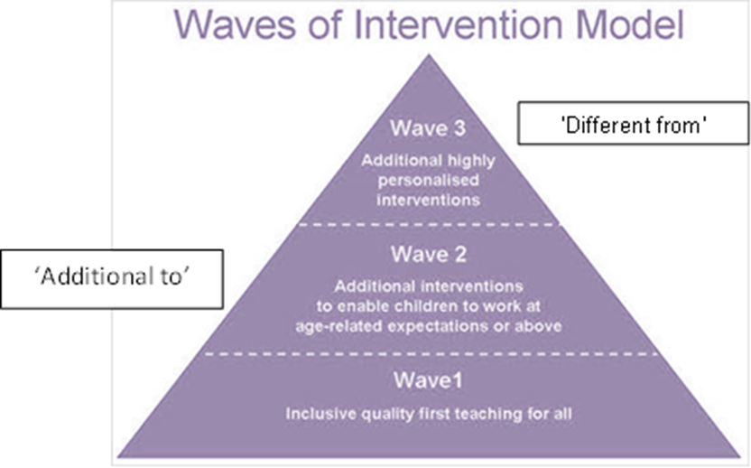
We make the following adaptations to ensure all pupils’ needs are met:
- Differentiating our curriculum to ensure all pupils can access it, for example, by grouping, 1:1 work, teaching style, content of the lesson, etc.
- Adapting our resources and staffing
- Using recommended aids, such as laptops, coloured overlays, visual timetables, larger font, etc.
- Differentiating our teaching, for example, giving longer processing times, pre-teaching of key vocabulary, reading instructions aloud, etc.
5.8 Additional support for learning
We have teaching assistants who have specific responsibilities across the curriculum. The main areas are:
- Numeracy
- Literacy
- Inclusion
Teaching assistants will support pupils on a 1:1 basis when necessary
Teaching assistants will support pupils in small groups within class and during intervention sessions.
The school has a mainstream autism base.
Autism Base Policy
The specialist provision of a mainstream autism base (the “Base”) opened at Waseley Hills High School in September 2004. The Base is in the Jubilee block and was upgraded in 2011. It is an integral part of the Student Support Centre. The Base has a study/teaching area, separate chill out room, individual workstations, kitchen and computers.
The Base provision is for up to eight students (with the possibility of 10 in exceptional circumstances). All students have an EHCP and are admitted with the County Autism Bases Admission Policy. The Base provides an environment designed to meet the needs of students with Autism. The senior TA has the responsibility for the routine management and daily running, with the SENCO overseeing the provision. The Senior TA is supported by several Base TA’s, who have or are expected to gain training and experience in working with students on the Autistic spectrum.

The Base runs in accordance with:
- All other school policies, in particular the main SEND Policy.
- The County Children’s Services’ Directorate Policy for Children with Autism Spectrum Conditions.
- The County Base Protocol.

Objectives of the Base Provision
- To provide a specialised curriculum to address the students’ needs in the areas of communication, social and emotional understanding and inflexible thinking.
- To maximise the opportunities for students from the Base to be included in mainstream school life, at a level appropriate to the individual, with specialist support, including for both curricular and extra-curricular activities.
- To provide a flexible approach to education, which is responsive to the changing needs of the students on a day-to-day basis, including using the Base as a haven for students when they need time away from the mainstream environment.
- To provide space for individual and small group teaching and learning.
- The aim is that each Base student will thrive in mainstream classes with reduced support as their confidence, academic abilities and self-management skills increase.

Roles and Responsibilities
The SENCO will oversee the Base facility and liaise with the Manager in charge of Base
- To oversee the establishment and management of the Base in accordance with the Objectives set out above and in the ISEN Policy.
- To manage and direct the support staff within the Base.
- To manage the support provided for students from the Base, as appropriate to everyone’s needs, in mainstream lessons, during Base lessons and at social times.
- To work collaboratively with mainstream staff to support the inclusion of students from the Base in the life of the school.
- To manage the additional support for students from the Base at each phase transfer including both entry to and exit from the school.
To manage the access to and content of the curriculum for students in the Base, including the disapplication of aspects of the National Curriculum where appropriate
5.9 We use the following agencies/specialist staff:
- Sensory support
- Complex Communication needs team
- Speech and language therapy
- Educational psychology
5.10 Evaluating the effectiveness of SEN provision
We evaluate the effectiveness of provision for pupils with SEN by:
- Reviewing pupils’ individual progress towards their goals each term
- Reviewing the impact of interventions
- Using pupil questionnaires
- Monitoring by the SENCO
- Using provision maps to measure progress
- Holding annual reviews for pupils with statements of SEN or EHC plans
5.11 Enabling pupils with SEN to engage in activities available to those in the school who do not have SEN
All of our extra-curricular activities and school visits are available to all our pupils, including our before-and after-school clubs.
All pupils are encouraged to go on our residential trip(s) All pupils are encouraged to take part in sports day/school plays/special workshops, etc.
No pupil is ever excluded from taking part in these activities because of their SEN or disability.
5.12 Complaints about SEN provision
The school’s complaints procedure is on the school website.
If a complaint relating to SEN provision cannot be resolved within school, the Local Authority provides a disagreement resolution service for parents of students with SEN. Advice on these services can be obtained from the Parent Partnership Service, (contact details available from school). Entering into the disagreement resolution process does not affect any right of appeal, which a parent may have to appeal to the SEN and Disability Tribunal.

6. Monitoring arrangements
This policy and information report will be reviewed by the governing body every year. It will also be updated if any changes to the information are made during the year.
It will be approved by the governing board.

7. Links with other policies and documents
This policy links to our policies on:
- Accessibility plan
- Behaviour
- Equality information and objectives
- Supporting pupils with medical conditions

