Subject: PSYCHOLOGY
2 Week Independent Learning plan
Email queries to: kballoo@waseleyhills.worcs.sch.uk
Mcrowther-green@waseleyhills.worcs.sch.uk
Teacher: Mrs Balloo/ Miss Green
Year: 10 Topic/theme: PAPER 2 REVISION
Lesson | What you need to take from this lesson | Resource to use or hyperlink | Suggested task
1 | - To be able to revise the memory topic of paper 2 | - Your own notes on memory from your exercise book and/or  - The learning tables on memory from the VLE  - https://facility.waseley.networcs.net/vle/Psychology.aspx  - Paper or card (lined or plain)  - Felt tips or pen | Create a set of flash cards on the whole topic of memory. Make sure you include key concepts, the multistore model, Clive Wearing, reconstructive memory theory, Braun, Ellis and Loftus and real life applications.
2 | - To be able to revise the social influence topic of paper 2 | - Your own notes on social influence from your exercise book and/or  - The learning tables on social influence from the VLE  - https://facility.waseley.networcs.net/vle/Psychology.aspx  - Paper or card (lined or plain)  - Pen (or this can be done on a computer)  - For a good example of a set of dominoes use the geography VLE | Create a set of dominoes on the whole topic of social influence. Make sure you include key concepts, situational factors, Bickman, Dispositional factors, Nat Cen, real life applications.
3 | - To be able to revise the sleep and dreaming topic of paper 2 | - Your own notes on sleep and dreaming from your exercise book and/or  - The learning tables on sleep and dreaming from the VLE  - https://facility.waseley.networcs.net/vle/Psychology.aspx  - Plain paper (A3 if possible)  - Felt tips  - A good example is shown below  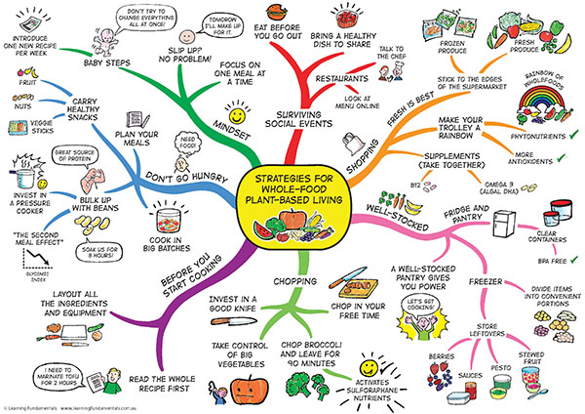 | Create a mind map on the whole topic of sleep and dreaming. Make sure you include key concepts, Freud’s theory or dreaming, Wolfman, Activation Synthesis Theory, Williams and real life applications.  Try to include key words, phrases and pictures, use colours if you can.
4 | - To be able to revise the research methods topic of paper 2 | - Your own notes on research methods (red books)  - Note: there is not a set of learning tables for research methods  - The past papers can be found at:  - https://www.ocr.org.uk/Images/309307-unit-j203-01-studies-and-applications-in-psychology-1-sample-assessment-material.pdf  - https://www.ocr.org.uk/Images/309314-unit-j203-02-studies-and-applications-in-psychology-2-sample-assessment-material.pdf | Using your own notes, have a go at answering SECTION D: Research methods ONLY of both papers.
5 | - To be able to revise the research methods topic of paper 2 | - Mark schemes can be found at the bottom of the question papers (link above)  - Green pen | Self-assess your answers to the questions you did previously. Add anything you missed in green pen.
Don’t forget you can access the school drives and resources form the school website: https://www.waseleyhills.worcs.sch.uk/

