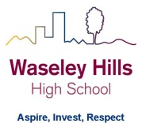
Subject: Geography
2 Week Independent Learning plan
Email queries to: nbaker@waseleyhills.worcs.sch.uk
Teacher:
Year: 11 Topic/theme: Paper 3: Fieldwork
Lesson | What you need to take from this lesson | Resource to use or hyperlink | Suggested task
1 | Know the main facts about your physical investigation.  HOW DOES ASHES HOLLOW STREAM CHANGE FROM SOURCE TO MOUTH? | VLE – scroll down to the bottom to find resources:  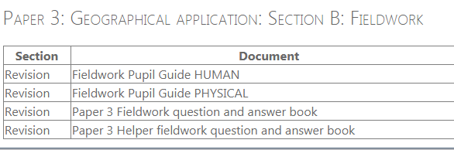 | Open document called:  Physical fieldwork questions.  Use your physical fieldwork booklet (blue cover) to answer the questions.  Use the digital copy off the VLE if you don’t have your own copy – it’s called ‘Fieldwork pupil guide PHYSICAL’  Open document called:  Physical fieldwork questions_answers.  Check your answers.
2 | Know the main facts about your human investigation.  Has the regeneration of Longbridge had a positive impact on its town centre? | VLE – scroll down to the bottom to find resources: | Open document called:  Human fieldwork questions.  Use your human fieldwork booklet (orange cover) to answer the questions.  Use the digital copy off the VLE if you don’t have your own copy – it’s called ‘Fieldwork pupil guide HUMAN’  Open document called:  Human fieldwork questions_answers.  Check your answers.
3 | Know how to answer Paper 3 style questions. | VLE – scroll down to the bottom to find resources: | Open document called:  Paper 3 Helper fieldwork question and answer book.  Use your fieldwork booklets to answer the questions using the advice given to you in the blue speech bubbles.  If you have a printer, you can write your answers on this document:  Paper 3 fieldwork question and answer book.
4 | Know how to answer Paper 3 style questions. | VLE – scroll down to the bottom to find resources: | Open document called:  Paper 3 Helper fieldwork question and answer book.  Use your fieldwork booklets to answer the questions using the advice given to you in the blue speech bubbles.  If you have a printer, you can write your answers on this document:  Paper 3 fieldwork question and answer book.
5 | Know key terms and case studies for Paper 1 and Paper 2. | VLE | Complete the revision tasks you have not yet completed.  Other revision resources:  - What you need to know  - Dominoes  - Quizzes
Don’t forget you can access the school drives and resources form the school website: https://www.waseleyhills.worcs.sch.uk/

