Subject: ICT
2 Week Independent Learning plan
Email queries to: nbaker@waseleyhills.worcs.sch.uk
Teacher: NJ
Year: 11 Topic/theme: R013 Coursework
Lesson | What you need to take from this lesson | Resource to use or hyperlink | Suggested task
1 | Test table | https://www.ocr.org.uk/qualifications/cambridge-nationals/information-technologies-level-1-2-j808/assessment/  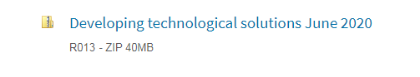 | What information needs to be included in a test plan?
2 | Review database task | https://www.ocr.org.uk/qualifications/cambridge-nationals/information-technologies-level-1-2-j808/assessment/ | What needs to be part of the review?
3 | Task 5: Presentation | https://www.ocr.org.uk/qualifications/cambridge-nationals/information-technologies-level-1-2-j808/assessment/ | Think about what makes a promotional presentation  What features/tools will you need to apply e.g. action buttons, transitions etc.  Which information will you include?  House style?
4 | Task 5: leaflet and business card | https://www.ocr.org.uk/qualifications/cambridge-nationals/information-technologies-level-1-2-j808/assessment/ | How will you inform customers of products?  What is the layout of an informative and promotional leaflet?
5 | Review the above 3 tasks | https://www.ocr.org.uk/qualifications/cambridge-nationals/information-technologies-level-1-2-j808/assessment/ | What needs to be part of the review?

