Year 6 English Transition Work
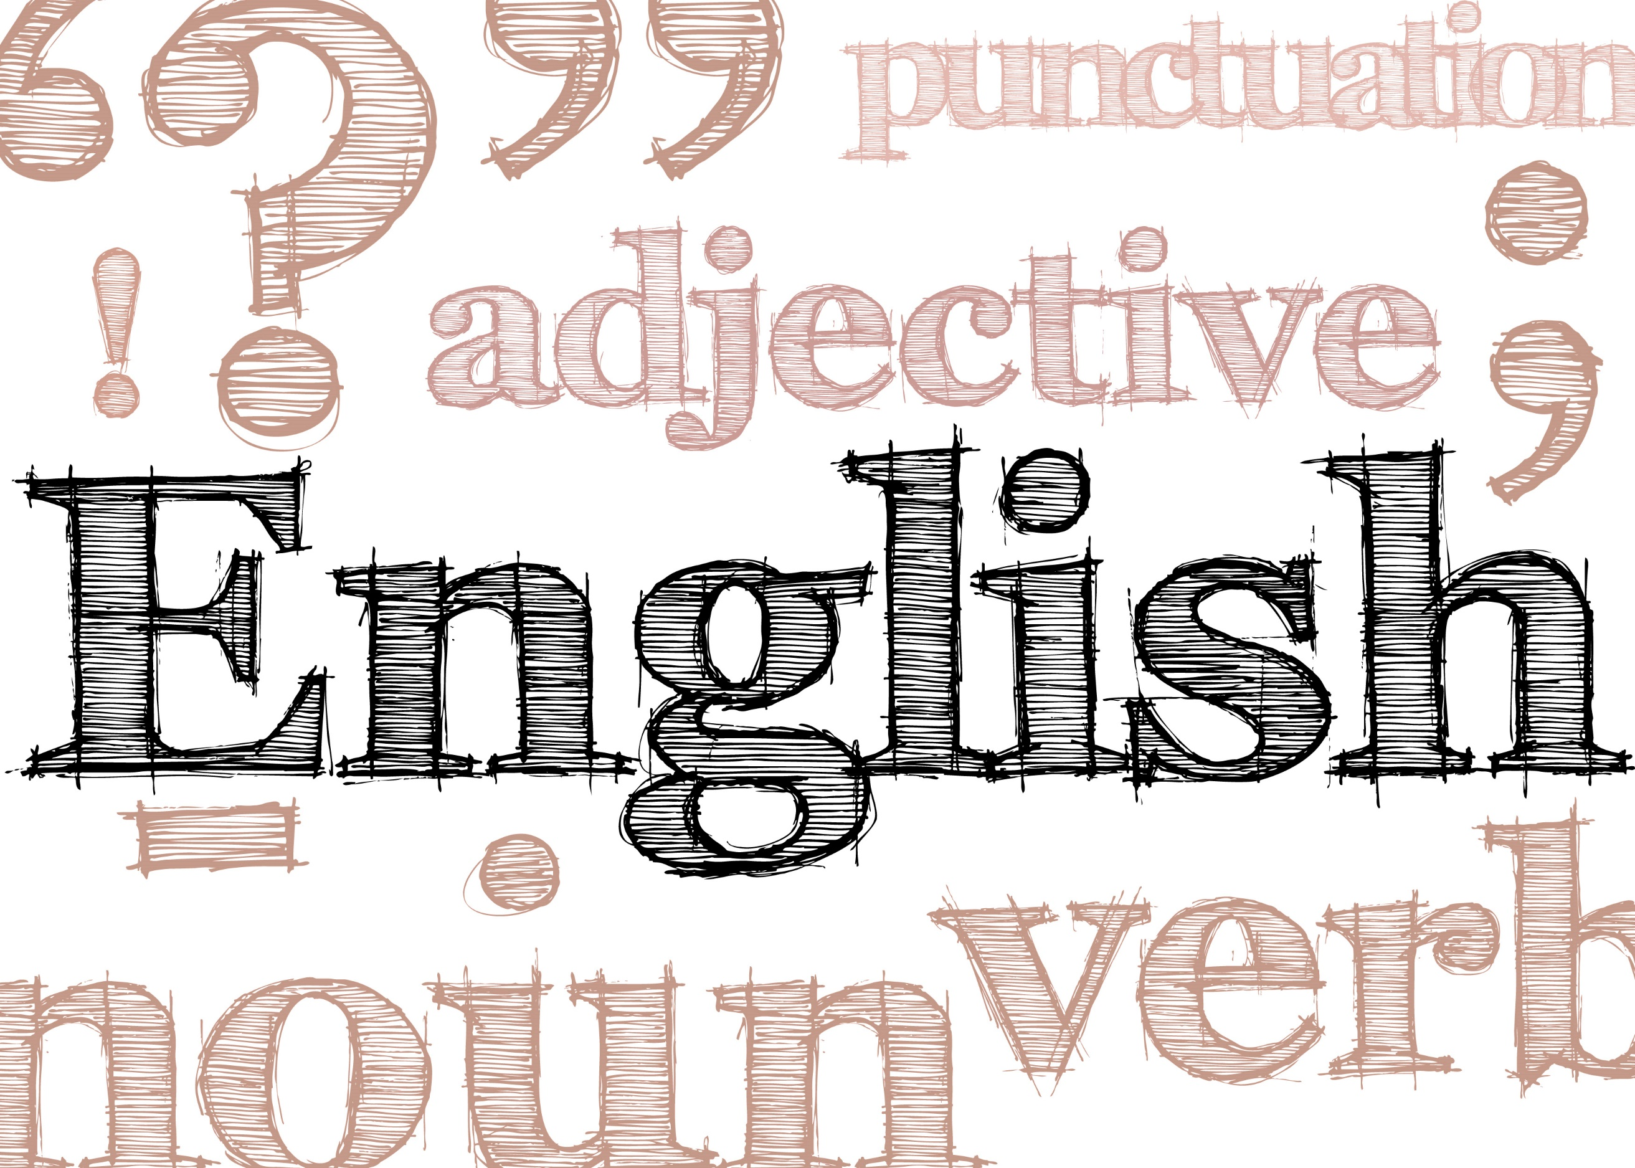

Welcome

Name:

English at Waseley Hills
We are very much looking forward to meeting you when you join us in September. We would like to find out something about you and especially what you enjoy about English.
The activities in this booklet will give you a taste of the sort of things we do in English and will allow your teacher to see what you are good at.
Answer the questions in the spaces provided.
Which bits of English do you enjoy most? What are you best at? Jot down some notes about what you like / dislike and are good at in the spaces below:

Reading: | Writing:  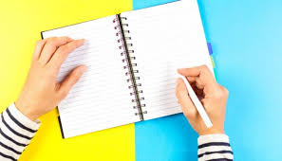
Speaking and Listening:

What do you think will be different from Primary School English lessons?
_________________________________________________________________
___________________________________________________________
Creating Character
Have a look at the painting below; it’s by the famous artist, L S Lowry. This is quite an unusual painting because it only features one person instead of the crowds which he usually painted. What do you think this character is like? Why is he lying on the wall? There are some clues, for example, his umbrella and briefcase, with the painter’s initials (LSL), the famous Manchester town hall clock and the factory chimneys behind him tell us where this is set.

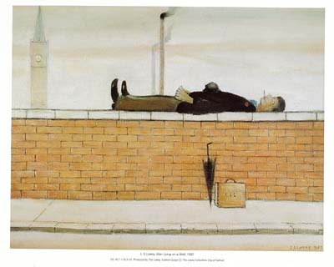
I think that the man is lying on the wall because ______________________
__________________________________________________________
He might be feeling ___________________________________________
The colours in the painting suggest that the mood is ___________________
If I were to give the man a backstory, I would imagine that he ___________
__________________________________________________________
__________________________________________________________
(You could think about his job, family, home, etc.)
Show Not Tell
Writers try not to ‘tell’ their readers everything; it’s better if the reader can work it out for themselves using ‘inference’. So, for example, rather than saying “She was angry” the writer might describe the person in this way: “She glared at the class with flashing eyes, her mouth was tightly buttoned up and her fingers were tapping on the desk in front of her.”
Try it out on these sentences: show not tell:
1. He was unhappy __________________________________________
___________________________________________________________
2. She was frightened _______________________________________
___________________________________________________________
3. The dog was excited ______________________________________
___________________________________________________________

Now let’s do the same for the ‘man on the wall’.
Write a paragraph about him but try to use ‘show not tell’ as much as possible.
___________________________________________________________
___________________________________________________________
___________________________________________________________
___________________________________________________________
___________________________________________________________
___________________________________________________________
___________________________________________________________
___________________________________________________________
___________________________________________________________
___________________________________________________________
___________________________________________________________
___________________________________________________________
___________________________________________________________
Not My Best Side
The next painting we are going to look at is based on the legend of St George and the Dragon. This is a painting by Uccello from 1470 and shows our patron saint, St George, the dragon and a princess. What do you think about the way the story is shown in the painting?
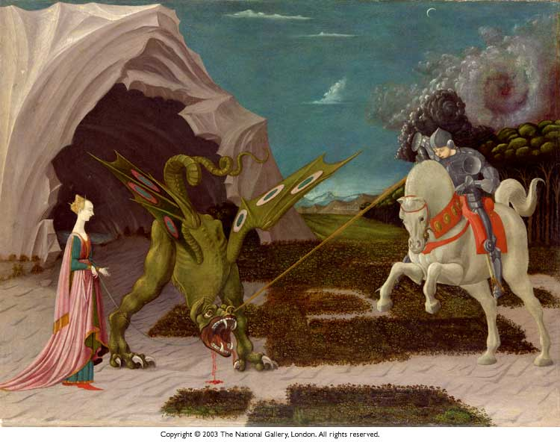
What do you think the two characters might be thinking? Fill in the thought bubbles.
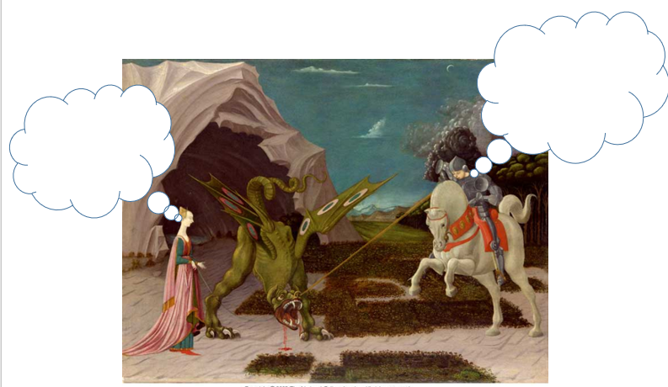

Now let’s look at the poem which the poet, U A Fanthorpe, wrote based on this very painting.
"Not my Best Side "
by U. A. Fanthorpe
I
Not my best side, I'm afraid.
The artist didn't give me a chance to
Pose properly, and as you can see,
Poor chap, he had this obsession with
Triangles, so he left off two of my
Feet. I didn't comment at the time
(What, after all, are two feet
To a monster?) but afterwards
I was sorry for the bad publicity.
Why, I said to myself, should my conqueror
Be so ostentatiously beardless, and ride
A horse with a deformed neck and square hoofs?
Why should my victim be so
Unattractive as to be inedible,
And why should she have me literally
On a string? I don't mind dying
Ritually, since I always rise again,
But I should have liked a little more blood
To show they were taking me seriously.
2
It's hard for a girl to be sure if
She wants to be rescued. I mean, I quite
Took to the dragon. It's nice to be
Liked, if you know what I mean. He was
So nicely physical, with his claws
And lovely green skin, and that sexy tail,
And the way he looked at me,
He made me feel he was all ready to
Eat me. And any girl enjoys that.
So when this boy turned up, wearing machinery,
On a really dangerous horse, to be honest
I didn't much fancy him. I mean,
What was he like underneath the hardware?
He might have acne, blackheads or even
Bad breath for all I could tell, but the dragon--
Well, you could see all his equipment
At a glance. Still, what could I do?
The dragon got himself beaten by the boy,
And a girl's got to think of her future.
Each verse of the poem is written by a different character from the painting. Can you work out which is which: St George, the Princess, or the Dragon?

Verse 1: ______________________
Verse 2: ______________________
Verse 3: ______________________
3
I have diplomas in Dragon
Management and Virgin Reclamation.
My horse is the latest model, with
Automatic transmission and built-in
Obsolescence. My spear is custom-built,
And my prototype armour
Still on the secret list. You can't
Do better than me at the moment.
I'm qualified and equipped to the
Eyebrow. So why be difficult?
Don't you want to be killed and/or rescued
In the most contemporary way? Don't
You want to carry out the roles
That sociology and myth have designed for you?
Don't you realize that, by being choosy,
You are endangering job prospects
In the spear- and horse-building industries?
What, in any case, does it matter what
You want? You're in my way.

Vocabulary
Some of the words in the poem might be unfamiliar to you. Can you work out the meanings for yourself or look them up in a dictionary? (There are online dictionaries, such as https://dictionary.cambridge.org/ )

1. ostentatiously ______________________________________________
2. deformed _________________________________________________
3. inedible ___________________________________________________
4. obsolescence _______________________________________________
5. contemporary ______________________________________________

Characters
What do you think each of the three characters is like, from how they describe themselves in the poem? Fill in the table with your thoughts.
1. The Dragon
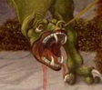

2. The Princess
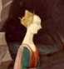

3. St George
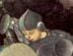

The Missing Voice?
Ursula Fanthorpe tells of how a ten year old girl once asked her why she had missed out the fourth character: the horse. Compose a new fourth verse from the horse’s point of view (it could include humour). Try to follow the original poem.
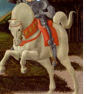
The Horse’s Story
_______________________________________________
_______________________________________________
_______________________________________________
_______________________________________________
_______________________________________________
_______________________________________________
_______________________________________________
_______________________________________________
_______________________________________________
_______________________________________________
_______________________________________________
_______________________________________________
_______________________________________________
_______________________________________________
_______________________________________________
_______________________________________________
_______________________________________________
_______________________________________________
_______________________________________________
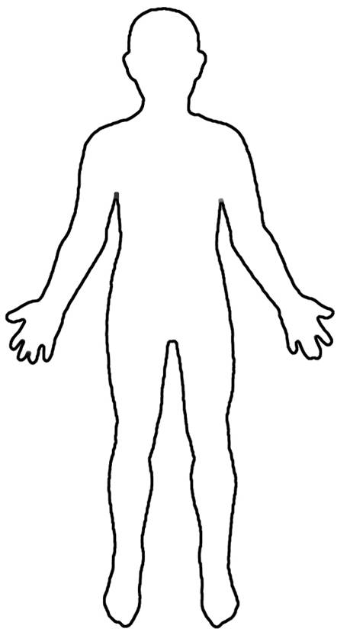
How tall are they, and what is their build?
Strengths:

Weaknesses:

Their biggest fear:

Their ultimate dream:

What is their relationship status?
How old are they?
Background:
Parents’ names:

Where did they grow-up?

Do they have any issues?

What is their style? What clothes do they like wearing? Do they wear jewellery?
What job do they have?
What shape and size is their nose?
What colour/texture is their skin?
What colour and length/style is their hair?
What shape is their face? What is their most striking facial feature?
Hobbies/interests:

