Waseley Hills High School
HOME SCHOOL AGREEMENT

Responsibility: Deputy Head

Author: Deputy Head

Date of Issue: Autumn 2019

Review Date: Autumn 2021

Reference: WHHS0014

The contents of this policy are reviewed and monitored on a regular basis by Senior Leaders, Heads of Subject and staff with responsibility to that area.
Direct responsibilities are written into job descriptions.

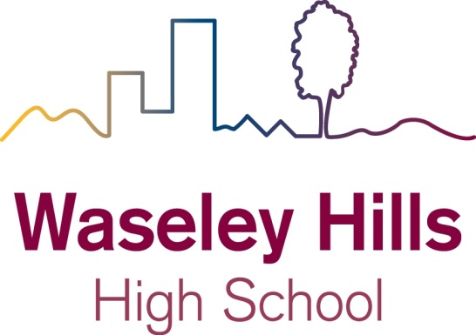

Parent Information

Our School Agreement

The five outcomes of the recent Every Child Matters legislation (2003) encourage schools to ensure that all students adopt a healthy lifestyle, feel safe and secure, that they enjoy their studies and achieve their potential. It also charges all schools to ensure that each an every child makes a positive contribution to their own future, their school and their local community. It also states that every child should be ready to take up the challenges of employment or further education. (Our school agreement uses the principles of Every Child Matters to underpin its home-school agreement).

As a student at Waseley Hills High School, I shall:

1. Behave in a sensible and acceptable manner at all times during the school day and on the way to and from school

2. Do as I am asked straightaway and without complaint

3. Be on time to school, registration and lessons

4. Wear my school uniform correctly and smartly

5. Do my best in each and every lesson

6. Be polite to all staff, students and visitors

7. Keep up to date with work and use my planner to meet deadlines for handling in homework and coursework

8. Not bring into school any inappropriate materials

As a parent/guardian of a student at Waseley Hills High School, I shall:

1. Make sure my child attends, and is punctual for, school every day

2. Make sure my child is properly equipped and dressed for school

3. Support the policies of Waseley Hills High School

4. Accept that school detentions are held after school and are not negotiable

5. Accept that my child can make mistakes and make poor decisions/errors of judgement

6. Support the school’s homework and coursework policies

7. Check and sign my child’s planner on a regular basis

8. Contact school if I need help, support or guidance

Staff at Waseley Hills High School shall:

1. Provide a safe and healthy learning environment

2. Model behaviour we expect from our students

3. Recognise and reward student success

4. Contact parents/guardians when issues regarding behaviour or learning arise

5. Seek views from parents, guardians and students

6. Apply its discipline policies in a firm, fair and consistent manner

7. All students’ work will be marked in line with the school marking policy

8. Encourage and provide opportunities for students to contribute to their school and local community

