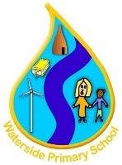


Waterside Primary School
Behaviour and Relationships Policy
[
Type here
]

Procedure Originator: N Rathbone
Approved by: Academy Council

Date Approved: September 2026

Our Rules
Be Ready, Be Respectful and Be Safe
The Waterside Way -
Characteristics of Learning

Respect, Excellence, Friendship, Courage, Determination, Inspiration, Equality.

1. Introduction
Waterside Primary School is committed to creating an environment where exemplary behaviour is at the heart of productive learning. Everyone is expected to maintain the highest standards of personal conduct, to accept responsibility for their behaviour and encourage others to do the same. Our behaviour policy guides staff to teach self-discipline not blind compliance. It echoes our core values with a heavy emphasis on respectful behaviour, a partnership approach to managing poor conduct and dynamic interventions that support staff and learners.
The fair and consistent implementation of our Behaviour Policy is everyone’s responsibility.

2. Our Core Beliefs
- Behaviour can change and every child can be successful.
- Positive, targeted praise is more likely to change behaviour than blaming and punishing.
- Reinforcing good behaviour helps children feel good about themselves.
- An effective reward system and celebrating success helps to further increase children’s self-esteem enabling them to achieve even more.
- Understanding each child’s needs and their individual circumstances helps us to act in the fairest way possible for that child, at that moment

3. Aims
Through this policy we aim to:
- To create a culture of exceptionally good behaviour: for learning, for community for life
- To ensure that all learners are treated fairly, shown respect and to promote good relationships.
- To refuse to give learners attention and importance for poor conduct.
- To help learners take control over their behaviour and be responsible for the consequences of it.
- To build a community which values kindness, care, good humour, good temper, obedience and empathy for others.
- To promote community cohesion through improved relationships.
- To ensure that excellent behaviour is a minimum expectation for all.

As a school community, through the taught curriculum as well as during all other opportunities e.g. lunchtimes and extended provision such as Breakfast and After School clubs, we aim to:
- Teach specific social skills e.g. sharing, turn taking, listening to each other, how to address people politely, etc.
- Teach strategies for children to solve conflicts peacefully.
- Teach specific co-operative and collaborative skills to enable children to work effectively as a member of a group.
- Agree boundaries of acceptable behaviour with all pupils and regularly remind children of these.
- Enable children to recognise, understand and respond to a range of feelings.
- Develop vocabulary to enable children to express feelings verbally rather than physically.
- Promote equal opportunities and instill a positive attitude towards differences.
- Promote an ethos of peer support.
- Ensure the atmosphere in the classroom environment is conducive to learning.
- Ensure children are aware of the consequences of their words and actions towards themselves and others.

4. Purpose
To provide simple, practical procedures for staff and learners that:
- Recognise behavioural norms
- Positively reinforces behavioural norms
- Promote self-esteem and self-discipline
- Teach appropriate behaviour through positive interventions

5. Behaviour for Learning: The Waterside Way

Be Ready, Be Respectful and Be Safe

We recognise that clear structures of predictable outcomes have the best impact on behaviour. Our school’s principles for behaviour sets out the rules, relentless routines and visible consistencies that all children and staff follow. It is based on the work of Paul Dix and his book ‘When the adults change, everything changes’. Good behaviour is recognised sincerely rather than just rewarded. Children are praised publicly and reminded in private.

Our school has three simple rules: ‘Be Ready, Be Respectful and Be Safe’, generated through discussions with staff, pupils and parents and which are applicable to a wide variety of situations. These rules, and our characteristics of effective learning (Respect, Excellence, Friendship, Courage, Determination, Inspiration, Equality.) are displayed in each classroom, and are explicitly taught and modelled by all members of our school community.

However, we also understand that for some children, following our behaviour expectations are beyond their current developmental level. In this case, these children will have access to bespoke positive behaviour plans (pathways), which may include carefully targeted sanctions and rewards to reinforce positive behaviour.

6. Roles and Responsibilities:
‘The culture is set by the way the adults behave.’ Paul Dix, 2017
All adults in the school are responsible for the consistent reinforcement of the behaviour policy.
Senior leaders and Governors are responsible for supporting staff to implement the policy. Parents are responsible for supporting the school’s behaviour policy by reinforcing key messages at home, helping children to complete ‘uncompleted’ work at home and providing a positive role model.

All Staff will:
- Meet and greet at the classroom door.
- Always redirect students by referring to ‘Be Ready, Be Respectful and Be Safe’.
- Model positive behaviours and build relationships.
- Plan lessons that engage, challenge and meet the needs of all learners.
- Use a visible recognition mechanism throughout every lesson.
- Focus on effort not achievement.
- Celebrate when children go above and beyond expectations.
- Be calm and give ‘take up time’ when going through the steps. Prevent before sanctions.
- Never ignore or walk past children who are behaving badly.
- Deliberately and persistently catch students doing the right thing and praise them in front of others.
- Know their classes well and develop positive relationships with all students.
- Relentlessly work to build mutual respect.
- Demonstrate unconditional care and compassion.

All Senior Leaders will:
- Be visible by routinely engaging with pupils, parents and staff
- Maintaining the behavior culture and environment where everyone feels safe and supported
- Ensure that all staff understand the behavioural expectations and the importance of maintaining them
- Make sure that all new staff are inducted clearly into the school’s behavior culture to ensure they understand its rules and routines and how best to support all pupils to participate in creating the culture of the school
- Consider any appropriate training which is required for staff to meet their duties and functions within the behaviour and relationships policy.
- Ensure that staff have adequate training on matters such as how certain special educational needs, disabilities, or mental health needs may at times affect a pupil’s behaviour.

All Pupils will:
- Be made aware of the school behaviour standards, expectations, pastoral support and consequence processes
- Understand that they have a duty to follow the school behaviour and relationships policy
- Uphold the school rules and characteristics of learning
- Treat others with consideration and respect
- Do their best and let others learn
- Follow instructions from teachers and other staff
- Support and encourage each other
- Take responsibility for their own actions
- Care for and take pride in the environment of the school
- Sort out difficulties appropriately, seeking adult help if needed

All Parents/Carers will:
- Familiarise themselves with the Waterside Primary School behaviour and relationships policy
- Where possible, take part in the life of the school and its culture
- Support the high expectations set by the school by understanding and reinforcing the school language as much as possible
- Work collaboratively with school so that children receive consistent messages about required behaviour at school, on their journeys to and from school, when representing the school or wearing the school uniform
- Support the implementation of the school behaviour and relationships policy if consequences have been issued to a child by a member of school staff
- Contact the Class Teacher, in the first instance, if there are any concerns
- Ensure that children attend school regularly, arriving on time, alert and ready for the tasks ahead and are collected, promptly, at the end of the day
- Share in the concern about standards of behaviour generally
- Support the work of the school as staff seek to support the while family

At Waterside, active parental involvement is welcomed, appreciated and deliberately encouraged in order to achieve the above points.

We will always aim to contact parents quickly when there are concerns about deteriorating levels of acceptable behaviour. However, staff will not routinely contact or inform parents of minor digressions.

6. Recording and Analysing behaviour incidents

At Waterside we understand the importance of logging and anyalsing positive and negative behaviour incidents efficiently. All positive and negative behaviour incidents are recorded within our MIS system Arbor so that the SLT and all staff monitor behaviour effectively.

To reward pupils and build teamwork, all children are assigned to one of our seven houses (Exellentia, Respicias, Determination, Fortitude, Amicitia, Aequalitas, Inspiration) and are rewarded house points for positive behaviour such as showing respect. When a child achieves 100 house points they will receive their bronze award, 200 points- Silver award, 300 points- gold award, 400 points- platinum award.

When a child displays negative behaviour and a caution is issued, it is logged on Arbor. If a child receives a negative 1, this behaviour is logged on Arbor. If a child receives a negative 2, it is logged on Arbor as a behaviour incident, a reflection is issued and parents are informed through an automated email. If a child receives negative 3 it is logged on Arbor as a behaviour incident and parents are informed through an automated email. The child will also be sent to a member of SLT and they will decide on the consequence issued depending on the severity of the incident.

7. Rewards
We recognise and reward learners who go ‘over and above’ our standards. Although there are tiered awards, our staff understand that a quiet word of personal praise can be as effective as a larger, more public, reward. Recognition of good behaviour, achievement, attainment, kindness etc. come in a variety of different forms and are given by all members of our school staff. Rewards must be attainable for all children and not just for a selected few. Rewards will never be taken away from a child.
The first and foremost form of recognition is through positive praise, enthusiasm, body language and oral recognition with feedback.
Specific rewards include:
- An automated email home for positive 2 and positive 3 house points.
- House points
- An individual token award e.g. Sticker.
- A visit to another member of staff for positive commendation.
- A public word of praise in front of a group, class, key stage or the school.
- School Certificates and awards, formally presented.

8. Stepped Sanctions
Consequences need to be immediate, short and appropriate for the behaviour and only aimed at the behaviour not the child.

This section outlines the steps an adult should take to deal with poor behaviour in the classroom. It includes micro-scripts for each step to ensure consistency in language and predictability for pupils which, in turn, results in all children being treated fairly. Staff should always use a measured, gentle approach; referring to the child by name; lowering themselves to the child’s physical level; making eye contact; delivering the required message; and then leaving the conversation to allow the child ‘take up time.’ Adults should not be drawn into and/or respond to any secondary behaviour, which children sometimes use as a distraction from the initial behaviour or to escalate the situation further.

Steps for dealing with poor behavior:
Reminder, Caution, Restorative Conversation, Consequence, Repairing Conversation, Phase Leader Intervention, Senior Leader Intervention
- Reminder - of the three rules, repeat as necessary.
- Caution - deliver in private if possible, make the child aware of his/her behaviour and clearly outline consequence if he/she continues e.g. having time out. Use phrase “Stop, think…. Make the right choice. “
- Restorative conversation - Speak to the child in private, give him/her a final opportunity to engage. Offer him/her a positive choice to do and use the micro script (see Behaviour Blueprint). The two minutes is owed when the child reaches this step, it is not part of a future negotiation on behaviour, and it cannot be removed reduced or substituted.
- Consequence – If the child hasn’t engaged after the third reminder he/she needs a 5 minute time out this is a few minutes for the child to think about his/her behaviour and calm down. This could also be time owed or homework given for any uncompleted work during the school day due to the child’s behaviour choices or pay it back. Followed by:
- Repairing Conversation – this might be a quick chat at break time in the playground or more formal meeting. (See repairing questions)
- Phase Leader Intervention – Repairing questions asked and parents contacted.
- Senior Leader Intervention – Repairing questions asked and a formal meeting with parents held.

Restorative Conversations
Following incidents of poor behaviour, it is imperative that the teacher who initially dealt with the behaviour (supported by a colleague or a member of SLT if appropriate) should conduct a restorative conversation with the pupil. This will help to ensure that the relationship between adult and pupil remains positive but also teaches the child to evaluate and reflect on their behaviour.

The questions used will depend on the age and individual needs of the pupil. For the youngest children, the three questions underlined should be used initially, with other questions being used if appropriate, so the children learn early on in their school life that their actions have an impact on others and also consequences for them.

Persistent Poor Behaviour
When a child receives more than 5 negative house points, in a half term, the class teacher will meet with the child and the child’s parents. If repeated poor behaviour continues and the child receives greater than 15 negative points, the Phase Leader will hold a meeting with the child’s Class Teacher and Parents. If the child receives greater than 20 negative points there will be a parent meeting with the behaviour lead and report card will be issued. The behaviour lead will continue to monitor the behaviour. If issues still arise, a formal meeting will take place with the headteacher and actions will be discussed.

As a school we recognise that behaviour is a way of communicating emotions. Where children persistently struggle to self-regulate their behaviour-class teachers will work in conjunction with parents/carers, SLT, SENDCo and the pastoral team to devise an individual support plan (behaviour pathway)

9. Serious Behaviour Incidents
Serious Incidents include:
- Bullying
- Fighting
- Inappropriate language
- Physical/Verbal attack on staff
- Racism
- Discrimination of any kind

Any of these behaviours are logged as a behaviour incident on Arbor and parents will be informed by an automatic email and/or phone call. The child will be sent to a member of SLT and they will decide on the consequence issued depending on the severity of the incident.

Consequences are:
- Half day internal reset
- Full day internal reset
- External reset (fixed term exclusion)

10. Bullying
At Waterside Primary School, we are aware that pupils may be bullied in our school as with any educational setting. We recognise that preventing, raising awareness and consistently responding to any cases of bullying should be a priority to ensure the safety and wellbeing of our pupils.

In line with the Equality Act 2010, it is essential that our school:
● Eliminates unlawful discrimination, harassment, victimisation and any other conduct prohibited by the Act
● Advance equality of opportunity between people who share a protected characteristic and people who do not share it
● Foster good relationships between people who share a protected characteristic and people who do not share it

At Waterside Primary School, we are committed to safeguarding and promoting the welfare of children and expect all staff and volunteers to share this commitment.

Bullying definition at Waterside Primary:
Bullying is defined as TIIP. Targeted- it is aimed directly at someone; Intent- the person is intending to cause harm; Imbalance of power- when an individual or group have power over another; persistent- it is continued and frequent.

When a bullying concern is raised, we will look at the behaviour incidents and see if it is targeted, with intent, if there is an imbalance of power and persistent. We will then put the incidents into one of four categories. These categories are:

- Relationship issues
- Unkind behaviour
- Mean behaviour
- Bullying

Depending on the category, we then put support into place to help the children and resolve the problem as quick as possible.

11. Child on child abuse
Child on child abuse is any form of abuse that intends to hurt others.

Child-on-child abuse is most likely to include, but may not be limited to:
• bullying (including cyberbullying, prejudice-based and discriminatory bullying)
• Abuse in intimate personal relationships between children (sometimes known as ‘teenage relationship abuse’)
• physical abuse such as hitting, kicking, shaking, biting, hair pulling, or otherwise causing physical harm (this may include an online element which facilitates, threatens and/or encourages physical abuse)
• Sexual violence, such as rape, assault by penetration and sexual assault; (this may include an online element which facilitates, threatens and/or encourages sexual violence)
• Sexual harassment, such as sexual comments, remarks, jokes and online sexual harassment, which may be standalone or part of a broader pattern of abuse
• causing someone to engage in sexual activity without consent, such as forcing someone to strip, touch themselves sexually, or to engage in sexual activity with a third party
• Consensual and non-consensual sharing of nude and semi-nude images and/or videos (also known as sexting or youth produced sexual imagery)
• Up skirting, which typically involves taking a picture under a person’s clothing without their permission, with the intention of viewing their genitals or buttocks to obtain sexual gratification, or cause the victim humiliation, distress, or alarm, and
• Initiation/hazing type violence and rituals (this could include activities involving harassment, abuse or humiliation used as a way of initiating a person into a group and may also include an online element).
Keeping Children Safe in Education (KCSiE), 2026

It could happen within children’s relationships, friendships or within wider peer associations. Everybody at Waterside Primary School is committed to the prevention, early identification and appropriate management of child on child abuse.

At Waterside Primary School, we recognise that it is essential for all of our staff to maintain the attitude of ‘it could happen here’ and to understand the importance of challenging inappropriate behaviours between peers that are abusive in nature.

“Downplaying certain behaviours, for example dismissing sexual harassment as “just banter”, “just having a laugh”, “part of growing up” or “boys being boys” can lead to a culture of unacceptable behaviours, an unsafe environment for children and in worst case scenarios a culture that normalises abuse leading to children accepting it as normal and not coming forward to report it.”
Keeping Children Safe in Education (KCSiE), 2026

All concerns around child on child abuse will be taken seriously, reported, investigated, recorded and managed in line with the procedures outlined in our Safeguarding and Child Protection Policy. Staff will follow guidance in this policy to respond to incidents of child on child abuse and they will do this immediately and sensitively. Staff will talk to children in a calm and consistent manner; they will not be prejudiced, judgemental, dismissive or irresponsible in dealing with such sensitive matters. Staff members responding to such incidents will alert the DSL or DDSL by speaking to them face-to-face where possible. It is the responsibility of the member of staff who is the first responder to ensure that the incident is logged. Any concerns raised regarding child on child abuse will be raised with any relevant parties.

12. Searching, Screening and Confiscation
Following guidance set out by the Education and Inspections Act 2006, our members of staff are authorised to use confiscation as a disciplinary sanction if it is lawful. This means that staff may confiscate or seize items in the possession of pupils that are illegal, or banned by the federation. It is our first priority to ensure that pupils are in a safe and secure environment when they are in our care, and any items that may jeopardise the safety of other pupils or themselves will be taken off pupils without notice.

A teacher or someone who has lawful control of the child can search a pupil with their permission to look for any item that the federation’s rules say must not be brought into school. Senior leaders and other members of staff authorised by them have the power to search a pupil without the pupil’s consent if they suspect they are in possession of ‘prohibited items’. Prohibited items that can be searched for without consent include:
• Knives or weapons
• Alcohol
• Illegal drugs
• “Legal highs”
• Stolen items
• E-cigarettes, tobacco and cigarette papers
• Fireworks
• Pornographic images
• Articles that have been or could be used to commit an offence or cause harm.
• Mobile phones in line with school policy

The Education Act 2011 allows for staff seizing an electronic device to examine any data or files on the device if they think there is good reason to do so. These data or files may be erased before returning the item if they believe there is good reason to do this.

13. Pupils with SEND
When a child is on the Special Educational Needs register for specific behavioural difficulties or has behavioural difficulties as a result of a disability, the procedure for dealing with that child may differ from our sanction system. The alternative adapted procedure will be formed in agreement with the child, their parents and relevant school staff and outlined on the child’s learning passport.

14. Support agencies
If behavioural difficulties continue the Head, SLT, SENDCo or Pastoral Team will become involved. The advice and input of outside agencies will be sought as necessary. These may include the Autism and Social Communication Team or other agencies that offer support for pupils and families.

15. Exclusions
We do not believe that exclusions are the most effective way to support children, and we will always try to adapt and personalise provision for all of our children in order to ensure that they are able to access education.

In exceptional circumstances it may be necessary to suspend a child for a fixed time period and this would always be considered very carefully.

Decisions to exclude children are made on an individual basis and should always be a reasonable and measured response, which will have impact and provide a learning opportunity for the child or young person.

Exclusions can also be managed internally and a child or young person may be removed from class for a fixed period of time.

Permanent exclusion will always be a last resort and the school will endeavor to work with the family to complete a managed move to a more suitable setting where possible. In all instances, what is best for the child will be at the heart of all decisions making processes.

16. Application and scope of this policy
This Behaviour Policy is applicable to our entire school community and will only be effective if everyone is empowered to use it with confidence and consistency. There may be occasions when special rules need to be applied, e.g. in the dining room, at play and lunch times or when off site, etc. but the same principles of promoting good behaviour will always apply.

17. Monitoring & Evaluation
The school’s Leadership Team will monitor the effectiveness of the policy at least once every two years and report back to the Local Governing Body. The Leadership Team will also monitor the visible consistencies around the school and the use of language and personal follow-up. Records will be kept by the Leadership Team in order to monitor and evaluate any changes brought about by the policy.

Appendix A: Behaviour Blueprint
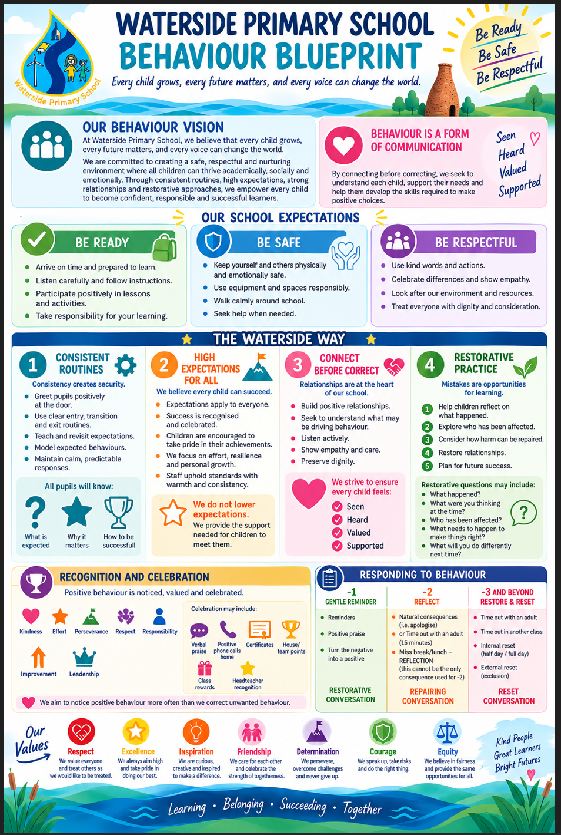

Appendix B: Rights and Responsibilities

Pupils’ Rights | Pupils’ Responsibilities
- To be able to learn to the best of their ability.  - To be treated with consideration and respect.  - To be listened to by the adults in the school.  - To know what is expected of them.  - To feel safe.  - To be treated fairly. | - To treat others with consideration and respect.  - To do their best and let others learn.  - To follow instructions from teachers and other staff.  - To support and encourage each other.  - To take responsibility for their own actions.  - To care for and take pride in the environment of the school.  - To sort out difficulties appropriately, seeking adult help if needed.
Staff Rights | Staff Responsibilities
- To be treated with respect by pupils, parents and colleagues.  - To be able to teach without unnecessary interruption.  - To work in a supportive and understanding environment.  - To feel safe. | - To create a safe and stimulating environment in which all children can learn.  - To treat pupils with consistency and respect at all times.  - To foster good relationships, leading by example.  - To involve parents when children are consistently finding it difficult to meet expectations of behaviour.  - To work as a team, supporting and encouraging each other.
Parents’ Rights | Parents’ Responsibilities
- To be sure their children are treated fairly and with respect.  - To know their children are safe.  - To be able to raise concerns with staff and be told when their child is experiencing difficulties. | - Work with the school to promote good behaviour, challenge inappropriate behaviour and to uphold the principles of this policy.  - Ensure children attend regularly and on time.  - Be aware of the strategies of the school and reinforce these at home.  - Promote good behaviour, politeness, courtesy and consideration for others.  - Inform the school of any concerns that may affect the behaviour of their child.

Appendix C: Positive House Points

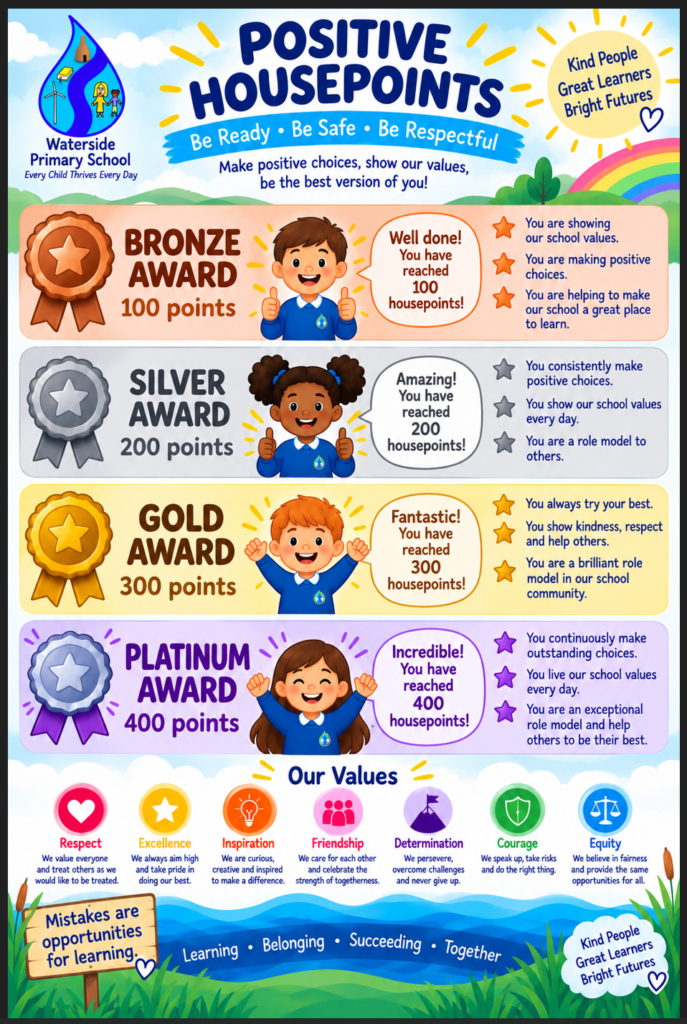

Appendix D: Negative House Points

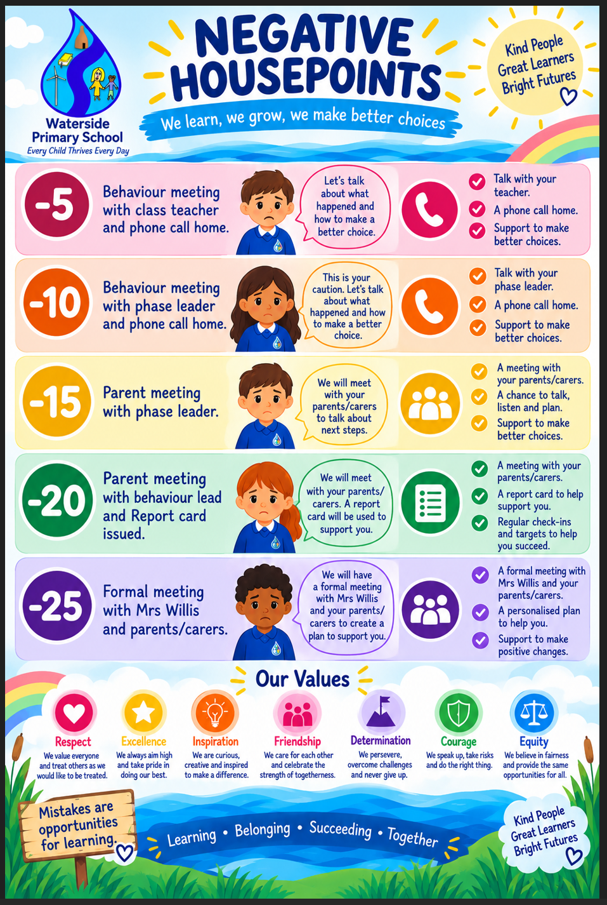

Appendix E: Behaviour Steps

