Activities marked with a star must be completed at least 3 times a week. Children are expected to complete 6 tasks from all other challenges (Art, Geography, History and Science) during this half term. Children should return their completed homework task, in their homework books, every Thursday. Books will be marked and returned on Friday.
Reading Rockets  Read at least 3 times a week for 10 minutes each time. Parents should sign to record that this has been completed in the reading diary.  Your reading book and diary should be in school every day. | Times tables  Practice two times tables weekly. It can be any of your tables from 2 to 12!  Start by saying your times tables in full.  Then write your times table out in full.  Ask an adult to give you written questions out of sequence, one at a time, from your chosen times table. Can you write the answer in 10 seconds? | Spellings  Practice the spellings in your spelling book.  Bring your spelling book back to school on Thursday when you will have your spelling test.  New spellings will be added into your book on Friday. You will either get a new list if you get all your spellings correct or more time to practice the original list. You will need to get 8/10 to move on to your new spellings.
Maths  Choose a four or five-digit number.  What is 1 more? 10 more? 100 more? 1000 more?  What is 1 less? 10 less? 100 less? 1000 less?  E.g. 1456  1456 + 1 = 1457 1456 + 100 = 1556  1456 + 10 = 1466 1456 + 1000 = 2456 | English  Turn this simple sentence into different complex sentences using the conjunctions: so, because, and, when, after  Oliver was hungry. | Science  Describe the seasonal changes in plants and trees. Why do these changes happen?  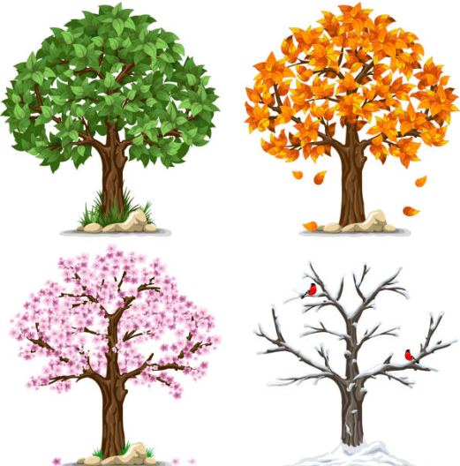
Science  Describe the life cycle of a butterfly and include a diagram.  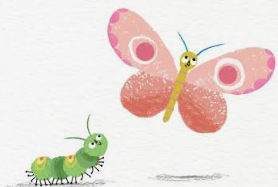 | PSHE  Imagine you had a 10 minute ‘soap box’ slot, where you can share with the rest of the class an interest you have, or things you would like to tell the class about your family, or home, a place you have visited or a particular person you know.  What would you talk about? Include pictures and information. | Art  Draw a still-life. Use shading techniques to give your image form and depth.  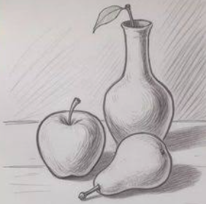
History  Make a poster to show your knowledge of the Stone Age.  Where did people live?  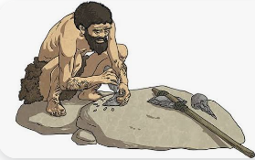  What did they eat?  What other facts do you know? | Reading  Complete a book review. It could be your favourite book, the book you are currently reading or a book you know your friends will love. Can you write a summary without giving away the plot? Why should your friends read this book? | History  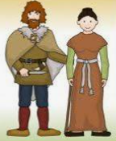  Make a factfile to show your knowledge of the Iron Age.  Where did people live?  What did they eat?  Why is it called the Iron Age?  What other facts do you know?

