Autumn Term Recommended Reads for Oak Class
Stories similar to Floodland
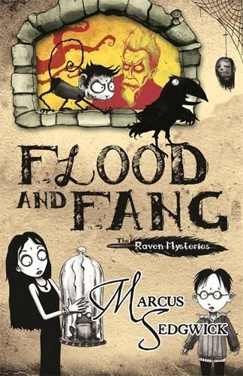 | Meet the wonderfully weird Otherhand family and their faithful guardian, Edgar the raven, and discover the dark secrets of Castle Otherhand. Edgar is alarmed when he sees a nasty looking black tail slinking under the castle walls. But his warnings to the inhabitants of the castle go unheeded: Lord Valevine Otherhand is too busy trying to invent the unthinkable and discover the unknowable; his wife, Minty, is too absorbed in her latest obsession - baking; and ten-year-old Cudweed is running riot with his infernal pet monkey. Only Solstice, the black-haired, poetry-writing Otherhand daughter, seems to pay any attention. As the lower storeys of the castle begin mysteriously to flood, and kitchen maids continue to go missing, the family come ever closer to the owner of the black tail...
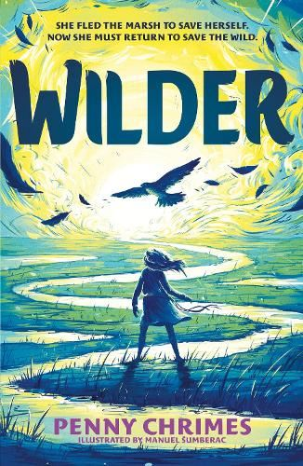 | A desperate village. A child who emerges from the marshes. A falcon that helps her save them all. The child - if child it was - came out of the wild-ness. It came out of the sparse bleak marsh where few dared go and none came back. And though the village grew accustomed to the creature they did not forget from whence it came. And they whispered that there was no knowing whether she was sent as a blessing or a bane.' When the child emerges from the wilderness, no one in the village knows what to do with her. She is odd - half-wild, without speech and seems to have an unnatural bond with animals - especially the falcon, who is always circling above her. The Wise-Woman takes her in, and names her Rhodd, but the rest of the villagers remain suspicious. Over the years, as Rhodd grows, the village realises that the river, which is their connection to the wider world, is beginning to die, and eventually a dark sickness begins to spread. Soon, too soon, the villagers turn their suspicion on Rhodd and her falcon. And so, Rhodd sets out to discover what - or who - is causing the river to dry up . . . to protect her mother, her falcon and herself.
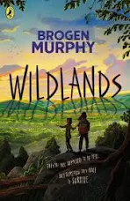 | Twenty-five years into the future, no humans are allowed in the Wildlands – a vast area in Britain where wolves, lynx and bison roam free. The only exception is a high-speed train line between London and Glasgow that crosses right through the heart of the project. Thirteen-year-old Astrid and her little sister, Indie, are onboard when their train slows to a brief, unexpected stop … and they find themselves accidentally left behind. Stranded in this place of astonishing natural wonders and terrible dangers, they have only a rucksack, a phone without signal – and each other. As every wrong turn takes them deeper into the Wildlands, do they have the ingenuity and determination to survive?  How far would YOU go to find your way home?

Stories about journeys or adventures
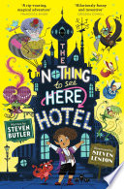 | Welcome to The Nothing to See Here Hotel! A hotel for magical creatures, where weird is normal for Frankie Banister and his parents who run the hotel.  When a goblin messenger arrives at The Nothing to See Here Hotel, announcing the imminent arrival of the goblin prince Grogbah, Frankie and his family rush into action to get ready for their important guest. But it soon becomes obvious that the Banister family are going to have their work cut out with the demanding prince and his never-ending entourage, especially when it turns out the rude little prince is hiding a secret...
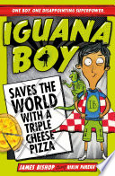 | Dylan has wanted a superpower for as long as he can remember, especially since his brother and sister have got really cool ones. But when his wish finally comes true, Dylan is MIGHTILY disappointed. For Dylan has become ... Iguana Boy. He can talk to Iguanas ... RUBBISH! And when supervillain Celina Shufflebottom kidnaps all the superheroes in London, Dylan must work out how to use his new team of chatty iguanas to save the day. He's going to have to think outside the box, (the pizza box), if he's going to become the hero he's always dreamed of. If he's going to make Iguana Boy cool.
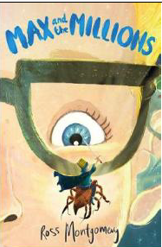 | Max is used to spending time alone - it's difficult to make friends in a big, chaotic school when you're deaf. He prefers to give his attention to the little things in life... like making awesome, detailed replica models. Then Mr Darrow, the school caretaker and fellow modeller, goes missing. Max must follow his parting instruction: 'Go to my room. You'll know what to do.'  There on the floor he finds a pile of sand ... and in the sand is Mr Darrow's latest creation... a tiny boy, no bigger than a raisin, Luke, Prince of the Blues. And behind the tiny boy... millions of others - a thriving, bustling, sprawling civilization!
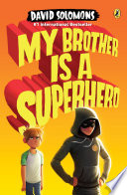 | Luke Parker was just your average comic book fan until his boring, teacher’s pet, helps-old-ladies-across-the-street brother Zack got turned into a superhero. Luke can’t believe the unfairness of it all—he’s the one with the encyclopedic knowledge of everything from Ant-Man to Wolverine! At least he can help Zack—aka Star Guy—with all the important parts of becoming a superhero, like using his newfound powers and deciding whether or not to wear a cape.  But when Star Guy gets into super-size trouble, it’s up to Luke—and his intrepid neighbor, Lara—to rescue his big brother and, with a little luck, help him save the world.

Non-fiction
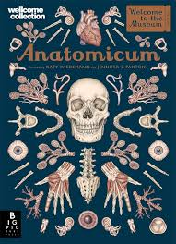 | Step inside the pages of Anatomicum to enjoy the experience of a museum from the comfort of your own home. The 2019 offering from Welcome to the Museum guides readers through the human body, from the muscles we use to show emotion, to the delicate workings of the brain. With sumptuous artwork by Katy Wiedemann and expert text by professor Dr Jennifer Z Paxton, this beautiful book is a feast of anatomical knowledge.
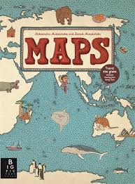 | Explore the world with this lavish book of maps. This collection of 52 highly illustrated maps details not only geographical features and political borders, but also places of interest, iconic personalities, native animals and plants, local peoples, cultural events, and many more fascinating facts associated with each region. This book is a celebration of the world, from its immense mountains to its tiny insects - and everything in between!
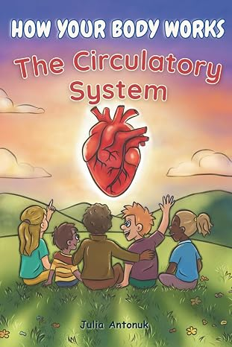 | “How does my heart work?”  If your child has ever asked this question, this beautifully illustrated human body science book for kids will turn curiosity into discovery.  Written by a Registered Nurse (RN, BSN), this beginner-friendly anatomy book for kids explains the circulatory system in a simple, engaging way that children ages 6–12 can truly understand.  Instead of overwhelming facts, this book connects science, feelings, and healthy habits so children can build a lifelong understanding of their amazing bodies.

