Chestnut Autumn Recommended Reads

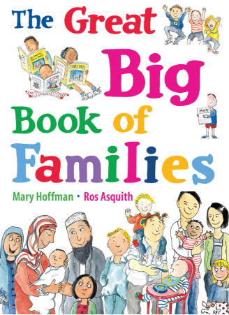 | The Great Big Book of Families by Mary Hoffman  All families are different and this lovely book explores what this may look like. Enjoy reading this at home as you discuss how different families look and how all families are special!
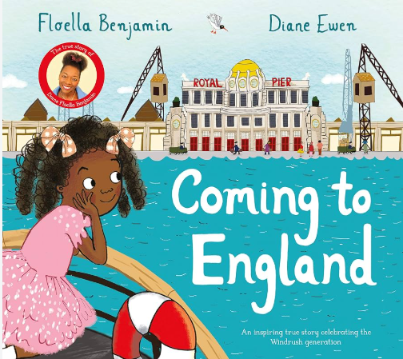 | Coming to England by Floella Benjamin  Coming to England follows the real life story of a young girl called Floella who lives in Trinidad and then moves to London with her family. This lovely story explores the feelings of children and families who have moved to a new country.
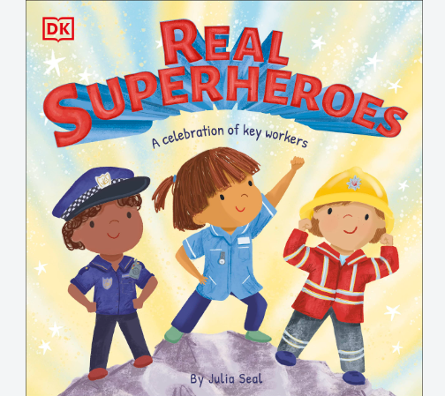 | Real Superheroes by Julia Seal  Real Superheroes is all about the people who are out helping us and keeping us safe including police officers, doctors and firefighters plus many more.
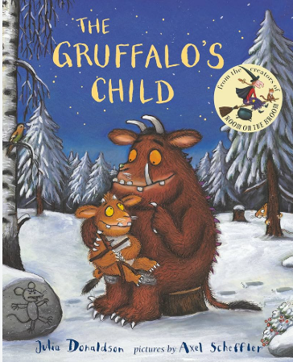 | The Gruffalo’s Child by Julia Donaldson  This half term, our Literacy story is ‘the Gruffalo’ by Julia Donaldson which is all about a strange creature called the Gruffalo and his adventure with a mouse. The Gruffalo’s Child is a brilliant continuation of this well–loved classic all about the adventures of the Gruffalo’s child who is off to find the big bad mouse!
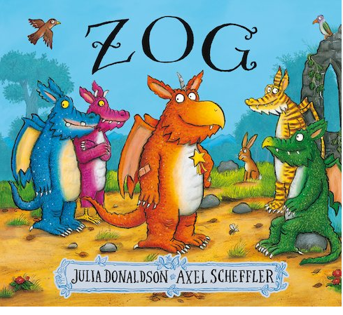 | Zog by Julia Donaldson  Zog is another brilliant story written by author Julia Donaldson. Listen out for the words in that story that rhyme as there are quite a few! Listen to how Zog gets on at his school, are his lessons the same as yours?
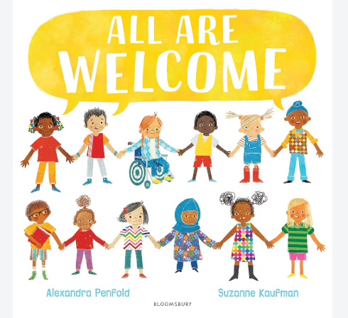 | All are Welcome by Linda Kranz  Everyone is different and everyone is special and ‘All Are Welcome’ is all about just that! Have a read to hear how important it is to welcome and respect everyone at school and in our world.
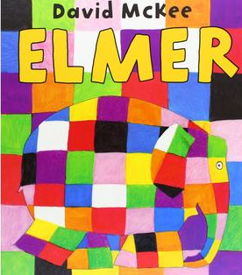 | Elmer by David McKee  This half term, our Art focus is using straight lines that can be vertical or horizontal to create shapes used in different pictures. One of which is Elmer! Elmer is covered in lots of amazing patchwork squares of all different colours, can you spot his colours and his shapes? Where can you see vertical or horizontal lines?
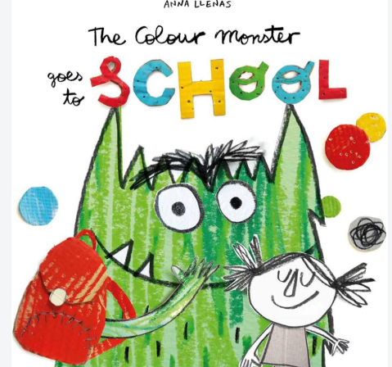 | The Colour Monster goes to School by Anna Llenas  We all feel different feelings at different times and for different reasons. The Colour Monster feels all mixed up when he started school and needed some help to settle. Once he did, he felt so happy! How did you feel about starting school? How do you feel now?

