The Gruffalo Rhyme
He has knobbly knees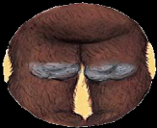
And turned out toes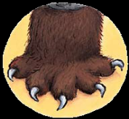
And a poisonous wart at the end of his nose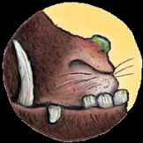
His eyes are orange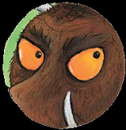
His tongue is black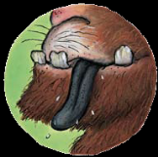
He has purple prickles all over his back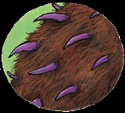
Oh help! Oh no!
It’s a Gruffalo
It’s a Gruffalo
