Autumn Term Recommended Reads for Elm Class

Our class reader this term is Oliver Twist, Retold by Gill Tavner
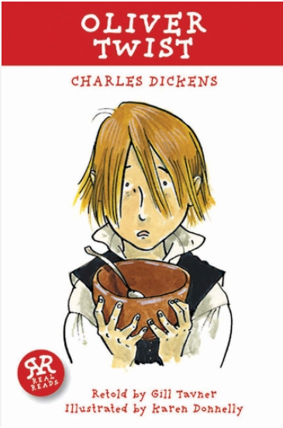 | With a hungry, timid request of ‘Please, sir. I want some more’, orphan Oliver Twist takes his first step on a terrifying journey.  In the dark, dangerous streets of Victorian London Oliver enters the world of people so poor and desperate that they will take any risk and know no mercy.  Relentlessly pursued by the menacing criminal world, who should Oliver trust? Are his true friends strong enough to resist the determined plotting of desperate villains?  In this gripping tale of kidnapping, shooting and murder, Charles Dickens shows the threats to a vulnerable boy’s existence and asks the eternal question: which is more powerful, good or evil?

Other narratives by Charles Dickens that have been adapted for children:
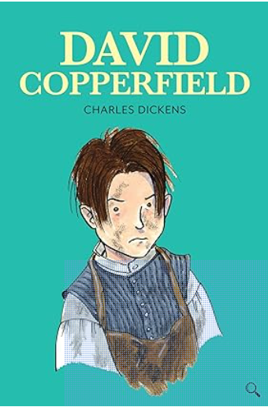 | When David’s mother marries the malevolent Mr Murdstone, David’s childhood happiness is destroyed forever.  Can one lonely little boy show the strength and determination to survive the dangers that lie ahead? Travelling along the rocky road from boyhood to manhood, how can David learn who to trust and who to love? Will David’s friends bring him happiness or heartache?  In this inspiring tale of trust, betrayal, courage and love, Charles Dickens presents a world of colourful characters to amuse us, astonish us, disgust us and move us to tears. Once encountered, David Copperfield’s friends and enemies will never be forgotten.
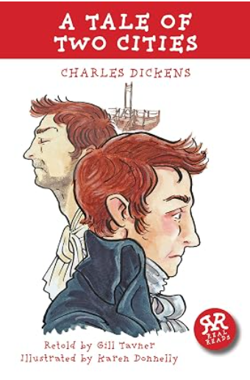 | ‘It is a far, far better thing that I do than I have ever done.’ Sydney Carton is a lawyer who has wasted his abilities and his life. Now he has to make a difficult choice about what is really important to him, which could be a matter of life or death.  The French Revolution is running its violent course; lives are ruined as a new France is created. How did the gentle Doctor Manette and his daughter Lucie become caught up in France’s struggles? What is the real identity of the handsome Charles Darnay, who wins Lucie’s hand in marriage? And why does the shadow of La Bastille Prison hang over them all? The best of times and the worst of times. London and Paris. Sydney Carton and Charles Darnay. A story of contrasts and chaos. Can peace ever be restored in France? Can it ever be restored in the hearts of the people involved?

Other Georgian era books:
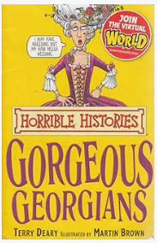 | Learn all about the Gorgeous Georgians with all the nasty bits left in. You probably thought that Georgians just spent their time prancing about in powdered wigs and pantaloons. Find out the horrible truth, like their sneaky schemes for hiding personal hygiene problems and about the schoolchildren who went to war with their teachers!

We will be learning about the Stone Age and the Iron Age in our history lessons. Here are some books linked to this topic:
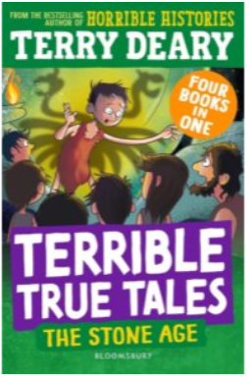 | Terrible True Tales is a selection of four short stories; all set in the Stone Age and previously published separately. The Stone Age stories are well written and make some of the factual information about the Stone Age come to life for the children. The stories are set in different places around the world, including Skara Brae, which is often a topic taught in primary history lessons.  The exciting tales are based on real historical and archaeological evidence, told with Terry Deary‘s imaginative style and dry wit.
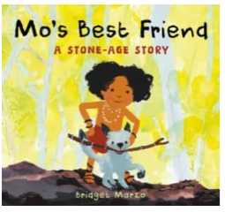 | This is the picture book story of a Stone Age child who makes friends with a wild beast, against the family’s wishes.  It is inspired by the discovery in France of a child’s footprint alongside a dog’s pawprint in a cave.  There are pleasant illustrations to help the understanding of the story, and a really useful part at the end, all about Stone Age survival skills, to help with the topic.
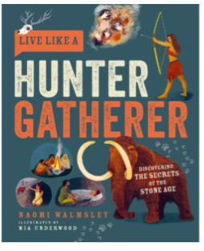 | Live Like a Hunter Gatherer is a fantastic guide to the Stone Age for primary-aged children to make links between life in the Stone Age and life today. For example, we all know that fire allowed people to stay up later, ward off predators and cook food, but did you know that the reduction in the need to chew cooked meat fewer times than raw meat meant that people had more time to chat, which caused a surge in language development?  A section which particularly appealed was the myth-busting page. This allows children’s preconceptions to be challenged as they explore the subject and build a revised mental picture of life in the Stone Age.

You might like to explore some books based on our Science focus, Cycles in nature:
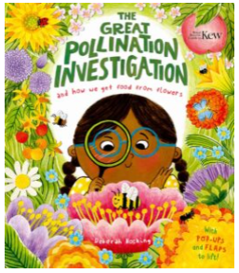 | Ever wondered how fruit starts to grow? This fun, lift-the-flap book guides you through the parts of a flower, how different pollinators support the plant life-cycle and how other parts of plants are used in our food. There is a great mix of scientific detail and engaging story-telling and this book is a great accompaniment to primary science topics about lifecycles and growing plants.  The information is presented attractively in bite-size chunks, making it accessible for children across the primary age-range, and the illustrations are colourful and eye-catching.
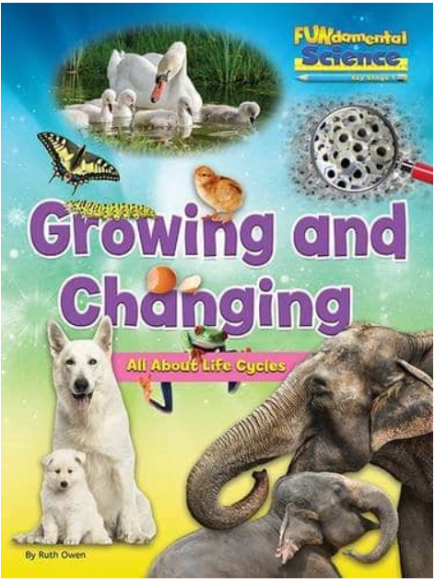 | What life cycle stages does a tadpole go through to become a frog? How do animals such as lambs, puppies, baby mice, blackbird chicks and caterpillars change and grow? Using examples of familiar animals, readers will investigate animal life cycles. How are the life cycles of different species the same and different? How do parent animals care for their young? And what are the life cycle stages that humans go through? Look for the download button throughout the book.
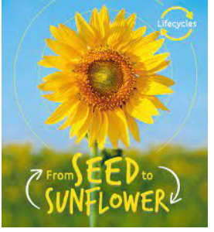 | How do sunflowers begin? What do sunflowers need to grow? When do the flowers open?  Discover the amazing stages of different life cycles and learn how different species are born, grow up and reproduce with this stunning series. Packed with amazing photographs of every stage, labelled diagrams to explain growth and development, fascinating facts and discussion points for further learning.

Miss Beaumont recommends:
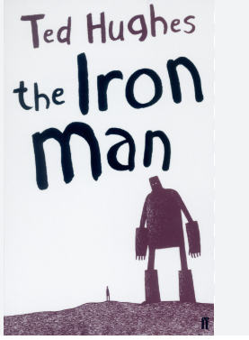 | The Iron Man came to the top of the cliff.  Where had he come from? Nobody knows.  How was he made? Nobody knows.  The Iron Man is causing destruction everywhere he goes, and humankind are setting a trap to stop him. But one little boy realises that the Iron Man is not here to destroy the Earth, he could even save the planet from a new, more deadly danger!
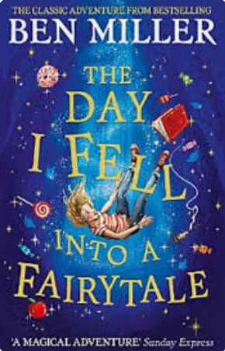 | Lana loves stories. Especially the ones she and her brother, Harrison, share in their make-believe games. But when Harrison decides he’s too grown-up to play with Lana she finds herself feeling lonely. Until something magical happens . . .  Hidden in the strange new supermarket in town, Lana discovers a portal to a fairytale world! But these aren’t the happy-ever-after fairytales that Lana knows, they are darker and more dangerous, and the characters need Lana’s help to defeat an evil witch. But she can’t do it alone. Can she convince Harrison to believe in stories again and journey to the world with her . . . before it’s too late?
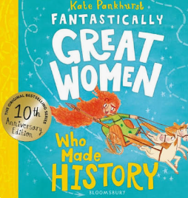 | Created by Kate Pankhurst, relative of suffragette Emmeline Pankhurst, the Fantastically Great Women series has inspired a generation of readers to dream big, stand proud and speak out. How will you change the world? Be inspired by fourteen true stories of fearless women whose remarkable lives marched them into our history books. Meet brave and powerful Boudicca, who fought for what she believed in; cosmonaut Valentina Tereshkova who was the first woman in space; and inventor and engineer Ada Lovelace, the world’s first computer programmer – plus many more! This incredible illustrated collection celebrates women who have made their mark on history and the world!

