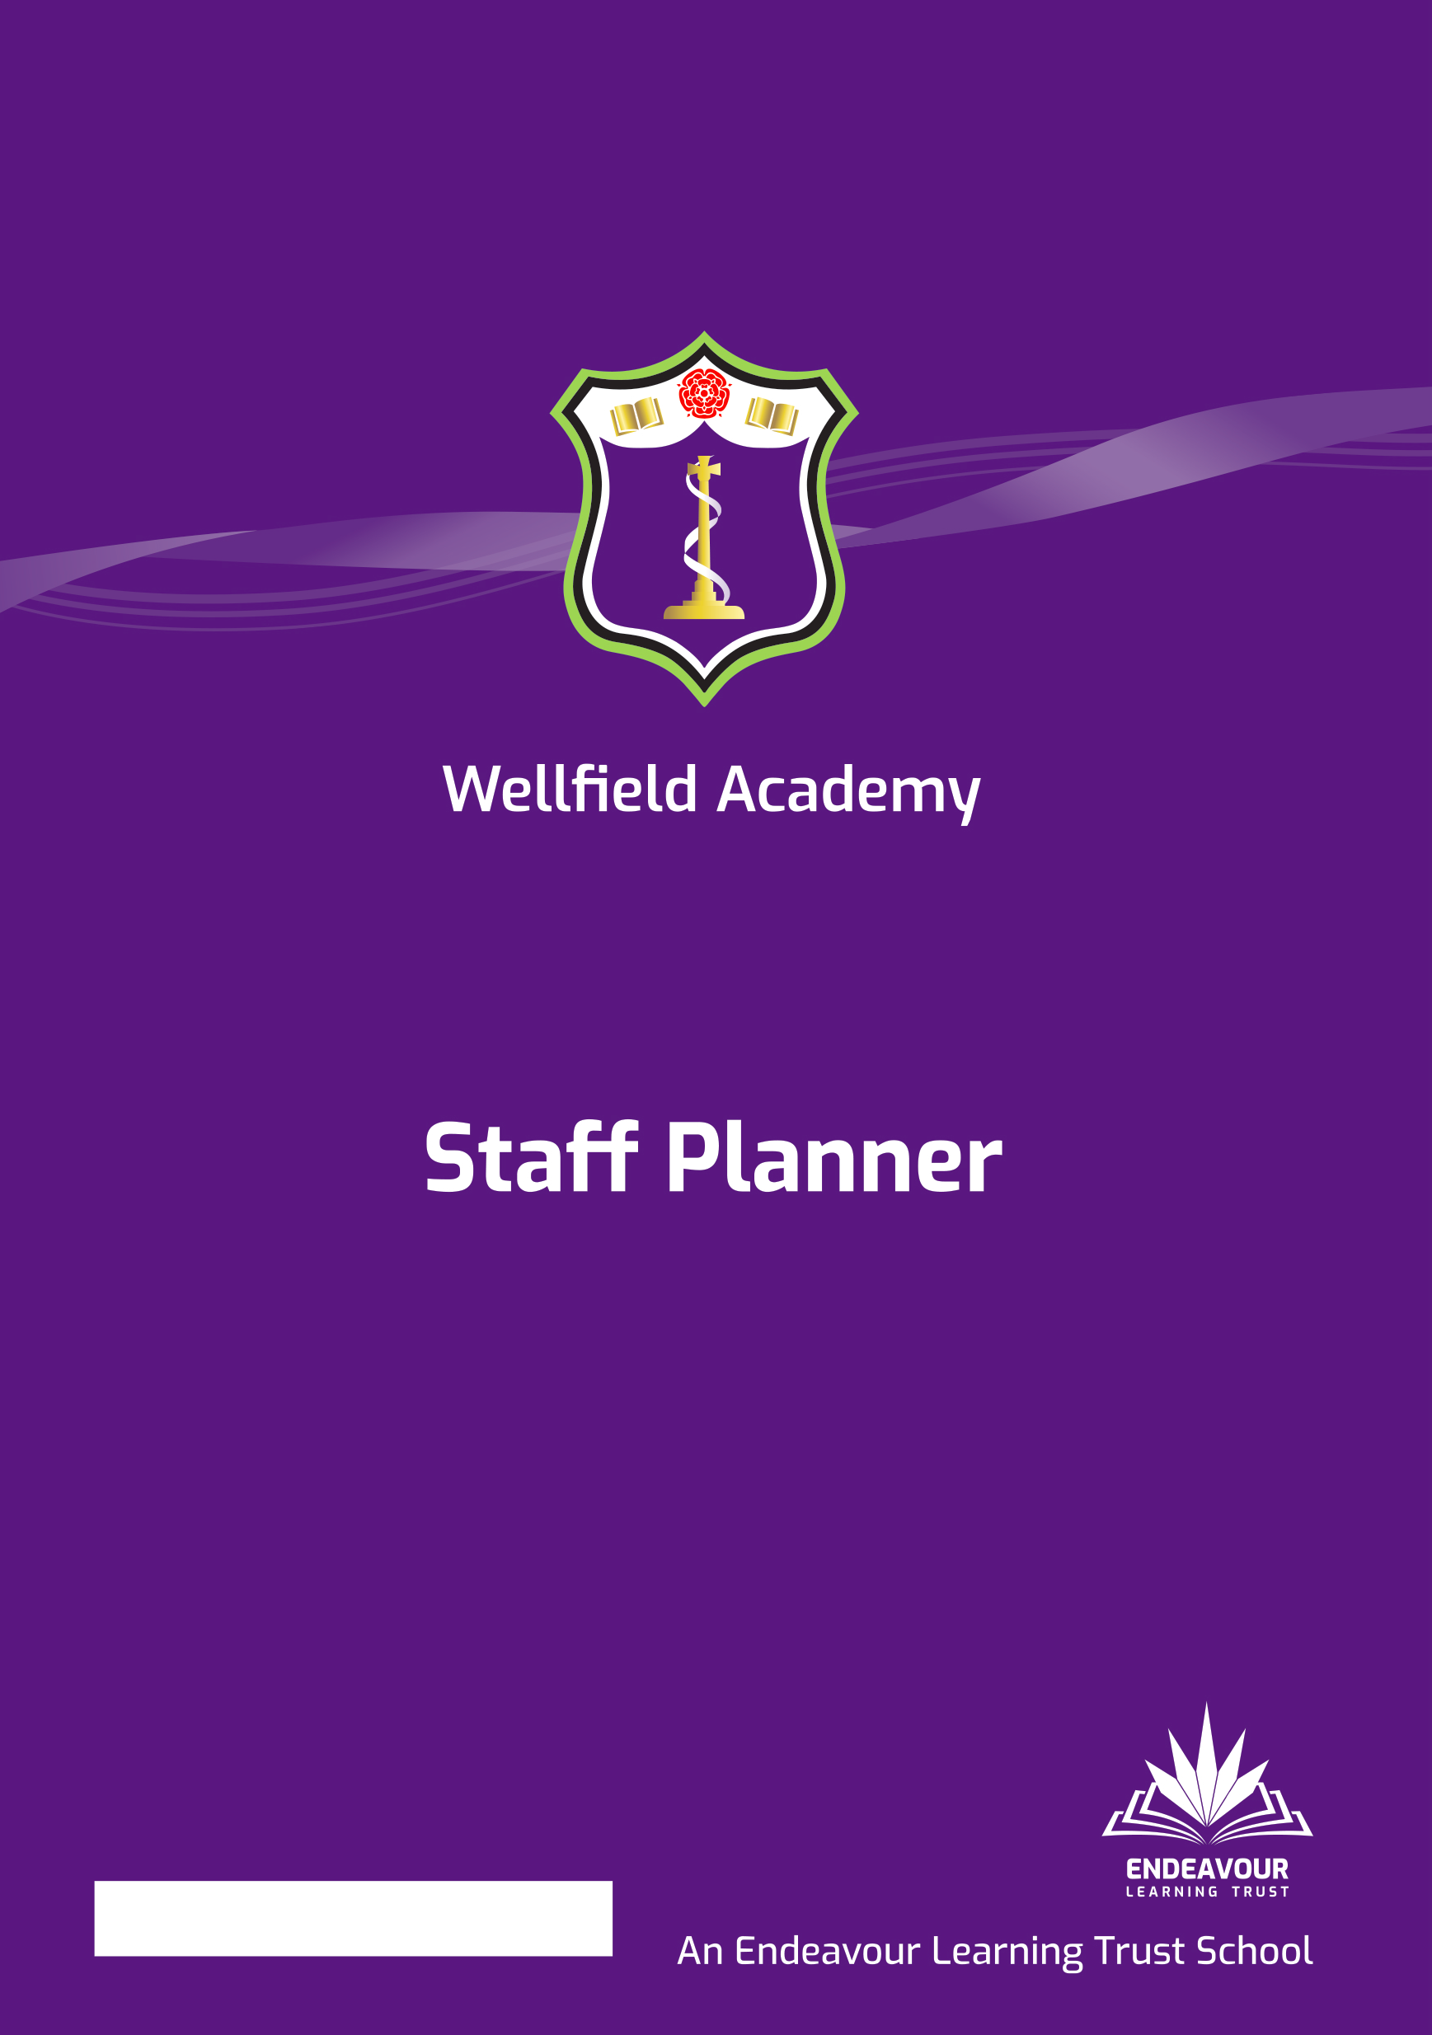
Commitment to Inclusion & Ambition through The Wellfield Standard

Parent & Student
Culture & Expectations Handbook
2025-26

Trust Values


Realising Potential

Mission Statement:
We will ensure that every child realises their potential

Our Schools are driven by our Trust values:

- Individuality - We are firmly committed to recognising, celebrating and investing in the individuality of all of our children and young people, each of our colleagues and the distinct ethos and identity of each of our schools, whilst remaining united by our core values. We don’t believe in a “one size fits all” approach, and will adapt our provision to meet individual needs.
- People Centred - Our work is driven by our responsibility to every individual within our Trust community. Every person deserves to be treated with respect, dignity and kindness. We demonstrate empathy and humility in our approach, ensuring that our Trust provides an environment where every individual feels confident to be their true authentic self.
- Belonging - Equity of opportunity is central to our practice and we will be relentless in our endeavour to identify and remove barriers that prevent full inclusion. Our culture extends beyond tolerance to one where difference is embraced and every individual is valued and celebrated for their unique contribution to our community. Every individual is a full member in our community.
- Transformational - We believe in the promise of each individual across the Trust and will ensure we inspire, support and challenge in proportionate measure, so that we all thrive and are able to achieve our own individual successes. We are bold in our approach, stretching perceived boundaries, to go further for our children, colleagues and communities. We continually develop our approach to respond to changes in the communities we operate within to support every child, colleague and partners to realise their potential.
- Togetherness - We are a proud family of schools bonded by our Trust vision, priorities and values. We work as one team in school, across our Trust and with our wider partners for the benefit of the communities we serve. Our collaborative approach inspires us to be bold and brings us together in ways that help us to make a difference. We are better together.

Commitment to Inclusion & Ambition through The Wellfield Standard

Intent

The aim of Commitment to Inclusion and Ambition is to ensure that students are nothing but their best every day. It helps to:
- Culture of high challenge, high support/ warm-strict
- Develop a sense of belonging
- Enhance relationships between staff and students
- Celebrate success
- Address any issues in a student centred manner
- Provide clarity, structure and a framework which drives the culture every day

#ThisIsWhatWeDo

Commitment to Inclusion & Ambition through The Wellfield Standard

Our Culture

At Wellfield, every student has the right to learn in a safe, happy, and positive environment. You also have the right to feel that you belong to our school community. To make this happen, we need a school where everyone works together to create an orderly, structured, and positive environment.

Why Culture Matters
The way we do things around here – our school culture – affects how we behave. If the culture is positive, behaviour is good. If we only focus on behaviour, we often react to the negative instead of celebrating and encouraging the positive.

At Wellfield, the adults in school are responsible for creating the right culture. But students play a key role too. The culture of our school is shaped by everyone’s actions, and we all contribute to it. When we all follow routines and live by our values, the school becomes a place where:
- Students achieve more academically and socially
- Time is used for better and more learning
- Staff and students feel happier and more supported

How you can help to create a positive culture:
- Follow the Wellfield Standard every day
  - Show respect to everyone
  - Try your best in lessons and activities
  - Take care of yourself and others
- Be ready to learn
  - Come to school on time with the right uniform and equipment
  - Participate fully in lessons
  - Focus on learning rather than distractions
- Respect routines and procedures
  - Follow instructions promptly
  - Move around school safely and calmly
  - Use positive language and behaviour at all times
- Support each other
  - Encourage classmates when they do well
  - Include everyone in group activities
  - Speak up if someone is being treated unfairly

The Big Picture
School culture doesn’t happen by chance – it depends on all of us. While adults create the foundation, students make it real every day. By following the Wellfield Standard, routines, and expectations, you help make our school a place where everyone can succeed, feel valued, and achieve their best.

Remember: your actions matter. When you contribute positively to our culture, you make learning better for yourself and everyone around you. Together, we make Wellfield a school we’re all proud of!

#ThisIsWhatWeDo

Commitment to Inclusion & Ambition through The Wellfield Standard

Cultural non-negotiables- The 4 Ps

At Wellfield, we follow the 4 Ps to make sure everyone in school feels supported, respected, and motivated to succeed. These are the expectations all staff follow every day, and they help create a safe, positive, and high-expectation environment for students and staff alike.

1. Praise
What it means: We celebrate your effort, attitude, and achievements.
Why it matters: Being praised motivates you, encourages good behaviour, and helps you build confidence.
What this looks like for you:
- Trying your best in lessons and activities
- Listening to and accepting praise from teachers
- Celebrating your classmates’ successes too
How you can commit to Praise:
- Recognise your own effort and improvements
- Encourage and support your classmates when they do well
- Reflect on your achievements regularly

2. Positive Culture
What it means: We all create a friendly, respectful, and inclusive school where everyone feels they belong.
Why it matters: A positive culture helps you feel welcome, engaged, and part of the school community.
What this looks like for you:
- Being polite and respectful to staff and classmates
- Smiling, saying good morning/afternoon, and using positive language
- Respecting others’ opinions and differences
- Following our school values in lessons and around school
How you can commit to Positive Culture:
- Treat everyone with respect, even if you disagree
- Include others in conversations, activities, and group work
- Speak up if you see someone being treated unfairly

3. Planning
What it means: Staff prepare lessons and activities that meet your learning needs.
Why it matters: Thoughtful planning helps you learn effectively, keeps lessons interesting, and supports everyone to succeed.
What this looks like for you:
- Engaging with lessons and activities
- Asking questions if you don’t understand
- Listening and responding positively when staff explain or guide you
How you can commit to Planning:
- Come to lessons ready with all your equipment and materials
- Focus on learning and use class time wisely
- Take responsibility for completing homework and tasks on time
- Reflect on your learning and set personal targets

4. Pastoral Support
What it means: We help you with your emotional, social, and personal development.
Why it matters: Feeling supported and safe helps you focus, learn, and thrive.
What this looks like for you:
- Talking to staff if you have worries or need guidance
- Using 1:1 support or interventions when offered
- Engaging in school activities that support your well-being
How you can commit to Pastoral Support:
- Be honest about how you are feeling and seek help when needed
- Support your peers and show kindness to others
- Take part in school initiatives that promote well-being
- Reflect on your behaviour and attitudes and make positive changes

Your Commitment to the 4 Ps:
As a Wellfield student, you are expected to actively follow the 4 Ps every day. This means:
- Trying your best and celebrating effort (Praise)
- Being respectful and inclusive (Positive Culture)
- Being prepared and responsible for your learning (Planning)
- Looking after yourself and others (Pastoral Support)

By committing to the 4 Ps, you help make Wellfield a school where everyone can do their best, feel valued, and achieve success.

#ThisIsWhatWeDo

Commitment to Inclusion & Ambition through The Wellfield Standard

Being Aspirational
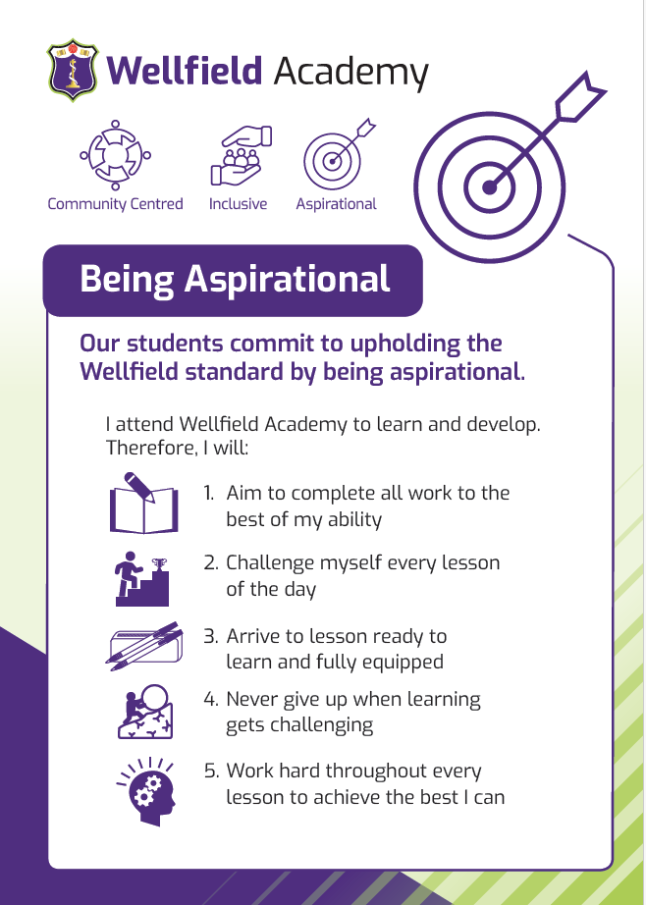

Commitment to Inclusion & Ambition through The Wellfield Standard

Being Inclusive
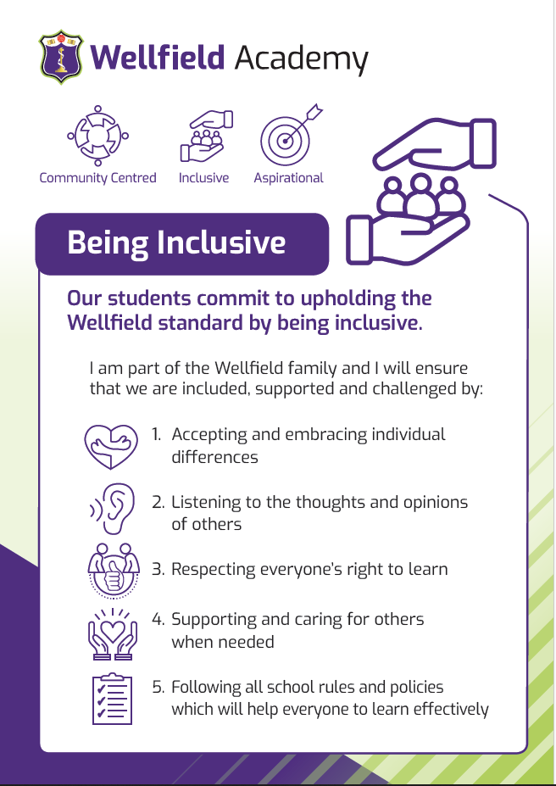

Commitment to Inclusion & Ambition through The Wellfield Standard

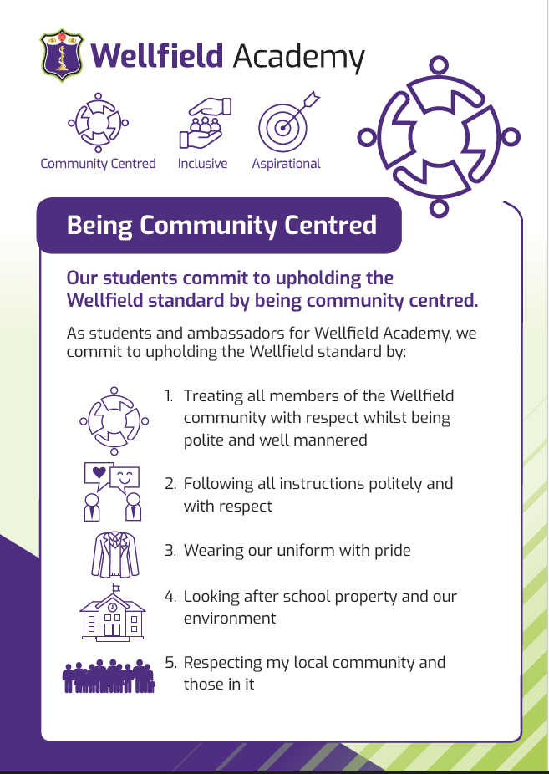
Being Community Centred
Commitment to Inclusion & Ambition through The Wellfield Standard

Our Routines

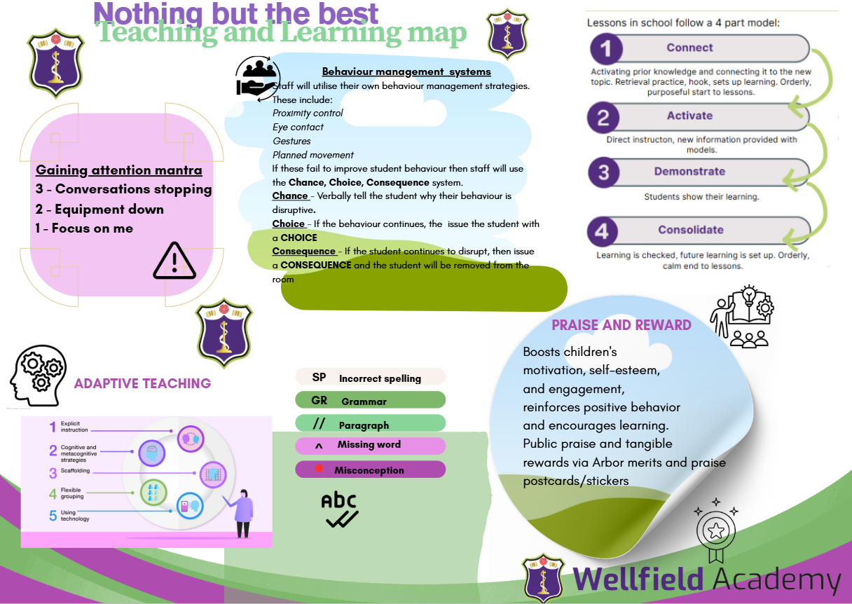

#ThisIsWhatWeDo

Commitment to Inclusion & Ambition through The Wellfield Standard

Communication

Effective communication with parents and carers is a vital part of our school culture and plays an essential role in supporting every student’s wellbeing and learning. We value open, respectful, and timely communication that fosters strong partnerships between home and school. Staff are encouraged to use a range of communication methods—including phone calls, emails, and our school’s digital platforms—to ensure information is shared clearly and efficiently. Urgent or important matters should be addressed immediately or as soon as possible to ensure student safety and wellbeing. For non-urgent enquiries, staff will respond within 48 hours during the school week. This approach helps maintain trust, transparency, and collaboration between staff and families, ensuring the best outcomes for our students.

Methods
- Arbor
- Email- ask@wellfieldacademy.org
- Phone- 01772 421 303
- Website- www.wellfieldacademy.org
- Facebook- WellfieldAcademy
- Twitter/X- @WellfieldAcad
- Parent drop ins
- Parents’ Evenings
- Parental Praise & Raise: https://forms.office.com/pages/responsepage.aspx?id=1yyn0vIGMUC1ynqX3Aoe4_XwAgC92VJKunGu-xy6stlUQklXTkRBS09WUUxKVTVMSUtXQUkyODk2QyQlQCN0PWcu&route=shorturl&fsw=0

#ThisIsWhatWeDo

Commitment to Inclusion & Ambition through The Wellfield Standard

Systems for recognition, rewards and celebration

We aim to create a culture of celebration in an environment where students are supported to become the best they can be whilst feeling valued in doing this. To this end, these guidelines have been developed to;
- Encourage and acknowledge consistently positive engagement in learning for each subject;
- Acknowledge good attendance and punctuality;
- Acknowledge the positive contributions and/or impact made by students both in and outside of the classroom;
- Acknowledge students who make a special contribution to school events or aspects of school life;
- Ensure that achievement points and rewards are consistently and fairly applied;
- Develop a sense of community and acknowledge year group, tutor and/or house achievements;
- Celebrate myriad occasions of success

Achieving Merits
Every student has the opportunity to earn additional merits on a daily basis in recognition of their contributions, effort, achievements, attendance, engagement and progress. These merits can be issued by all staff members, both teachers and support colleagues. These merits should be consistently and fairly awarded to each student’s individual total throughout the year and all staff should actively look to find opportunities to praise and reward students.

Celebrating individual success on a regular basis
We acknowledge that it is important to recognise and celebrate success on a regular basis and, although there are half termly/termly rewards for students to work towards, we aim to acknowledge good engagement on a regular basis. Some rewards may be issued on a weekly or fortnightly basis whilst others might be issued sporadically.

- Phone calls home
- Postcards
- Stickers
- Milkshake with the Headteacher (weekly)
- Weekly tutor presentations (every Monday)
- Weekly year group Assemblies
- Dining room fast pass
- SLT Award (certificate)
- Headteacher’s Award (certificate)
- ‘Nothing but the Best Work Wall’ and celebration of work displays
- WOW Wednesday
- Messages within the Wellfield Weekly newsletter

All staff within the school will have access to postcards and stickers which will be distributed occasionally as they see fit. Similarly, certificates, both hard and electronic copies, will be available for distribution to students as appropriate.

All of the above will be celebrated and acknowledged in different ways. For example, some will be highlighted in our weekly celebration newsletter, called Rewards Round Up, whilst others will be posted on social media and/or communicated via Arbor.

Half termly rewards
Each year will hold a rewards assembly to recognise and celebrate the successes of individuals and tutor groups during that term/half term. At the end of every half term, some students will receive rewards to acknowledge their effort and engagement. These include;
- Subject Awards - One student per class in every year group with one overall winner
- Attendance Awards – recognising the most improved and highest attenders

Termly rewards
At various points in the year, students will receive rewards to acknowledge their effort and engagement.

Gold, Silver, Bronze Merit Awards
Achievable at the end of each term:
- Gold
The top individual merits achiever, along with the next highest male and female merits achiever from each year (approximately 15 students in total) will be provided with a free VIP lunch meal and be awarded an educational voucher.

- Silver
The next highest merits achiever, along with the next highest male and female merits achiever, from each year (approximately 15 students in total) who did not receive a gold award will be provided with a free VIP lunch meal and have their names put into a random prize draw to win prizes such as an educational voucher.

- Bronze
The top 20% merits-achievers from each year will have their names put into a random prize draw to win prizes such as an educational voucher.

End of Year Rewards
Endeavour Awards
- Achievable at the end of the school year
- Nominations completed by subject teachers to acknowledge students who have consistently demonstrated ‘Endeavour’ qualities of resilience, perseverance and commitment
- Bronze, silver, gold and platinum awards are made dependent on overall frequency of nominations and this may vary by year group
- Awarded in end of year assembly with parents invited as appropriate depending on numbers (e.g. only Platinum, Gold and Silver)
- Individual subject awards (1 or 2 for example) that don’t meet bronze threshold acknowledged by letter

Subject Learner of the Year
- Awarded to one student in every year group based on nominations from subject teachers

Learner of the Year
- Awarded to one student in each year group based on a range of data, evidence and nominations from all staff. Certificate, voucher, VIP lunch and parents invited in for assembly.

Receiving Team Rewards
At key stages during the year, merits totals will be used to reward individuals, tutor groups and year groups. These will include:
- Tutor group of the week- rewarded with a trophy
- Tutor attendance winners- rewarded with a trophy
- Tutee of the week- rewarded with a further merit and small ‘Star’ trophy for each individual
- Year group net merits winners- announced within Rewards Round Up newsletter

Commitment to Inclusion & Ambition through The Wellfield Standard

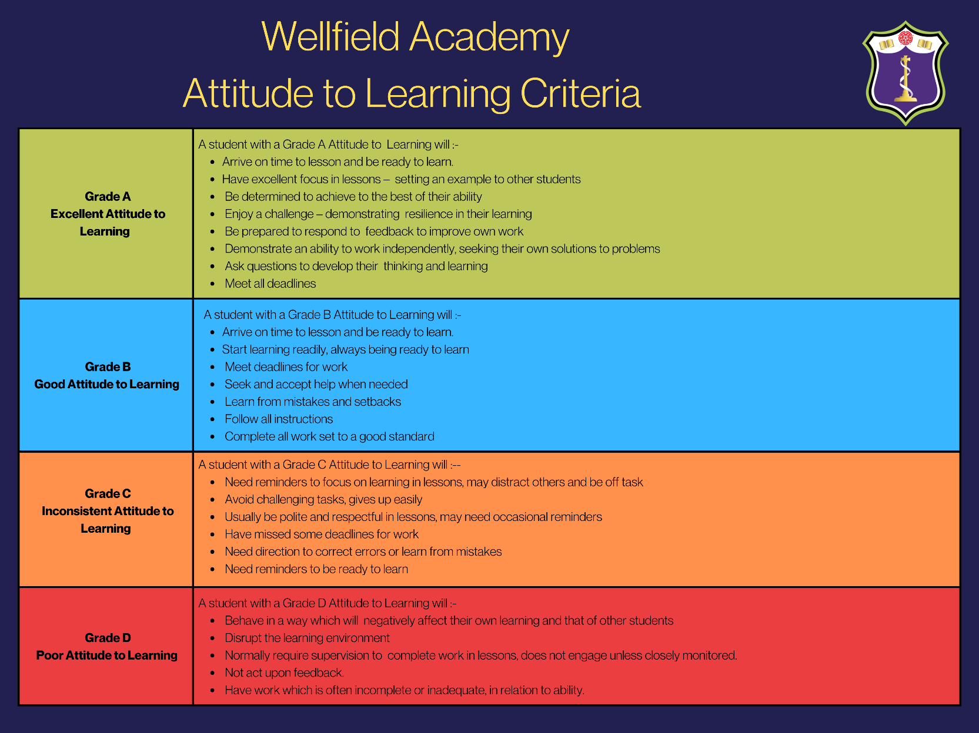
Attitude to Learning

#ThisIsWhatWeDo

Commitment to Inclusion & Ambition through The Wellfield Standard

Consequences (classroom based)

We are all responsible for the standards and behaviour in our school; a teacher and other supporting adults are responsible for creating a positive climate for learning in a classroom. We aim to have simple rules and expectations which are communicated consistently and fairly applied. There is a predictability about our work because we establish routines, share information and repeatedly give signals about transitions. As a staff team, we will explicitly teach the behaviours we expect so that everyone has the best opportunity to succeed – students should not need to guess our expectations. This will ensure that all of students have an equal and fair chance to thrive and learn in an atmosphere of respect and dignity.

Our principle is ‘warm strict’ with high challenge and high support centred around our expectations of ‘Nothing but the best’ and core values of aspirational, inclusive and community centred. A caring approach and definite boundaries are not mutually exclusive. To have defined boundaries and high expectations for conduct and learning demonstrates care.

Our aim is for our students to be engaged in the learning process. Supportive measures and reasonable adjustments should be made for students with additional needs as suggested by the Learning Support Team and especially the student’s Passport.

In order to achieve the behaviours and attitudes we expect, we will:
- Explicitly teach these at whole school level, through the tutor programme and in every classroom
- Model behaviours as the norm (social behaviours or learning behaviours)
- See the opportunity to reboot as a normal part of school life that reinforces our commitment to our standards.
We expect:
Kind words and actions | Positive body language for learning
Good manners | One person talking, everyone listening
Appreciation of others | Following specific instructions
Respect for a range of opinions | On task and engaged in learning

We will reteach, encourage, praise and reinforce the behaviours when things are going well; everyone is more receptive and will listen to correction in moments of calm. As adults we must establish, observe, celebrate and narrate the positive (rather than seeking the negative). In doing so, we flood our students with the social norms that are acceptable in our classrooms, and thus we create the culture of our school, where learning can flourish.

For example:

Teacher Explanation or Direction | Related to a learning activity
Front-loaded expectations | ‘Answer this question by writing on your whiteboards.’
Specify the conditions in which you expect an activity to be completed | ‘This task should be completed in silence.’  ‘In a moment, I’ll ask you to stand in order to discuss this question with your partner.’
Praise those who are doing the right thing | ‘Thank you to those of you whose pens are down and are ready to listen to my next explanation.’
Check for understanding | ‘Niamh, please summarise the explanation for the class.’
Celebrate mistakes/misconceptions when they arise | ‘I’m really pleased you’ve made that mistake, Tom! Let’s see if we can dig into that a bit further and correct that…’
Specify the time limit students have to complete a piece of work | ‘It is 11.45, you have five minutes, 11.50 to compose your ideas before we share. Go!’
Be seen looking – observe | Be a vigilant presence around the room, especially the perimeter for maximum line of sight.  ‘Watch the classroom at all times for rudeness, bullying, mocking or discrimination, and banish these things forever.’  Bennett, Tom. Running the Room: The Teacher's Guide to Behaviour (p. 75).
Narrate (and gesture) the positive | ‘Thank you, so far I can see ideas and there is evidence of use of the key vocabulary from the board.’
Constantly celebrate the values you want to inculcate. | ‘Fantastic, Lucy, I’m really glad to see you didn’t give up and really tried your best to check all your spellings. Perseverance helps you to improve your work.’
Anonymous individual correction | ‘Nearly everyone has a growing list of ideas, just over four minutes left.’
Private individual correction  Eye contact/Non-verbal cues and gestures | Pen tap/gesture or ‘Jack, explain the task to me.’

Having employed a combination of the above strategies, if the teacher feels that the student is choosing not to correct their behaviour to meet the expectation despite individual encouragement, then we use the school’s behaviour interventions to prioritise the learning in the room:

Classroom Procedures- Consequences
 | CHANCE  We give all students opportunities to engage with the activity in the room through a variety of strategies. Students who are actively not meeting behaviour expectations should have this brought to their attention. This must be a clear VERBAL warning with a positively framed explanation given to the student at an appropriate time.
 | CHOICE  Students who are still not meeting expectations should have this brought to their attention. Issue a clear warning using the language of ‘Choice’ and redirect the student indicating the behaviour that is desired. Teacher must record the Choice on Arbor
 | INTERVENTION DISCUSSION  To ensure that students, where possible, remain in the classroom to continue their learning, teachers may request an ‘Intervention Discussion’ which is requested via Arbor. The staff member undertaking collections will take the student out of the lesson for a short period to reflect upon what can be done to address any issues and to prevent a Consequence.
 | CONSEQUENCE  If the same student resumes behaviour that is classed as a serious issue/disruptive then the member of staff should bring this to their attention and request via Arbor for the student to be collected from class as a Consequence. Teachers must complete the log on Arbor immediately and have written work available to allow the student to access the learning outcomes. The teacher must verbally explain the reason or the consequence the collecting staff member.  The student will undertake a short reflective discussion with the staff member before completing their work in the room of a Subject Leader or another appropriate staff member.  All Consequences will receive a same day detention.

Commitment to Inclusion & Ambition through The Wellfield Standard

Restorative Conversations

Every incident that disrupts learning or relationships will be followed by a restorative conversation. This ensures accountability, repair of relationships, and learning from mistakes.

Expectations:
- The conversation should take place promptly, in a calm and private setting.
- All staff are expected to lead or facilitate these conversations consistently.
- The conversation should genuinley be a two way discussion and not another opportunity for the student to be sanctioned

Guidance for questions to ask:
- Can you tell me what happened? – Encourage the student to explain in their own words.
- What were you thinking at the time?- Encourage reflection
- What have you thought about since?- Help students to understand their thoughts and feelings
- Who has been affected and in what way? – Help them understand the impact of their actions.
- What needs to happen to make things better? – Support ownership and responsibility.
- How can we prevent this in the future? – Guide reflection and growth.

Why it matters: Restorative conversations build trust, teach responsibility, and strengthen the school community by focusing on solutions rather than blame.

#ThisIsWhatWeDo

Commitment to Inclusion & Ambition through The Wellfield Standard

Detentions

Purpose of detentions
A detention (break, lunch or after school) may be issued as a consequence outside of the classroom when:
- A student has not responded to a warning from a member of staff. For example, if a student continues to be disruptive on corridors despite being clearly warned by a member of staff
- A student has been disrespectful, ignored or challenged a member of staff
- A tutor, Head of Year or Head of Key Stage identifies a concerning pattern of behaviour (eg persistently eating on corridors) and requires further escalation

Expectations in detentions
Students are expected to demonstrate exemplary attitudes to learning within all detentions. Students must be punctual to their detentions. If late, or demonstrating any concerning attitudes to learning, staff member will utilise the Chance, Choice and Consequence process. If a student reaches a consequence, they will be asked to leave the detention and escalation will take place. Escalation from after school detention will result in escalation to a one-hour SLT detention on a Friday, 3.10-4.10pm.

Upon arrival at detention, students should:
- Arrive by 3.15pm (supervising HOY should arrive by 3.10pm with the detention tray)
- Line up quietly and sensibly outside of the old gym/room
- Wait to be seated by staff members
- Ensure uniform remains smart and that relevant equipment is taken out for the detention

Within detentions, after completing the detention reflection sheet, students may:
- Complete homework
- Complete mindfulness colouring
- Complete other appropriate tasks such as reading/revision
Students are not allowed to place their heads on desks but may sit in silence throughout the whole of detention.
If a student arrives late for an after-school detention without a reasonable explanation, the time will be added onto the end of the detention. The length of the detentions should always match what is stated in this policy (eg after school should always be for 45 minutes).

Resources
A detention resource tray will be shared with the supervising staff member. This tray must include:
- A copy of this document (the detention process)
- The detention register
- Detention reflection sheets
- Mindfulness colouring sheets
- Coloured pencils
- Any other appropriate resources for students to complete
- At the end of the detention, all completed Reflection sheets should be returned to the relevant HOY to be stored in a student folder

#ThisIsWhatWeDo

Detention Types
An overview of detentions is given below
Type of detention | Time of Detention | Issued by | Supervised by | Location
Lates Detention | Break / Lunch / After school | Attendance Support Worker/ Manager | Attendance Support Worker/ Manager | Old reintegration room
Consequence Detention / unnecessarily late to class x2 | After school | Class teacher | Head of Year (SLT support at start) | Old gym
Behaviour Detention | Lunch/after school | SLT / Student Services staff | Head of Year (SLT support at start)
Departmental Detention | After school (45 minutes- Monday to Wednesday) | Teachers | Heads of Department/Subject
SLT detention | Friday after school (one hour) | SLT/ staff supervising detentions | SLT

Lesson consequence detentions
- One consequence in a day= 20 minute detention (3.15-3.35pm)
- Two consequences in a day= 30 minute detention (3.15-3.45pm)
- Leaving a classroom without permission= 45 minute detention (3.15-4pm)
- Being collected from another classroom after being moved there during a Consequence= 45 minute detention (3.45-4pm)
- Refusal to move into another classroom- escalated to SLT Link for the year group to decide upon appropriate consequences

Break Time Detention (10 minutes in length- 11.15-11.25am)
- Late to school first time in week
- Late to registration

Lunch Time Detention (15 minutes in length- 1.35-1.50pm)
- Missed break detention
- Chance, Choice and Consequence in break detention
- Second late to school/tutor in a week
- Used as a consequence for poor behaviour during unstructured time that cannot be resolved immediately by a staff member (persistently out of bounds/unkind or unsafe behaviour)

After School Detention (All in old gym- 3.15pm start)
- Missed lunch detention
- Consequence from lunch detention
- Third late to school/tutor in a week
- Collection from lesson (‘Consequence’)
- Used as a consequence for disrespectful behaviour towards staff (including indirect swearing and inappropriate language)

SLT Detention (Friday only- 60 minutes in length)
- Consequence in any after school detention
- Any other reason as decided by SLT
- Any Consequences issued on Friday will also undertake their detention within SLT and HOY supervising in addition
#ThisIsWhatWeDo

Commitment to Inclusion & Ambition through The Wellfield Standard

Other Consequences

Head of Year Day
HOY Day will be utilised by Heads of Year as an escalation process within the policy.
- Why? HOY day is used to prevent students being able to mix with peers throughout the whole school day and to reflect upon their choices such as uniform infringements
- Time? 8.45-3.10pm
- Where? This area is located in the student services room
- Tutor supervision and period 1? From 8.45-9.15am is supervised by Head of Year. A break/lunch order form must be completed during this time and handed to the office/canteen.
- Lessons? All lessons are supervised by Heads of Year and students should complete the work set paper based work by the subject teacher for their lesson.
- Break? 11.05-11.25am. Toilet break at 11.05am before returning to Student Services or supervising HOY for break 11.10-11.25am
- Lunch? 1.25-2.00pm. Toilet break at 1.25pm before returning to Student Services or supervising HOY for lunch- 1.30-2.00pm
- Work? When it is planned that a student will spend time in HOY day, this will be added to the daily ‘work request’. Teachers must set work for every lesson. This should be clearly labelled to avoid any issues with students not knowing which work to complete.
- Support? If a student is demonstrating challenging behaviour within this room, the teacher should call the school office to request support. The office staff should follow the same process as a Consequence when requesting support by contacting a HOY, SLT, HOY, HOD/S.

Reflection (previously called Isolation)
Reflection will be utilised by SLT, Deputy Head for Behaviour and Attitudes and Heads of Year as an escalation process within the policy.
- Why? Reflection is used to prevent students being able to mix with peers throughout the whole school day and to reflect upon their choices
- Time? 8.45-3.10pm
- Where? This room is located in the Reflection Room (next door to the library- bottom of Ambleside building)
- Tutor supervision? From 8.45-9.15am is supervised by Head of Year. A break/lunch order form must be completed during this time and handed to the office/canteen.
- Lessons? All lessons are supervised by subject teachers and students should complete the paper based work set by the subject teacher for their lesson. Break and lunch are supervised by a member of SLT.
- Break? 11.05-11.25am. Toilet break at 11.05am before returning to Reflection for break 11.10-11.25am
- Lunch? 1.25-2.00pm. Toilet break at 1.25pm before returning to Reflection for lunch- 1.30-2.00pm
- Work? When it is planned that a student will spend time in Reflection, this will be added to the daily ‘work request’. Teachers must set work for every lesson. This should be clearly labelled to avoid any issues with students not knowing which work to complete.
- Support? If a student is demonstrating challenging behaviour within this room, the teacher should call the school office to request support. The office staff should follow the same process as a Consequence when requesting support by contacting a HOY, SLT, HOY, HOD/S.

Suspension
All students are entitled to an education where they are protected from disruption and can learn in a calm, safe and supportive environment. Suspension and permanent exclusion will be used in response to serious incidents or in response to persistent poor behaviour/breaches of school policy which has not improved following in-school sanctions and interventions. All suspensions must be followed by a reintegration meeting using a set pro forma and they should include SLT for serious incidents or recidivists.

#ThisIsWhatWeDo

Commitment to Inclusion & Ambition through The Wellfield Standard

Interventions & Support

When students need additional help, staff should take proactive steps to ensure they can succeed. Possible actions include providing one-to-one support, adjusting lesson tasks, offering targeted feedback, checking in regularly, involving pastoral or specialist teams, setting clear goals with the student, and maintaining consistent communication with parents or guardians. Using a combination of these strategies helps students overcome challenges, build confidence, and achieve their full potential.

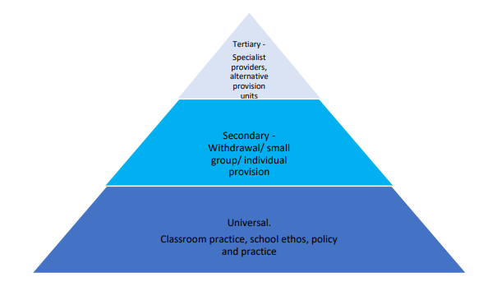

Other interventions to be considered:
- Use of sensory spaces  - Wellbeing room booking  - Subject intervention  - Reviewing Pupil Passports  - Form Tutor support  - Attendance Team intervention  - Pastoral Support Plans  - Referral to SEND  - Support from Endeavour Thrive  - Head of Year referral  - Contact with parents  - Recognition Report  - Level 2 Early Help referral  - Monitoring Report | - Attitude to Learning Reports  - Meeting with parents  - SNAP assessment  - ELT Vulnerable Pupil Panel  - Early Help Assessment  - Level 3 Early Help referral  - Off Site Direction  - Alternative provision offer  - CAMHS referral  - Reduced timetable (for health grounds only)  - Children’s Champion referral  - Educational Psychologist Assessment  - Level 4 referral to Children’s Social Care  - Seclusion

Commitment to Inclusion & Ambition through The Wellfield Standard

Interventions & Support

When a student’s behavior escalates, staff should follow a clear, consistent process to support them effectively. The stages include: calmly addressing the behavior and setting clear expectations, giving a reminder or verbal warning, providing a short reflection or time-out if needed, involving a senior staff member or pastoral lead for additional support, and, where appropriate, engaging parents or guardians. At each stage, the focus is on de-escalation, maintaining safety, and helping the student reflect on their actions to repair relationships and prevent future incidents.
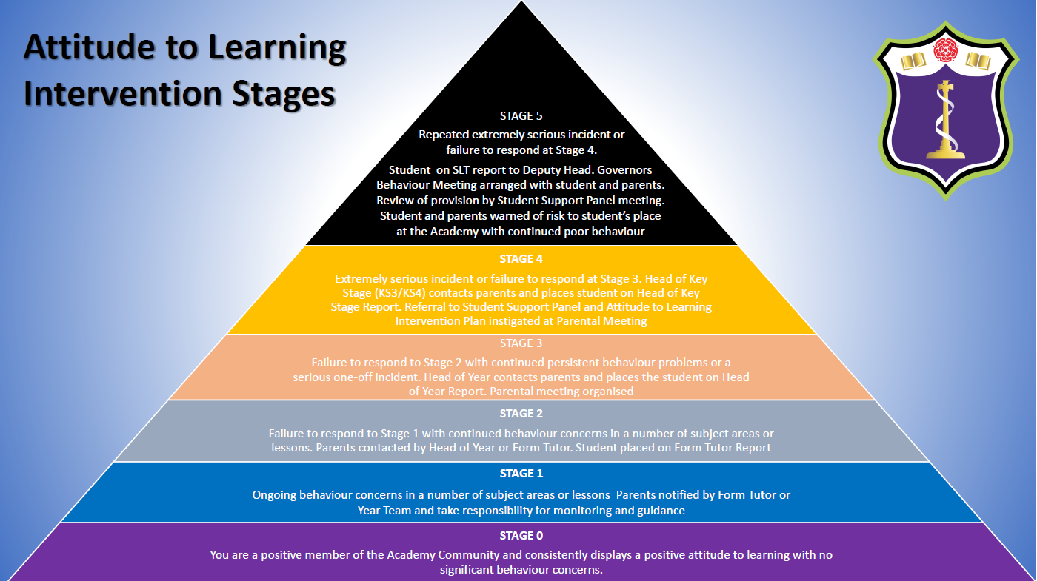

#ThisIsWhatWeDo

Commitment to Inclusion & Ambition through The Wellfield Standard

Home School Agreement

At Wellfield Academy we are very fortunate to have supportive parents who recognise that educating young people is a process that involves a strong partnership between home and school, positive working relationships and clear lines of communication. The aim of this home-school agreement is to work together to ensure a safe and positive school environment.

Parent/ Guardian Responsibilities:
I/We agree to
- Setting a good example to all students in the way they behave, communicate and dress when on the school premises
- Treating all school personnel, students and other parents with dignity and respect
- Ensure that my child arrives at school on time and before 8.38am and that they are prepared for lessons that start at 8.40am;
- Ensure that my child wears full school uniform appropriately;
- Ensure that my child attends regularly and record absence via Arbor Attendance with an explanation if my child is absent;
- Attend Parents’ Evenings to discuss my child’s progress;
- Support my child with the organisation and completion of homework;
- Support and reinforce the school’s policies and guidelines for rewards and consequences and regularly review my child’s engagement through the school’s Arbor system;
- Let the school know about any concerns or problems that might affect my child’s work or behaviour;
- Work together with staff for the benefit of children. This includes approaching the school to make appointments to discuss and resolve any issues of concern;
- Park with consideration and respect for others when delivering and collecting children from school;
- Keeping pets off the school premises;
- Approach the school with any worries, frustrations or concerns so these can be addressed;
- Working together with staff members for the benefit of their child to resolve any issues or concerns;

Students Responsibilities:
I agree to:
- Commit to The Wellfield Standard which focuses upon being aspirational, inclusive and community centred
- Attend school every day;
- Arrive at school on time before 8.38am;
- Be fully prepared for lessons with the correct equipment;
- Wear school uniform properly and be tidy in my appearance;
- Adhere to the school rules, policies and procedures;
- Do all my classwork and homework to the best of my ability and hand it in to meet the deadlines set by staff;
- Be polite and considerate to others in the school community;
- Respect the school environment and its wider community;
- Strive to reach my individual targets.

Social Media:
Social media and social networking sites play an important role in the lives of many youngsters. This agreement gives clarity to the ways in which social media is used by students, school staff and parents at Wellfield Academy.
- Parents should make complaints through official school channels rather than posting them on social networking sites. Parents who do this will be requested to attend a meeting at which the relationship between school and home will be discussed and parameters set;
- Parents should not post malicious or fictitious comments on social networking sites about any member of the school community. In the event that any student or parent/carer of a child educated at Wellfield Academy is found to be posting libellous or defamatory comments on Facebook or other social network sites, they will be reported to the appropriate 'report abuse' section of the network site. The school will also expect that any parent/carer or student removes such comments. In serious cases the school will also consider its legal options to deal with any such misuse of social networking and other sites;
- Cyber-bullying and the use by any member of the school community to humiliate or intimidate another by inappropriate social network entry will be dealt with as a serious incident of bullying.

In order to support a calm and safe school environment, the school does not tolerate from parents/guardians:
- Disruptive behaviour which interferes with the operation of a classroom, an office area or any other part of the school grounds;
- Using loud and/or offensive language;
- Threatening harm or the use of physical aggression towards another adult or child;
- Approaching someone else’s child in order to discuss or chastise them;
- Physically damaging or destroying school property;
- Abusive, threatening, malicious or inflammatory emails, phone or social network messages;
- Smoking/vaping/e-cigarettes and the consumption of alcohol or other drugs or accessing the school site whilst intoxicated.

#ThisIsWhatWeDo

Commitment to Inclusion & Ambition through The Wellfield Standard

Impact

Every action we take as staff and students contributes to the culture of our school. When we consistently uphold our non-negotiables, model positive behavior, and support students through restorative practices and interventions, we create an environment where students feel a genuine sense of belonging and develop positive attitudes toward learning. The right culture leads to improved attendance, stronger academic progress, and a safe, respectful community. It also enhances staff well-being, satisfaction, and collaboration, making our school a place where everyone-students and staff alike-can thrive and be Nothing but The Best.

#ThisIsWhatWeDo

