Subject: Art & Design Curriculum Map
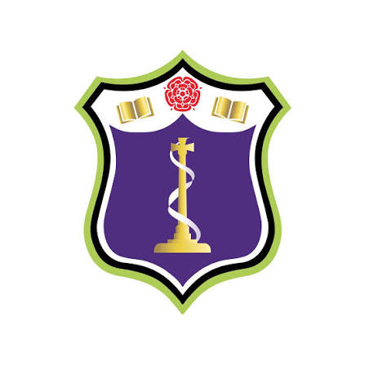
Subject Intent:
The Art & Design curriculum aims to develop creative, confident and reflective learners through a knowledge-rich sequence of drawing, painting, printmaking, sculpture, mixed media and digital practice. Students build technical proficiency, critical understanding and cultural awareness from KS2 through KS5 while preparing for further education and careers within the creative industries.
KS2 national curriculum or KS2 curriculum links | Time | 7 | 8 | 9 | 10 | 11 | KS5 | Careers
Pupils should be taught to develop their techniques, including their control and their use of materials, with creativity, experimentation and an increasing awareness of different kinds of art, craft and design. Pupils should be taught: ♣ to create sketch books to record their observations and use them to review and revisit ideas ♣ to improve their mastery of art and design techniques, including drawing, painting and sculpture with a range of materials [for example, pencil, charcoal, paint, clay] ♣ about great artists, architects and designers in history. | HT1 | Tasty Treats  Artist analysis – Sarah Graham  Obs. drawing, colour theory, watercolour | Colour and form  Gouache painting  Observational drawing  Colour theory | Hands  Observational drawing  Acrylic marker application | OCR: Theme launch, AO1/AO2/AO3/AO4 | Independent projects – component 1 (60%) | A Level Art & Design:  Personal Investigation  Related Study  Advanced drawing  Independent experimentation  Mixed media  Critical analysis  Refinement  Exhibition  Preparation for Higher Education. | Illustrator  Fine Artist  Architect  Graphic Designer  Animator  Photographer  Textile Designer  Product Designer  Game Artist  Teacher  Curator  Art Therapist
 | HT2 | Ndebele Patterns  Artist analysis  Poly printing  Design composition | Marbles  Pencil blending  Observational drawing | Portraiture  Observational drawing  Pencil blending  Scale and proportion | Independent projects – component 1 (60%) | OCR: Ext Task (60%) launch
 | HT3 | Gothic Architecture  Artist analysis -Ian Murphy  pencil / charcoal blending  Mark making | Botanical Studies  Lino printing  Design composition  Mark making  Artist analysis | Digital Distortion  Artist analysis  Photography  Adobe  Water colour blending | Independent projects – component 1 (60%) | Ext Task – Component 2 (40%)
 | HT4 | Lunar New Year  3D lanterns & symbolism  Acrylic paint  Design composition | 3D Graffiti  Typography  3D Construction  Acrylic painting | Watercolour Animals  Observational drawing  Watercolour  Mark making  ink | Independent projects – component 1 (60%) | Ext Task – Component 2 (40%)
 | HT5 | Natural Forms  Marcia Baldwin  Oil pastels blending  Observational drawing | Crushed Cans  Grid method  Enlarged drawing  Pencil blending | Construction  3D construction  Design composition acrylic paint | Independent projects – component 1 (60%) | Ext Task – Component 2 (40%)
 | HT6 | Natural Forms  Marcia Baldwin  Oil pastels blending  Observational drawing | Crushed Cans  Grid method  Enlarged drawing  Pencil blending | Construction  3D construction  Design composition Acrylic paint | Independent projects – component 1 (60%) | Ext Task – Component 2 (40%)

