

Behaviour Policy
September 2025

Trust policy lead | David Clayton – CEO  Heather Fowler – Head of Safeguarding and Welfare
Safeguarding Governor/  Chair of Governors | Helen Dicker  Chair of Trustees
Last Updated | September 2025
Approved by the Governing Body/Board
Date to Review | September 2026

Contents
1.Introduction 2
2.Legal framework 4
3.Roles and responsibilities 4
4. Responding to behaviour: Recognition and consequences 7
5. Removal from classrooms 8
6. Detentions 9
7. Mobile phones 10
8. Prohibited items, searching pupils and confiscation 10
9. Child on child sexual abuse/violence – This section has changed to be brought in line with Safeguarding Policy………………………………………………………………………………………………………………………………11
10. Reasonable force 14
11. Suspension and permanent exclusion 16
12. APPENDIX: SCHOOL PROCEDURES………………………………………………………………………………………………….……..12

- Introduction
Endeavour Learning Trust believes that all members of our communities have the right to a safe and positive educational environment where they can learn and thrive free from disruption, violence, discrimination, bullying and abuse. Every member of our Trust has a responsibility to practice in a way which facilitates this, in line with our Trust values:
Belonging, People Centred, Togetherness, Transformational, Individuality
Endeavour Learning Trust believes:
- We must provide a safe environment for all pupils based on a sense of connection and belonging where they can learn and fulfil their unique potential.
- All behaviour is communication or indicator of need. It is our role to support children in understanding their emotions and needs teaching them effective self-regulation strategies enabling them to communicate, and therefore, behave appropriately.
- It is the job of all adults working for and representing the Trust to model appropriate behaviour at all times, responding to all pupils with praise or challenge.
- Mistakes are part of the learning process, and we recognise that all our students are at various stages of their development. We review and acknowledge, ensuring all adults are doing everything we can to ensure pupil’s needs are met. All staff ensure consistent application of this policy, keeping clear boundaries and maintaining high expectations, thus promoting trusting and mutually respectful relationships.
- We must ensure fair treatment for all, considering individual needs and fulfilling our responsibilities under the Equality Act.
- In listening to and collaborating with pupils and families as partners in their education and to remove any barriers to learning.

Where there is an incident of behaviour that breaches the high standards expected by all schools, pupils will be supported through education, reasonable and proportionate consequences, alongside exploration of the pupil’s circumstances, experiences and needs both within and outside of school and any underlying cause, including additional needs.
All our schools will ensure:

- Culture, ethos and environment – the health and wellbeing of pupils and staff is promoted through the relationships, practice and examples set by staff, including leadership practice, policies, values and attitudes, alongside the social and physical environment
- Teaching – the curriculum is used to develop pupils’ knowledge about health and wellbeing
- Community engagement – schools proactively engages with parents, outside agencies and the wider community to promote consistent support for pupils’ health and wellbeing

Endeavour Learning Trust acknowledges the impact that adversity, past/recent/current trauma, including abuse, neglect and exploitation, can have on a pupil’s development and presentation, including their wellbeing and behaviour. All staff are aware that behaviour can be an indicator that something isn’t right for a pupil and will respond to all incidents with curiosity to explore the pupil’s lived experience with the underpinning principle of safeguarding and wellbeing as paramount.
Endeavour Learning Trust served pupils spanning across educational phases from EYFS up to sixth form. Each individual school has the responsibility to provide developmentally appropriate procedures for their setting in line with this policy, DfE guidance and relevant legislation, attached as an appendix to this policy.
- Legal framework
This policy has due regard to all relevant legislation and statutory guidance including, but not limited to, the following:
- Education Act 1996
- Education Act 2002
- Education and Inspections Act 2006
- Health Act 2006
- The School Information (England) Regulations 2008
- Equality Act 2010
- Voyeurism (Offences) Act 2019
- DfE ‘Use of reasonable force’
- DfE ‘Special educational needs and disability code of practice: 0 to 25 years’
- DfE ‘Mental health and behaviour in schools’
- DfE ‘Behaviour in schools: Advice for headteachers and school staff’
- DfE ‘Keeping pupils safe in education
- DfE ‘Searching, Screening and Confiscation: Advice for schools’
- DfE ‘Suspension and Permanent Exclusion from maintained schools, academies and pupil referral units in England, including pupil movement’
- DfE ‘Early Years Framework’

This policy operates in conjunction with the following Trust and school policies:
- Complaints Procedures Policy
- Child Protection and Safeguarding Policy
- Acceptable Use Policy
- Anti-bullying Policy
- School Uniform and Appearance Policy
- Supporting Pupils with Medical Conditions Policy
- Suspensions and Exclusions Policy

- Roles and responsibilities
The Board of Trustees will have overall responsibility for:
- Ensuring that this policy, as written, does not discriminate on any grounds, including, but not limited to, age, disability, gender reassignment, gender identity, marriage and civil partnership, race, religion or belief, sex and sexual orientation.
- Ensuring this policy is adhered to in line with relevant legislation, DfE guidance and Trust values.
- Handling complaints regarding this policy, as outlined in the school’s Complaints Procedures Policy.
- Ensuring this policy is published on the school website.

The Headteacher, with the support of the Executive Team will be responsible for:
- Establishing a culture of built on Trust values.
- Ensure positive behaviour of all stakeholders.
- The monitoring and implementation of this policy and of the behaviour procedures at the school.
- Establishing and maintaining high expectations of pupils’ behaviour, and ensure appropriate strategies are used to support and intervene where standards are breached.
- The day-to-day implementation of this policy and school based procedures.
- Reporting to the Board of Trustees on the implementation of this policy.

All members of staff, including teaching and support staff, and volunteers will be responsible for:
- Adhering to this policy and applying it consistently and fairly considering the individual needs of pupils.
- Developing relationships with pupils that are conducive to a safe and positive learning experience for all.
- Supporting pupils in understanding and adhering to this policy.
- Work to ensure a calm, orderly and supportive high-quality learning environment.
- Modelling appropriate behaviour at all times.
- Communicate with each other around the needs of pupils, sharing good practice and appropriate strategies for supporting pupils.
- Work closely with external agencies where required.
- Support pupil’s in understanding their own emotions and developing appropriate strategies to help them to communicate and behave appropriately.
- Be aware that behaviour is a form of communication and respond with curiosity to the underlying cause of any concerning behaviour.
- Maintain high expectations for all pupils, ensuring they are not limited by background or circumstances.
- Ensure pupils requiring a personalised approach to behaviour and learning are supported in line with the strategies agreed.
- Keeping the relevant staff up-to-date with any changes or concerns identified from pupil’s behaviour.
- Address any incidents of behaviour in line with relevant legislation, DfE guidance. policy and school-based procedures.

Definitions
For the purposes of this policy, The Trust defines “serious unacceptable behaviour” as any behaviour which may cause harm to oneself or others, damage school environment, damage the reputation of the school within the wider community, and/or any illegal behaviour. This will include, but is not limited to, the following:
- Discrimination – not giving equal respect to an individual on the basis of age, disability, gender identity, marriage and civil partnership, pregnancy and maternity, race, religion or belief, sex, and sexual orientation
- Harassment – behaviour towards others which is unwanted, offensive and affects the dignity of the individual or group of individuals
- Bullying – a type of harassment which involves personal abuse or persistent actions which humiliate, intimidate, frighten or demean the individual being bullied
- Cyberbullying – the use of electronic communication to bully a person, typically by sending messages of an intimidating or threatening nature
- Harmful sexual behaviour/Sexual harassment/violence – sexual behaviour that is problematic, abusive or violent, unwanted conduct of a sexual nature or sexual assault
- Possession of legal or illegal drugs, alcohol or tobacco
- Possession of banned items
- Truancy and running away from school
- Refusing to comply with disciplinary sanctions
- Theft
- Verbal abuse, including swearing, racist remarks and threatening language
- Fighting and aggression
- Persistent disruptive behaviour
- Extreme behaviour, such as violence and serious damage to property
- Any behaviour that threatens safety or presents a serious danger
- Any behaviour that seriously inhibits the learning of pupils
This includes behaviours both online and offline.

- Responding to behaviour: Recognition and consequences
Endeavour Learning Trust believes in working preventatively, embedding and regularly communicating clear and consistent expectations and routines, creating a sense of safety, stability and predictability.
We will support our pupils through a combination of education, recognition, consequences and curious exploration of a pupil’s live experience and any underlying cause or need.
We will communicate with pupils and families about their own/their child/ren’s progress and development, including celebration not only of their achievements but also for their effort, as we recognise every pupil has a unique learning journey which we aim to support through recognition of their individuality. We believe that ‘what you draw attention to, you get more of’ and positive reinforcement through praise and rewards supports pupils in developing confidence and self-esteem which contribute to effective communication and self-regulation.
Instances of unacceptable behaviour will be taken seriously with a focus on the safety and welfare of all. Staff will respond promptly, predictably and with confidence to maintain a calm, safe learning environment. Staff will consider afterwards how to prevent such behaviour from recurring.
When a pupil disrupts learning or behaves inappropriately within the school, there are consequences for those actions. There are many possible consequences to an incident, and schools ensure that the consequence relates very much to the specifics of the incident. Consequences can include sanctions. Consequences should not be considered in opposition to recognition, but rather as two complementary strands of intervention that support children in learning about and understanding the impact of their behaviour on themselves and others, provide an opportunity to resolve the incident and develop new skills to communicate and therefore behave appropriately.
Sanctions are lawful if they are reasonable in the circumstances, proportionate to the circumstances and any special circumstances, such as age, SEND or religious requirements, have been considered.
For sanctions to be lawful, all schools will ensure that:
- The decision to sanction a pupil is made by a paid member of school staff (but not one who the headteacher has decided should not do so) or an unpaid member of staff authorised by the headteacher;
- The decision to sanction the pupil and the sanction itself are made on the school premises or while the pupil is under the lawful charge of the member of staff;
- It does not breach any other legislation (for example in respect of equality, special educational needs and human rights) and it is reasonable in all the circumstances.

All schools will ensure that sanctions do not compromise a pupil’s safety.
A pupil’s behaviour online and via media (e.g. by text message or phone call), including outside of school hours, will be considered within our policies whenever that behaviour could impact on members of our Trust communities or the reputation of the school/ Trust itself.
All known and suspected criminal behaviour will be reported to the police without delay. Staff will refer to the NPCC guidance ‘When to Call the Police: Guidance for Schools and Colleges’.

Schools should consider whether the pupil’s behaviour gives cause to suspect that they are suffering, or is likely to suffer, harm. Where this may be the case, as set out in Part 1 of Keeping children safe in education, school staff should follow the school’s child protection policy and speak to the designated safeguarding lead (or deputy). They will consider if pastoral support, an early help intervention or a referral to children’s social care is appropriate.
Incidents of behaviour will be recorded using the Trust’s systems to help identify pupils whose behaviour may indicate unidentified underlying causes.
It is the responsibility of each individual school to set out a clear system of possible mechanisms for recognition and consequence, in line with guidance and this policy, communicate it to all staff, pupils and families, and ensure that it is upheld on a day to day basis.
- Removal from classrooms
Removal from the classroom is considered a serious sanction and only used when necessary to restore order and calm following unreasonable levels of disruption and to enable pupils who have been removed to continue to be educated in a managed environment. Removal from the classroom will only be used once classroom behaviour strategies/ individual behaviour plans have been attempted or if the behaviour is extreme enough to warrant immediate removal.
The use of removal should allow for continuation of the pupil’s education in a supervised setting. The continuous education provided may differ to the mainstream curriculum but should still be meaningful for the pupil.
Removal can be used for the following reasons:
a) to maintain the safety of all pupils and to restore stability following an unreasonably high level of disruption;
b) to enable pupils that have caused disruption to be taken to a place where education can be continued in a managed environment;
c) to allow the pupil to regain calm in a safe space.
Removal should be distinguished from the use of separation spaces (sometimes known as sensory or nurture rooms) for non-disciplinary reasons. For instance, where a pupil is taken out of the classroom to regulate his or her emotions because of identified sensory overload as part of a planned response.
Schools will inform parents the same day when a removal has taken place. For children with a social worker and looked after children, contact will be made to inform the social worker of every instance of removal from class and where applicable, the Head of the Virtual School for the authority caring for the child.
- Detentions
DfE guidance defines a detention as ‘… a commonly used sanction, often used as a deterrent to future misbehaviour. It is typically a short period where the student is required to remain under supervision of school staff when their peers have been allowed to go home or to a break.’
In our Trust, detentions and the specifics of their use will be individual to each school
In all cases, a detention incorporates the following:

- an element of restoration, guidance and / or support as relevant to the situation
- if taking place at lunch or break, sufficient time to eat, drink and use the toilet
- if taking place out of school hours, consideration of any impact on the pupil’s safety and wellbeing
- Safe travel to and from school
- known caring responsibilities in the home
- conflict with medical appointments, including mental health appointments
- if the arrangement is in any way likely to put the pupil at increased risk of harm
- Use of detention outside of the normal school day is lawful if safety considerations have been made, the pupil is under 18, the Headteacher has clearly communicated to families that this form of sanction may be used, and it is on one of the following days:
- any school day on which the student does not have permission to be absent
- weekends during term time (not including a weekend that directly precedes or follows a school holiday)
- non-teaching days i.e. training days, but not public holidays; the day preceding the first day of term; during a half term; or after the last school day of the term

- Mobile phones
All our schools prohibit the use of mobile phones during school hours, unless they are required for an identified purpose, e.g. needed for a medical condition, required for caring responsibilities, or to provide information to staff in relation to online incidents.
Pupils who bring mobile phones to school for use whilst travelling to and from school must ensure they are switched off and stored safely and securely during school hours.
- Prohibited items, searching pupils and confiscation
Searching can play a critical role in ensuring that schools are safe environments for all pupils and staff. It is a vital measure to safeguard and promote staff and pupil welfare, and to maintain high standards of behaviour through which pupils can learn and thrive.
Headteachers and staff they authorise have a statutory power to search a pupil or their possessions where they have reasonable grounds to suspect that the pupil may have a prohibited item listed below or any other item that the school rules identify as an item which may be searched for.
The list of prohibited items is:
- knives and weapons
- alcohol
- illegal drugs
- stolen items
- any article that the member of staff reasonably suspects has been, or is likely to be used to commit an offence
- to cause personal injury to, or damage to property of; any person (including the pupil)
- an article specified in The School Regulations 2012
- tobacco and cigarette papers
- fireworks
- pornographic images
The school will also identify the following as prohibited items which may be searched for by authorised staff without consent if necessary:
- E-cigarettes/vapes
- Electronic devices – including where there are concerns over digital content
- Lighters
Being in possession of a prohibited item may mean that the pupil is involved, or at risk of being involved, in criminal behaviour including child exploitation. A search may play a vital role in identifying pupils who may benefit from early help or a referral to the local authority Children’s Social Care services.
All searches must be carried out by at least two members of staff, at least who is of the same gender as the pupil being searched, and with the prior knowledge and agreement of the Senior Leadership Team.
The person conducting the search must not require the pupil to remove any clothing other than outer clothing. ‘Outer clothing’ means any item of clothing that is not worn wholly next to the skin or immediately over a garment that is being worn as underwear, including hats, shoes, boots or scarves.
Parents should always be informed of any search for a prohibited item listed in this policy that has taken place, and the outcome of the search as soon as is practicable. A member of staff should inform the parents of what, if anything, has been confiscated and the resulting action the school has taken, including any sanctions applied.
All searches will be recorded using school’s recording systems in line with DfE guidance.
- Child on child sexual abuse/violence
The Trust will refer to the specific guidance in Keeping Children Safe in Education Part five: Child on Child Sexual Violence and Sexual Harassment.
Child on child abuse, including sexual violence and harassment, as defined above, will not be tolerated within the Trust or any of its schools. Pupils will be taught about how to raise concerns and make a report, including concerns about their friends or peers, and how a report will be handled. Reports of upskirting and sexual harassment will be managed by school in line with the Behaviour Policy and statutory guidance.
All staff will be aware that child-on-child abuse can occur between pupils of any age and gender, both inside and outside of school, as well as online. All staff will be aware of the indicators of child-on-child abuse, how to identify it, and how to respond to reports. All staff will also recognise that even if no cases have been reported, this is not an indicator that child-on-child abuse is not occurring. All staff will speak to the DSL if they have any concerns about child-on-child abuse.
All staff will understand the importance of challenging inappropriate behaviour between peers and will not tolerate abuse as “banter” or “part of growing up”.
The procedures for managing instances of child-on-child abuse is outlined in the Behaviour Policy. Staff will follow these procedures, as well as the procedures outlined in the school’s Anti-Bullying Policy, where relevant.
Child-on-child abuse can be manifested in many different ways, including:
- Bullying, including cyberbullying and prejudice-based or discriminatory bullying.
- Abuse in intimate personal relationships between peers.
- Physical abuse – this may include an online element which facilitates, threatens and/or encourages physical abuse.
- Sexual violence – this may include an online element which facilitates, threatens and/or encourages sexual violence.
- Sexual harassment, including online sexual harassment, which may be standalone or part of a broader pattern of abuse.
- Causing someone to engage in sexual activity without consent.
- The consensual and non-consensual sharing of nude and semi-nude images and/or videos.
- Upskirting.
- Initiation and hazing-type violence and rituals, which can include activities involving harassment, abuse or humiliation used as a way of initiating a person into a group, and may also include an online element.
All staff will be clear as to the school’s policy and procedures regarding child-on-child abuse and the role they have to play in preventing it and responding where they believe a child may be at risk from it.
All staff will be made aware of the heightened vulnerability of pupils with SEND who, evidence suggests, are more likely to be abused than their peers. Staff will not assume that possible indicators of abuse relate to the pupil’s SEND and will always explore indicators further.
All staff will be made aware of the heightened vulnerability of LGBTQ+ pupils who, evidence suggests, are also more likely to be targeted by their peers. In some cases, pupils who are perceived to be LGBTQ+, regardless of whether they are LGBTQ+, can be just as vulnerable to abuse as LGBTQ+ pupils. The school’s response to sexual violence and sexual harassment between pupils of the same sex will be equally as robust as it is for incidents between children of the opposite sex.
The curriculum will ensure that pupils of all ages are taught about and understand the concept of consent and its importance in an age-appropriate way.
Following a report of child-on-child sexual harassment, assault, violence or harmful sexual behaviour, the Designated Safeguarding Lead (or deputy) will consider the following:

- the wishes of the child who has been harmed in terms of how they want to proceed
- the nature of the reported incident
- the ages of the children involved
- the development stages of the children involved
- any power imbalance between the children
- is the incident a one-off or a sustained pattern of abuse
- are there ongoing risks to either the child who has been harmed or the child who has harmed, other children, school or college staff
- contextual safeguarding issues.
- Refer to guidance in Keeping Children Safe in Education Part 5.

Each report will be addressed on a case-by-case basis with the DSL considering all information available, and where required will seek advice from the Trust’s Head of Safeguarding and Welfare, the Local Authority School Safeguarding Service, Multi-Agency Safeguarding Hub or police, and consult AIM Checklists (www.aimproject.org) to help assess the level of behaviour in line with pupils’s stages of development.
The DSL will decide on an appropriate course of action. This will be one of the four options below:
- Manage internally. In some cases of sexual harassment, for example, one-off incidents, school may decide that it would be appropriate to handle the incident internally, perhaps through utilising sanctions outlined in this behaviour policy and by providing pastoral support.
- Early Help. Early help can be particularly useful to address non-violent Harmful Sexual Behaviour and may prevent escalation of sexual violence.
- Referrals to local authority pupils’ social care. Where a child has been harmed, is at risk of harm, or is in immediate danger, school will make a referral to local authority pupils’s social care.
- Reporting to the police. Where a report of rape, assault by penetration or sexual assault is made, the starting point is that this should be passed on to the police. Whilst the age of criminal responsibility is ten, if the alleged perpetrator(s) is under ten, the starting principle of reporting to the police remains.
All schools will not wait for the outcome (or even the start) of a local authority Children’s Social Care investigation before implementing appropriate measures to protect the child that may have been harmed and the child who may have harmed. Immediate actions/sanctions will be implemented when an incident is reported. This will allow schools to gather information to be able to inform any necessary further actions and sanctions. All schools will ensure that there are appropriate risk management plans in place.
Immediate actions might include the following, but not exclusively:
  - Removal from circulation to an internal learning space away from other pupils to ensure the pupil who may have harmed is appropriately supervised and supported whilst further investigation takes place.
  - Suspension
Decision on the course of action may change once full information is obtained and on advice from external agencies, where they are involved.
All schools will provide ongoing support for the child who has been harmed and the child who has harmed through discussion with the pupils, families and any external agencies involved, where requested and deemed to be appropriate.
DSLs in schools will be supported by the Head of Safeguarding and Welfare who is trained to use AIM checklists and Risk Assessment Management Plans to ensure an appropriate assessment of behaviour is completed, including considering age and developmental stage of the child/ren involved.

All cases that are assessed using the AIM Assessment and categorised as abusive/violent (including all reports of rape), will be referred to the police and Children’s Social Care. School will always aim to be transparent and share information with families, however cases of child on child abuse can be complex and where external agency input is felt necessary, advice will be sought on what information can be shared by school. This may mean that families are not immediately informed where a concern has been reported.

Where required, risk assessments will be written, informed by the voice of the children involved, consulted on with parents and any agencies involved, shared on a need to know basis with relevant staff and kept under review as a minimum, termly.

The DSL will work closely with other agencies where needed and ensure ongoing multi-agency work to support all parties involved.

Pupils and families can seek advice from Lucy Faithful Foundation for concerns around any type of sexual abuse, including child on child abuse.
- Reasonable force
The use of reasonable force and other restrictive interventions can have a significant impact on the pupils, staff members and parents involved, as well as the wider classroom. However, there are times when the use of reasonable force and other restrictive interventions will be lawful; for example, to keep individuals and the wider school community safe. All members of school staff have a legal power to use reasonable force in certain circumstances. This includes:
  - Preventing a pupil from harming themselves
  - Preventing harm being cause to others
  - Significant damage to property
  - Significant and prolonged disruption to the learning environment

All schools will ensure a whole school approach that minimises the need for use of reasonable force and/or restrictive interventions. This will include:
- Consideration of how the school and classroom environment can support all pupils to achieve and thrive
- Sharing best practice for whole-class behaviour management, and for managing communal spaces such as corridors and playgrounds
- Training staff in effective communication strategies, such as using appropriate tone of voice and empathy to aid de-escalation
- Development of working staff-pupil relationships and trust
- Recording and analysing data on the use of reasonable force and other restrictive interventions to inform improvement planning.
Where pupils require an individual approach to supporting them with behaviour, school will:
- Work closely with families and external agencies, where consent to do so, to identify and support children’s individual needs
- Give pupils time, space and strategies to calm down before their behaviour escalates
- Implement brain-based de-escalation strategies
- Develop strategies to support individual pupils based on their identified needs, including the development of bespoke Inclusion Plans
Where a pupil has a disability, schools have a legal obligation under the Equality Act 2010 to support pupils with reasonable adjustments, making sure they can benefit from what the school offers in the same way as a pupil who is not disabled.
The decision on whether it is reasonable to use force and/or other restrictive interventions depends on the individual circumstances of each situation. In assessing whether force and/or other restrictive interventions are reasonable in a situation, the member of staff should use their professional judgement and consider:
  - Is it necessary?
Staff should consider all alternative ways to manage the situation and if the use of reasonable force/restrictive interventions will improve or escalate the situation.
  - Is it proportionate?
Staff should use the least amount of force or least restrictive intervention necessary for the least amount of time required to reduce the relevant risks.
  - Has the pupil’s welfare been considered?
Staff should consider the impact on the pupil’s overall welfare, balanced against any actions taken. For example, pupils who have experienced an adverse life event, with diagnosed or undiagnosed medical conditions or sensory impairments, past trauma or neglect, communication difficulties, or other needs, may find the use of reasonable force and other restrictive interventions particularly distressing.
Every incident involving the use of reasonable force and/or other restrictive intervention, is a significant incident. After every incident, schools will evaluate what happened to understand why reasonable force and/or other restrictive interventions were used, the impact on pupils and staff, any patterns and trends, and how the use of reasonable force and other restrictive interventions might be avoided in future. This will include reviewing the pupil’s voice and account of the incident and, consideration of an individualised approach to supporting a pupil’s behaviour, including advice from external agencies.
School will consider what post-incident support is required by the pupil, family and staff member/s involved in the incidents. The pupil’s voice, wishes and feelings and account of the incident will be sought through appropriate communication methods in line with their developmental stage and individual needs.
All staff involved in the incident will be supported through a de-brief meeting to check their wellbeing.
There is a legal duty for schools to record all incidents where reasonable force has been used. The Trust will ensure that all schools will record all incidents where reasonable force and/or restrictive interventions, in line with recommended best practice. Incidents will be recorded on CPOMS using the custom form to ensure a thorough, detailed and accurate record. This includes the pupil’s voice and their account of the incident. Incidents will be recorded as soon as is practicably possible following the incident, but must be before the end of the school day. The Head of Safeguarding and Welfare and the Director of SEND will be alerted to every recorded incident of use of reasonable force/restrictive interventions to support schools in developing their practice and reviewing pupil’s needs.
Families will be verbally informed the same day the incident occurred. This may be by phone or face to face in a meeting. Email/written communication is not acceptable.
Data on use of reasonable force and restrictive interventions will be collated and analysis by school for patterns. Where repeated incidents are occurring, reasons for this should be explored by school leaders with a view to reducing these where possible, reviewing the whole school approach to behaviour, including additional training and agency advice and the individual needs of the pupil/s.
Data on use of reasonable force/restrictive interventions will be reported to Local Academy Councils and Trustees regularly.
- Suspension and permanent exclusion
All our schools work tremendously hard to avoid suspension and permanent exclusion but, at times, it can be necessary to address a more serious behaviour matter when considering the safety of the school community. All our schools will comply with the law and communicate with families as clearly as possible. Further information can be found in the Suspension and Permanent Exclusion Policy.



School procedures- Recognition, Celebrations and Sanctions/Consequence Guidance
Introduction
Our Celebration and Consequence guidelines have been developed to ensure that all of our students are provided with ‘Nothing but the Best’ to help create a culture of high challenge and high support. Our mission is to provide the very best for all of our community. This means creating an inclusive environment where staff and students are known as individuals to aspire to be the best they can be in a highly ambitious learning community.

The Behaviour Policy will determine the expectations for student behaviour as well as the responsibilities of the school and the responsibilities of parents or carers of students in order that the aims described above can be achieved collaboratively. The policy also determines the levels of reward and sanctions that will be applied in relation to the expectations for behaviour.

It is important that an orderly framework for behaviour exists, so that the curriculum can be delivered effectively within a safe and positive learning environment. The school also holds an important position in the broader community, educating our young people in a way that will ensure that they take a positive and proactive role within their communities. It is therefore essential that our students develop high self-esteem and confidence, learning within a high-quality positive environment that is underpinned by a clear and consistent system of rewards and sanctions.

Through the rewards/recognition and celebration system, the school aims to reward positive aspects of student work and behaviour in a fair and equitable manner.

We expect all staff and students to consistently uphold ‘The Wellfield Standard’ each and every day. Where The Wellfield Standard is met, we celebrate and reward success. In cases when the standard is not met, we have a culture of high challenge along with high support.

The Wellfield Standard
The Wellfield Standard has been developed with our students to ensure clarity around our core principles and expectations. It is a standard that all colleagues are committed to and, in a supportive manner, we continue to strive on a daily basis to ensure students uphold the standard by being aspirational, inclusive and community centred. These are the ‘agreed consistencies’ that all of the Wellfield community commit to.
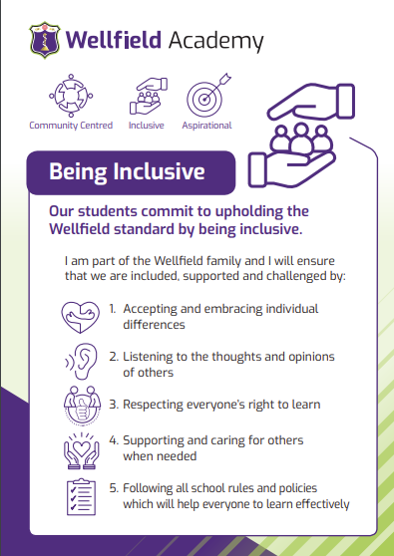
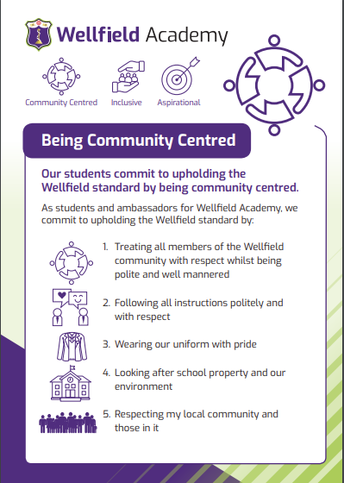
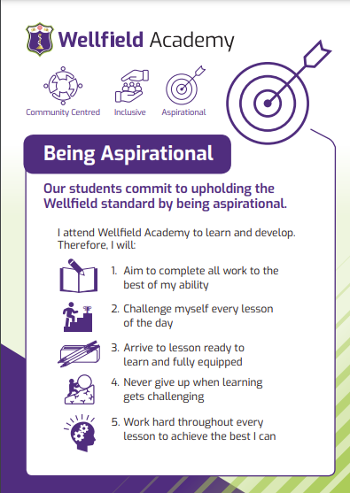

Recognition, rewards and celebrations
We aim to create a culture of celebration in an environment where students are supported to become the best they can be whilst feeling valued in doing this. To this end, these guidelines have been developed to;
- Encourage and acknowledge consistently positive engagement in learning for each subject;
- Acknowledge good attendance and punctuality;
- Acknowledge the positive contributions and/or impact made by students both in and outside of the classroom;
- Acknowledge students who make a special contribution to school events or aspects of school life;
- Ensure that achievement points and rewards are consistently and fairly applied;
- Develop a sense of community and acknowledge year group, tutor and/or house achievements;
- Celebrate myriad occasions of success

Monitoring Individual Rewards/ Merits
To ensure the success of these guidelines, Wellfield Academy seeks to build a partnership between the school and parents. Parents can actively track their son/daughter’s rewards on a daily basis through the Arbor app. The school will also seek to inform parents when other rewards are achieved. Students are also able to track their own Arbor to identify when rewards have been provided.

Achieving Merits
Every student has the opportunity to earn additional merits on a daily basis in recognition of their contributions, effort, achievements, attendance, engagement and progress. These merits can be issued by all staff members, both teachers and support colleagues. These merits should be consistently and fairly awarded to each student’s individual total throughout the year and all staff should actively look to find opportunities to praise and reward students.

Celebrating individual success on a regular basis
We acknowledge that it is important to recognise and celebrate success on a regular basis and, although there are half termly/termly rewards for students to work towards, we aim to acknowledge good engagement on a regular basis. Some rewards may be issued on a weekly or fortnightly basis whilst others might be issued sporadically.

- Phone calls home
- Postcards
- Stickers
- Milkshake with the Headteacher
- Weekly tutor presentations (every Monday)
- Weekly year group Assemblies
- Dining room fast pass
- SLT Award (certificate)
- Headteacher’s Award (certificate)
- ‘Nothing but the Best Work Wall’ and celebration of work displays- staff to email recommendations
- Messages within the Wellfield Weekly newsletter

All staff within the school will have access to postcards and stickers which will be distributed occasionally as they see fit. Similarly, certificates, both hard and electronic copies, will be available for distribution to students as appropriate.
All of the above will be celebrated and acknowledged in different ways. For example, some will be highlighted in our weekly celebration newsletter, called Rewards Round Up, whilst others will be posted on social media and/or communicated via Arbor.

Half termly rewards
Each year will hold a rewards assembly to recognise and celebrate the successes of individuals and tutor groups during that term/half term. At the end of every half term, some students will receive rewards to acknowledge their effort and engagement. These include;
- Subject Awards - One student per class in every year group with one overall winner
- Attendance Awards – recognising the most improved and highest attenders

Termly rewards
At various points in the year, students will receive rewards to acknowledge their effort and engagement.

Gold, Silver, Bronze Merit Awards
Achievable at the end of each term:
- Gold
The top individual merits achiever, along with the next highest male and female merits achiever from each year (approximately 15 students in total) will be provided with a free VIP lunch meal and be awarded an educational voucher.

- Silver
The next highest merits achiever, along with the next highest male and female merits achiever, from each year (approximately 15 students in total) who did not receive a gold award will be provided with a free VIP lunch meal and have their names put into a random prize draw to win prizes such as an educational voucher.

- Bronze
The top 20% merits-achievers from each year will have their names put into a random prize draw to win prizes such as an educational voucher.

End of Year Rewards
Endeavour Awards
- Achievable at the end of the school year
- Nominations completed by subject teachers to acknowledge students who have consistently demonstrated ‘Endeavour’ qualities of resilience, perseverance and commitment
- Bronze, silver, gold and platinum awards are made dependent on overall frequency of nominations and this may vary by year group
- Awarded in end of year assembly with parents invited as appropriate depending on numbers (e.g. only Platinum, Gold and Silver)
- Individual subject awards (1 or 2 for example) that don’t meet bronze threshold acknowledged by letter

Subject Learner of the Year
- Awarded to one student in every year group based on nominations from subject teachers

Learner of the Year
- Awarded to one student in each year group based on a range of data, evidence and nominations from all staff. Certificate, voucher, VIP lunch and parents invited in for assembly.

Receiving Team Rewards
At key stages during the year, merits totals will be used to reward individuals, tutor groups and year groups. These will include:
- Tutor group of the week- rewarded with a trophy
- Tutor attendance winners- rewarded with a trophy
- Tutee of the week- rewarded with a further merit and small ‘Star’ trophy for each individual
- Year group net merits winners- announced within Rewards Round Up newsletter

Attitude to Learning

At Wellfield, our staff and students will refer to a Grade A attitude to learning (criteria below) as a form of motivation and encouragement for our students. Students are also made aware, through use of the criteria, where their attitude to learning may drop below a Grade A and how they can address this.
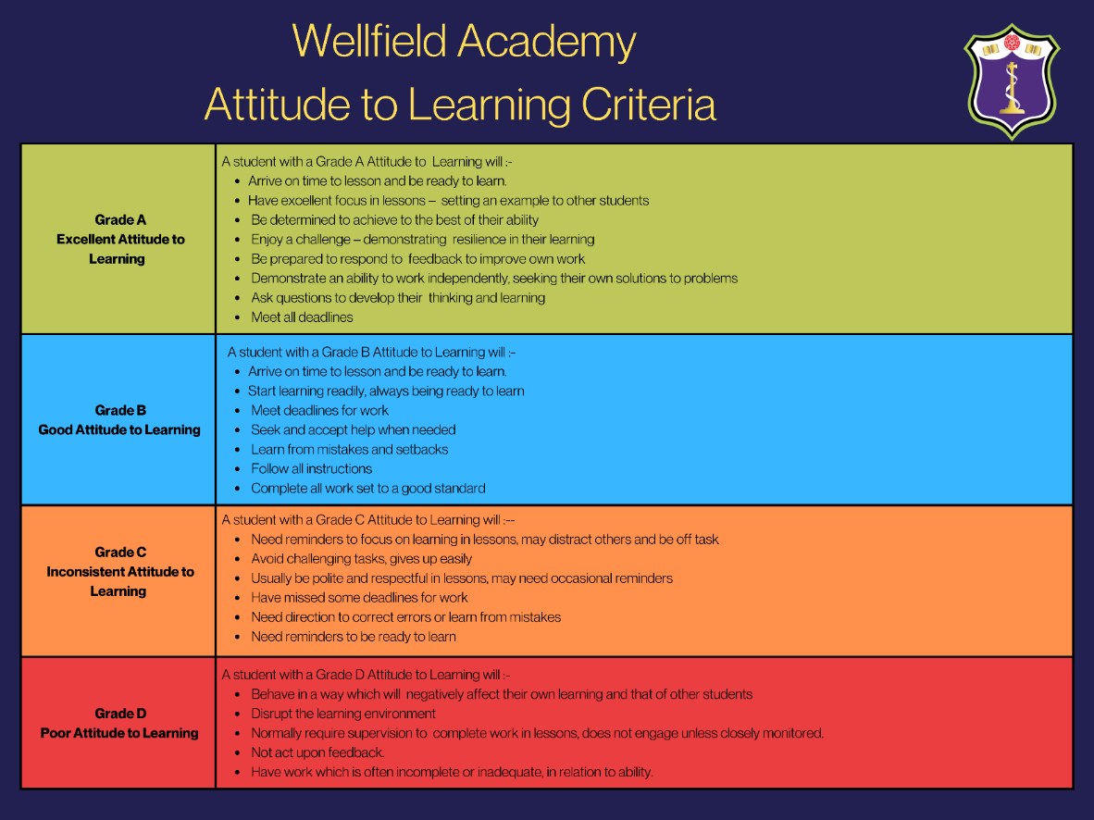

Responding to misbehaviour / Consequences

Expectations
The expectations for behaviour apply at all times during the school day, whether students are on or off the school site, and at all times when students may be considered to be representing the school, for example by wearing the school uniform during journeys to and from school, and at all times during school trips and visits.
The expectations and responsibilities of the school, students, parents and carers in relation to this policy are set out in the Home School Agreement. The general principles in relation to behaviour are set out below:

Home School Agreement
The School will:

• Provide a safe, secure and inclusive environment in which every student is valued.
• Act at all times in accordance with the shared values of the Wellfield Academy community.
• Stay committed at all times to delivering the highest standard and quality of education to all students.
• Teach students about safeguarding issues including online safety, social media and healthy relationships.
• Actively use the reward system to recognise, motivate and engage students.
• Ensure that extensive time is dedicated to ensure that all students understand and respect the school’s
classroom expectations which are applied consistently by all staff.
• Ensure that parents/ carers are kept closely informed of any incidents involving their child.
• Confiscate any property that is found on school premises which is prohibited either by law or by school policy, or which may cause injury, offence or disruption to learning.
• Respond to all emails or phone calls within two working days.

Responsibilities of Parents and Carers:

• To engage with the school and to support excellent behaviour at all times by committing to the terms of the Home School Agreement.
• To ensure that the student arrives at school on time every day with the correct uniform and equipment.
• To ensure that family holidays are not taken in term-time.
• To contact the school promptly with an explanation on the first day of any absence.
• To support the school’s policies and guidelines, including those on behaviour, uniform and mobile phones, the safe use of technology and social media, including by monitoring student devices and social media use at home.
• To communicate with the school using the correct school communication channels, and not encourage students to use their mobile phones to communicate with home during the school day.
• To take responsibility for the online behaviour of their child.
• To ensure that homework is completed on time.
• To support the school in ensuring appropriate behaviour on the way to and from school.
• To attend Parent Evenings and other Information Evenings.
• To treat all members of the school community with courtesy and respect.

Responsibilities of the Student:

• To commit to the terms set out in the Home School Agreement.
• To behave in a sensible, safe and reasonable manner at all times both on and off the school site, showing respect for each other and property.
• To never engage in bullying behaviour of any kind.
• To ensure that their own learning and the learning of others is prioritised.
• To ensure that they do not bring the school into disrepute through unacceptable behaviour off-site, whether in the community, travelling to and from the school, or further afield e.g. on school trips.
• To ensure that they do not engage in any behaviour (including online behaviour) which poses a threat to any member of the school community or a member of the public, or which could adversely affect the reputation of Wellfield Academy.
• To ensure that they do not bring or use items or articles in school that are ‘illegal’ or ‘prohibited’ (eg: Tobacco, vaping devices, E-cigarettes, items that may be used as weapons of any type) which could endanger or put the health and safety of students and staff at risk.
• To treat all staff and students with respect and to follow instructions from all members of staff.
• To move around the school site in a sensible manner and to respect the fittings and decoration.
• To use only allocated toilets and only one student at a time.
• To eat only in designated areas and put all litter away in the bins provided.
• To ensure that mobile phones are kept in bags

Implementing the Behaviour and Consequence Policy for Students with SEND

When dealing with misbehaviour from students with SEND, especially where their SEND affects their behaviour, the school will balance their legal duties when making decisions about enforcing the behaviour policy.

The legal duties include:

• Taking reasonable steps to avoid any substantial disadvantage to a disabled student being caused by the
school’s policies or practices (Equality Act 2010)
• Using our best endeavours to meet the needs of students with SEND (Children and Families Act 2014)
• If a student has an education, health and care (EHC) plan, the provisions set out in that plan must be secured and the school must co-operate with the local authority and other bodies

Trauma informed practice
Wellfield Academy strives to create a school community which embodies our aspiration to build an inclusive, nurturing, caring ethos which permeates our school environment. We have developed a behaviour policy which places relationships as the cornerstone for students to thrive, both academically and in relation to their wellbeing.

Our trauma informed and student centred approach to behaviour management benefits all students and staff for the following reasons:
- Relationships and a young person’s sense of safety and security are placed at the heart of classroom management.
- Our approach encourages nurture, respect and empathy, even when a young person is presenting with behaviours that feel challenging.
- Individual circumstances are taken into account.
- A sense of community and belonging is promoted.

Restorative Conversations
After any behaviour incidents students will be spoken to by the appropriate member of the Pastoral or Senior Leadership team and a restorative conversation may be held with either staff or other students involved. Teachers are expected to ensure that a ‘fresh start’ is given to every student following a consequence/ removal or other incident.

Consequences
Where any student fails to meet the behaviour expectations determined in this policy and in the Home School Agreement, a range of consequences may be applied. Consequences will be applied fairly and consistently and in proportion to the ways in which the Home School Agreement or behaviour policy has been breached. Sanctions/ consequences may also be escalated depending on the seriousness of any particular incident, or if an incident occurs as part of a series of repetitive breaches of the terms set out in the Home School Agreement or behaviour policy over a period of time. Sanctions/consequences are not applied as a ‘punishment’, but rather to teach students that actions and behaviours have consequences, as this is essential to their personal development.

Sanctions for Inappropriate Behaviour in Lessons
In addition to the behaviour expectations set out in the Home School Agreement, if the behaviour of any student causes any kind of disruption to lessons, the following process will apply:

- First incidence of disruptive behaviour (Chance): A verbal warning will be issued and the student will be given an opportunity to immediately correct their behaviour.
- Second incidence of disruptive behaviour (Choice): A verbal warning will be issued and the teacher will log this on Arbor and will result in a demerit.
- Intervention conversation: At the request of the teacher, another staff member will be asked to speak to the student outside of the classroom with the aim of helping them to get back on track with their learning in the classroom
- Third incidence of disruptive behaviour (Consequence): The student will be collected from the lesson and will spend the remainder of that lesson under the supervision of a Subject Leader or within an alternative classroom. The student will then sit an after school detention on the same day (or the next day if issued during Period 5), during which they will complete a reflection activity. This will be logged on Arbor

Examples of behaviour in lessons for which these sanctions could be applied (the bullet points below serve as examples rather than being an exhaustive list):
- Persistently failing to follow instructions from a member of staff
- Being disrespectful towards staff or students
- Persistently disrupting the learning of others
- Unsafe behaviour

Consequences for Inappropriate Behaviour Outside of Lessons
The terms of the Home School Agreement and behaviour policy also apply outside of lessons and at all times. For incidents which do not require immediate further action or escalation because of their seriousness, the following process will apply:

For the first incidence of inappropriate behaviour, the student will sit a 30 minute detention on that day, dependent on the incident.

If the behaviour occurs during a social time (for example at morning break or lunchtime), the student may be withdrawn from social times for that day or for a longer period if necessary. In these cases, the student will spend social times under the supervision of a member of staff.

Examples of behaviour outside of lessons for which these consequences could be applied (the bullet points below serve as examples rather than being an exhaustive list):

• Attempting to argue with a member of staff or another student
• Causing any form of disruption to teaching and learning
• Arriving late to school or lesson
• Failure to complete homework
• Incorrect school uniform
• Behaving in a way which disrupts the work of school staff
• Any type of bullying
• Failing to follow instructions from a member of staff
• Being disrespectful towards any member of staff or student
• Swearing
• Graffiti on property, books, learning equipment or hands / arms / legs / faces (the student will also be required to remove / wash away the graffiti)
• If a mobile phone is confiscated due to being seen or heard by a member of staff
• Being in the wrong place at the wrong time (out of bounds areas)
• Any behaviour which could cause a risk to health and safety
• Breaching the terms of the Home School Agreement

Escalation of Consequences for Repetitive Breaches of the Behaviour Policy
It is anticipated that the majority of students will avoid the sanctions detailed above, and for those students who are involved in such incidents, that a detention session will be enough to help them to reflect on their conduct so that it is not repeated. Conversely, where behaviour incidents are repeated or where multiple detentions are accrued for assorted reasons, the school will escalate sanctions in response. This is intended to reinforce the message that behaviours and actions have consequences, and that repeated negative behaviours will not be accepted.

Repetition of Incidents / Intervention Stages
If a student does not comply with the school rules repeatedly, consequences may be escalated at the discretion of the school, depending on the nature of the behaviour incidents. Please see below a list of sanctions that could be used (although this is not an exhaustive list):

- Monitoring the student for two weeks on a form tutor/Head of Year/Head of Key Stage report
- Senior Leadership report
- Head of Year internal exclusion day
- Reflection room
- Seclusion (a fixed term period at another school in their isolation room)
- Suspension (out of school)
- Off Site Direction (Managed Transfer Referral)

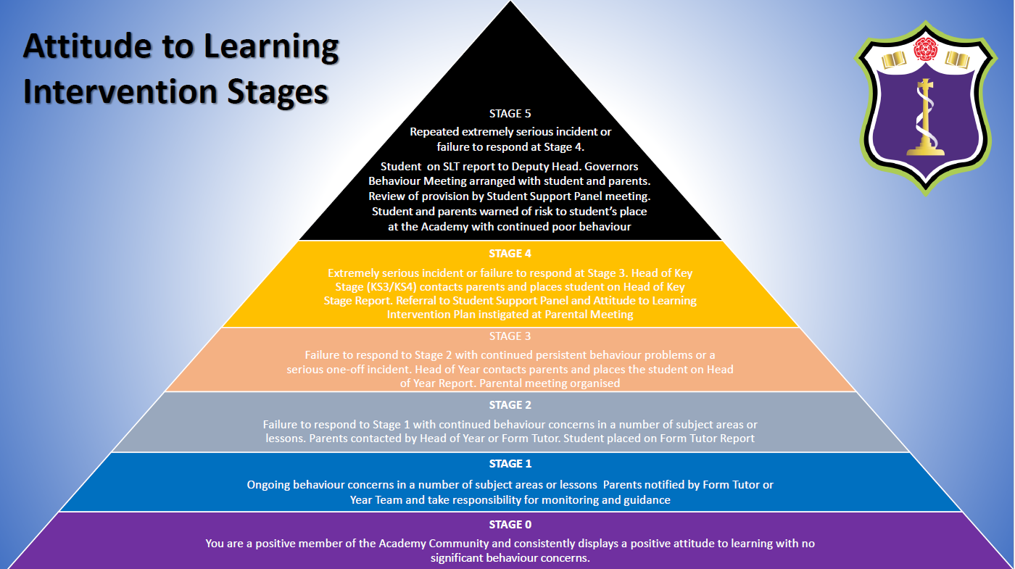

Serious Behaviour Incidents Requiring Immediate Further Action
Behaviour incidents of a more serious nature will require immediate action which may include the student being removed from lessons or social times immediately. With these incidents, more serious sanctions will be applied as defined in the Notes on Types of Sanction section below. These could include Internal exclusion with Head of Year, allocating time in the Isolation Room, Seclusion (a fixed term period at another school in their isolation room), Off Site Direction (Managed Transfer Referral), Suspension, and ultimately, for the most serious or repetitive breaches of the behaviour policy and Home School Agreement, Permanent Exclusion. The type of sanction applied will be commensurate with the seriousness of the incident and / or the previous conduct of the student involved.

Examples of behaviour requiring immediate further action and may result in informing the police (illustrative but not exhaustive):

• Fighting
• Any type of bullying
• Assault
• Theft
• Bringing the school into disrepute
• Causing damage to school property
• Racism, homophobia and discrimination against any protected characteristic (eg. gender identity).
• Smoking/vaping and/or in possession of vaping/tobacco products
• Possession of and or consumption of alcohol, drugs or other prohibited items
• Being concerned in the selling, buying or distribution of tobacco or vaping products, alcohol, drugs or other prohibited items
• Being in the presence of others using or possessing alcohol, drugs or other prohibited items
• Possessing any offensive weapon or imitation offensive weapon
• Truancy
• Being present in a toilet cubicle with another student or students
• Repetition of behaviour that disrupts learning
• Swearing or any other form of verbal abuse towards a member of staff
• Persistent non-compliance with school uniform expectations
• Any behaviour which presents a serious risk to health and safety or wellbeing
• Cheating in an examination
• Making false allegations against a member of staff

Behaviour on school trips and non-compulsory activities
On any trip run by school staff, all parts of this policy apply. Where students demonstrate poor behaviour, they will be sanctioned on their return to school and may be banned from participating in future trips and activities. In cases of serious behaviour incidents, parents or carers may be contacted and asked to collect their child from the site of the visit.

Mobile phones
Our mantra regarding mobile phones is simple and consistent. We do not expect mobile phones to be used at any point during the school day so the message is that phones should be ‘off and in school bag’. If seen by a staff member at any point during the school day, the mobile phone will be confiscated and must be handed to the main office at the earliest opportunity. Once confiscated, the staff member should check the condition and inform the student of any cracks/marks to ensure there are no allegations that a phone has been damaged whilst in school’s possession.

The Education and Inspections Act 2006 confirms the right of schools as a 'disciplinary penalty' to seize a student's possession, or to retain a possession of a student, or dispose of it. The staff concerned will not be liable in any proceedings if he/she proves that the seizure, retention or disposal was lawful (see below). Nor will staff be liable for any damage or loss as a consequence if the seizure, retention or disposal is lawful. Parents and students should note that this includes mobile phones, other expensive digital items or jewellery. The seizure, retention or disposal will be lawful if in breach of any statutory requirement, and therefore will be reasonable in the circumstances.

Notes on types of consequences:

Detention

• Detentions are either 10, 15, 30 or 45 minutes in length and are held daily
- SLT detentions are 60 minutes and are held on Wednesday and Friday
• Detentions are conducted in silence
• Parents will be notified in advance via email from Arbor

• If a student fails to attend a detention, the time will increase to the next timescale up e.g. 10 minute breaktime late detention will escalate to 15 minute lunchtime if missed.
• If a student fails to attend an SLT detention, an escalated sanction will follow

Detention sessions can be given to individual students by any member of staff for any breach of the behaviour policy or Home School Agreement.

Students may be detained for 15 minutes after school at the discretion of teaching staff. Parental consent is not required for these detentions.

Attitude to Learning Reports
Students can be placed on a monitoring report for failing to meet learning expectations, failure to submit homework or inappropriate behaviour.

A Positive Reinforcement report is used to monitor and support students who have gained a number of behaviour incidents in one week eg: for uniform, late to school or other recurring behaviour incidents. The purpose of this report is to record what is going well in addition to any other relevant teacher comments, so that students are encouraged to adopt a more positive attitude to learning. At the first stage, the report will usually be monitored by the Form Tutor. If the first stage of the report is not successful, then a further period of being on report will commence, where the student will report to their Head of Year.

The Leadership Team report is the next level of support and is used to support the behaviour of students who have failed to meet the expectations of a Positive Reinforcement Report or who present serious behaviour concerns and are at risk of suspension.

Students on report will report daily to the member of staff who has been assigned to monitor their report.

Head of Year Day
An HOY day is a type of consequence which is used for incidents of a serious nature or for persistent breaches of the Home School Agreement and Behaviour Policy. When a student is placed into HOY Day, the student attends school each day arriving and leaving at the normal time, but they do not attend their regular timetabled lessons. Instead, the student will spend their day under the supervision in reintegration. They are given appropriate work to complete throughout the day. Head of Year Days can be issued for one day or for multiple days as appropriate.

Reflection Room
The Reflection Room is a type of consequence for incidents of a more serious nature, or for persistent breaches of the Home School Agreement and Behaviour Policy. Students who are placed into Reflection will be expected to attend school at 8.45am, where their mobile phone will be handed in and uniform checked. When a student is in the Reflection Room, they are expected to work silently and are not allowed to participate in social times. Time in the Reflection Room can be issued for one day or for multiple days as appropriate. There will be planned opportunities for education and intervention for those students during the school day, including personal development reflection tasks to encourage learning opportunities and growth/improvements in the future.

Seclusion
For incidents of a serious or repetitive nature, including where a student has failed to attend an Reflection in school, or has potentially been suspended, the school may issue a Seclusion Referral. This is an arrangement between Headteachers where a student attends another school for an agreed period of time. Work will be set by the referring school and sent to the host school. This sanction may be offered as an alternative to a Suspension, where appropriate. If a student fails to attend a Seclusion Referral, a suspension will result as the next level of sanction.

Suspension
The school will follow the Department for Education guidance ‘Suspension and Permanent Exclusion from maintained schools, academies and student referral units in England, including student movement’ (September 2023). To suspend (exclude) a student from school for a fixed term is a very serious step to take. Only the Headteacher has the authority to issue a suspension. In all cases the parents or carers will be informed of the reasons for the exclusion either by telephone or letter as soon as is practicable following the decision to exclude. A written notification will also be sent home regarding the suspension. All students returning from a suspension are required to attend a reintegration meeting, accompanied by a parent / carer. This meeting will seek to establish practical ways in which further exclusions can be avoided and behaviour modified to acceptable standards in partnership between student, parent and school. It may also be relevant to complete a risk assessment at this meeting. Work will be set during the period of exclusion and will be indicated in the letter.

Permanent Exclusion
A decision to exclude a student permanently is very serious indeed and will be considered as a last resort, in response to a serious breach, or persistent breaches of the school's behaviour policy and where allowing the student to remain at Wellfield Academy would seriously harm the education or welfare of others in the school. The decision to permanently exclude will be taken by the Headteacher.

Power to search students without consent
In addition to the general power to use reasonable force described above, the Headteacher and authorised staff can, as is reasonable given the circumstances, conduct a search for the following prohibited items (the list below provides illustrative examples and is not exhaustive):

• Any type of offensive weapon
• Alcohol
• Illegal drugs
• Stolen items
• Any illegal or otherwise prohibited items
• Tobacco and cigarette papers, vaping products or E-cigarettes
• Fireworks
• Pornographic images
• Any article that has been or is likely to be used to commit an offence, cause personal injury or damage to property.
• Any item which is likely to result in a risk to health and safety or wellbeing of any member of the school community.

Safekeeping
Staff are obliged to take reasonable care of confiscated property, in which case no liability will attach to the school for any loss or damage. The school will make every reasonable effort to ensure that confiscated property will be locked away and a record taken of the owner, who confiscated it and when and how long the confiscation is to last. All confiscated items will be handed to the Reception in a sealed envelope with the student’s name, tutor, date and time of confiscation together with the name of the member of staff who confiscated the item written clearly on the outside. Staff may confiscate students' property where it is necessary for disciplinary reasons. This is at the discretion of the staff member.


