Wellfield Academy Pupil Premium Strategy Statement

This statement details our school’s use of pupil premium funding to help secure the engagement and success of our disadvantaged students.

It outlines our pupil premium strategy, how we intend to spend the funding in this academic year and the effect that last year’s spending of pupil premium funding had.

School overview
Detail | Data
School name | Wellfield Academy
Number of students in school | 563
Proportion (%) of pupil premium eligible students | 39.7% 224
Academic year/years that our current pupil premium strategy plan covers (3 year plans are recommended) | Sept 2024-August 2027
Date this statement was published | Revised September 2025
Date on which it will be reviewed | 1st September 2026
Statement authorised by | Mr Jamie Lewis
Pupil premium lead | Mr Rob Beattie
Governor / Trustee lead | Mrs Hazel Nicholson
Funding overview
Detail | Amount
Pupil premium funding allocation this academic year | £219,897.18
Recovery premium funding allocation this academic year
Pupil premium funding carried forward from previous years (enter £0 if not applicable) | £0
Total budget for this academic year  If your school is an academy in a trust that pools this funding, state the amount available to your school this academic year | £219,897.18

Part A: Pupil premium strategy plan

Statement of intent
Wellfield Academy believes that all students deserve nothing but the best. We aim to ensure that our disadvantaged students enjoy and succeed here. We intend that they leave their school equipped with skills, attitudes and qualifications that enable them to access and make the best choices to succeed in life.
Our strategy for pupil premium students is woven through all that we plan and do here. placing these students at the heart of our intentions, discussions, decisions and actions.

Our ambition for pupil premium students mirrors the high expectations we have for all of our students. Our focus is on ensuring the strategy accurately identifies the barriers and obstacles that can make such success more difficult for these students, and makes clear how and we can all seek to resolve these.

Our approaches take full account of the Education Endowment Fund’s guide to Pupil Premium which aims to help schools maximise the impact of the grant. We also utilise the research from Marc Rowland to inform our strategy.

We align our actions to the three strands of our School Development Plan (SDP). These are:
- Attend & Belong
- Assess & Intervene
- Include & Stretch
On this basis, our Pupil Premium spend uses the EEF tiered approach to improving outcomes for disadvantaged students.

These are 1 – High Quality Teaching, 2 - Targeted Academic Support and 3 - Wider Strategies.

As the EEF explains, our strategies will overlap and the balance between them will vary year on year.

The key driver of our strategy is to ensure that high quality engagement and teaching is experience and enjoyed by all students.

So, our approaches will:

- ensure that any support required is identified early and implemented clearly. We work collaboratively and in partnership with stakeholders.
- be based on diagnostic assessment of information, data and need. It will not assumption about the impact of disadvantage.
- ensure every child has the opportunity to succeed and thrive at Wellfield Academy. This is regardless of starting point, background or the challenges they may encounter (be they at home, school, physical, mental or academic).
- Students’ personal development play an integral part of ‘what we do’ as a school community. We want our students to become proactive responsible citizens. We want them be to pursue and follow ambitious and fulfilling careers; ones that they are passionate about. We intend to play an important role in preparing students to live healthy, happy, and safe and secure lives.

Funding
Pupil premium funding is allocated to eligible schools based on the number of:
- Students who are recorded as eligible for free school meals, or who have been recorded as eligible in the past 6 years (referred to as Ever 6 FSM).
- Children previously looked after by a local authority or other state care, including children adopted from state care of equivalent from outside England and Wales.

Pupil premium is not a personal budget for individual students, and schools do not have to spend pupil premium so that it solely benefits students who meet the funding criteria. It can be used:
- To support other students with identified needs, such as those who have or have had a social worker, or who act as a carer.
- For whole class interventions which will also benefit non-disadvantaged students.

Challenges

This details the key challenges to achievement that we have identified among our disadvantaged students.
Challenge number | Detail of challenge
1 | Curriculum ambition and implementation: Research clearly shows that disadvantaged students are disproportionately affected when the quality of teaching is not deemed to be good. Therefore, quality first teaching is the main focus to ensure strong progress for disadvantaged students. We make sure that staff know who disadvantaged students are in their classes. They know how to and ensure that they are supported to flourish academically in lessons
2 | Literacy and reading: At significant number of disadvantaged students join us with reading ages that are below others and less than chronological reading age. Sometimes they are at the earliest stages of learning to read accurately and confidently. As such, these weaker readers are unable to access parts of the curriculum without intervention and support. We support these students to catch up and keep up with their important reading knowledge and expertise, with the curriculum. This helps them to read more accurately and easily, and to learn what they need to across the curriculum.
3 | Attendance: At our school there is a legacy of disadvantaged students attending less often than they should. In the past they have attended at a rate that is well below other students nationally. This includes casual absence, persistent absence and sometimes severe absence. This means that they miss out on good life habits, learning and other social aspects of school life.
4 | Punctuality: In the past, too many disadvantaged students have been late to lessons. This has had a negative impact on their engagement and success with their learning.
5 | Lower aspirations and expectations: Disadvantaged students are more vulnerable than others to transition. This includes the end of KS3 and end of KS4. We noted a pattern where the options pathways were less ambitious and others and, consequently, students did not take as ambitious steps as others. This impacted the courses that they were equipped to follow at the end of key stage 4.
6 | Obstacles to parental opportunities for communication and active partnership: We found that the parents of some disadvantaged pupils found active partnership with school events more difficult than others. For example, in attending parents’ evening, where these parents had family and work commitments. We are tackling, from the school end, more flexibility and school communication with the homes of disadvantaged students.
7 | Socio-economic disadvantage: The availability of resources [and finance] available for supporting school, learning and enrichment experiences for disadvantaged students means that they can be disproportionately impacted when compared to their peers. This includes equipment, resources, participation in trips and visits.
8 | SEMH needs: The proportion of disadvantaged students with SEMH concerns, including self-esteem and self-confidence, is larger than that of their non-disadvantaged peers. In the past this has led to an increased vulnerability for these students to engage, enjoy and succeed in school.
9 | Vocabulary gap: We have seen that disadvantaged students come to Wellfield Academy with a disproportionate vocabulary gap. We noted how this has manifested speaking, listening and comprehension weaknesses within lessons.
10 | Handwriting: We have found that some disadvantaged students do not readily write clearly and legibly, and sometimes not accurately and comfortably. This has been notable at the start of Year 7 in particular, in the transition from primary school. A closer look revealed that for some students this has been because the standard of the handwriting slipped, so needed assessment and support to rectify. Others have required catch-up intervention to support their handwriting knowledge, practice and fluency.

Intended outcomes
This explains the outcomes we are aiming for by the end of our current strategy plan, and how we will measure whether they have been achieved.
Intended outcome | Success criteria
To end the attainment gap between disadvantaged students and their non- disadvantaged peers at Key Stage 4, so that all students achieve at least the same outcomes as non-disadvantaged students nationally. Progress towards this will be assessed and evidenced through marked strengthening of results each year.  (SDP priority- Assess & Intervene) | 2025-2026 KS4 outcomes to demonstrate progress for disadvantaged students has closed significantly against non-PP students, but more work is now required to reduce this gap even further.  The work and knowledge of disadvantaged students demonstrates the embeddedness of this strengthened position. All students tend to achieve well in their in-school tests and assessment, and not least disadvantaged students.  This includes the ‘mock-examination’ outcomes of those students now in Year 11. This compares very well against previous cohorts.  Regular checks of these student’s workbooks also present this is the case.  Continued focus on this area will allow for a further reduction in the gaps in achievement between PP and non-PP students.
To spot and support those disadvantaged students with weaker foundational knowledge [including reading, writing, handwriting and vocabulary and speaking and listening skills] so that they are as strong as they should be in these key areas of knowledge and practice.  (SDP priority- Assess & Intervene) | Following Year 7 benchmarking, there will be evidence of improvement in reading ages through high quality interventions.  This will be demonstrated through improved reading ages via targeted NGRT testing.  Handwriting is a key area for development for PP students and the Wellfield Academy marking policy ensures staff liaise with the SENDCO to identify students who require support so that improvements in handwriting are made. QA and book looks will show improvement with handwriting over time for identified students.  4-part lesson structure has allowed for greater opportunities for oracy and a focus on developing independent work. The progress shown in books demonstrates that students are writing more throughout the key stages and that many are showing greater fluency. The demonstrate phase of lessons also allows for the use of challenging texts, where students are regularly exposed to and taught a wide range of vocabulary. CPD has been delivered on how to decode words to improve understanding and fluency. The marking policy allows staff to closely monitor spelling and intervene when necessary. Work in these areas will continue to show improvements in extended writing, foundational skills and handwriting, which will be seen via internal QA.  The work alongside Laura Kay has supported the English department in altering the curriculum at KS3 and KS4 to develop writing skills and vocabulary with disadvantaged students foremost in mind. This work will continue, with progress identified through more extended writing, noted in work scrutinies and, ultimately, improved outcomes for disadvantaged students.
To spot, support and make sure that disadvantaged students attend school all or almost all of the time. Additionally, to make sure that when they are in school they are motivated and supported to get to lessons on time.  (SDP priority- Attend & Intervene) | The attendance of disadvantaged students broadly matches the attendance of their non-disadvantaged peers, or the attendance gap is measurably reducing. Data is in line with, or above, national averages.  Staff CPD has also focused on presence on doors at lesson changeover to actively encourage purposeful movement to class. This is showing an impact with fewer ‘unnecessarily late to lesson’ marks on Arbor.  Attendance and punctuality will continue to improve compared to 2024-2025 academic year.
To increase disadvantaged students’ engagement in school life and aspirations and support improved parental engagement.  (SDP priority- Include & Stretch/Attend & Belong) | Increase the percentage of parents accessing support and engaging with school in regular constructive/supportive contact with school.  Parents evenings are well attended, with an average attendance of 62% last year, rising to 72% for the latest parents evening of 2025-2026. The school now tracks PP and SEND attendance at parents evenings. The timings of parents evening have been adapted to move later and the window for signing up for parents evenings has been extended to allow longer for parents to sign up for appointments. QR codes are displayed to allow parents to request support with a range of issues, from accessing Arbor to help with purchasing uniform. Attendance of PP students will continue to improve as a success criteria.  Ensure that disadvantaged students are supported in accessing extra-curricular opportunities. A homework club has been created and is well attended at lunchtimes. Year 11 revision clinics are also run and well attended by students.  Increase the percentage of disadvantaged students accessing aspirational and appropriate post 16 education. The tracker for 2024-2025 showed only 1 student as NEET, from a cohort of 61.  Monitor homework and curriculum access to ensure disadvantaged students are completing tasks and are making appropriate progress from their starting points.  Homework club will show an increase in students accessing the support.

Activity in this academic year – 2025/2026
This details how we intend to spend our pupil premium (and recovery premium funding) this academic year to address the challenges listed above.

Teaching (for example, CPD, recruitment and retention)
Budgeted cost: £126,356
Activity | Evidence that supports this approach | Challenge number(s) addressed
Plan and implement high quality CPD for Teaching staff | CPD will be delivered using the 4-part lesson with a focus on the use of high-quality assessment and feedback, as well as formative assessment. Providing high-quality feedback to students is integral to effective teaching. Equally, gathering feedback on how well students have learned a topic is important in enabling teachers to address any misunderstanding and provide the right level of challenge in future lessons. This will be carried out via student voice during 3 review points within the year.  https://educationendowmentfoundation.org.uk/guidance-for-teachers/assessment-feedback  https://www.instructionalcoaching.com/wp-content/uploads/2021/12/Frazier-Dissertation-Final-4-17-18.pdf | 1, 4
Enhanced use of Reading Plus, Fresh Start Phonics and reading across the curriculum | Reading comprehension strategies focus on the learners’ understanding of written text. Students learn a range of techniques which enable them to comprehend the meaning of what they read. NGRT tests carried out to allow reading ages to be shared with teaching staff and displayed on Arbor.  EEF Reading Comprehension Strategies | 2, 8
Purchase of Sparx Maths and Academy 21 | Used to support and close gaps in Maths knowledge and skills. Students receive bespoke, tailored feedback to focus on gaps.  Academy 21 will be utilised to support students with more individualised English and Maths online tutoring.
Employ additional Teaching staff to enable students to be supported in the Endeavour Thrive unit | The EEF notes that smaller class sizes and 1:1 support or small group interventions allow students to make up to 5 months progress. | 1, 2, 7
Consistent approach for homework | EEF Homework  Use of digital packages and Homework that is linked to classroom work tends to be more effective. Policy rebranded and communicated to parents, students and staff. Need to monitor progress/completion  Homework club provision provided during lunch and after school hours.  The EEF also notes that Homework, when set effectively, can have up to 5 months progress for students.  Sparx, Educake and Seneca are utilised across different departments to support with homework. | 1, 4
Purchase of standardised diagnostic assessments. Completion of NGRT/CAT4 diagnostic testing upon entry.  Training will be provided for staff to ensure assessments are interpreted correctly. | Standardised tests can provide reliable insights into the specific strengths and weaknesses of each pupil to help ensure they receive the correct additional support through interventions or teacher instruction:  EEF Assessment and Feedback | 1, 2

Targeted academic support (for example, tutoring, one-to-one support structured interventions)
Budgeted cost: £26,853
Activity | Evidence that supports this approach | Challenge number(s) addressed
Recruitment of Level 3 TA to enhance reading interventions across the school | This will support students to access the learning and will support with their progress via reading interventions in the Learning Hub. They will also support with the handwriting interventions for those identified as needing further support. | 2, 10
Academy 21 | Purchased for students that are struggling to attend school due to severe anxiety.  EEF notes that this 1:1 tuition can have an impact of 5 months for student progress. | 7, 9, 1
High Quality CEIAG Programme embedded into the PSHCE Curriculum through the introduction of weekly PD lessons and TLR responsibility for a PD Curriculum & Aspirations Leader | Our school’s CEIAG programme, underpinned by Career North – ensures all disadvantaged students have access to careers guidance, experience of the work place and visits to FE and Higher Education Establishments Aspiration Interventions EEF  Each student receives at least 2 career appointments, with career’s advisors also attending Parents Evening in Year 10 and 11.  Preston College, Runshaw College and Myerscough College trips are also arranged, with PP students specifically targeted to attend. | 5, 7, 8

Wider strategies (for example, related to attendance, behaviour, wellbeing)
Budgeted cost: £66,688
Activity | Evidence that supports this approach | Challenge number(s) addressed
Additional pastoral staff, Attendance Support Manager & Support Worker and Heads of Key Stage to track and support PP student’s attendance at extra-curricular activities | Embedding principles of good practice set out in DfE’s Improving School Attendance advice  Improving School Attendance  This is supported with the use of 2 attendance officers so that attendance can be carefully tracked and monitored and so that rapid communication with homes can support students in re-engaging with school. | 3, 7
SOL | SOL has been purchased in order to support tracking of attendance and guidance on strategies to improve attendance, with a particular focus on disadvantaged students.
Provide breakfast every morning so students are ready to learn | Ensure students are able to start each day with a suitable breakfast to aid in their engagement in learning. | 3, 4
Implementation of the Arbor attendance module to enhance ‘pattern spotting’ of poor attenders | Rapid intervention in ‘slipping’ attendance leads to measurable improvements. Attendance heroes launched and embedded with targeted interventions.  Drive on punctuality carried out with communication home and Arbor being adapted to show unnecessarily late to lessons.  Inform on U codes also sent out to parents to overcommunicate need to be in school punctually. | 3, 4
Offer subsidies for general subject trips throughout the year | Support students to access rich opportunities that enhance their curriculum experience and impact upon their levels of engagement and aspiration  Providing for young people’s needs can also help to build a positive relationship with families and communities, which can support better engagement with young people as well.  YEF-Insights-Brief-1-Engaging-young- people-during-the-COVID-19-pandemic- FINAL.pdf (youthendowmentfund.org.uk) | 3, 4, 5, 7, 8
Subsidise uniform costs and equipment where needed | Some households are less likely to be able to afford the cost of school uniforms thus affecting attendance/ increasing barriers to attending school.  School provides assistance to these families and supports with the cost of uniform and school shoes in order to remove barriers to attendance. | 6, 7, 8
Improve tracking and monitoring systems | Ensure that disadvantaged students are appropriately tracked to ensure that they receive rewards and behaviour points in line with disadvantaged students and their attainment and progress is in line with or better than prior attainment Improving Behaviour in Schools EEF  Tracking is also maintained through assessment tracking so that early intervention can be used when PP students are under performing academically. This is done on both a class level and SLT level so that intervention is timely and effective. | 1, 4
Implementation of School Cloud meeting software | Provision of alternative means of communicating with parents such as online/video meetings. Providing opportunities for further positive dialogue with parents/carers is recommended by the EEF as a means to improve engagement. This also links to our professional standards model with increased explicit opportunities for celebration of student achievement.  Working with Parents to Support Children's Learning | EEF | 4, 5, 6
Additional pastoral staff, Safeguarding & Wellbeing Manager to provide high quality pastoral care particularly for those with SEMH concerns | Appointment of Amina Descei for role to develop the emotional regulation and support for our most vulnerable students.  The appointment of a HLTA will also support with handwriting intervention with identified students. | 3, 7, 8

Total budgeted cost:

Part B: Review of outcomes in the previous academic year

Pupil premium strategy outcomes
This details the impact that our pupil premium activity had on students in the 2024 to 2025 academic year. This was the first year of the 3 year strategy.
Priority 1: To close the attainment gap between disadvantaged students and their non- disadvantaged peers at Key Stage 4
GCSE Results Analysis
Students with PP secured notably strong results in the 2024-2025 summer examinations than in the previous year. The 2025 results show that the actions taken across school and in classrooms to support disadvantaged students are already making the marked impact that we anticipated. We can see that the disadvantaged students quickly strengthened their knowledge and attainment, even those in KS4 who had not benefitted from the new strategies previously. We are encouraged by the impact to date and so feel justified in sustaining this approach to support our current cohort of students.

Disadvantaged A8 data has increased to 35.0, up from 26.8 in 2024. National average for disadvantaged students in 2024 was 34.6, showing WA’s A8 for 2025 is slightly above all disadvantaged students nationally and an increase of 8.2 from the previous cohort in school.

This also indicates a movement towards non-disadvantaged students nationally. Disadvantaged students in 2024 secured A8 of 26.8 and were 23.8 points behind the non-disadvantaged students nationally. In 2025, this gap had markedly decreased between school disadvantaged students and non-disadvantaged students nationally to 15.3 points.

In 2025 disadvantaged students achieving a grade 4 in English and Maths was 50% of students attained this benchmark in school. This compares to 30.4% attaining the same benchmark in 2024, an increase of almost 20%, and above the 2024 average for disadvantaged students nationally, which was 43.4%. The gap between the A8 at 4+ in English and Maths of disadvantaged students in school and non-disadvantaged students nationally has also markedly decreased. In 2024 it was 42.4%, and in 2025 this same measure is now 22.7%.

In 2025 disadvantaged students achieving a Grade 5+ in English and Maths was 37.5% of students attained this benchmark in school. This compares to 8.7% attaining the same benchmark in 2024, an increase of almost 28.8%, and above the 2024 average for disadvantaged students nationally, which was 25.8%. The gap between the A8 at 5+ in English and Maths of disadvantaged students in school and non-disadvantaged students nationally has also markedly decreased. In 2024 it was 44.4%, and in 2025 this same measure is now 15.3%.

Table 1:
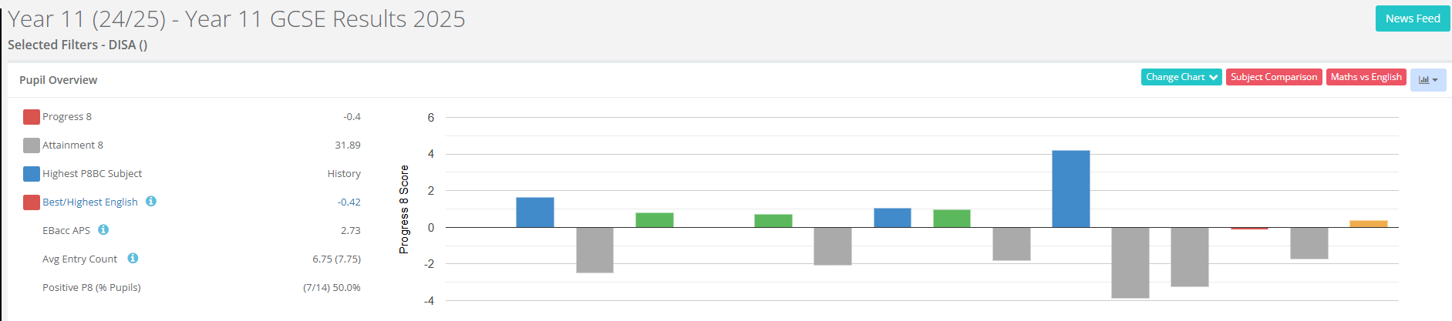
Table 2 shows the individual performance data of each PP student. Although the data highlights key areas for improvement, it should also be noted that this is an improvement on the 2024-2024 figures, with attainment gaps closing and more PP students attaining on and above target.
Table 2:
The table below shows positive gains for attainment in History, Art, R.E. and Spanish, with overall A8 showing progress compared to 2023-2024 for PP students.
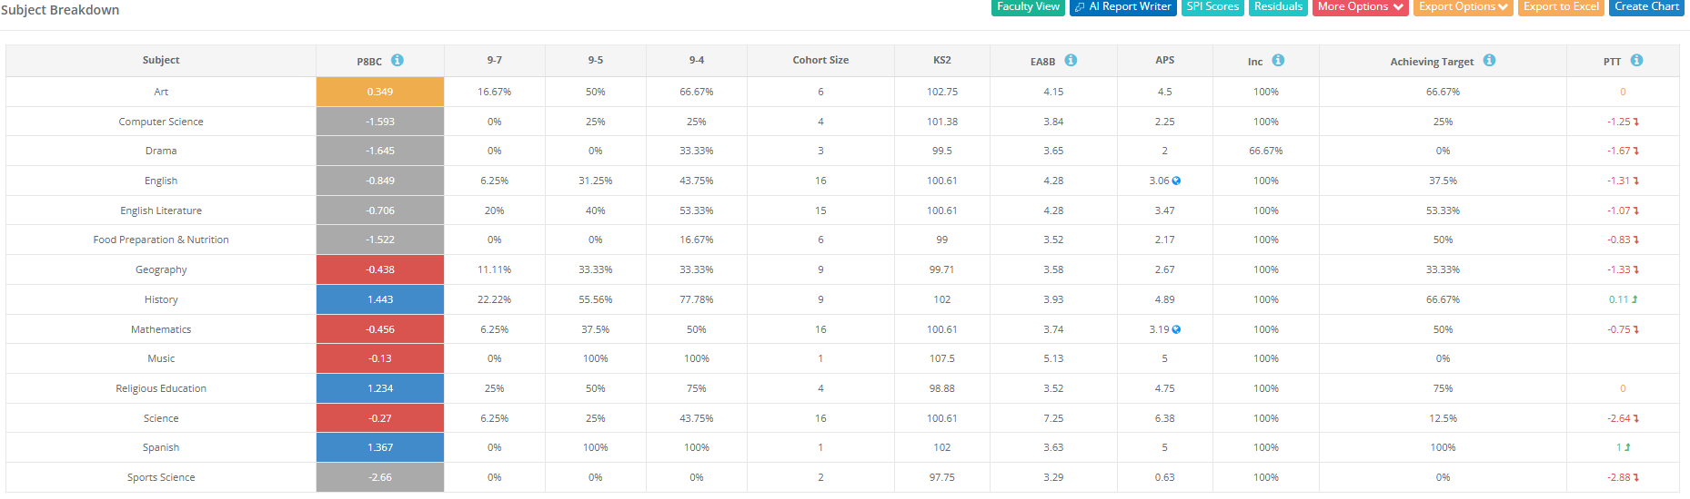

Priority 2: To address students with lower than chronological reading ages

We have continued to keep reading as a whole school priority, with CPD on how to deliver guided reading and the importance of utilising challenging texts and breaking down vocabulary delivered on the September INSET and through HT1 and HT2.

Curriculum plans now reflect the use of guided reading and how departments weave this through their curriculums in order to actively support reading. Form time now has a far larger emphasis on reading, with 4 form periods a week utilising guided reading of specifically chosen texts to expose students to a wider range of genres and to expand their fluency of reading. QA has shown examples of best practice with staff having been filmed delivering form time reading, which will then be shared as examples of best practice.

NGRT tests carried out in 2025-2026 show an improvement in reading ages for disadvantaged students in school, although at time of writing this report further testing is scheduled to take place in December, with a focus on those students whose reading age is below chronological reading ages and, in particular, for those who are receiving targeted intervention via Reading Plus.

Further NGRT testing is scheduled for w/b 15th December as a follow up for targeted Year 8 and 9 students to show impact of interventions. This testing will continue through the 2026 calendar year so that the testing of reading ages is tracked and intervention can be applied, with particular focus on PP students.

Form time has also been heavily adapted with the increase to a 32.5 hour contact time so that form tutors now carry out reading with their forms. This follows a careful CPD package with the selected texts seeking to engage students. Student voice indicates that this is having a positive impact and that students enjoy the opportunity to read, and be read to, which in turn supports improvements in reading and comprehension.

Table 1: 2024-2025 table for disadvantaged students NGRT scores from targeted students based on previous NGRT data [from tests currently carried out, more are scheduled for December]

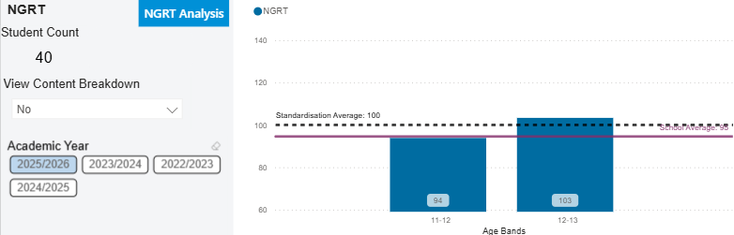

Table 2: 2024-2025 NGRT test results show a slight improvement in 12-13 age brackets has taken place in 2025-2026 cohort, with more testing required in December 2025.

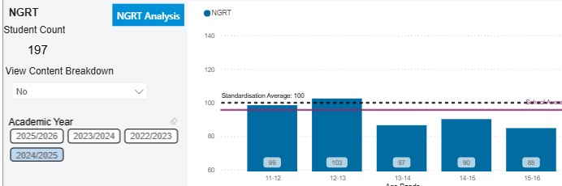

More data will be added to this report following the analysis of NGRT testing in HT3 of 2025-2026.
Priority 3: To increase disadvantaged students’ engagement in school life and aspirations
Attendance:
The table below shows a comparison of data for school attendance between last academic year and this year to date.

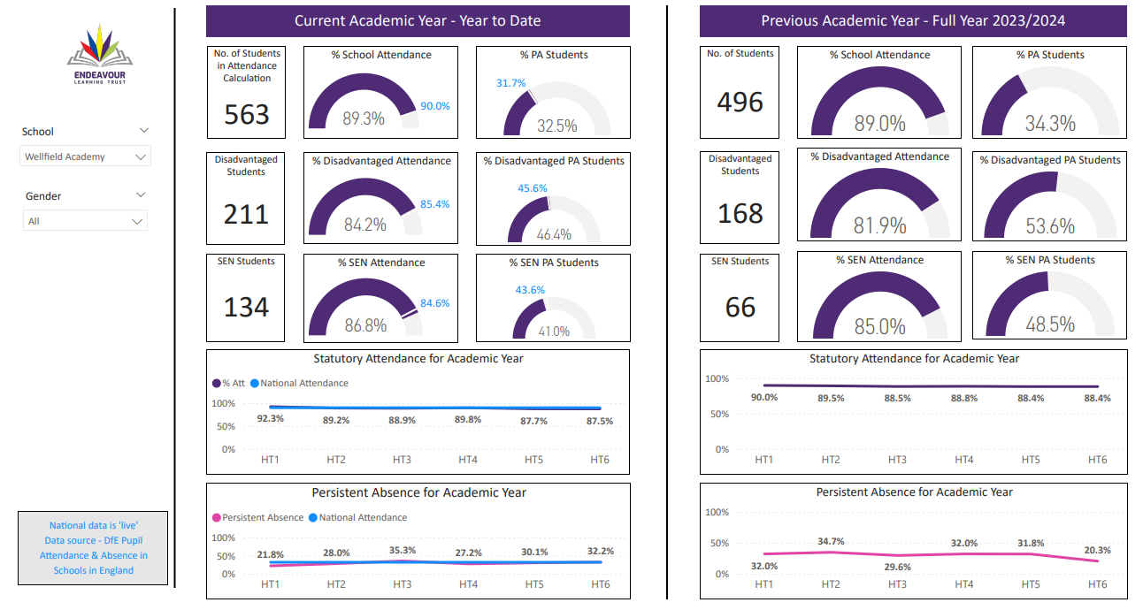

The reduction in PA figures from 2023/2024 is positive and there is also a 2.3% increase in PP attendance, which is encouraging even with an increasing cohort of students. The strategy for 2025-2026 is heavily based on tangible rewards, targeted intervention and support for families and actions that seek to identify and break down the barriers to attendance. Early indications for 2025-2026 show that attendance is improving overall and that PP attendance, which is encouraging. At the time of writing, current PP attendance for 2025-2026 is 85.7%, which shows an improvement again on the 2023-2024 and 2024-2025 pattern of attendance, again with an increase in PP students overall to 230.
Extra-Curricular:
This data has been extracted from Arbor to show attendance at Extra-Curricular activities.
Year | Pupil Premium % | Pupil Premium Pts | Non-Pupil Premium Pts
7 | 36 | 61 | 78
8 | 31 | 83 | 256
9 | 33 | 33 | 182
10 | 39 | 2 | 11
11 | 38 | 38 | 62
Pro-rata by % Pupil Premium there was excellent engagement in extra-curricular activities for PP students in Y7 and on-parr engagement in Y8 (83/256 = 33%). Participation declined in years 9/10 - though data is very limited for the year 10 students. Year 11 are being tracked with merits for attendance to revision clinics.
Parents’ Evening:
We have used the School Cloud system to improve the engagement of our disadvantaged parents at Parents’ Evening. Data from School Cloud shows an improvement from 2024-2025, but longer term comparisons are not possible due School Cloud not maintaining data. Year teams and form tutors routinely contact families of PP students and look to arrange suitable times for them to attend and, where attendance has not been possible, bespoke reports are created to share with families.
Year Group | Disadvantaged Cohort | % of disadvantaged students attendance at Parents’ Evening | Overall % attendance
7 | 46 | 65.52 | 73.2%
8 | 47 | 63.63 | 57.62
9 | 46 | 59.09 [Yr8 PE] | 63.9%
10 | 46 | 52.6% [Yr9 PE] | 73% attendance overall
11 | 29 | 60% | 71%
The aim is to now improve parents’ evenings further with access to a QR code to allow parents that attend to request wider support, relating to things like uniform, use of/access to Arbor, support with free school meals and accessing careers advice. At the latest Year 11 Parents’ Evening we arranged for 3 college providers and our careers’ advisor to be present and this provided further support for our PP students, as well as the rest of the cohort.
Priority 4: To ensure consistent, high-quality Teaching and Learning for all students
A comprehensive CPD programme was put in place to enable high quality teaching and learning for all students, including those who are disadvantaged. All members of teaching staff have received throughout the year:
- 2 hours T&L CPD after-school per half term
- 15 minutes T&L CPD per week in briefing [with a particular focus on PP CPD and the reading strategy]
- 3 INSET days, with at least 1 hour in each of these focussed purely on T&L and PP
- DDRs with a focus on support for PP students.

This programme ensured all members of staff are kept abreast of the latest pedagogical research and given the opportunity to put these into classroom practice. A new programme of departmental development reviews, which have a specific focus on SEND and students with PP, are also to be utilised for the 2025-2026 academic year, which will build on the awareness and focus on PP students that was well established in 2024-2025.

Reviews of the curriculum and lessons showed that PP strategies around quality first teaching are in use, with staff utilising clear circulation and formative assessment to establish student understanding. Vocabulary is broken down and resources adapted to ensure that cultural capitals gaps are planned for, i.e. demonstration of what Caernarfon Castle looks like. Staff circulate regularly in lessons, utilising the seating plans with PP students identified, in order to support students on a ‘well worn path’ around classrooms. CPD focused on the need for ‘active circulation’, with PP and SEND students supported first at the start of demonstrate tasks in order to establish their understanding and check for common misconceptions.

CPD was also delivered on strategies to support PP students and the use of adaptive teaching, which is used to identify and remove barriers for students. This was shown to be taking place both at intent and implementation phases of lessons via QA in school. Student voice from PP students also notes that they feel supported and that they are able to make good progress here, which is supported by the outcomes detailed from the 2024-2025 GCSE results.

All CPD is based on research from the EEF and Marc Rowland, which allows for a targeted, forensic approach towards strategies that support quality first teaching. The purchase of visualisers in 2024-2025 for a number of staff allowed for clearer modelling, for example, so that students could be shown what a strong answer or response looked like and so that best practice could be shown in lessons. This had a positive impact and was noted via QA student voice as having been helpful to develop student understanding of tasks.

