25th June 2021
Dear Parent/ Guardian,
Year 6 Parental Update Letter- School Status & Uniform
Update on School Status
As we are fast approaching the start of your child’s journey with us at Wellfield, it is important that you are aware of some key changes to our school status and uniform.

You may be aware we are still a Local Authority maintained school but one working in very close partnership with Endeavour Learning Trust. Whilst the pandemic has unsurprisingly pushed back our plans, we are still hopeful of gaining academy status and officially joining the Trust at some point in the near future. However, we have continued our preparations for academisation by gaining governor agreement to change our name. We are delighted to confirm that we will become Wellfield Academy which will come into play from September 2021.

There are, however, some minor uniform changes from September which include a change to our proposed badge. Our previous new badge was designed around 12 months ago and, as time has passed, we have continued to work with the design company to make this more vibrant. These are all detailed below.

What does this change?
As we have been working closely with Endeavour Learning Trust since September 2017, this means that there are no significant changes aside from our new badge and tie (see below) and some small changes in uniform. Becoming Wellfield Academy does not have an impact on our staffing, policies and procedures or your child for when they start with us in September 2021.
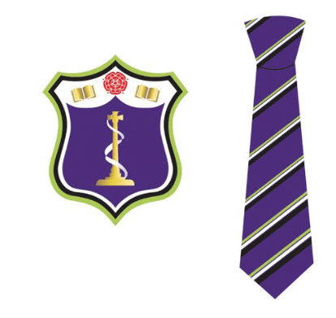

Uniform
During this academic year we have been working closely with our new supplier, Monkhouse, to prepare for the changes to our uniform for September 2021. Whilst all of the information can be found in your transition packs, we wanted to write to you to outline more details around purchasing the uniform and how we can support.

How you can purchase uniform
There are a number of ways in which you will be able to purchase our school uniform from Monkhouse. From 1st July 2021, you will be able to:
- Book 1:1 appointments in store with staff- Store Appointments (monkhouse.com)
Fishergate Shopping Centre, Preston
- Order online - Parent Guide (monkhouse.com)
- Order over the phone- 01772 259586/ 0161 476 7216 - Monday to Thursday - 8.30am to 5pm, Friday - 8.30am to 3pm
We would advise parents to order uniform as early as possible and Monkouse do also provide incentives for doing so.

Support provided by Wellfield
We are aware that some parents may wish to visit the store but might find this difficult. Therefore, we have requested a range of sample uniforms to be provided to us in school which we would be happy to organise for your son/daughter to try on. We would ask parents to contact us if there are any difficulties at all in accessing school uniform (transition@whs.lancs.sch.uk)

Uniform provided by Wellfield
One of our main priorities when sourcing a new supplier and making any changes to the uniform was to ensure the cost remains low to our parents. As part of our welcome bundle, we will be providing all students with a blazer and two ties free of charge as well as a sports kit. One tie will be provided in September.

In order to take advantage of this, we will provide all students with a specific code that must then be used to order these items over the phone or in store only. Unfortunately, it is not possible to provide parents with an online voucher. By providing your name, contact number, address, student name and the code provided to you, there will be no charge for these items and these will be delivered to your home (£4.50 charge). Alternatively, you can provide these details in store to purchase the items.

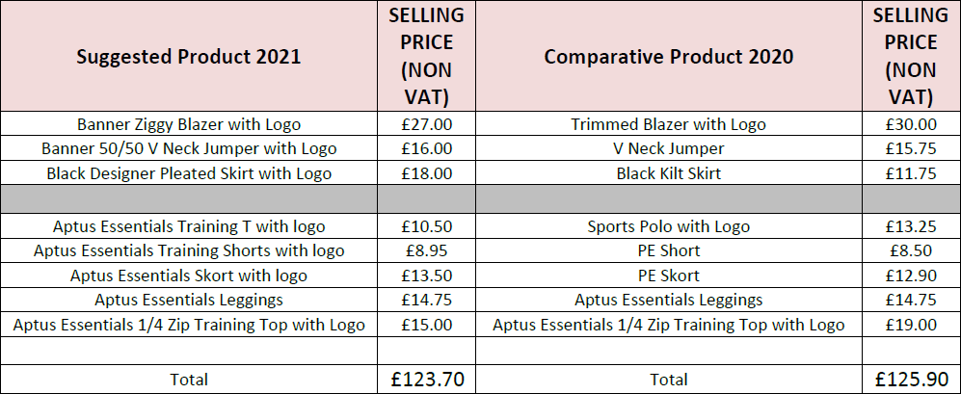

Finally, if purchasing uniform is an issue for any parent, please contact us (enquiries@whs.lancs.sch.uk) so we can look at how we may be able to help. We do not want any parent to struggle and have tried hard to make the uniform offer as cost effective as we possibly can.

Yours sincerely,

Mr J Lewis

Head of School

