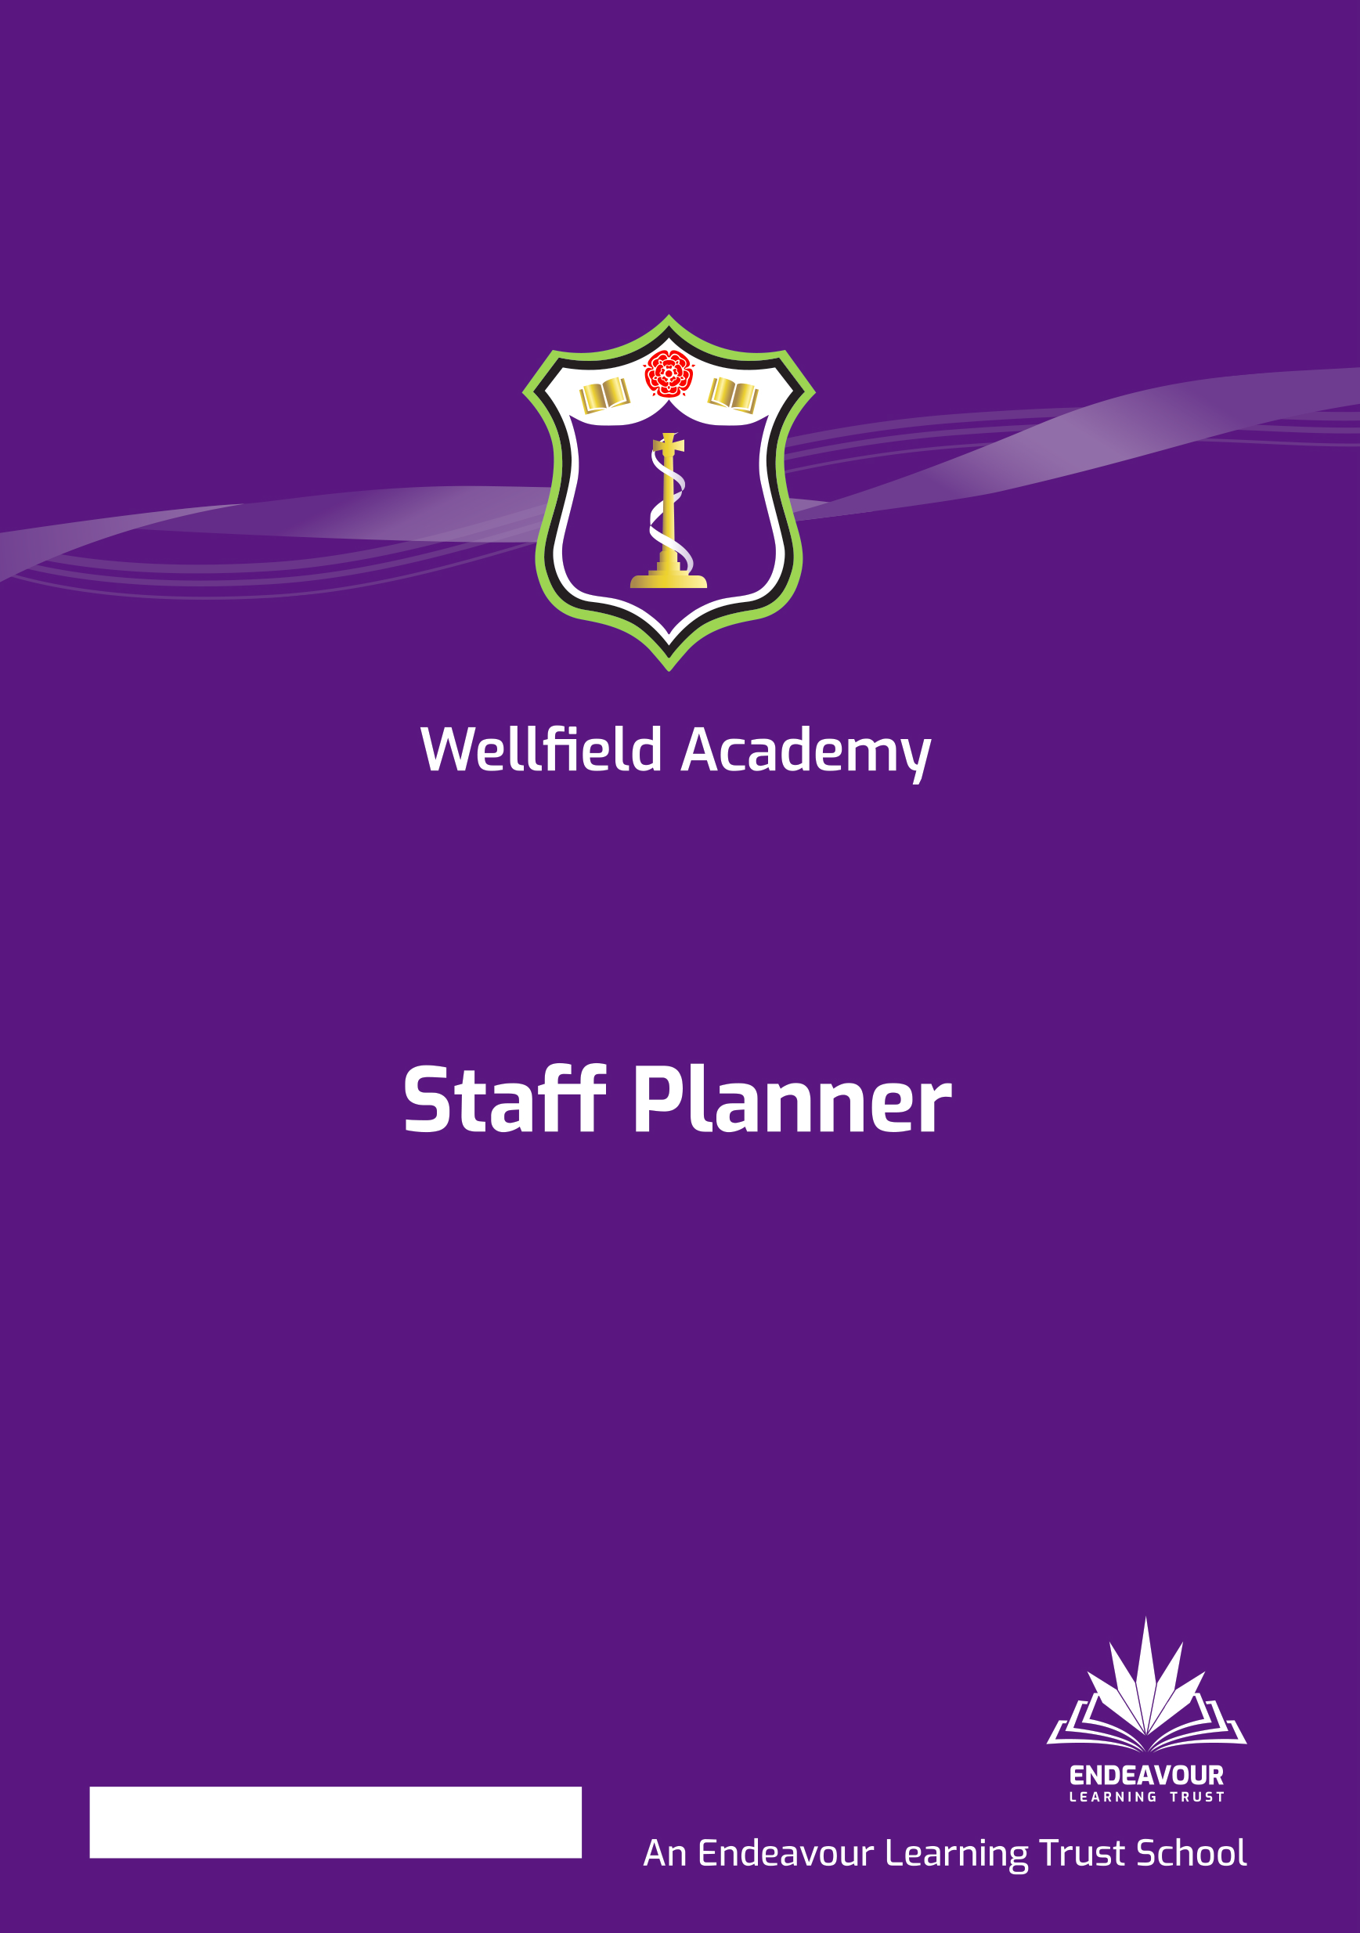
Home School Agreement 2023-2024
Home School Agreement

At Wellfield Academy we are very fortunate to have supportive parents who recognise that educating young people is a process that involves a strong partnership between home and school, positive working relationships and clear lines of communication. If your child attends Wellfield Academy, families and students are committed to this agreement. The aim of this home-school agreement is to work together to ensure a safe and positive school environment.
‘Nothing but the Best’
Our mission is to provide the very best for all of our community. This means creating an inclusive environment where staff and students, who are known as individuals, endeavour to be the best they can be in a highly aspirational learning community.

Our core values are:
Aspirational
We believe in the promise of each individual across the Trust and will ensure we inspire, support and challenge in proportionate measure, so that we all thrive and are able to achieve our own individual best potential.
Inclusive
Equality of opportunity is central to our school and we invest heavily in genuinely knowing our staff and students as individuals so that everyone is included, supported and challenged to remove any barriers to success and provide the chance to be their very best.
Community Centred
We foster authentic, positive relationships which are based on the foundations of respect, listening, kindness, support and constructive challenge. We are a school with a ‘family feel’ and one which genuinely cares about our whole school and local community.

Parent/ Guardian Responsibilities:
I/We agree to
- Setting a good example to all pupils in the way they behave, communicate and dress when on the school premises
- Treating all school personnel, pupils and other parents with dignity and respect
- Ensure that my child arrives at school on time and before 8.40am and that they are prepared for lessons that start at 8.45am;
- Ensure that my child wears full school uniform appropriately;
- Ensure that my child attends regularly and record absence via ClassCharts Attendance with an explanation if my child is absent;
- Attend Tutor and Parents’ Evenings to discuss my child’s progress;
- Support my child with the organisation and completion of homework;
- Support and reinforce the school’s policies and guidelines for rewards and behaviour and regularly review my child’s engagement through the school’s ClassCharts system;
- Let the school know about any concerns or problems that might affect my child’s work or behaviour;
- Work together with staff for the benefit of children. This includes approaching the school to make appointments to discuss and resolve any issues of concern;
- Park with consideration and respect for others when delivering and collecting children from school
- Keeping pets off the school premises
- Approach the school with any worries, frustrations or concerns so these can be addressed.
- Working together with staff members for the benefit of their child to resolve any issues or concerns

Students Responsibilities:
I agree to:
- Commit to the Wellfield Standard which focuses upon being aspirational, inclusive and community centred
- Attend school every day
- Arrive at school on time before 8.40am
- Be fully prepared for lessons with the correct equipment;
- Wear school uniform properly and be tidy in my appearance;
- Adhere to the school rules, policies and procedures;
- Do all my classwork and homework to the best of my ability and hand it in to meet the deadlines set by staff;
- Be polite and considerate to others in the school community;
- Respect the school environment and its wider community;
- Strive to reach my individual targets.

Social Media:
Social media and social networking sites play an important role in the lives of many youngsters. This agreement gives clarity to the ways in which social media is used by students, school staff and parents at Wellfield Academy.
- Parents should make complaints through official school channels rather than posting them on social networking sites. Parents who do this will be requested to attend a meeting at which the relationship between school and home will be discussed and parameters set;
- Parents should not post malicious or fictitious comments on social networking sites about any member of the school community. In the event that any student or parent/carer of a child educated at Wellfield Academy is found to be posting libellous or defamatory comments on Facebook or other social network sites, they will be reported to the appropriate 'report abuse' section of the network site. The school will also expect that any parent/carer or student removes such comments. In serious cases the school will also consider its legal options to deal with any such misuse of social networking and other sites;
- Cyber-bullying and the use by any member of the school community to humiliate or intimidate another by inappropriate social network entry will be dealt with as a serious incident of bullying.

In order to support a calm and safe school environment, the school does not tolerate from parents/guardians:
- Disruptive behaviour which interferes with the operation of a classroom, an office area or any other part of the school grounds;
- Using loud and/or offensive language;
- Threatening harm or the use of physical aggression towards another adult or child;
- Approaching someone else’s child in order to discuss or chastise them;
- Physically damaging or destroying school property;
- Abusive, threatening, malicious or inflammatory emails, phone or social network messages;
- Smoking/vaping/e-cigarettes and the consumption of alcohol or other drugs or accessing the school site whilst intoxicated.

