AQA-style Language Paper 2A:
Writers’ Viewpoints and Perspectives

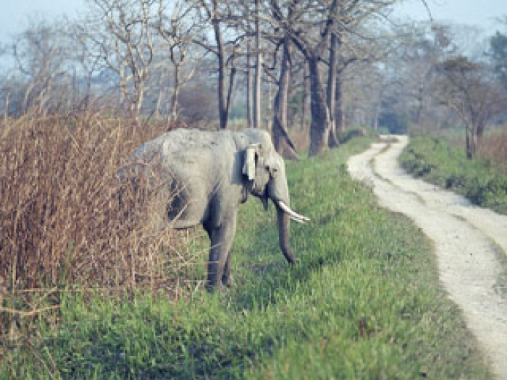

ELEPHANTS

SOURCE A: George Orwell – “Shooting an Elephant”

In this account, set in 1936, George Orwell is a young police officer serving in Burma, India, which was then part of the British Empire. He has been sent to deal with a troublesome elephant.

1  2  3  4  5  6  7  8  9  10  11  12  13  14  15  16  17  18  19  20  21  22  23  24  25  26  27  28  29  30  31  32  33  34  35  36  37  38  39  40  41  42 | As I started forward practically the whole population of the quarter flocked out of the houses and followed me. They had seen the rifle and were all shouting excitedly that I was going to shoot the elephant. They had not shown much interest in the elephant when he was merely ravaging their homes, but it was different now that he was going to be shot. It was a bit of fun to them, as it would be to an English crowd; besides they wanted the meat. It made me vaguely uneasy. I had no intention of shooting the elephant – I had merely sent for the rifle to defend myself if necessary – and it is always unnerving to have a crowd following you. I marched down the hill, looking and feeling a fool, with the rifle over my shoulder and an ever-growing army of people jostling at my heels. At the bottom, when you got away from the huts, there was a metalled road and beyond that a miry waste of paddy fields a thousand yards across, not yet ploughed but soggy from the first rains and dotted with coarse grass. The elephant was standing eight yards from the road, his left side towards us. He took not the slightest notice of the crowd's approach.  But at that moment I glanced round at the crowd that had followed me. It was an immense crowd, two thousand at the least and growing every minute. It blocked the road for a long distance on either side. I looked at the sea of yellow faces above the garish clothes-faces all happy and excited over this bit of fun, all certain that the elephant was going to be shot. They were watching me as they would watch a conjurer about to perform a trick. They did not like me, but with the magical rifle in my hands I was momentarily worth watching. And suddenly I realized that I should have to shoot the elephant after all. The people expected it of me and I had got to do it; I could feel their two thousand wills pressing me forward, irresistibly. And it was at this moment, as I stood there with the rifle in my hands, that I first grasped the hollowness, the futility of the white man's dominion in the East. Here was I, the white man with his gun, standing in front of the unarmed native crowd – seemingly the leading actor of the piece; but in reality I was only an absurd puppet pushed to and fro by the will of those yellow faces behind. To come all that way, rifle in hand, with two thousand people marching at my heels, and then to trail feebly away, having done nothing – no, that was impossible. The crowd would laugh at me.  But I did not want to shoot the elephant. I watched him beating his bunch of grass against his knees, with that preoccupied grandmotherly air that elephants have. It seemed to me that it would be murder to shoot him.  It was perfectly clear to me what I ought to do. I ought to walk up to within, say, twenty-five yards of the elephant and test his behaviour. If he charged, I could shoot; if he took no notice of me, it would be safe to leave him until the mahout came back. But also I knew that I was going to do no such thing. I was a poor shot with a rifle and the ground was soft mud into which one would sink at every step. If the elephant charged and I missed him, I should have about as much chance as a toad under a steam-roller. The sole thought in my mind was that if anything went wrong those two thousand Burmans would see me pursued, caught, trampled on and reduced to a grinning corpse like that Indian up the hill. And if that happened it was quite probable that some of them would laugh. That would never do.  There was only one alternative. I shoved the cartridges into the magazine and lay down on the road to get a better aim. The crowd grew very still, and a deep, low, happy sigh, as of people who see the theatre curtain go up at last, breathed from innumerable throats. They were going to have their bit of fun after all.
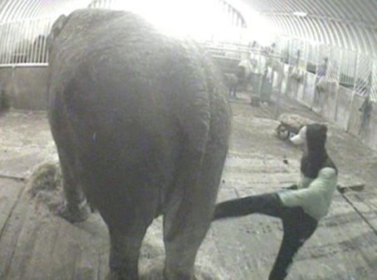
SOURCE B: Taken from The Daily Mail online, March 28th, 2011

Anne's agony: battered, kicked and stabbed,
the desperate plight of Britain's last circus elephant

1  2  3  4  5  6  7  8  9  10  11  12  13  14  15  16  17  18  19  20  21  22  23  24  25  26  27  28  29  30  31  32 | With each repeated blow, the pitchfork makes a sickening thwack as it slams into Anne the elephant's hide. She flinches, at one point even appearing to lose her footing under the weight of a particularly savage strike. The disturbing images come from a secretly shot video which campaigners say lays bare the cruel reality of her life as Britain's last circus elephant.  In secretly shot video, a worker swings a vicious kick into the belly of 58-year-old Anne the elephant. Animal Defenders International planted the device because of concerns about how Anne was being treated at Bobby Roberts's Super Circus. It shows Anne enduring the abuse at the hands of her so-called ‘carers’ while shackled in a dingy barn during the circus' winter break.  As well as being repeatedly hit with a pitchfork by one worker employed to feed and look after her, the 58-year-old elephant also appears to be stabbed in the face with the tool's metal prongs during one attack. A total of 48 strikes, including kicks to her body and head, were recorded as she was left chained to the spot by her legs.  Campaigners claimed shackling Anne with leg irons is particularly cruel because she suffers arthritis and her movements are already badly hampered. They have repeatedly called for circus owner Bobby Roberts to hand over Anne so she can live out her days in a wildlife sanctuary. But Mr Roberts, whose Super Circus began its latest tour on Thursday, insists the elephant is 'part of the family' and to separate her from the circus would cause her to 'pine away and die'. Anne is the oldest surviving elephant in Europe and is wheeled out in a headdress to pose for photographs with audience members up to twice a day.  The Asian elephant has been travelling with the Bobby Roberts Super Circus since the 1950s when she was bought by Mr Roberts's parents for around £3,000. At the time she was one of many performing elephants but since then most circuses have stopped using animals. In 2005, her plight was revealed by our sister newspaper the Mail on Sunday and angry readers sent more than 1,500 letters to Ben Bradshaw, then Labour's Animal Health and Welfare Minister.  Jan Creamer, who leads Animal Defenders International (ADI), said her organisation has been concerned for Anne's welfare for 'many years'. She called on police to examine the material with a view to investigating the circus for offences under the Animal Welfare Act. Ms Creamer said: 'ADI is discussing the potential for legal action with its lawyers and will be in touch with the police. Poor Anne has been with the circus for over 50 years since she was a baby, having been caught in the wild and torn from her family. Elephants are social and extremely intelligent so this has been a living hell for her. At last we have managed to expose this circus operation for the cruel farce that it is.’

Q1: Read Source A, lines 27 to the end.
Choose four statements below which are TRUE.

- Orwell was keen to shoot the elephant.

- The elephant is causing chaos, stampeding in the village.

- Orwell felt that it would be cruel to shoot the elephant.

- Orwell lay down to get a better aim.

- Orwell claims to be a good shot with the rifle.

- Orwell claims to be a poor shot with the rifle.

- The villagers wanted to see Orwell shoot the elephant.

Q2: Refer to source A and Source B. Write a summary to explain the differences in the writers’ attitudes to the elephant they each describe.

Q3: Re-read the extract below, from Source B.

“With each repeated blow, the pitchfork makes a sickening thwack as it slams into Anne the elephant's hide. She flinches, at one point even appearing to lose her footing under the weight of a particularly savage strike. The disturbing images come from a secretly shot video which campaigners say lays bare the cruel reality of her life as Britain's last circus elephant.

In secretly shot video, a worker swings a vicious kick into the belly of 58-year-old Anne the elephant. Animal Defenders International planted the device because of concerns about how Anne was being treated at Bobby Roberts's Super Circus. It shows Anne enduring the abuse at the hands of her so-called ‘carers’ while shackled in a dingy barn during the circus' winter break.

As well as being repeatedly hit with a pitchfork by one worker employed to feed and look after her, the 58-year-old elephant also appears to be stabbed in the face with the tool's metal prongs during one attack. A total of 48 strikes, including kicks to her body and head, were recorded as she was left chained to the spot by her legs.”

How does the writer use language here to convey the cruelty suffered by Annie the circus elephant?

Q4: Now refer to both Source A and Source B.
Compare how the writers convey their attitudes to the elephant they
each describe. [16 marks]

In your answer, you should:

• compare their different attitudes
• compare the methods they use to convey their attitudes
• support your ideas with quotations from both texts

