Disasters!
HMS Titanic: A survivor’s story
SOURCE A

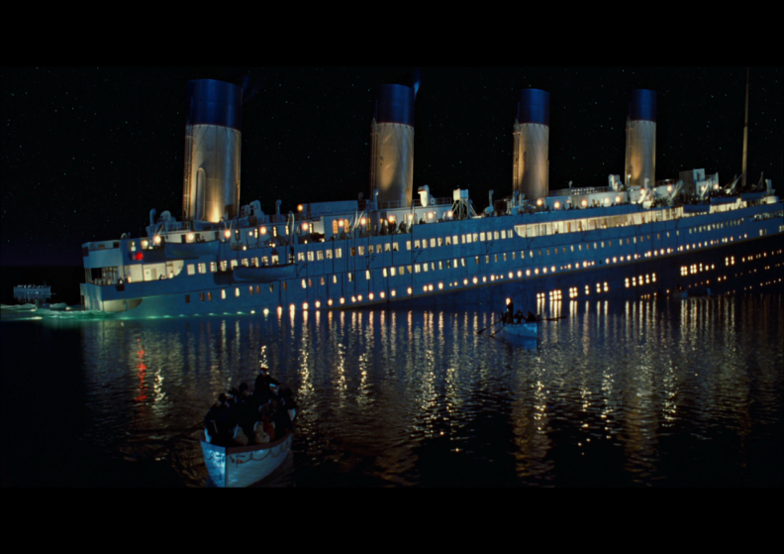
Elizabeth Shutes, aged 40, was governess to nineteen-year-old Margaret Graham who was travelling with her parents. As Shutes and Margaret sit in their First Class cabin they feel a shudder travel through the ship. At first comforted by her belief in the safety of the ship, Elizabeth's confidence is soon shattered by the realisation of a terrible disaster:

"Suddenly a strange shaking ran under me, apparently the whole length of the ship. Startled by the very strangeness of the shivering motion, I sprang to the floor. With too perfect a trust in that mighty vessel I again lay down. Someone knocked at my door, and the voice of a friend said: 'Come quickly to my cabin; an iceberg has just passed our window; I know we have just struck one.'

No confusion, no noise of any kind, no immediate danger. Our stewardess came and said she could learn nothing. Looking out into the corridor I saw heads appearing, asking questions from half-closed doors. All was still, no excitement. I sat down again. My friend was by this time dressed; still her daughter and I talked on, Margaret pretending to eat a sandwich. Her hand shook so that the bread kept parting company from the chicken. Then I saw she was frightened, and for the first time I was too, but why get dressed, as no one had given the slightest hint of any possible danger? An officer's cap passed the door. I asked: 'Is there an accident or danger of any kind? 'None, so far as I know', was his polite answer, spoken quietly and most kindly. This same officer then entered a cabin a little distance down the companionway and, by this time distrustful of everything, I listened intently, and distinctly heard, 'We can keep the water out for a while.' Then, and not until then, did I realise the horror of an accident at sea. Now it was too late to dress; no time for a waist, but a coat and skirt were soon on; slippers were quicker than shoes; the stewardess put on our life-jackets, and we were just ready when Mr Roebling came to tell us he would take us to our friend's mother, who was waiting on the deck above ...

Now only pale faces, each form strapped about with those white bars. So gruesome a scene. We passed on. The awful good-byes. The quiet look of hope in the brave men's eyes as their wives were put into the lifeboats. Nothing escaped one at this fearful moment. We left from the sun deck, seventy-five feet above the water. Mr Case and Mr Roebling, brave American men, saw us to the lifeboat, made no effort to save themselves, but stepped back on deck. Later they went to an honoured grave.

Our lifeboat, with thirty-six in it, began lowering to the sea. This was done amid the greatest confusion. Rough seamen all giving different orders. No officer aboard. As only one side of the ropes worked, the lifeboat at one time was in such a position that it seemed we must capsize in mid-air. At last the ropes worked together, and we drew nearer and nearer the black, oily water. The first touch of our lifeboat on that black sea came to me as a last good-bye to life, and so we put off - a tiny boat on a great sea - rowed away from what had been a safe home for five days.”

SOURCE B

The Real Story of the RMS Titanic

Taken from www.teenink.com an online magazine written for teens, by teens

SOS! SOS! On April 15, 1912, RMS Titanic frantically summons help as the ship sinks farther and farther in the frigid water. Sadly, all the other nearby ships have their radios off at night and no-one answers the Titanic’s call for help. Shortly before midnight, the Titanic struck an iceberg and sank. The wreck changed 706 people’s lives and ended the lives of 1,517 more.
Claimed ‘Unsinkable’, the Titanic did not live up to its name. However, what made this accident such a big deal was the huge error the White Star Line made. The ship had a lifeboat capacity of 1,178 people, yet carried 3,547 passengers. When the ship started to sink, people panicked and left with the lifeboats only half-full. Many people jumped off the boat, only to catch hypothermia and die. Surviving passengers still remember the ghostly wails of dying passengers.
To truly understand the awful fate of the Titanic you have to go back to the very beginning. The Titanic was christened the ‘Unsinkable’ ship, but soon proved its nickname to be wrong. The actual voyage of the Titanic got off on the wrong foot. As the Titanic was pulling away from the port for the first time, the suction from its enormous size caused the ropes of a nearby boat to snap. The small boat almost crashed into the Titanic. Some passengers took this to be a bad omen and coincidentally or not, it was.

There are a number of odd rumours and legends about the Titanic but most are false. Among the more popular ones are that the bottle of champagne used to christen the Titanic didn’t break on the first swing. This is untrue however, as the White Star Line did not believe in the custom. Other rumours include the fact that the Titanic had the cursed Hope diamond aboard the ship and that’s why it sank, but this is also false. Another is that one of the ship’s builders was accidentally sealed in the hull – also false. Silly rumours or not, they seemed to have predicted the Titanic’s future better than we did.
At 11:40 pm on April 14, 1912, the two lookouts on duty, Fredrick Fleet and Reginald Lee spotted a large mass of ice and immediately rang the warning bell three times. “DING! DING! DING!” was all that the captain heard as he hurriedly gave the order “hard-a-starboard”, meaning an abrupt turn toward the left. The iceberg managed to brush the right-side of the ship crushing the hull. The Titanic’s safe design included water-tight compartments that would allow the ship to stay floating in case of a minor incident. However, the ship could only stay floating as long as less than 5 compartments were filled; 5 compartments were filling fast. Several ships hear the Titanic’s calls for help but are too far away to be of any assistance. The ship’s crew members were given the awful job of trying to persuade reluctant passengers that the boat was really sinking. Many passengers only heard a dull scraping noise as the ice went past the ship’s side and went back to sleep.

Q1: Read lines 6 to 20 of Source A.
Choose four statements below which are TRUE.

- Elizabeth was, at first, unconcerned by the noise

- The noise was not noticed by other passengers

- Margaret was nervous and her hand trembled

- The officer lied to reassure Elizabeth all was OK

- The women put on their own life-jackets

- The stewardess put on their life-jackets

- Their friend’s mother was waiting below deck

Q2: Refer to Source A and Source B. Write a summary of the differences
between the two texts. Aim to write 100 – 150 words.

Q3: Re-read the extract below, taken from Source A.

Now only pale faces, each form strapped about with those white bars. So gruesome a scene. We passed on. The awful good-byes. The quiet look of hope in the brave men's eyes as their wives were put into the lifeboats. Nothing escaped one at this fearful moment. We left from the sun deck, seventy-five feet above the water. Mr Case and Mr Roebling, brave American men, saw us to the lifeboat, made no effort to save themselves, but stepped back on deck. Later they went to an honoured grave.

Our lifeboat, with thirty-six in it, began lowering to the sea. This was done amid the greatest confusion. Rough seamen all giving different orders. No officer aboard. As only one side of the ropes worked, the lifeboat at one time was in such a position that it seemed we must capsize in mid-air. At last the ropes worked together, and we drew nearer and nearer the black, oily water. The first touch of our lifeboat on that black sea came to me as a last good-bye to life, and so we put off - a tiny boat on a great sea - rowed away from what had been a safe home for five days.”

How does the writer use language to convey a sense of fear to the reader?

