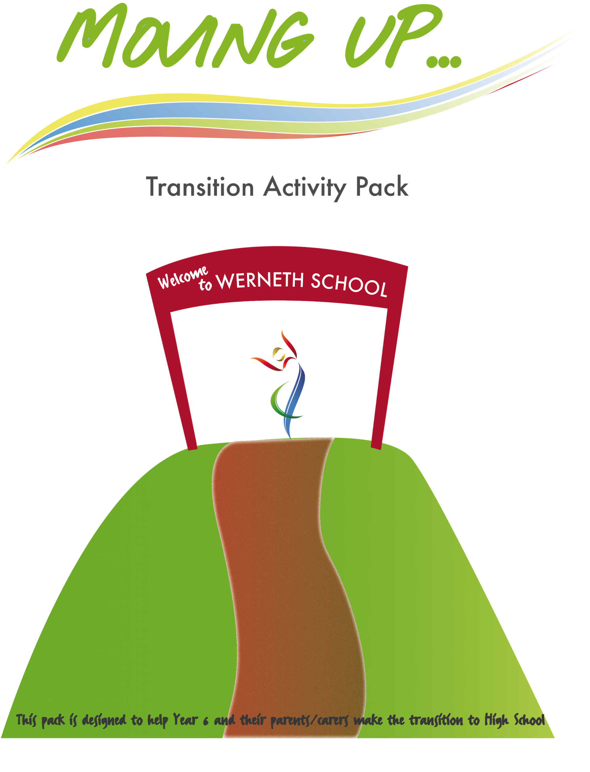
TRANSITION PACK

Contents

Contents 2
Getting to School 3
Timetables 5
Expectations and Rewards 6
New App 6
Lunch Time 8
Uniform 9
Year 7 Team 10
Attendance 11
MUFC 12
Behaviour for Learning 13
Werneth Leadership Academy 14

Getting to School
Your new school may be further away from where you live than the school you go to now.
One of the things that grownups are most worried about is your safety, they will want you to get to and from school as quickly and safely as possible.

What’s the best way to get there?
Tick or colour the bubbles to show which things you will need to talk about with your parent/carer – not all of them will apply to you.
Where is the bus stop?
How am I getting to school?

What is the quickest way?

What is the safest way?

Do I get a bus pass?

Where can I leave my bike?

Where am I going?
How long will it take?

Who will drive me?
Will I go with a friend?

Will I get a lift home?
Do I need a bike lock

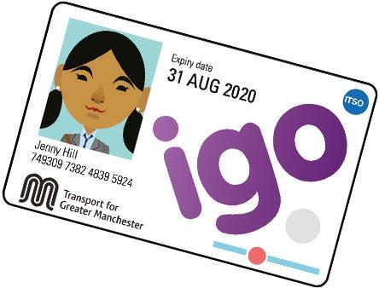
IGO Bus Pass
If you use public transport and are in secondary school you will need an IGO pass. To obtain an IGO you will need to either go to the bus station and collect an application form or download one from;
https://www.tfgm.com/tickets-and-passes/igo-pass

All this information can be found on our website with links to apply.

What happens if I’m late?

School starts at 8.40 every day and you must try to arrive in school with plenty of time to get to form. If you arrive to school after form time has finished (9.05) the student entrance will be closed and you must enter through the Reception entrance. You will be given a late mark for a late arrival.

If you are late twice in the same week you will be issued with a detention by your form tutor, this is if you have arrived late of your own accord.

If you are persistently late a letter will be sent home, if this does not improve your parents will be invited in for a meeting with our attendance officer.

If you have been for an appointment you must have a note or medical card.
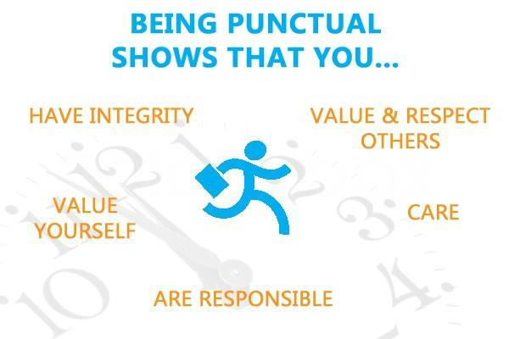

Timetables
Staff name (shortened staff code) and room/floor number.

 | P1 | P2 | P3 | P4 | P5
RMon | Technology  ROA A13 | Technology  ROA A13 | English  SWN B32 | Science  EBE C50 | Exp Arts  GWO A4
RTue | MFL  DMA A10 | PE  RBR SH | PE  RBR SH | English  SWN B32 | Life Learn  NSM A1
RWed | Geog  JNI C49 | Maths  PBR C44 | English  EWA B35 | Science  AJN C41 | MFL  DMA A10
RThu | History  SMO B20 | English  SWN B32 | Music  ODA A6 | MFL  DMA A10 | Science  EBE C50
RFri | Maths  PBR C44 | Rel Ed  AEL B19 | Exp Arts  GWO A4 | Music  ODA A6 | English  EWA B35

Times of the day;
Form time 08.45 - 9.05
We have a Red and a Blue week

P1 09.05 – 10.10
P2 10.10 – 11.10

Break 11.10 - 11.30

P3 11.30 – 12.30
P4 12.30 – 1.30

Lunch 1.30 – 2.10

P5 2.10 – 3.10
3.10 - After school activity or home time

Expectations and Rewards

Outstanding Behaviour at Werneth School

At Werneth we believe that students respond best to praise and reward.
Through recognition and reward we seek to develop a culture of celebrating both academic and personal achievement, this is distinct from expected behaviour i.e. attending school when fit to do and following the code of conduct it is about going ‘over and above’.
We want to develop the character of you, our students – your personal qualities, or virtues – so you can go on and become happy, engaged, fulfilled citizens. We want to develop your skills so that you not only want to help people, but they know how to help people.
Character is about doing the right thing at the right time for the right reason; sometimes it is described as “making the right choices when no one is looking”. Students in Year 7 will learn the Werneth Way through ABC 123.

New App
We have launched a new school app and you will receive further information once you have started at Werneth on how to download and access all the features. This will be done with your form tutor in the first week in September.

Lunch Time

At primary school you probably have your lunch in the school hall or in your classroom, at Werneth the only place you are allowed to eat food is in the school canteen. We will try to encourage you to eat healthily and there will be a bigger choice of food than there is in primary school. At Werneth we use fingerprint technology, this means that you don’t bring any money to school, your parent/carer will put money into a school account, when you buy food you scan your finger and it takes the money from your account.
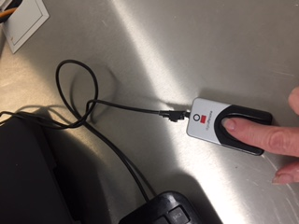
If you were to have £3.00 on your school account what would you choose to eat? How much would you spend at break time and how much at lunch time?

In an emergency you can also put money into your account using this machine…
And this is what the machine looks like that scans your fingerprint.
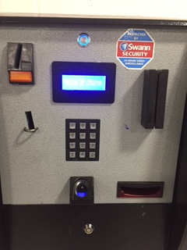

When you start at Werneth you will be given a letter to take home, this will have a login and password for your parents to create a ‘Parentpay’ account. This is where your parent/carer can add money to your account for you to spend on breakfast, break and lunch. This can also be used to pay for trips or any other activities.

Uniform

We pride ourselves on exceptional uniforms in school. We wear our uniform with pride within school. The leadership team will meet you at the gate in morning to welcome you into school and check your uniform. If your uniform is incorrect, a loan uniform will be issued. A sanction will be given for breaking the uniform rule within school.

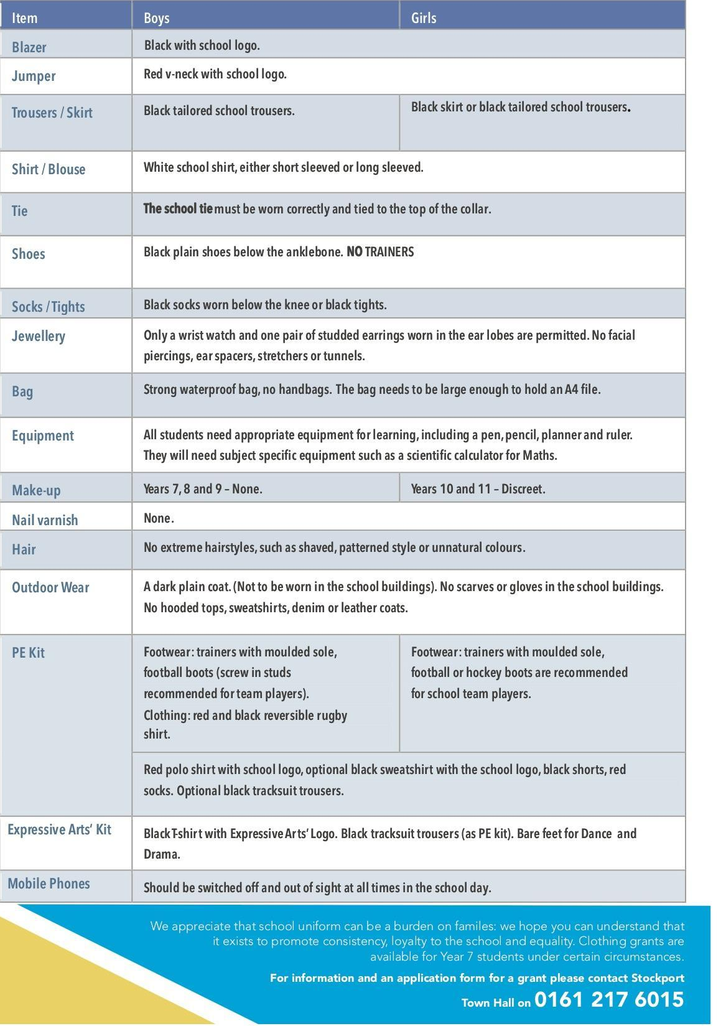

Year 7 Pastoral Team

Head of Year 7 - Mrs Tonge / Mrs Tracy Taylor

SENDCO/ Assistant SENDCO - Mrs S Burke, Mrs K Sutcliffe, Ms Cuthbert

SLT Link for Year 7 - Miss J Dee

Safeguarding Lead and Assistant headteacher- Miss J Dee

Assistant headteacher responsible for behaviour - Mr D Willis

Form tutors - TBC

The Year 7 team will be on hand to help support you on your transition to Werneth. We will be able to answer any concerns or worries you have as you move up to secondary school.

Parents and Carers can email the Year 7 lead, Mrs Tonge on transition@wernethschool.com and she will answer any questions you have.

Who is a form Tutor and what do they do?

- See you every morning to take the register and complete form time activities
- Support you every day with attendance, behaviour, uniform and equipment
- Answer questions & give you information
- Inform you of trips and activities
- Support you during fire alarms
- Be the first point of call for parent enquiries

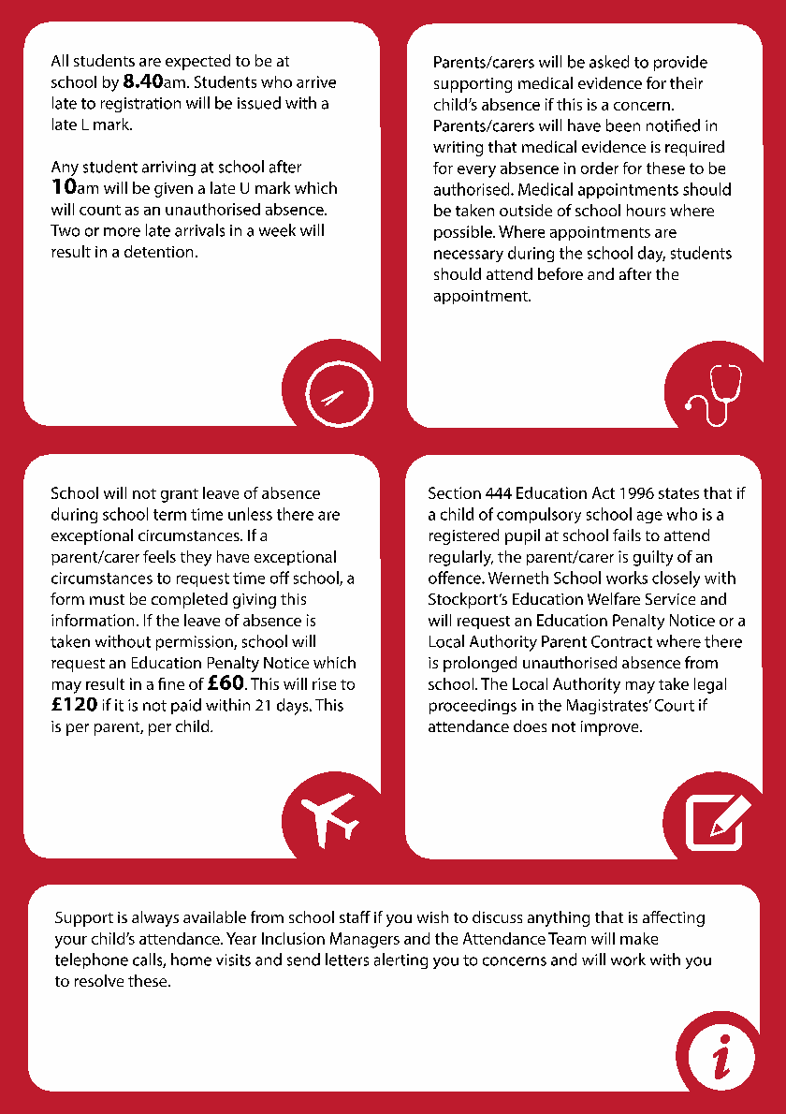
Attendance

MUFC

The Foundation works with Werneth School to deliver a schedule of innovative projects for local primary school and high school pupils. The Foundation also provides support with additional activities such as enrichment, after school clubs whilst uniting the surrounding community through the power of football.
Manchester United Foundation and Werneth School will be working in partnership on the following areas of development:
- Leadership
- Pupil mentoring
- Coaching Education
- Increasing football and sports participation
- Football skill development
- Enrichment opportunities
- Transition of pupils from local primary schools
- Delivery of physical literacy and healthy eating projects in local primary schools

You can view the latest MU newsletter on this link…
https://www.wernethschool.com/school_life/mufs.html/

Behaviour for Learning

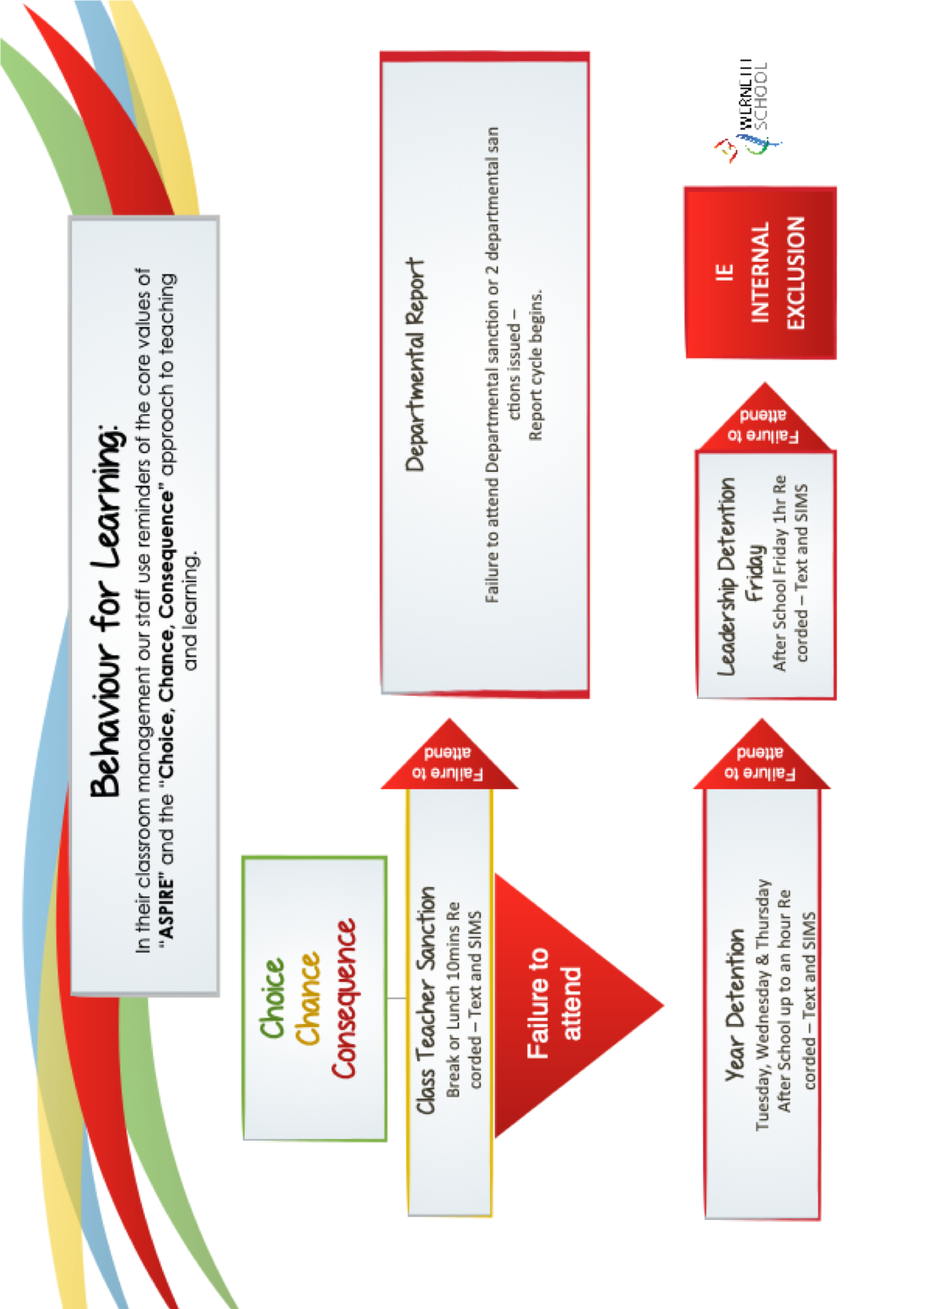

Werneth Leadership Academy

