West Heslerton Y5/6 Learning Project – More Music Maestro!
work set for the week beginning: 15/06/20 (week 3) and the week beginning: 22/06/20 (week 4)
Message for all of Farthing Wood…
I am sure that there will be plenty in this learning project for keep everyone thinking and moving forward over the next couple of weeks (sorry parents but this may involve a little bit of noise!)
This week in class we have been working on the Yr6 yearbook, and it has also been great to receive some children’s yearbook pages via email from those of you who are busy working on these at home. Just to warn you…I have managed to find some great photos to add to some of your pages!
Weekly Maths Tasks – shape and angles  (aim for one per day) | Weekly Reading Tasks (aim for one per day)
- Yr6 – Maths secondary school transition project. I have been speaking with the cluster of schools (including the local secondary school Maths departments) who we have been working with on a project since the Autumn term. We have decided that it will be possible to carry on with the project as planned. This will mean that you all have something to take with you to your first Maths lessons in September. All the info that you need is attached on extra sheets for you to print at the end of this newsletter.  - Y6 – improve your calculator skills ready for secondary school​ by completing the ‘Calculator Crunch’ daily question, each weekday from 15th-25th June.  - Y6 - Work on your reasoning and problem solving​ by practising past SATs questions from your maths folder – keep to the set timetable.  - All – Each day Gareth Metcalfe from ‘I See Maths’ (some of his materials which we use in class) will be posting a daily video for Years 5 and 6 to complete. The videos explore a big mathematical idea in small steps and there are a range of independent tasks for you to complete. There is also parental introduction video here to explain more.  - All - Times Table Rockstars​​.​ Access this programme with your school login. On Times Table Rockstars, children should aim to play Soundcheck for 20 minutes daily.  - All - Find the missing angle in the ​triangles​ or ​around a point.  - All - Draw a map from your bedroom to the kitchen. Calculate the total degrees of turn involved on the journey. You can repeat this activity for other areas in your home or for your daily walk.  - All - Look for and collect 3D objects around the home. For the ones you have selected, name the 3D shape, list the properties (the number of edges, faces and vertices) and draw the net to match.  - All - Practise measuring and reading angles with a protractor with this ​online game​.  - All - Create a rhythm by clapping/clicking, e.g. ​clap, clap, clap, click, clap, clap, clap, click etc​. Predict what action you would do on the 15th beat. Can you work it out without having to do the rhythm? What about the 20th, 50th, 99th beat? Do you notice any patterns? | - Yr6 – Write your personal page for this years Year 6 leavers yearbook – see more details in the Year 6 sections below. Here are some examples to get you started. Send your written pieces to fw@heslerton@n-yorks.sch.uk  - All – The class reading book for the rest of the Summer term will be ‘Can You See Me?’ by Libby Scott and Rebecca Westcott.  Week 3 – Chapters 7-12 – read and answer questions  Week 4 – Chapters 13-19 – read and answer questions  - All - Listen to a free age-appropriate audiobook here​, choose a book from ​GetEpic.com ​ ​ or continue with you home reading book.  - All – work on your non-fiction reading comprehension skills by logging in to Readtheory.org and complete three texts and questions. Login details are recorded in your reading logs/planners.  - All - ​During your daily reading, play some classical music, rock music, jazz music and pop music.​ ​Draw an emoji to represent how each music genre made you feel whilst they were reading.  - All - Find the lyrics to your favourite song and to create some new verses. Can you perform the new verses to the family?  - All - Click ​here​ for a reading activity about ​Music​. Read the text in 3 minutes and complete the questions.  - All - Listen or read along to the poem Cat Rap ​here​. Can you write their own version using a different noisy animal?  - All - Visit​ ​Audible​ and choose a book to listen to. Write a review when they have finished and share it with a friend (remotely).

Weekly Spelling Tasks  (aim for one per day) | Weekly Writing Tasks  (aim for one per day but these may take longer)
- All - Pick 5 Common Exception words from the ​Year 5/6 spelling list​. Play a song and stop it at different points. When it stops, one spelling should be selected and you must spell it before the music starts again.  - All - The word ​rhythm​ has a silent letter - what other words can you spell which also have silent letters?  - All - Practise spellings on ​Spelling Frame​ ​or practise spelling words with silent letters on ​this game​.  - ​All - Using the letters ​C A R N I V A L​, make a list associated adjectives or verbs that correspond with each letter.  - All - Create a musical glossary for the following vocabulary: dynamics, structure, timbre, texture ​& ​tempo.  - All – Practise spellings on Spelling Shed. Login details are recorded in your reading logs/planners. | - All – Various writing tasks: Visit the Literacy Shed for this wonderful resource on ​Once in a Lifetime.  - All – Story task: ​Listen to ​A Night on Bare Mountain​ by​ ​Modest Mussorgsky​ and the inspiration behind it. Create a story with the same title that could be told along with the music.  - All – Story task: ​ Change the lyrics of your favourite song into a short story. Alternatively, they could write and perform their own song.  - All – Information writing: Create an information booklet about two pieces of music you have listened to. Include information about the instruments you have heard within each piece and a brief history on the musicians.  - All – Playscript task: ​Listen to​ ​'Toccata and Fugue in D Minor'​. Think about what the setting might be and describe the atmosphere. Create two characters and think about what could be happening. Write a short play script/ piece of dialogue between the characters that would go with this music.
Year 6 Maths Transition Project
Maths secondary school transition project - I have been speaking with the cluster of schools (including the local secondary school Maths departments) who we have been working with on a project since the Autumn term. We have decided that it will be possible to carry on with the project as planned. This will mean that you all have something to take with you to your first Maths lessons in September. All the info that you need is attached on extra sheets for you to print at the end of this newsletter to do with ‘Frayer Models’

Year 6 Leavers Preparation
Year 6 Yearbook – we are planning on putting together a year book, which would mean everyone, whether at home or school could get involved. This would then be sent out to each of you as a keepsake and reminder of all your wonderful times at West Heslerton Primary School.

Each of you will have a whole page dedicated to talking about your favourite memories, your achievements, the things you are proud of and what you are looking forward to in the future. There are some brilliant examples here for you to have a read through to help you really narrow down what you would like to say. Then email your piece to me at fw@heslerton.n-yorks.sch.uk and from there I will edit your written work ready for publishing in the yearbook.

Agingbooth app photo or from a similar photo aging program – Please forward or screen shot and send your aged photo to fw@heslerton.n-yorks.sch.uk this will be used as part of your Year book page. Your page will also include lots of other photos that I have been gathering up from over the years!

Learning Project to be completed throughout the next two weeks
The project this week aims to provide opportunities for your child to learn more about music. Learning may focus on famous musicians, listening to and performing music and exploring a range of music genres and instruments.

- Sound Effects - ​Many audio books use sound effects to enhance the retelling of books. Ask your child to think about a narrative that they are currently reading or have read recently. What sound effects would enhance the retelling of the story? Ask your child to source a range of props to help add sound effects and record the retelling of the story with their sound effects.

- Carnival Time - ​The Rio carnival is a spectacle of samba, costumes and dance and takes place every year. ​Here are​ some of the pictures from this year’s parade. Challenge your child to research the samba inspired costumes and headdresses worn during the parades. Ask them to design, label and make their own mask or headdress taking inspiration from the research completed​.

- Expression - ​Kandinsky​ felt that he could express emotions and music through colours and shapes within his painting. Ask your child to create a piece of artwork inspired by their favourite piece of music. Encourage them to listen to the music several times and feel free to draw or paint the emotion they feel at the time.

- I’m with the Band! - ​Ask your child to create their own musical instrument. This could be a cereal box guitar, drums or shakers. They may even want to make a range of instruments to create a family band. Ask your child to decorate their instruments to make them appealing. After this, your child can research which famous musicians perform with their chosen instrument and watch videos of their performance to inspire their own!

- Music Video Directors - ​Using the song your child created for their writing task this week, direct them to think about the sort of music video that they could create to go with it. They could storyboard their ideas and think about whether they need any props or even come up with a dance routine before recording it.

STEM Learning Opportunities #scienceathome
Making Instruments
- A kazoo is a simple wind instrument that allows the player to create sound by humming.
- You will need a cardboard tube, square of grease proof paper and an elastic band. Cover the end of the tube in paper and secure it in place using the elastic band.
- Hum a tune into the open end of the kazoo. What happens to the kazoo? What happens to the sound of your voice?
- Learn more about sound by researching how ears work and different ears are adapted to different environments. Find out why elephants have such big ears.

Additional learning resources parents may wish to engage with
- BBC Bitesize​ - ​Lots of videos and learning opportunities for all subjects.
- Classroom Secrets Learning Packs​ ​- Reading, writing and maths activities for different ages.
- Twinkl​ - ​Click on the link and sign up using your email address and creating a password. Use the offer code UKTWINKLHELPS.
- White Rose Maths​ online maths lessons. Watch a lesson video and complete the worksheet (can be downloaded and completed digitally).
- IXL online. Click here for ​Year 5​ or here for ​Year 6​. There are interactive games to play and guides for parents.
- Mastery Mathematics Learning Packs. ​Take a look at the mastery mathematics home learning packs with a range of different activities and lessons.
- Mastery English Learning Packs. ​Take a look at the mastery mathematics home learning packs with a range of different activities and lessons.
- Y5 Talk for Writing Home-school Booklets​ and ​Y6​ ​are an excellent resource to support your child’s speaking and listening, reading and writing skills.
The next Farthing Wood learning project will be out on – Friday 26th June 2020

Yr6 Secondary School Maths Transition Project – Frayer models

You will need to complete three Freya Models: one for fractions, one for decimals and one for percentages. We have done these before in class but just to remind you…

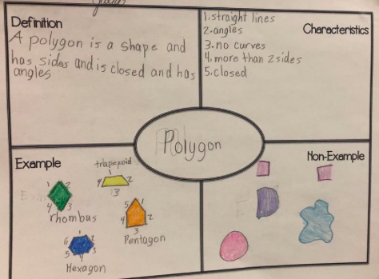

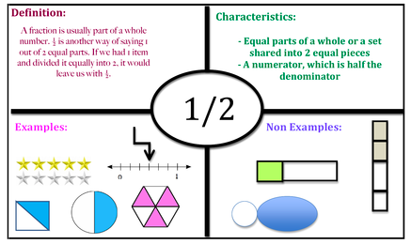

BLANK FREYA MODEL BELOW TO PRINT IF NEEDED

Once completed you will need to:
- where possible, email me to fw@helserton.n-yorks.sch.uk (either as a photo or as an attached document) your three completed Freya models.
- Print/keep a copy for yourself, somewhere safe, that you can take with you to your Maths lessons at secondary school in September.

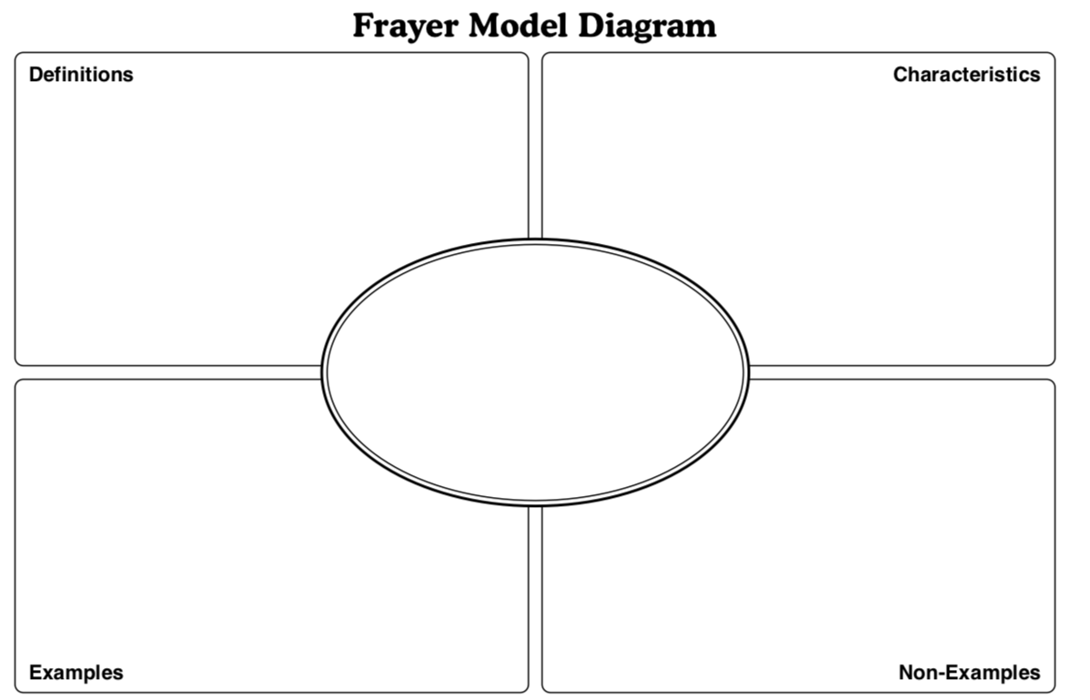
Fractions
Decimals
Percentages

