West Heslerton Y5/6 Learning Project – Famous and Significant People
work set for the week beginning: 01/06/20 (week 1) and the week beginning: 08/06/20 (week 2)

Message for all of Farthing Wood…
Hope you are all well and staying safe. A few additions and slight changes to to look out for this week, such as ‘I see maths’ video links and the class reading book. There are also few extra sections this week specifically for Year 6. These include completing work for the Year 6 transition the=o secondary school Maths project and we need to quickly get thinking about putting something together to help the Year 6 celebrate leavers with regards to a Year book (see separate Year 6 sections).
Weekly Maths Tasks – addition and subtraction  (aim for one per day) | Weekly Reading Tasks (aim for one per day)
- Yr6 – Maths secondary school transition project. I have been speaking with the cluster of schools (including the local secondary school Maths departments) who we have been working with on a project since the Autumn term. We have decided that it will be possible to carry on with the project as planned. This will mean that you all have something to take with you to your first Maths lessons in September. All the info that you need is attached on extra sheets for you to print at the end of this newsletter.  - All – Each day Gareth Metcalfe from ‘I See Maths’ (some of his materials which we use in class) will be posting a daily video for Years 5 and 6 to complete. The videos explore a big mathematical idea in small steps and there are a range of independent tasks for you to complete. There is also parental introduction video here to explain more.  - All - What different calculations can you create when adding and subtracting the numbers 111, 8276, 529, 18391, 9238 and 4163 ? Make sure you check it is correct using the inverse operation. CHALLENGE: Can you make some decimal numbers and add these to one of the whole numbers.  - All - Play this online addition and subtraction game. They can play it more than once to see if they can reach the top score.  - All - Play this missing box addition game or missing box subtraction game. Work on the level that adds/subtracts 3 digits by clicking on the orange three. Can you make your own addition/subtraction calculations like this?  - All - Roll a dice and make a 6 digit number (target number). If you do not have a dice, make up a 6 digit number. Write 2 addition and 2 subtraction calculations where the answer is the target number given. Make this easier by reducing the number of digits in the target number.  - All - Find out when each family member was born and record this. Add all of the years up together and find a total. Add up the years from the same generation - which decade has the most/least members?  - Y6 - Work on your reasoning and problem solving​ by practising past SATs questions from your maths folder – keep to the set timetable.  - All - Times Table Rockstars​​.​ Access this programme with your school login. On Times Table Rockstars, children should aim to play Soundcheck for 20 minutes daily. | - Yr6 – Write your personal page for this years Year 6 yearbook – see more details in the Year 6 sections below. Here are some examples to get you started. Send your written pieces to fw@heslerton@n-yorks.sch.uk  - All – The class reading book for the rest of the Summer term will be ‘Can You See Me?’ by Libby Scott and Rebecca Westcott.  Week 1 – Chapters 1-5 – read and answer questions  Week 2 – Chapters 5-7 – read and answer questions  - All – Have a read of some of the wonderful stories, poems, essays and pictures in this ‘Book of Hopes’. It is an electronic book especially written by more than 100 children’s writers and illustrators to help comfort, inspire and entertain children in lockdown.  - All - Listen to a free age-appropriate audiobook here​, choose a book from ​GetEpic.com ​ ​ or continue with you home reading book.  - All – work on your non-fiction reading comprehension skills by logging in to Readtheory.org and complete three texts and questions. Login details are recorded in your reading logs/planners.  - All - Can somebody who is important to you read to you? Perhaps they could share an extract from their favourite book or a poem?  - ​All - Read a newspaper article about a famous person. What can you tell about the person from the language used? Does the article criticise them or is it complimentary – how can you tell?  - All – Click here for a reading comprehension activity about a famous botanist. Read the text in under 3 minutes and complete the comprehension questions.  - All - Visit Ducksters and choose a person that interests you to read about. Can you record 10 facts you discovered?  - All - Create a character profile about a famous book character e.g. Harry Potter, Matilda Wormwood or Percy Jackson.

Weekly Spelling Tasks  (aim for one per day) | Weekly Writing Tasks  (aim for one per day but these may take longer)
- All - practise the Year 5/6 Common Exception Words (see list in homework books). Then choose 5 Common Exception words. Follow ‘This Link’ for some interesting ideas on how to learn these  - All - Choose 5 Common Exception words here. Write the meaning, synonyms (word with the same/similar meaning) and antonyms (word that has the opposite meaning) for each word.  - All – Make a mind map of the vocabulary that you associate with the following significant people: The Queen, Guy Fawkes, Helena Lucas and Rosa Parks.  - All - Complete this segment puzzle (click Spelling Tiles) which focuses on words ending in: -able, -ible, -ably and -ibly ?  - All - Practise spellings on Spelling Frame. Use a dictionary to clarify any unfamiliar vocabulary.  - All – Practise spellings on Spelling Shed. Login details are recorded in your reading logs/planners. | All – Story/letter writing task: Visit the Literacy Shed for this wonderful resource on The Clocktower or write a letter/email to an important family member updating them on events from the last few weeks.  All – Poetry task: Using the words FAMOUS PEOPLE, get your child to write an acrostic poem about significant British people in history.  All –Speech writing task: Listen to Martin Luther King’s speech I Have a Dream. Now write their own speech about your dreams. Use the same techniques such as repetition, personification and powerful verbs.  All – Information report task: Create an information report about a significant/famous person of interest. Perhaps choose a famous author, athlete, popstar or even a local hero such as a doctor or nurse. Include: birthplace, what they’re most famous for, significant events/achievements and any other interesting facts.  All –Autobiography task​: Write in role as that person and create a short autobiography of their life. Remember to think about the person’s emotions during key parts of their life.
Year 6 Maths Transition Project
Maths secondary school transition project - I have been speaking with the cluster of schools (including the local secondary school Maths departments) who we have been working with on a project since the Autumn term. We have decided that it will be possible to carry on with the project as planned. This will mean that you all have something to take with you to your first Maths lessons in September. All the info that you need is attached on extra sheets for you to print at the end of this newsletter to do with ‘Frayer Models’

Year 6 Leavers Preparation
Year 6 yearbook – we are planning on putting together a year book, which would mean everyone, whether at home or school could get involved. This would then be sent out to each of you as a keepsake and reminder of all your wonderful times at West Heslerton Primary School.

Each of you will have a whole page dedicated to talking about your favourite memories, your achievements, the things you are proud of and what you are looking forward to in the future. There are some brilliant examples here for you to have a read through to help you really narrow down what you would like to say. Then email your piece to me at fw@heslerton.n-yorks.sch.uk and from there I will edit your written work ready for publishing in the yearbook.

Agingbooth app photo or from a similar photo aging program – Please forward or screen shot and send your aged photo to fw@heslerton.n-yorks.sch.uk this will be used as part of your Year book page. Your page will also include lots of other photos that I have been gathering up from over the years!

Learning Project to be completed throughout the next two weeks
The project this week aims to provide opportunities for your child to learn more about famous or significant people. Learning may focus on past or present inventors, explorers or scientists and how they influence society today.

- Famous Brits - Lots of significant people in history have been British. Emmeline Pankhurst, Guy Fawkes and Mary Anning are just a few. Ask your child to research one of these or another famous Brit of their choice. They could create a fact file, a presentation, a chronological report of their life or present their research in any way they like.

- The Queen’s Speech - The Queen spoke to the nation on Sunday 5th April from Windsor Castle. She had an important speech to deliver where she wanted to thank people for what they were doing and to give hope that things would eventually return to normal. Ask your child to think about what they would say if they had to speak to the nation? What messages of hope would they want to give to their friends and family? Your child could write their speech or record themselves delivering their speech.

- Inspiration for Inventors - These inventors talk about where they found the inspiration for their inventions. Ask your child what problems they incur in their daily life? What inventions would make their life easier? How could they turn their idea into a product? Direct your child to mind map ideas of how they could solve their problem before designing and annotating a product. Your child may even want to make a prototype or test parts of their design to see if it would work.

- Significant to Me - Discuss with your child a person who is significant to them. This could be a famous person who has inspired them or someone who has made a positive impact on them from their everyday life. Ask them to discuss the attributes that this person has - why are they inspiring? You could share someone who is significant to you with your child as well and talk about how they have influenced you. They may wish to draw a portrait of this person.

- What it Takes - Ask your child to watch this interview with Paralympic gold medallist Helena Lucas. In this interview it talks about the dedication needed to be a successful sportsperson. Direct your child to set themselves a goal to work on every day. They could create a poster outlining their goal and the steps they will take each day to work towards it. They may want to include steps they will take when they return to school.

STEM Learning Opportunities #scienceathome
Sophia Barnacle
- Sophia was a British inventor who invented the Helter-skelter in 1907.
- Try using junk box material to make your own helter-skelter or marble run.
- Try and make a run that takes exactly 60 seconds for the marble to complete the run.
- To find out more about building your own marble run click here.
Additional learning resources parents may wish to engage with
- BBC Bitesize​ - ​Lots of videos and learning opportunities for all subjects.
- Classroom Secrets Learning Packs​ ​- Reading, writing and maths activities for different ages.
- Twinkl​ - ​Click on the link and sign up using your email address and creating a password. Use the offer code UKTWINKLHELPS.
- White Rose Maths​ online maths lessons. Watch a lesson video and complete the worksheet (can be downloaded and completed digitally).
- IXL online. Click here for ​Year 5​ or here for ​Year 6​. There are interactive games to play and guides for parents.
- Mastery Mathematics Learning Packs. ​Take a look at the mastery mathematics home learning packs with a range of different activities and lessons.
- Mastery English Learning Packs. ​Take a look at the mastery mathematics home learning packs with a range of different activities and lessons.
- Y5 Talk for Writing Home-school Booklets​ and ​Y6​ ​are an excellent resource to support your child’s speaking and listening, reading and writing skills.
The next Farthing Wood learning project will be out on – Friday 12th June 2020

Yr6 Secondary School Maths Transition Project – Frayer models

You will need to complete three Freya Models: one for fractions, one for decimals and one for percentages. We have done these before in class but just to remind you…

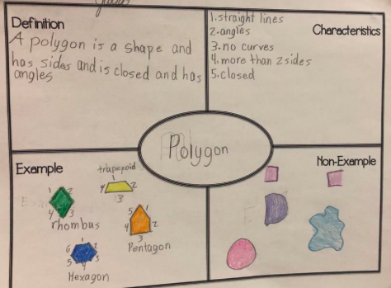

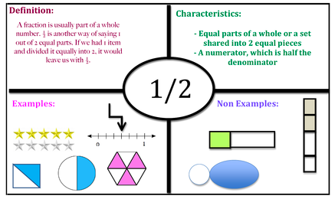

BLANK FREYA MODEL BELOW TO PRINT IF NEEDED

Once completed you will need to:
- where possible, email me to fw@helserton.n-yorks.sch.uk (either as a photo or as an attached document) your three completed Freya models.
- Print/keep a copy for yourself, somewhere safe, that you can take with you to your Maths lessons at secondary school in September.

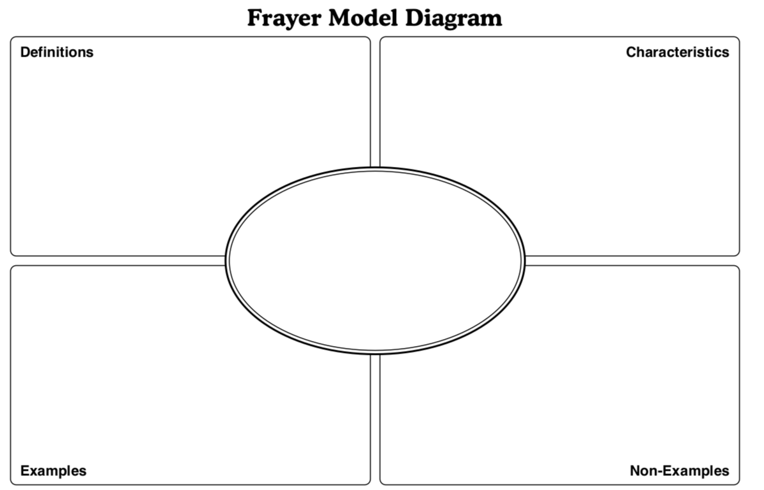
Fractions
Decimals
Percentages

