West Heslerton CE VC Primary School, Keeper Wood Year 3 and 4
Weeks beginning 11th May and 18th May
Well done with all your hard work. It’s been lovely to see photos of your work via email. Here are some more activities for you to complete, Whiterose maths has changed slightly, see maths section. The work provided is for the next two school weeks. Remember you can email the class email address kw@heslerton.n-yorks.sch.uk to show me any work that you have completed, if you need assistance or if you just want to say hello!

Weekly Reading tasks | Weekly Maths tasks
*Daily reading- read a range of different material e.g. a non-fiction book, a car manual, part of a cooking book, a leaflet, a KS2 appropriate newspaper article. Vary your reading and also enjoy your current reading book. If you have the chance, read to an adult, or ask them to read to you. Remember to record your reading in your reading record.  *Read Theory sessions. Login details are recorded in your Reading logs. https://readtheory.org  *Read ‘How To Train Your Dragon’ by Cressida Cowell audiobook read by David Tennant. Listen to three chapters over the next two weeks; just like in our guided reading lessons answer the comprehension questions (provided chapter 4-7).  Remember you can listen to the chapter as many times as you need until you hear the answers to the questions.  *Work through the appropriate year group printable packs from ‘English Mastery’  * Read this extract from ​Ocean Emporium​. Then use a dictionary​ to clarify any unfamiliar vocabulary.  https://www.lovereading4kids.co.uk/extract/15536/Ocean-Emporium-by-Susie-Brooks.html | *We are focusing on time for the next couple of weeks. This includes analogue and digital time and knowledge of months and days in each month.  https://www.bbc.co.uk/bitesize/topics/zkfycdm/articles/zcrmqty  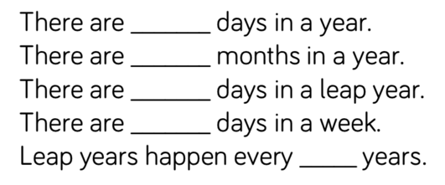  *Practise telling the time with an analogue and digital clock. If you wear a watch make sure you tell a grown up the time when you start and finish an activity. https://mathsframe.co.uk/en/resources/resource/116/telling-the-time Y3 and Y4: Pupils need to read to the quarter hour and the nearest 5 minutes.  *Whiterose maths home learning online.  https://whiterosemaths.com/homelearning/  From Monday 11th May the worksheets will revert back to only being available for premium subscribers but there will be some resources available. They have been working with https://www.bbc.co.uk/bitesize/dailylessons where you can find daily maths lessons.  *Work through (15-20 min) the appropriate year group printable packs from ‘Maths Mastery’  *Daily TT Rockstar practise- children have login in their logs.
Weekly Writing tasks | Weekly Spelling tasks
*Story writing- Complete the DADWAVERS (remember each letter of DADWAVERS stands for something different). Focus on the picture in the centre of the paper (Aysgarth Falls), fill in the areas around the picture thinking about this being your setting of your story.  *The story starter that you have already written (from the last home learning newsletter), can you now adapt your starter to fit in with the setting that you have created with your DADWAVERS?  * Write a detailed explanation of how the water cycle works and what is involved with each transition. Use your science work already completed to help you achieve this.  *Research David Attenborough, who he is and what does he do? Write a list of questions you would like to ask David (more than 10 questions). Make sure you write a variety of questions using different question words.  *Watch https://www.youtube.com/watch?v=Hb7yykqb85U  Choose a plot section below after watching the video.  Plot point 1: Special deliveries Time: 0:12 – 0:42  Plot point 2: Cloud guys Time: 0:43 – 1:04  Plot point 3: Bundles of cuteness Time: 1:05 – 1:26  Plot point 4: A tough, lonely job Time: 1:27 – 2:22  Plot point 5: Another challenge Time: 2:23 – 3:06  Plot point 6: A prickly problem Time: 3:07 – 3:42  Plot point 7: Are you serious? Time: 3:43 – 4:09  Plot point 8: Anger and despair Time: 4:10 - 4:31  Plot point 9: Feather of hope Time: 4:32 - end  https://www.youtube.com/watch?v=TvbAIbC3r6s Watch video from 5:50-25:55. This will demonstrate what you could write. Have a go at writing your own, remember you may have chosen a different section to the video and also use words that you feel comfortable using.  Remember to include prepositional phrases, a hyphen and rhetorical question like demonstrated. | *Practise the Year 3/4 for ​Common Exception​ words​. These spellings are in the front of your homework books. There are also year 1/2 common exception words for you to practise if there are some that you are unsure of.  *Practise your spelling on​ ​Spelling shed. There are spellings on there for each group for the next 2 weeks, these are the spellings that you would normally be getting as your weekly homework. There are also previous weeks to practise if you haven’t done so already.  https://www.edshed.com/en-gb/login  *Practise your spelling on​ ​Spelling frame https://spellingframe.co.uk  * ​R​a​in​ ​b​o​w​ ​w​o​r​d​s​. Choose 5 ​Common Exception​ words and choose different colours to write each letter and create rainbow words.  * Alphabetical order- L​ist each letter of the alphabet and ask your child to think of a ​water related word that corresponds with each letter. It could be an adjective to describe how the water is moving/moves.
Topic Tasks
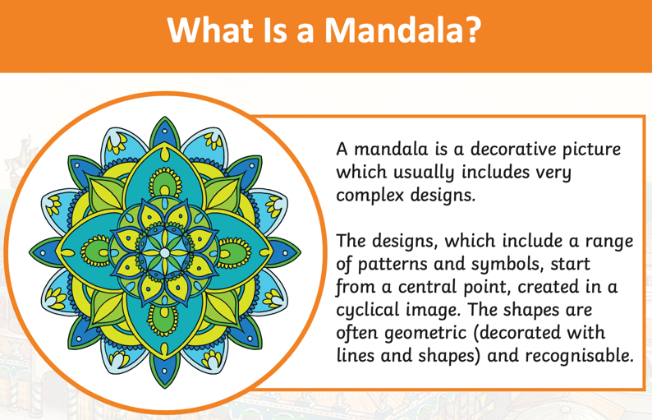

Art
*Design your own Hindu mandala using the template below to help (if you need it), you could use a compass if you have one. As part of our R.E we are looking at Hindus in Britain. Hindus believe that by expressing yourself through the design of a mandala, you are sharing yourself with those who view it.

Geography
*Watch the video and look at the resources provided by Yorkshire Water
https://www.yorkshirewater.com/education/home-learning/
https://www.youtube.com/watch?v=_zOf2wkMnis

https://www.youtube.com/watch?v=ylHT6fOPIcE Have a go at making the water filtration system after watching some of the other videos. Write about the water filtration system and what it does.

R.E
*Write about what is important to these hindu children. What is Karma and why do they believe in it? What do they believe about birth and death? Find the information in this video.
https://www.bbc.co.uk/teach/class-clips-video/religious-studies-ks2-my-life-my-religion-hinduism-meeting-two-british-hindus/zkghf4j

Reef Research​
*The Great Barrier Reef is the only living thing which is visible from space! Take a virtual tour of the reef using ​AirPano and create a poster or video to promote the Great Barrier Reef. Use scientific language relating to the habitats and species groups found in the reef. Can you identify the main threats to The Great Barrier Reef and include these too?
https://www.airpano.com/360photo/Great-Barrier-Reef-Australia/

Be active
*Keep active by joining in some online child friendly exercise videos, go for a walk or run, making sure you use your daily outdoor exercise allowance, if you can and it is safe to do so. Maybe you could do some gardening, start growing something from seed?
https://www.youtube.com/user/thebodycoach1
https://www.youtube.com/channel/UC0Vlhde7N5uGDIFXXWWEbFQ Just Dance videos available on Youtube.
Recommendation at least 2 hours of exercise a week.

Additional learning resources parents may wish to engage with

https://www.bbc.co.uk/bitesize/levels/zbr9wmn *BBC Bitesize- the BBC have provided lots of free resources for all primary and secondary aged children. There are daily lessons that include a variety of subjects and activities.

https://www.bbc.co.uk/teach/supermovers *BBC Super movers provide fun curriculum linked videos to get your children moving while they learn.

https://www.natgeokids.com/uk/home-is-good/ *Activities provided by National Geographic Kids

https://www.instagram.com/thedadlab/?hl=en *Science experiments and fun activities from DadLab.

The next Keeper Wood weekly tasks will be out on – Friday 22nd May 2020

How To Train Your Dragon
Written by Cressida Cowell
Questions from Literacy Shed https://www.literacyshedplus.com
Audio book https://www.youtube.com/watch?v=8wAeB09o0BI

Chapter 4
Vocabulary | What does the word ‘viciously’ mean?  What does the word ‘solemn’ mean? Use a dictionary to write a definition of the word.  Can you hear an example of alliteration? Find a word that shows the Great Hall was very noisy.
Infer | How are Snotlout and Hiccup similar? How are they different?  What does the phrase ‘went very white in the face’ suggest about how Fishlegs is feeling?  Who do you think Fishlegs defends Hiccup in front of Snoutlout?
Predict | What methods do you think Hiccup will devise for training his dragon?
Explain | Snotlout is a bully. Discuss.  Can you design a new front cover for Professor Yobbish’s book? Explain why you chose your particular design?
Retrieve | What names does Snotlout suggest for Hiccup’s dragon? Hiccup’s dragon has razor sharp teeth. True or false?  Name two other books written by Professor Yobbish.
Chapter 5
Vocabulary | What does the word ‘quarrelling’ mean?
Infer | What does the verb ‘shovelling’ suggest about Stoic?  Why does Old Wrinkly turn his laugh into a cough?  What does the simile ‘as flat as glass’ suggest about the sea?  What does the adverb ‘gloomily’ suggest about Hiccup’s feelings?  Why is Hiccup reluctant to admit he can talk to dragons?
Predict | What role do you think Old Wrinkly will play in the rest of the story?
Explain | Explain Old Wrinkly’s views on leadership and what makes a good leader.
Retrieve | What is the name of Hiccup’s mother?  What must Hiccup do by Thor’sday Thursday? What have the boys started calling Hiccup?
Summarise | Can you re-tell this chapter from Old Wrinkly’s point of view?

Chapter 6 and 7
Vocabulary | Find and discuss any words or phrases that suggest the Sea Dragon is very big.  The word ‘ravenous’ is closest in meaning to...  Which words and phrases suggest that the underwater animals are afraid?  The word ‘indignantly’ is closest in meaning to...
Infer | What does the phrase ‘underwater desert’ suggest?  If you were making a film of Chapter 6, what sort of music would you choose as a soundtrack and why?  How do we know Hookfang and Newtsbreath mean to do Toothless harm?
Predict | What role do you think the Sea Dragon will play in the rest of the story?
Explain | Fishlegs is intelligent and quick thinking. Do you agree? Disagree? Use examples.  Do you think it is important for the Vikings to be able to speak Dragonese?
Retrieve | Why has the Sea Dragon been asleep for so long? What language does Toothless speak?  How can you tell when a dragon is scared or angry? Why does Toothless bite Hiccup?
Summarise | Re-tell Chapter 7 from Stoic’s point of view.

