WEST HESLERTON C.E. PRIMARY SCHOOL
Head: Rachel Wells B.A.(Hons)Q.T.S. NPQH
High Street, West Heslerton, Malton, North Yorkshire. YO17 8RD
Telephone/Fax:- 01944/728286; E-mail:- admin@heslerton.n-yorks.sch.uk ; www.westheslertonschool.co.uk

“Children are at the centre of all we do.”
NEWSLETTER February 11th 2022
A paper newsletter will be sent home each Friday, you may wish to isolate this for 48 hours before reading it. This will also be on the school website. www.westheslertonschool.co.uk
COVID
Covid cases have reduced and we are doing all we can to help maintain this. Classrooms are well ventilated, therefore please wear extra layers every day!
The wearing of wear masks when dropping and collecting pupils from the school is currently voluntary but may need to be reintroduced if numbers increase.
Should you have any positive Covid test results, please share these with us using covid@heslerton.n-yorks.sch.uk
Pupils, staff and other adults must not come into the school if they have one or more coronavirus (COVID-19) symptoms. Government guidelines for testing must be followed. If positive, please remain at home for at least 5 days and 2 negative tests.
Children who are at home due to covid will have work set on Dojo. If well enough they can access this through their login (not the parents login) and submit any work via their portfolio please.
BADGER WOOD VISIT TO YORKSHIRE AIR MUSEUM
The children in Badger Wood will be visiting the Yorkshire Air Museum, York on Thursday, March 10th to explore the development of flight from 1300 to 1949. They will look at Chinese kites, hot air balloons, gliders and jets as well as the role of aircraft in WWI and WWII through group participation, demonstrations and displays.
School will pay the cost of the coach to York. May we please ask for a parental contribution of £7 per child to cover the cost of admission and activities. This may be paid on Parent Pay using you login, please ask if you have any questions.

The children will travel with Fletcher’s coaches and be accompanied by Mrs Woodward, Miss Johnson, Ms Trueman, Mrs Taylor-Barber and Miss Hopkinson.. We will leave school at 9.00 and return for the end of the school day. The children will need to bring a packed lunch, drinks only in cartons please, no cans or bottles. School is able to provide a packed lunch if you wish, please indicate this on the attached form. The children will not need any money with them. Children will need sensible footwear, and warm waterproof coats.
Pupils will need to take their own inhalers if necessary. School carries insurance for all school trips. In case of emergency please contact the school.

FAIRTRADE STALL
.

SCHOOL MEALS
Pupils’ choice for pudding on Thursday next week is: meringues, berries and cream

SCHOOL WEBSITE
School have a new website with a calendar of events, term dates etc. have a look!

CLUB PLACES
Confirmation of places has been sent via Dojo to those who requested a place.

SCHOOL DINNERS
The children really enjoyed spaghetti bolognaise with carrot sticks and home-made bread on Thursday.
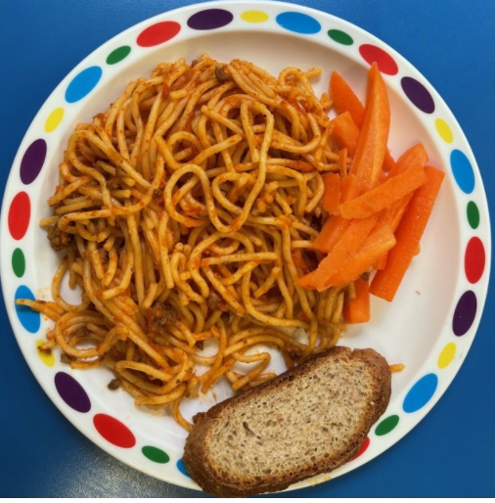

BADGER WOOD
We enjoyed sports skills in the sunshine, practising ball skills in pairs and individually, and having fun games.

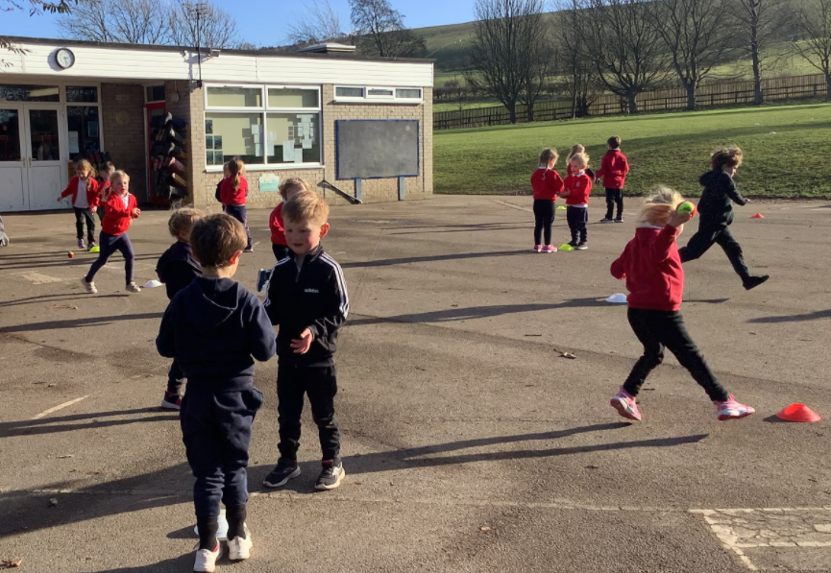

FIRE SERVICE
We have had a visit from the fire service. They talked to us about all the situations that they may be called out to. Then they also showed us the equipment that they would need if they were called out to a fire.
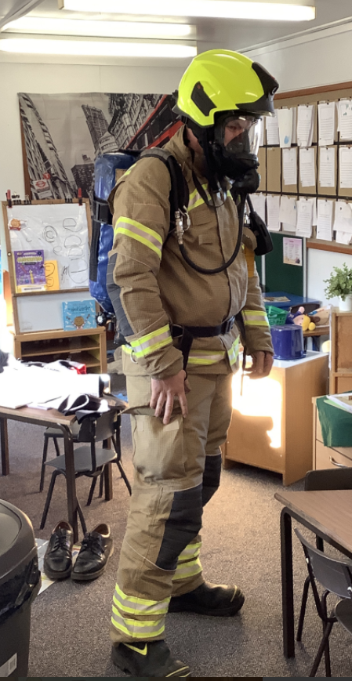

KEEPER WOOD
CRICKET 🏏
The children have had a great afternoon in their cricket session playing “rockets and planets” and ending with a game of “last bat standing”.
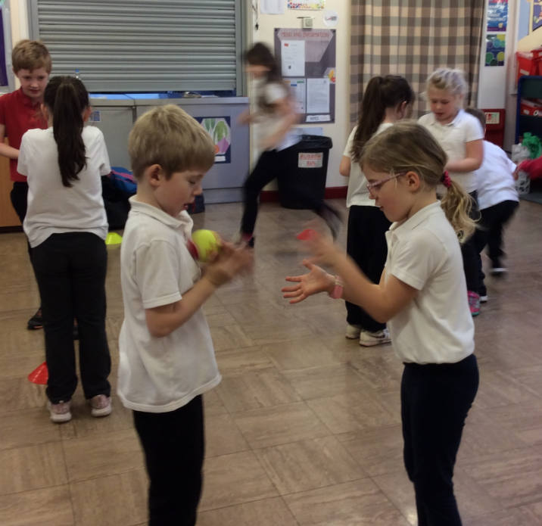
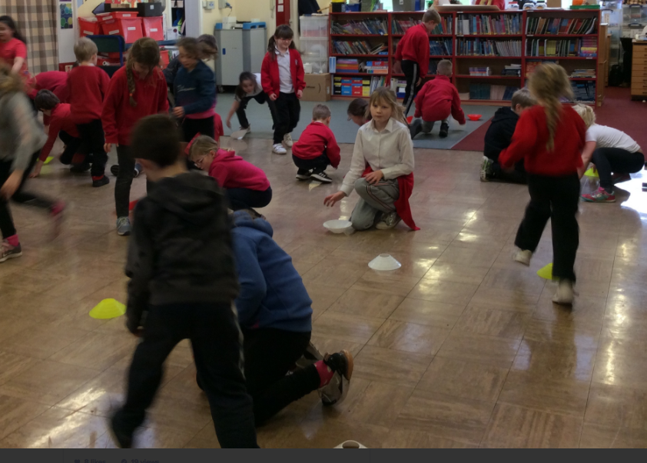

FARTHING WOOD
A very energetic afternoon playing cricket and doing street dance with our expert visitors!
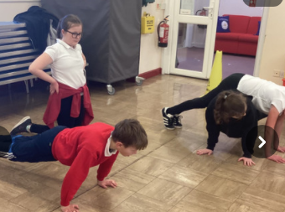

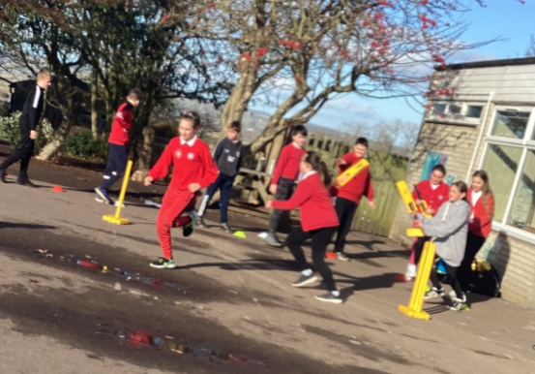

CRICKET SESSIONS IN HALF TERM
We have been asked to advertise the soft ball cricket camps at Terrington during the half term break. Full details can be found using this link.
https://srcdg-world-cup-legacy.myshopify.com/collections/february-enjoy-cricket-camp-terrington-hall

HESLERTON AFTER SCHOOL CLUB
This week we have been making drop scones and decorating them to look like birds’ nests with eggs in. Children have been weighing out ingredients and mixing the batter, and a gluten-free mixture has worked well too.

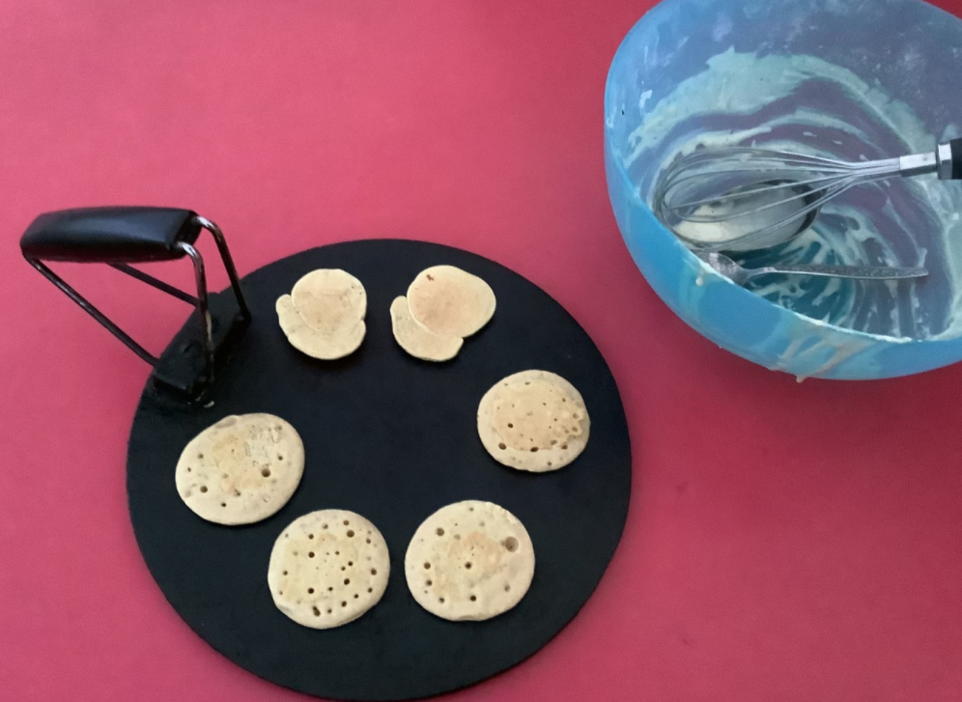

The after school club is getting busy! Please book in advance if possible, spaces may be available on th day but this can not be guaranteed.
Please see attached a booking form for next half term.

ATTACHED
Please find attached:
- After school club booking form
- Packed lunch form - Badgers
- The Bothies flyer
- Lunch form - Badgers

PARENT EVENING
Thank you to all parents who have spoken with their child’s teacher recently. This is a helpful means of keeping in touch with your child’s progress.

