WEST HESLERTON C.E. PRIMARY SCHOOL
Head: Rachel Wells B.A.(Hons)Q.T.S. NPQH
High Street, West Heslerton, Malton, North Yorkshire. YO17 8RD
Telephone/Fax:- 01944/728286; E-mail:- admin@heslerton.n-yorks.sch.uk ; www.westheslertonschool.co.uk

“Children are at the centre of all we do.”
NEWSLETTER February 18th 2022
A paper newsletter will be sent home each Friday, you may wish to isolate this for 48 hours before reading it. This will also be on the school website. www.westheslertonschool.co.uk

SATS SUPPORT
The Adult Learning team at NYCC are running free online courses to provide parents with the knowledge to support their child in their English and Maths year 6 SATs.
Maths support course, Tues 1st March at 18:30-20:30
English support course, Wednesday 2nd March at 09:30 -11:30 or 18:00 – 20:00

For more information and to book online,

https://ebsontrackprospect.northyorks.gov.uk/page/findcourse?utm_campaign=2115895_CYPS%20eRed%20Bag%20-%2018%20February%202022&utm_medium=email&utm_source=North%20Yorks%20County%20Council&dm_i=4BPJ,19CMV,34L2U6,5SZCJ,1
Search for SATs and the day of the course.

WORLD BOOK DAY
We will be celebrating 25 years of World Book Day on Thursday, 3rd March.
We have been looking at European authors and would like to invite the children to come to school dressed as a European author or a character from one of their books. Ideas include, Roald Dahl, Hans Christian Anderson, Greek Myths, Beatrix Potter, Enid Blyton.
Please find attached a World Book Day voucher for your child.

The children in Keeper Wood and Farthing Wood have produced an excellent poster which will be displayed in Kemp’s bookshop in Malton from February 26th to March 12th

There will be a special World Book Day lunch:

Positivity Pizza
You Can Do It diced potatoes
Brave broccoli
Courageous carrots

Mole Mud Muffins
(Chocolate muffins)

School meals cost £2.50 for children from years 3-6.

COVID
Covid cases have reduced and we are doing all we can to help maintain this. Classrooms are well ventilated, therefore please wear extra layers every day!
The wearing of wear masks when dropping and collecting pupils from the school is currently voluntary but may need to be reintroduced if numbers increase.
Should you have any positive Covid test results, please share these with us using covid@heslerton.n-yorks.sch.uk
Pupils, staff and other adults must not come into the school if they have one or more coronavirus (COVID-19) symptoms. Government guidelines for testing must be followed. If positive, please remain at home for at least 5 days and 2 negative tests.
Children who are at home due to covid will have work set on Dojo. If well enough they can access this through their login (not the parents login) and submit any work via their portfolio please.

WOODLAND HOLIDAY CLUB
We hope all those attending this club have a great time! Don’t forget your packed lunch!

If there are any changes to the bookings for the Woodland Activity Club, please contact Will Watts on 07964759433. Please await a confirmation that this message has been received

SCHOOL MEALS- SHROVE TUESDAY
The children will have pancakes for pudding on Tuesday, March 1st, Pancake Day.

SCHOOL DINNERS
The children really enjoyed spaghetti bolognaise with carrot sticks and home-made bread on Thursday.
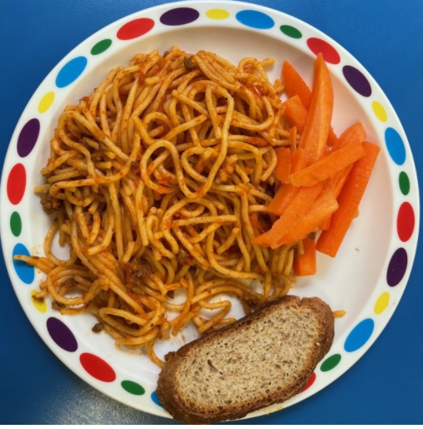

BADGER WOOD
Some of our year one children have built this wonderful train. They said it’s the Mallard. Here we are enjoying the sunshine. The children have decided we are going to London and Australia. “There’s a very big problem “ Poppy says, “ Australia is closed”

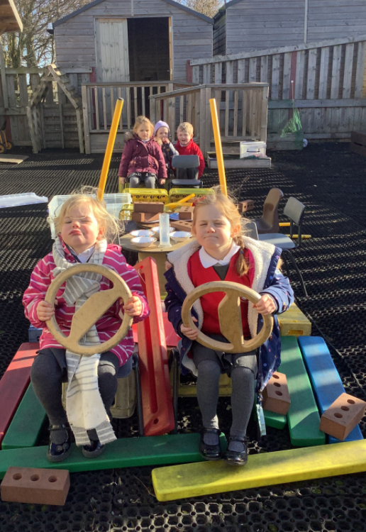
KEEPER WOOD
FOREST SCHOOLS
The children have completed a circular route round the forest, working in teams.
They have also started creating dead ends to confuse people going around the labyrinth.
We have seen some fantastic team work.

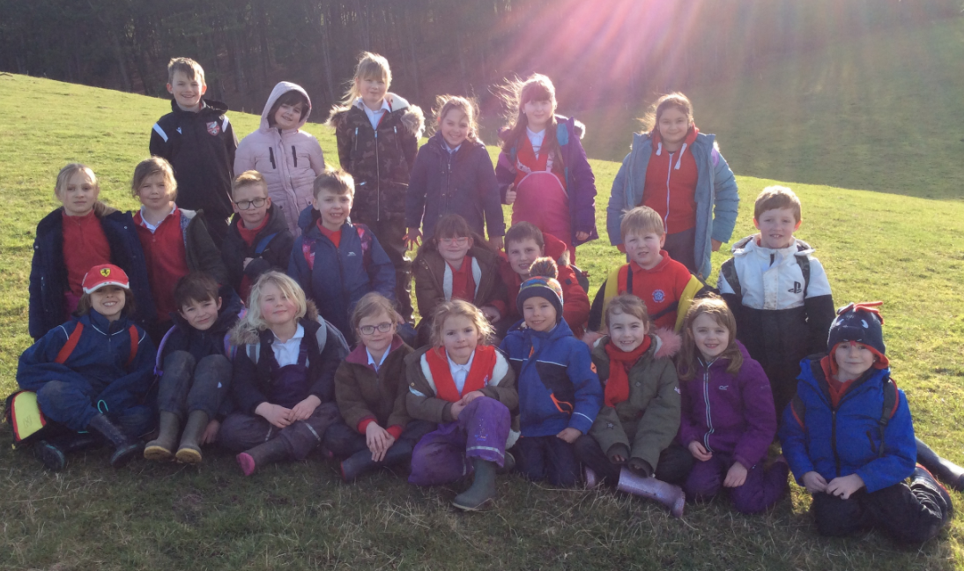

FARTHING WOOD
As a stimulus for writing a letter of complaint, we took part in some role play. Linked to our story in English, the Happy Endings from fairy tales have been stolen by the wicked witch. We held a public meeting with the Government Ministers of the Forest where parents of young children, who had been traumatised by the unhappy endings to their bedtime stories, came to complain and demand the situation be resolved!

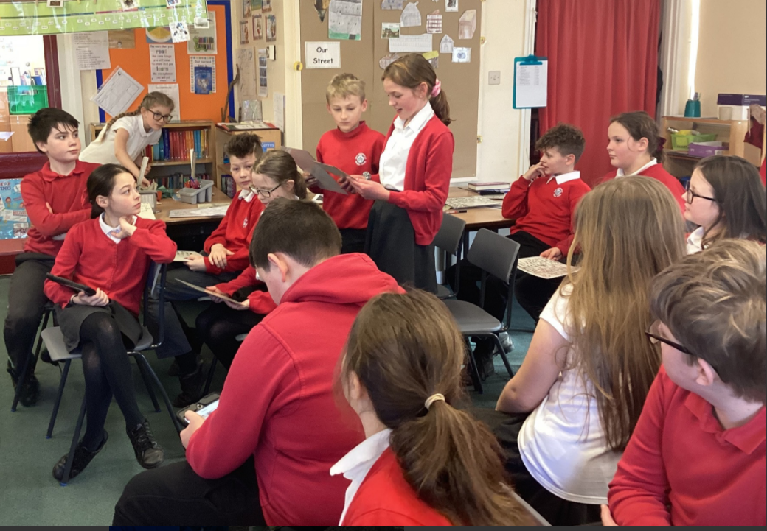

BADGER WOOD VISIT
The children in Badger Wood will be visiting the Yorkshire Air Museum, York on Thursday, March 10th to explore the development of flight from 1300 to 1949.
School will pay the cost of the coach to York. May we please ask for a parental contribution of £7 per child to cover the cost of admission and activities. This may be paid on Parent Pay using your login, please ask if you have any questions.
The children will need to bring a packed lunch, drinks only in cartons please, no cans or bottles. School is able to provide a packed lunch if you wish, please return the form sent home last week, thank you.

CHILDREN’SUNIVERSITY
There will be a Children’s University passport check in school on Monday, March 7th.

CRICKET
All pupils have been able to try a cricket session in school with Yorkshire Cricket Board recently. Please see the posters below for further fun training sessions happening in our area on Sundays. These sessions will be popular so please book your space. For any questions, please email sarah.midge@icloud.com
ATTACHED
Please find attached:
- London update letter – Farthing Wood
- Holiday dates
- World Book Day voucher

CRICKET SESSIONS IN HALF TERM
We have been asked to advertise the soft ball cricket camps at Terrington during the half term break. Full details can be found using this link.
https://srcdg-world-cup-legacy.myshopify.com/collections/february-enjoy-cricket-camp-terrington-hall

MATHS THROUGH STORIES SESSION
Thursday 3rd March 3.45-5.45pm
Join Dr. Natthapoj Vincent for an online session Thursday 3rd March 3:45-5:45 Maths Through Stories
Whether you are an experienced teacher, a teacher trainee, a teacher educator or a parent, we hope you will find this session interesting and useful. We want to share with you the benefits of teaching and learning mathematics through stories and creative writing, as well as to offer practical ideas for teachers and parents on how to embrace this approach.
Dr. Natthapoj Vincent Trakulphadetkrai is Associate Professor of Mathematics Education at the University of Reading. His research interests are centred around the use of storytelling (particularly in the story picture book format) to help enrich mathematics teaching and learning experiences. He founded the MathsThroughStories.org initiative back in 2015, and officially launched its website in March 2017.
Follow this link to book your place - https://www.eventbrite.co.uk/e/maths-through-stories-dr-natthapoj-vincent-trakulphadetkrai-associate-p-tickets-255086499587
Should you have any queries, please do not hesitate to contact a.southall@coastandvale.academy

