West Kidlington Primary and Nursery School
Nursery 2-Year Old Application Form

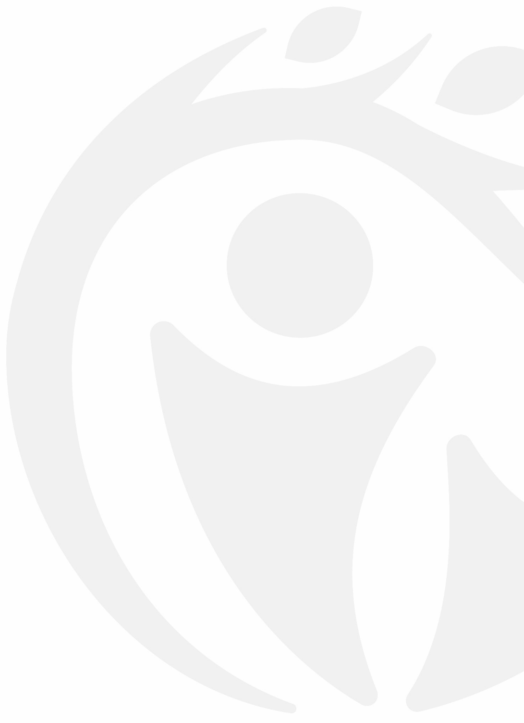
Please return this form to the school office with your child’s birth certificate or passport
Full name of child: | Sex:  Male/ Female | Date of Birth dd/mm/yy
Address where child resides:

Postcode
Who does the child live with?

Names and dates of birth of any siblings:

Dietary/ Medical Concerns/ Allergies/SEN

Name of parent 1 |  | Relationship to child
Address if different from child

Postcode
Telephone | Landline 📞 | Mobile📱
email address
Name of parent 2 |  | Relationship to child
Address if different from child

Postcode
Telephone | Landline 📞 | Mobile📱
email address

Does your child currently attend another setting? Yes/No | Name of current setting if attending?
Please Turn Over

FOR SCHOOL USE ONLY
Date application form received___________________
Birth Certificate/ passport checked/ seen, and a copy made. Yes □ No □ Date seen_________________ Number___________________
(please circle which document was seen and photocopied) Signed____________________________ Print________________________

2-Year-Old Application

If you are not entitled to free early education for 2-year-old funding or Working Parent Entitlement, you will be charged for sessions.

Eligibility Criteria for free Early Education For 2-Year-Olds
- Income Support
- income-based Jobseeker's Allowance (JSA)
- income-related Employment and Support Allowance (ESA)
- Universal Credit - if you and your partner have a combined income from work of less than £15,400 a year after tax (not including benefit payments)
- the guaranteed element of Pension Credit
A child can also get free early education and childcare if any of the following apply:
- they’re looked after by a local council
- they have an education, health and care (EHC) plan
- they get Disability Living Allowance
- they’ve left care under a special guardianship order, child arrangements order or adoption order

Please enter entitlement codes (if applicable)
Working Parent Entitlement code
Free Early Education for 2-year-olds code
Parent name
Parent DOB
National Insurance number
To find out about Working Parent Entitlement click on the link Free early education for eligible working families | Oxfordshire County Council

To find out about Free 2 year old funding click on the clink Free early education for Early Learning for 2 year olds | Oxfordshire County Council

We do not offer combinations of sessions. ie mixing am only and pm only sessions on different days
Please tick sessions required
 | Breakfast  8.00am-8.30am | Morning  8.30am- 11.30am | Lunch  11.30am-12.30pm | Afternoon  12.30pm- 3.15pm | Tea-time  3.15pm-4.00pm
Monday
Tuesday
Wednesday
Thursday
Friday

We cannot guarantee your preferred session, but we will do our best to accommodate you when we allocate sessions.
Please return this form to the school office with your child’s passport or birth certificate

Please note that completion of this form does not guarantee a place for your child. If you decide you no longer require a place, please inform us. We will retain your personal information on this form for as long as is required to be on the waiting list. It will not be shared with other parties.

