West Kidlington Primary and Nursery School

Positive Behaviour and Nurture Policy

2023/24
Reviewed: September 2023
Next review date: September 2024

Role | Name | Signature
Headteacher | Simon Isherwood | S.Isherwood
Assistant Headteacher | Jo Simpson | J.Simpson
Chair of Governors | Charlotte Christie | C.Christie

Aims
At West Kidlington Primary and Nursery school. We believe in providing a safe, welcoming, happy, calm and purposeful school environment in which children can learn effectively and reach their full potential. Our core values are at the heart of everything we do with the aspiration that we are all the best, decent and moral human beings that we can be. It is widely accepted that for children to learn and perform at their best, and to form and sustain positive friendships and relationships with others, children need to acquire the skills to manage themselves and their behaviour choices. We all experience a greater sense of security when boundaries and expectations are clear and consistent. As such, a clear policy is imperative - not to punish, but to create a predictable environment in which both children and staff can work and learn.

We believe that the partnership between home and school plays a vital role, and that all members of the school community should be valued and supported equally. We recognise that behaviour can be a form of communication which is acknowledged in the revised September version of ‘Keeping Children Safe in Education’, 2023.
We believe that a whole school community approach is the means to achieving the positive behaviour that allows us all to learn and grow as people.
The purpose of this policy is to ensure a consistent approach within our school community, one which also understands that we are all individuals.
Our main message that is promoted consistently throughout the school and forms our core purpose is – be kind and give your best. We also believe the ethos of the school should be built on a foundation of core values: Peace, Unity, Responsibility. Respect, Kindness and Resilience. These core values are the basis for the social, intellectual, emotional, spiritual and moral development of the whole child. We encourage children to absorb these values, thereby developing knowledge, skills and attitudes which enable them to develop as reflective learners and grow to be stable, educated, respected and respectful adults.

Objectives
- To promote mutual respect between all members of the school community
- To provide a safe and positive learning environment, where praise, encouragement and love of challenge will allow all learners to succeed
- To engender a strong sense of responsibility for our own behaviour

Rights
Every member of the West Kidlington community has the right to:
- Learn in an environment where people are kind
- Feel safe and happy within our school
- Be treated with respect, consideration and courtesy
- Enjoy our break and lunchtimes

Responsibilities
- All members of our school community will give their best in whatever they do
- All members of the school community have a responsibility to ensure this policy is consistently and fairly applied
- Our approaches are based upon values-led learning, underpinned by calmness
- All members of the school community will ensure their behaviour meets the expectations of the school, including lunch and break times and during out-of-school activities.

Our Values Pact
At West Kidlington we have a ‘pact’ that is linked to our core values of Peace, Unity, Responsibility. Respect, Kindness and Resilience. This pact is the basis of our expectation for the behaviour of the whole school community. This is displayed in all classrooms and in key areas. The pact is referred to in all our dealings regarding behaviour.
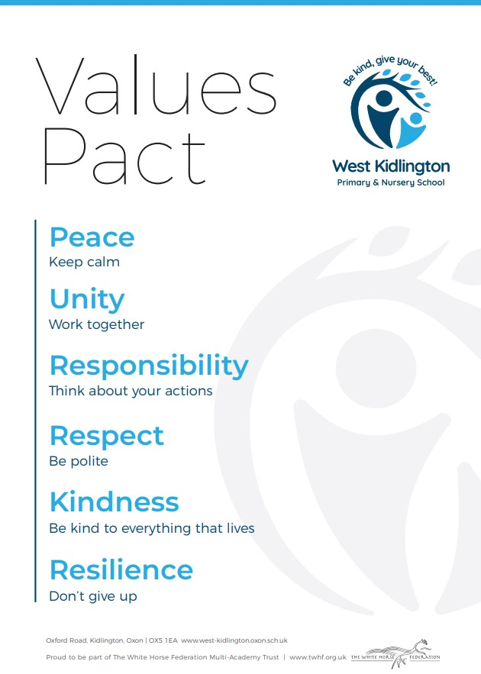
The School’s Value Pact

Emotional Regulation
At West Kidlington we know that a child’s behaviour can be a form of communication. This can be caused by many traumatic under lying factors such as feeling anxious, insecure or grief to name a few.
We capture the child’s voice in a variety of ways including on the school’s behaviour incident form. Here the children are asked to reflect on their thoughts and feelings regarding their behaviour choices.
At West Kidlington we are inspired by the picture book ‘The Colour Monster’ to support children in understanding and regulating their emotions. This book allows children to explore colours associated with feelings in a fun and nurturing way. This is used in Early Years and in Key Stage 1. By the end of Key stage 1 children should know what makes them feel a certain way and have personal strategies to regulate their individual emotions. Please see the progressive outcomes the school have identified.
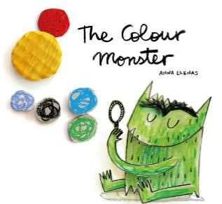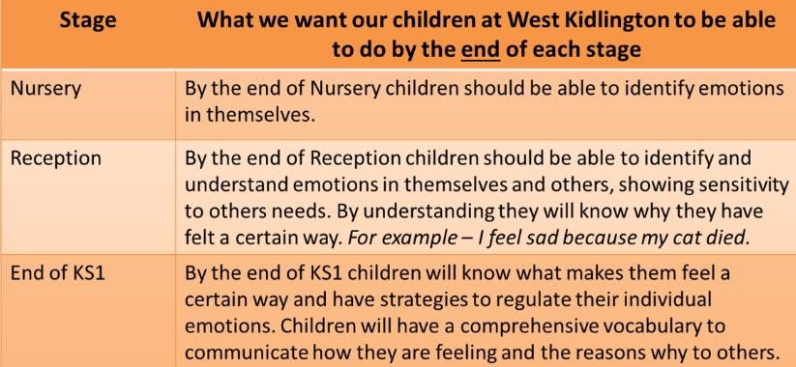

Learning Powers
At West Kidlington the ‘Learning Powers’ are taught in Key Stage 2 as a progression from the ‘The Colour Monsters’ in Early Years and Key Stage 1. Learning Powers are delivered through real life stories. West Kidlington’s five Learning Powers are: Make Links and Connections, Perseverance, Have a Go, Communicate Effectively and Be Creative. These five learning powers have close links with the school’s values.
With this in mind children should transition into KS2 with personal strategies to regulate their individual emotions and therefore be ready to ‘learn how to learn’. By the end of Key Stage 2 children are ready to transition into Secondary School and move into the next phase of their lives knowing what is required to be a good learner and appreciate that success is not all about academia.

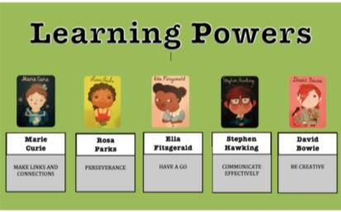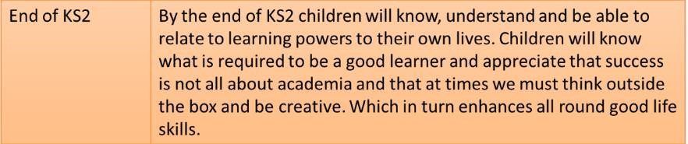

KS2 children who need further self-regulation support
In the event of children not being able to fully self -regulate, the school will look carefully at these individual children. Neuroscience tells us that if patterns of misbehaviour become established, we need to break the pattern. In order to do this, an individual intervention is developed. This is only provided for small numbers of children who are not able to self-regulate in Year 3-6.
The intervention may include:

Using evidence based neuroscience to create new messages through positive psychology, e.g. red, amber, green charts, teaching about the brain, affirmation cards, enhanced personal wellbeing books – basically what is needed for a child to break and renew their behaviour pattern.

-Developing children’s individual understanding of their own behaviour risk factors that are influenced by their own behavioural challenge e.g., child who has a tendency to anger is shown strategies for grounding and appropriate response, the child who has hyper energy is shown awareness of the effects of food, the child who needs to run off their energy and switch environments – essentially breaking a pattern, switching the energy and applying opposite to the behaviour shown and the emotion felt

-Positive time out with adult, in a quiet place e.g, relax sessions/yoga/MindUP /Headspace

-Carefully unpicking any underlying causes

Teachers will inform other staff of specific strategies used for individual children.

Rewards
At West Kidlington we look for every opportunity to praise and reward children, not just for academic achievement but for positive attitude, effort, care and kindness towards each other.
Positive behaviour will always be rewarded in the first instance by praise (verbal and nonverbal) and adults visiting each other’s classrooms are encouraged to comment on the excellent behaviour they see.
Likewise, every adult will use a system of tactical ignoring or use of non-verbal cues such as praising the behaviour of others.

Rewards System
Each class will have a values circle, linked to the values pact and every day all names start in this circle.
- Children receive marbles for upholding the Values Pact. Teachers should aim to give at least 5 marbles in a lesson. This emphasises that positive learning behaviours are the most important focus of our school.
- When the class marble jar is full, there is an immediate reward - the class go out with their teacher and learn a new playground or constructive games/puzzles game. The children have lots of fun but at the same time are learning alternate ways of playing, teamwork and strategy skills. This finishes after 15 minutes, wherever they are in the game and the only way to continue or to learn a new game is to fill the marble jar again.
- Children earn Quality Counters for producing work that, for them, is outstanding. The school’s children will work together to fill the four jars in the central part of the school. When the jars are a full, a whole school reward will be initiated (magician, theatre visit etc)
- Children can be awarded Lunch Time raffle tickets. Only one can be issued by staff who notice positive behaviour. This could be helping others, playing nicely and being polite. At the end of a term the school organises between 5-10 prizes and raffle tickets are drawn from a jar.
- Teachers choose special positions in the class as a reward for children who always shine: i.e. star of the week, class rep.

Sanctions
There is a clear line of progressive sanctions that all adults must follow
Level 1:
Children are moved out of circle for doing the opposite of what is outlined in the values pact: calling out, poor listening, noisy when lining up, shouting in corridors etc. There is an expectation that they will correct their behaviour and will be moved back into the circle in the same lesson. If they remain out of the lesson by end of the lesson, they move to level 2.
Level 2:
The child will spend five minutes with class teacher during break or lunch (whichever is closest) with their class teacher talking about the values pact and what they need to do to be moved back into the circle in the next lesson. If this in the afternoon, then it will be next day’s break. If possible, the younger children need to be spoken to that afternoon in order to remember why they have lost 5 minutes the next day. Again, the class teacher may choose to do more than 5 minutes. If the child has to do this with the class teacher three times, then move to level 3 the same week. The teacher will also have a verbal conversation with the child’s parent at the end of the day /via phone to keep them fully informed.
Level 3:
The child is sent to the phase leader at the next break/lunch time to repeat the 5 minutes with them (the phase group leader may choose more than 5 minutes). If a phase group leader is absent, then send to a different phase group leader. If the child is sent to the phase group leader 3 times within a short term, then the child moves to level 4

Level 4:
The child is placed on an Individual Support Plan (ISP) form in a meeting with the child, a parent, the class teacher and a member of SLT or phase leader. This must be reviewed after 3 weeks. If ISP form review shows that this is not working, then the child is moved to level 5
Level 5:
The Senior Leadership Team (SLT) decides whether the child needs to be on restricted timetable and how this can be supported
Level 6:
Temporary exclusion will only be considered when a child is displaying extreme, violent or aggressive behaviour, thereby endangering themselves and/or others. A decision to exclude will be made by the Headteacher and may be used if allowing the pupil to remain in school will seriously harm the education, health welfare or safety of themselves and others in the school community.
Any child at risk of exclusion will either be placed on a behaviour report or be placed on a individual support plan and TWHF high risk of exclusion grid will be referred to.
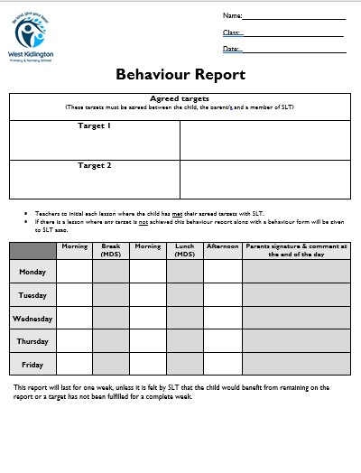
Exclusion, in the first instance, will usually be for a short period (1-3 days). If the pupil incurs additional exclusions, these may be for a longer period at the discretion of the Headteacher. Once the exclusion period is over, parents and child will have re-entry meeting with a member of SLT, where an approach to modify the child’s behaviour will be agreed, targets will be set and a behaviour report will be issued to the child’s teacher. The report will last for one week, unless SLT feels the child would benefit from this support for an extended period. This would be extended if the child had not met the set objectives.
The Governing Body, Educational Welfare Officer and the White Horse Federation are informed of any exclusion and may be involved in discussion with parents and child and school in devising an action plan.

Lunchtimes
A member of SLT is present at every lunch time and this is key to our behaviour approach and supporting MDSAs in their role.
At the end of lunch, the dinner supervisor will report to the teacher any children who should be moved out of the circle. The child will be expected to write a letter of apology to the dinner supervisor explaining why they should be allowed back in the circle. The dinner supervisor will report back to the teacher after the next day’ lunch.
Every child is back in the circle the following day.
To promote the school’s values there is a separate reward system that involves MDSA (midday supervisors) looking for children who are being responsible, playing fairly and giving their best. Each member of staff are able to give raffle tickets to children who excel. These raffle tickets are placed in a jar in the reception area. At the end of the Autumn, Spring and Summer term tickets are drawn to win motivational prizes. The whole school takes part in these celebration assemblies.

Immediate sanctions for extreme behaviour
If a child swears to be offensive, uses verbal aggression or deliberately physically hurts by punching, kicking, spitting or slapping, this child is taken straight to a member of SLT. This child will spend the remainder of that day’s breaks and the next days with the SLT member, a phone call will be made home and a letter of apology written.

Preventative Strategies
- All children will enter the school building as soon as they arrive after the gate is opened at 8:45am
- There will always be a minute of reflection after break and lunch to re-focus both children and staff on the values pact.

Training for Staff
As part of continuing professional development, training will be given to all staff on our values led learning and on the delivery of our positive behaviour management system. This includes having up to date knowledge about how to keep children safe. The school updates the staff annually, weekly and termly. Our Anti-Bullying Policy reflects our approach to Bullying. It also states how we tackle Bullying when it happens. We support and challenge all children who may be involved. Our training also includes Child on Child Abuse understanding. It recognises that Bullying and Sexual Abuse can happen amongst our pupils and that Child on child sexual abuse is a form of child sexual abuse in which a prepubescent child is sexually abused by one or more other children or adolescents, and in which no adult is directly involved. Reporting Bullying and Child on Child abuse is essential in our school. Some of the sign of abuse and bullying may involve, unexplained changes in behaviour or personality, becoming withdrawn, anxiety becoming uncharacteristically aggressive, lacking in social skills and has few friends or always choosing to wear clothes which cover their body.

Nurture Support
As a support to this behaviour policy, any child that is presenting poor behaviour choices or showing signs of emotional difficulties will be Boxall profiled. This will identify the developmental and diagnostic needs for the individual child and equip the Nurture team to make a well informed plan to support them.
At West Kidlington Primary and Nursery School we have a referral system for children, staff and parents in which they can seek support.
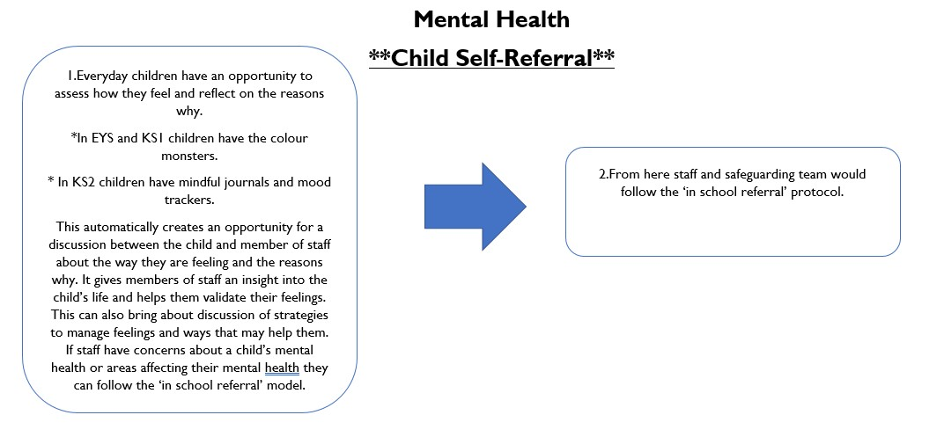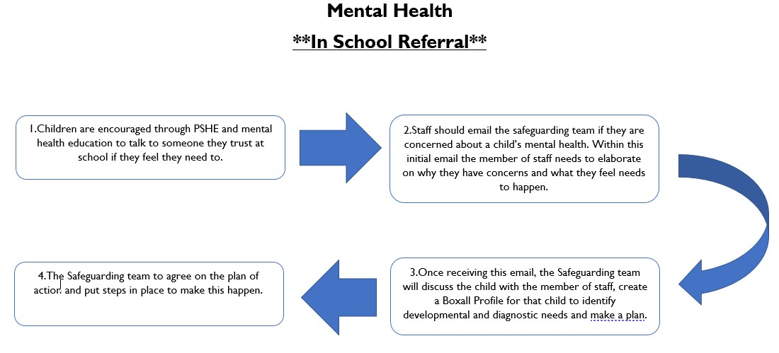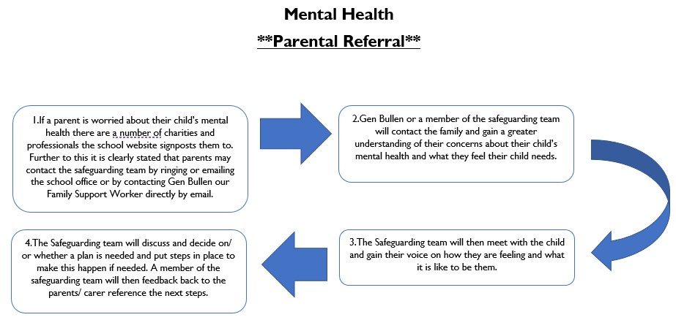

Supporting children with additional needs
It is vital that all children are known as unique individuals and that all staff are aware of the individual needs of all children. We have high expectations of all pupils but all staff at West Kidlington School, including MDSAs know how children cope with specific situations and ensure that both academic and social experiences are dealt with in a way that is beneficial to that individual. Teachers & TAs discuss the needs of pupils with each other, the SENCo and SLT. The SLT has regular contact with MDSAs. The school has strong links with external professionals/agencies if additional advice is required.

Reception Behaviour Expectations
In order to support behaviour and academic achievement/progress children will move their name up and down the ladder. All children will start the day ‘ready to learn’. When a child is recognised for outstanding behaviour or for exceeding expectation in their work, they will go up the ladder to the ‘Sparkle Zone’. Each time a child reaches this zone they will be rewarded with a marble. If a child’s behaviour does not comply to the values pact, they will be asked to move their name down.
The child will move their name to the sad face. The child will speak with an adult to discuss the choices they have made. If a child continues to make poor choices or they have hurt another child or damaged school equipment deliberately they will be asked to move their name to the very sad face. The child will speak with an adult to discuss the choices they have made. They will be given a 5-minute sand timer and must sit quietly. Parents are informed at the end of the day.

Nursery Behaviour Expectations
In the nursery the adults have high expectations of behaviour standards that the children will comply with. Children are informed about the nursery rules formally after they start through carpet time, circle time and reminders throughout the sessions when required.
The nursery has a values board to help remind the children about our expectations.

Positive and desired behaviour in Nursery is rewarded
- In the first instance (and most often) verbally and shared with the other children and with the other members of staff
- With stickers which are rewarded to a child where they are consistently working and playing within the boundaries or have made a caring and considerate action towards another child
For outstanding behaviour, a child may be taken to the Headteacher for recognition.
Parents are informed of exceptional positive behaviour that may occur.

Undesired behaviour is sanctioned in Nursery
- With the child being spoken to with an expectation that they will apologise
- With other members of staff supporting each other in expressing why the child and adult are ‘feeling sad’ and by expressing the hope that the situation will be resolves quickly. Warning of consequences are issued, such as restrictions on playing outside or being asked to go inside

In addition in Nursery
- The child is given choices where they need help in making the right decisions
- If a child persists in their undesired behaviour or if an incident is serious enough, they are asked to sit out and have some time to think about their behaviour. An adult will then go back after this thinking time talk, to the child and discuss their behaviour choices. Adults will give the child appropriate sentences to help the child should a similar situation arise
- Children may be required to play and work with an adult to carry out a variety of tasks under close supervision
- Parents or carers are informed upon collection about any incidents that occur
- If there is persistent and recurrent undesired behaviour, then a behaviour chart will be introduced, the child and the parent will be informed about how the behaviour chart will work. The child has specific targets to meet in order to put a smiley face or a ‘thumbs up’ on the chart each day. The chart is sectioned into different short portions that naturally fall in the nursery session. If a child completes a set at the end of each day, then a sticker is received. As behaviour improves, beads in a box may also be introduced where all the children help the child achieve a bead. Once the box is full the class gets a treat.
- In the event of extreme behaviour a child will be taken to the Headteacher. The child will be asked to say what happened and if unable to, the adult will explain; the child will be expected to apologise to all to rebuild the relationship. The parent will be informed at the send of the session. The child will be taken back to the Headteacher when a positive incident has taken place in order to further rebuild relationships.

